You Reckon Introductory PowerPoint – Teacher notes

The commentary offered here does not go into whether the different claims are right or not, but is looking at developing an understanding of what the different claims actually say, and what they would mean to the man in the street.

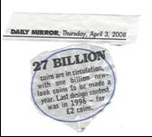 | This appears to be a statement of fact – but how many of these coins are actively in circulation? Pupils might like of think of ways coins are not in active circulation at any given time:  - Down the back of a sofa  - In a piggy bank  - Thrown down a wishing-well ….
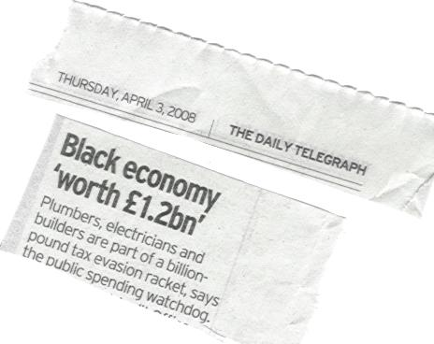 | Lots of things here – is it that £1.2 billion is lost in tax, or that tax is being evaded on £1.2 billion worth of business or work? How were they able to get this figure? How accurate or reliable is it?
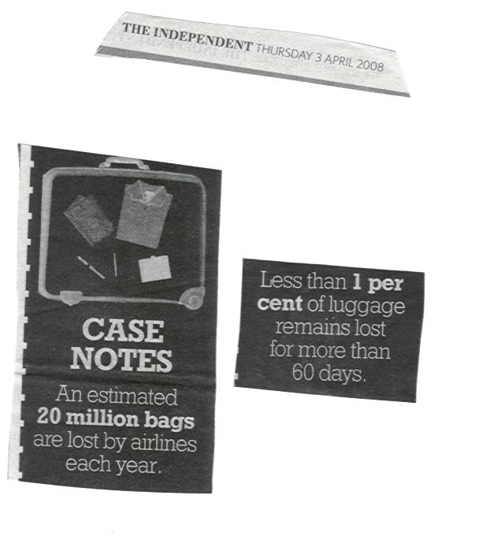 | There are two separate figures quoted here – relating to different events: ‘lost’ and ‘lost after 60 days’.  When looking at whether or not claims are reasonable it is important to be clear about exactly what is meant by certain terms, and also what group is being referred to: if this is 20 million bags lost by all airlines across the world it is a different story to it being 20 million bags lost in UK airports for example.
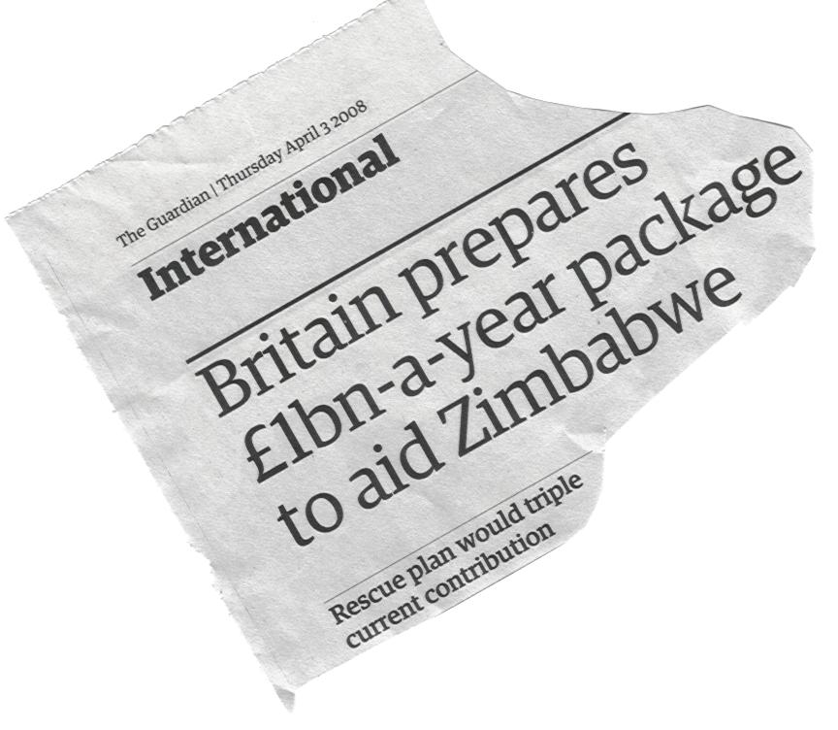 | This is a statement of fact – but what does this mean in terms of the people of Zimbabwe – is it enough to relieve the suffering?  Who will decide how it is spent?
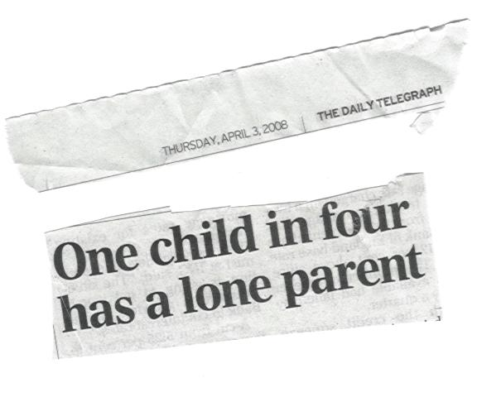 | How many children is this in the UK?  Are they across all sections of the community or are some groups more likely to be in this situation than others?
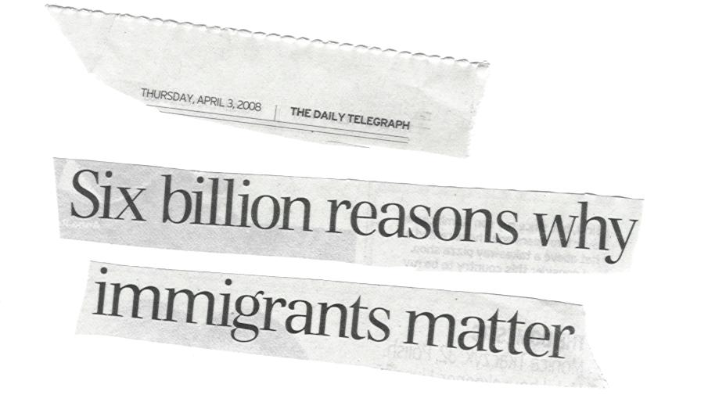 | The headline doesn’t say whether its origin is in a £6 billion contribution to the economy from immigrant workers, or a £6 billion cost to the economy from expenditure on health and other benefits – in fact it does not even say the 6 billion is a £ figure at all.
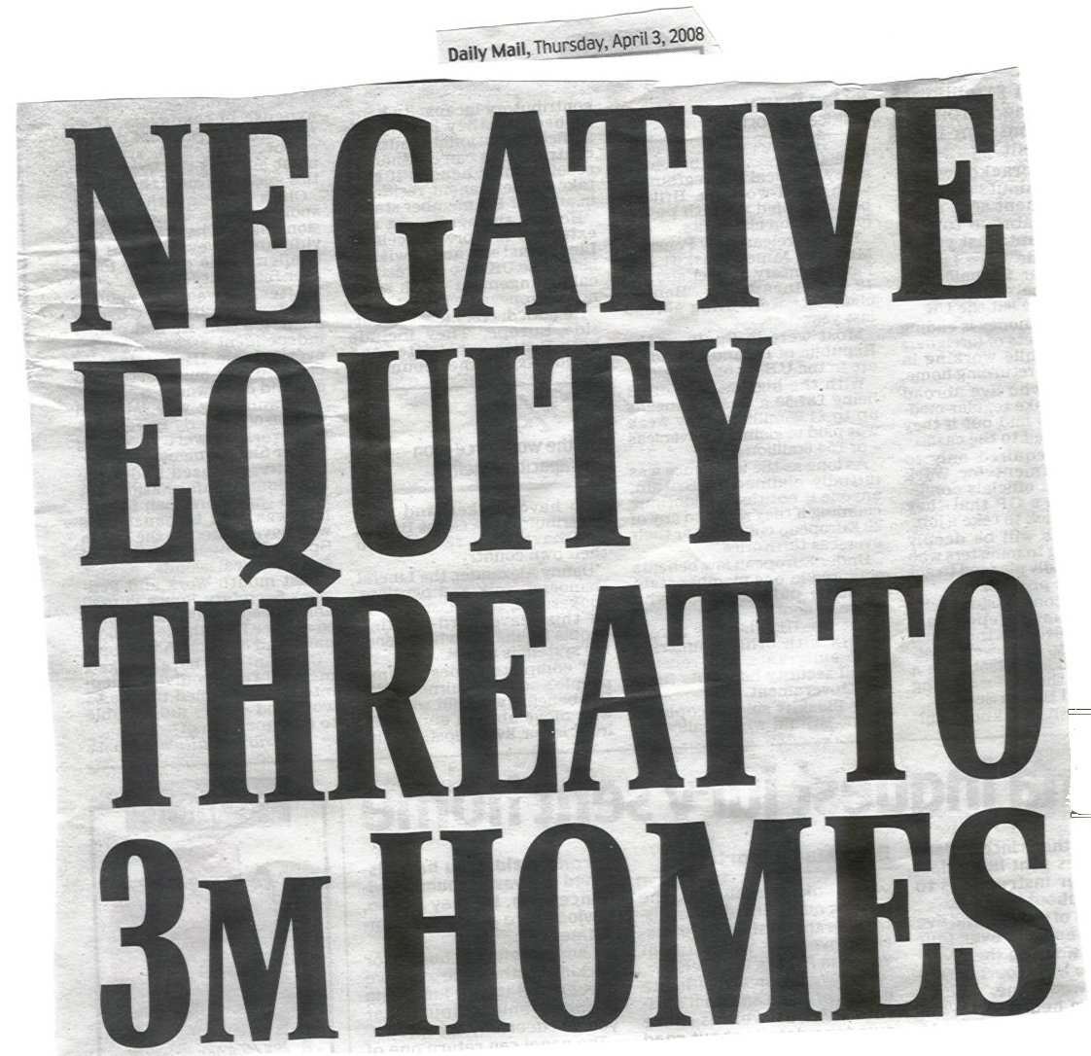  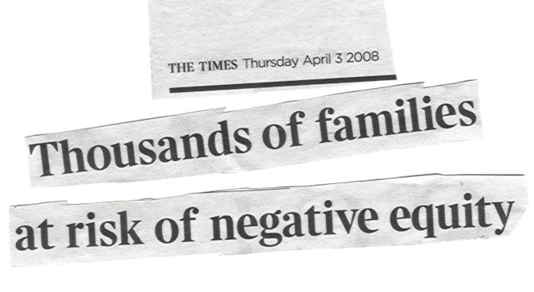 | These two headlines, from the same day’s newspapers, give strikingly different messages – illustrating that projections such as these are extremely difficult to evaluate without knowing the basis on which they are made.
 | If people are concerned about an issue, how can they know what steps are effective in addressing the problem and what are not?
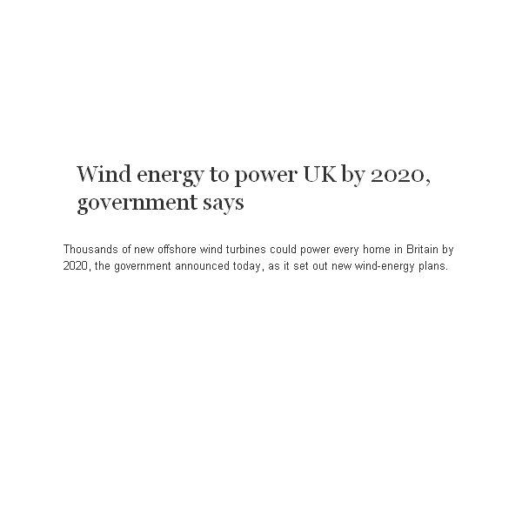 | Is this sensible – how many wind turbines would need to be built to power every home in Britain?
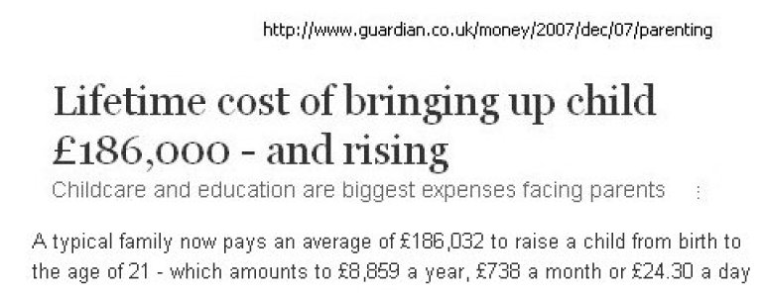 | Is this reasonable? Where do these figures come from?

