Splash Down

Our school wants to use rainwater for flushing toilets and watering the school grounds.

How much rainwater can we collect from the roof?

Is this enough water for all the toilets in school?

Teacher Notes: Splash Down

Time: 60 mins, or longer if extension tasks are used

Class Organisation: Pupils work in groups of 3 or 4

Resources:

A plan of the school, or a simplified plan, or a plan of another school [or a simple shape, for lower attaining pupils].
Google Earth (http://earth.google.com/) may already be available in your school through the Geography department, or
Google maps (http://maps.google.co.uk) should let you access aerial pictures of your school site to estimate the roof area.

Rainfall data can come from a variety of sources.
You could use the graphic on the powerpoint to estimate the annual rainfall for school.
Your geography department may collect rainfall statistics on your school site.
You can give the pupils preprinted data on rainfall from the file in the Printable Materials section. (The Met Office have kindly supplied us with a dataset giving monthly rainfall statistics over a 20 year period for about 60 stations across the UK. There should be data on rainfall quite close to your school). In this case, you need to decide how much data to give them – whether to give them all the regions, a small number or just the data from the station nearest to you.

Other approaches would be to give them the datafile and let them use a spreadsheet program to analyse the data themselves, or give them a web link to research themselves e.g. The Met Office http://www.metoffice.gov.uk/education/secondary/students/bi_climate.html

Lesson Activities

There is a short powerpoint to introduce the task as an alternative to giving pupils the task on paper.

This task comes late in the sequence of lessons, so pupils should be encouraged to tackle the problem with little help from you. You might choose to use some of the ideas in the General Teaching Notes to help here.

How much rainwater can we collect from the roof?

Solution:

Volume of rain water = area * rainfall

Teaching Issues

Conversion of units – mm/cm/metres and cm³/m³/litres
Estimation of areas
Estimation of rainfall

Rainfall Method 1 (simple): the whole rainfall for the year.

Rainfall method 2 (fancy): the rainfall for the school year – you will need monthly rainfall data for this.

Discussion Topics

Invite pupils to explain their solutions to the class. As you walk around, be alert for interesting approaches, and the variety of solutions available. Encourage discussion about different results, and the likely accuracy of different answers.

We are assuming that all the rain from the roof can be collected in the downspouts. We are assuming that no rain is lost BUT this can be discussed, and some losses could be allowed for.

Some pupils might want to talk about evaporation – we suggest you don’t go there! (Talk about covered containers)

http://www.harvestyourrain.com/
http://www.harvestyourrain.com/calc.htm

http://www.environment-agency.gov.uk/commondata/acrobat/cwb_chapter1_tiolets_889561.pdf has a 4 page flyer about new toilet technology.

http://www.environment-agency.gov.uk/subjects/waterres/286587/286911/548861/? has links to a number of documents which might be of use to pupils researching this topic – the whole booklet is only 26 pages, but chapters are also available as individual downloads.

Is this enough water for all the toilets in school?

Pupils need to estimate the number of flushes per pupil, and the number of pupils in the school. They need to know the volume of water in each flush.

The Environment Agency brochure says ‘An average household [assume an average of 2.4 people] with a nine litre toilet flushes around 110 litres down the pan…per day’.
So each person flushes the toilet 110÷(9×2.4) times per day at home – about 5 times.
At school, a generous estimate would be 4 flushes per person per day.
Discussion Points:

Rainfall is variable, so it might not always be possible to flush toilets with rainfall.

If the school does want to store enough water, schools in areas with heavy, steady rain will be able to use smaller barrels than barrels in areas with light, intermittent rain.

Loo zers ( a hard extension to Splash Down)

Suppose all the school toilets used rain water.

Get the rainfall data from last year, and work out how many days there would be no flushing toilets.

This could provide a challenging task using spreadsheets for high attaining students.

Historical data is available from the Met Office at

http://www.metoffice.gov.uk/climate/uk/stationdata/index.html

There is monthly rainfall data for a place near you for the last 100 years or so…

From The Met Office:
http://www.metoffice.gov.uk/education/secondary/students/bi_climate.html

Rainfall - Background Information
The average annual rainfall varies enormously over the UK from about 5,000 mm (200 inches) in parts of the western highlands of Scotland to about 500 mm (20 inches) in parts of East Anglia and the Thames Estuary. Overall, the wettest areas are in the western half of the country.
The wettest areas occur in the west for two reasons:
- they are nearest to the normal track of rain-bearing depressions;
- the most mountainous parts of the UK are in the west and, when the moist westerly winds are forced to rise over the mountains, rain is produced.
The south-eastern parts of the country have low rainfall because they are further away from the normal track of the depressions. However, much of the Midlands, north-east England and eastern Scotland also have low rainfall because the westerly winds have already dropped much of their water over the mountains in the west. These regions are in a 'rain shadow'.
Although the wettest parts of the UK have, on average, ten times as much rain as the driest parts, there is much less difference in the number of rain days (defined as days when 0.2 mm (0.01 inches) or more of rain falls). On average, the drier areas have 150 such days a year, while the wettest areas have just over 200. In most areas, December is the month with the highest number of rain days.
In western areas, the winter half of the year (October to March) tends to receive over half the annual average rainfall. However, in eastern areas there is not such a marked variation, although they generally have more rain in the autumn and less in the spring than in the other two seasons.

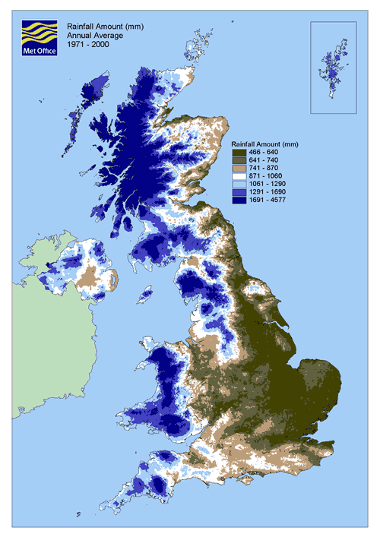
Annual average rainfall amount (1971-2000)
The nature of the rainfall varies during the year. In summer, rainfall is often of a showery nature and is normally more intense than winter rainfall, which tends to be associated with fronts and depressions. The heaviest falls of rain are usually associated with summer thunderstorms. Rainfall amounts in thunderstorms can be more than 100 mm (4 inches) per hour for a short period.

