Games On

The organizers of the 2012 London Olympics need your help!

They want all the athletes to be present at the opening ceremony, in the centre of the athletics track.

Can everyone fit in?

Explain why or why not, in a letter.

- At the 2004 Olympic Games in Athens 11,000 people from 296 countries took part. Assume the same number take part in 2012.
- The stadium has the dimensions shown on the diagram below [square sides are 10 metres].
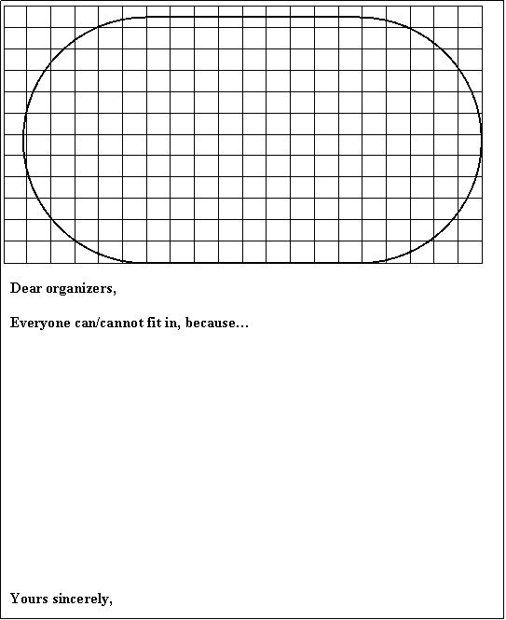

Standing Room Only

Ron claims that the whole population of China could stand on the Isle of Wight.

The CIA World-FactBook web page gives the population of China to be : 1,321,851,888. (July 2007 estimated.)

And Wikipedia.org gives the area of the Isle of Wight as: 380 km² (146.7 sq mi)

Is Ron’s claim plausible?

