HOMEWORK

MAKING THE HEADLINES

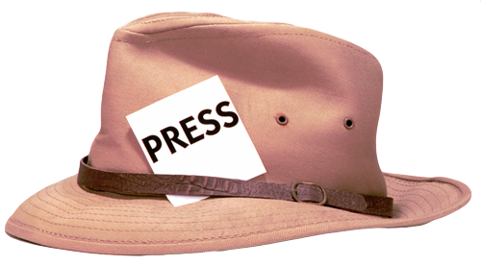
The WWRB Gazette is looking to feature a country in its next issue. Use the information and data you just learned about any of the 3 countries to make an objective assessment of their water situation. Make a simple news flier to show how the people in Algeria, Jordan OR Turkey are affected by their water situation.

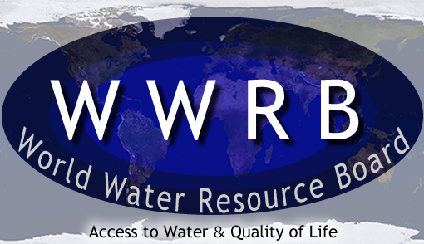
The WWRB Gazette

Paste image/ graph here

Headline 1: ____________________________________________________

_______________________________________________________________

Headline 2: ____________________________________________________

_______________________________________________________________

Headline 3: ____________________________________________________

_______________________________________________________________

