Counting Trees

This diagram shows some trees in a plantation.
The circles show old trees and the triangles show young trees.
Tom wants to know how many trees there are of each type, but says it would take too long counting them all, one-by-one.

- What method could he use to estimate the number of trees of each type?
Explain your method fully.

- On your worksheet, use your method to estimate the number of:
  - Old trees
  - Young trees

Follow-up task for students

Look carefully at the following extracts of work from other students. Imagine you are their teacher. Go through each piece of work and write comments on each one.
- Have they chosen a sensible method?
- Are the calculations correct?
- Are the conclusions sensible?
- Is the work easy to understand?
Name | Comments
Sarah
Laura
Jenny
Woody
Amber

Now try to write out an answer that is better than all of them!
Sample response: Sarah
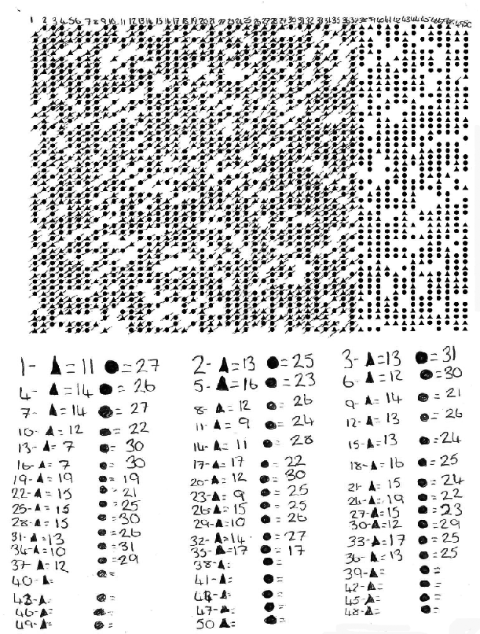
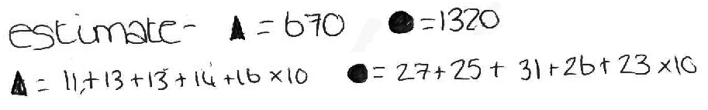

Sample response: Laura

Sample response: Jenny
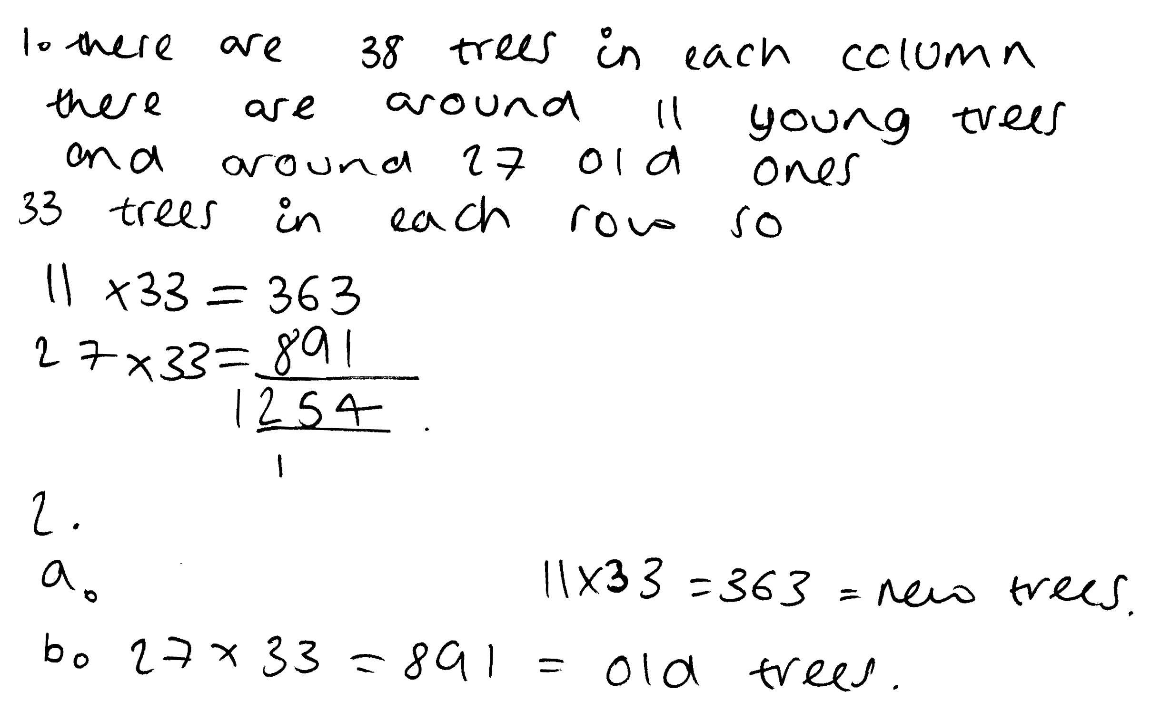

Sample response: Woody

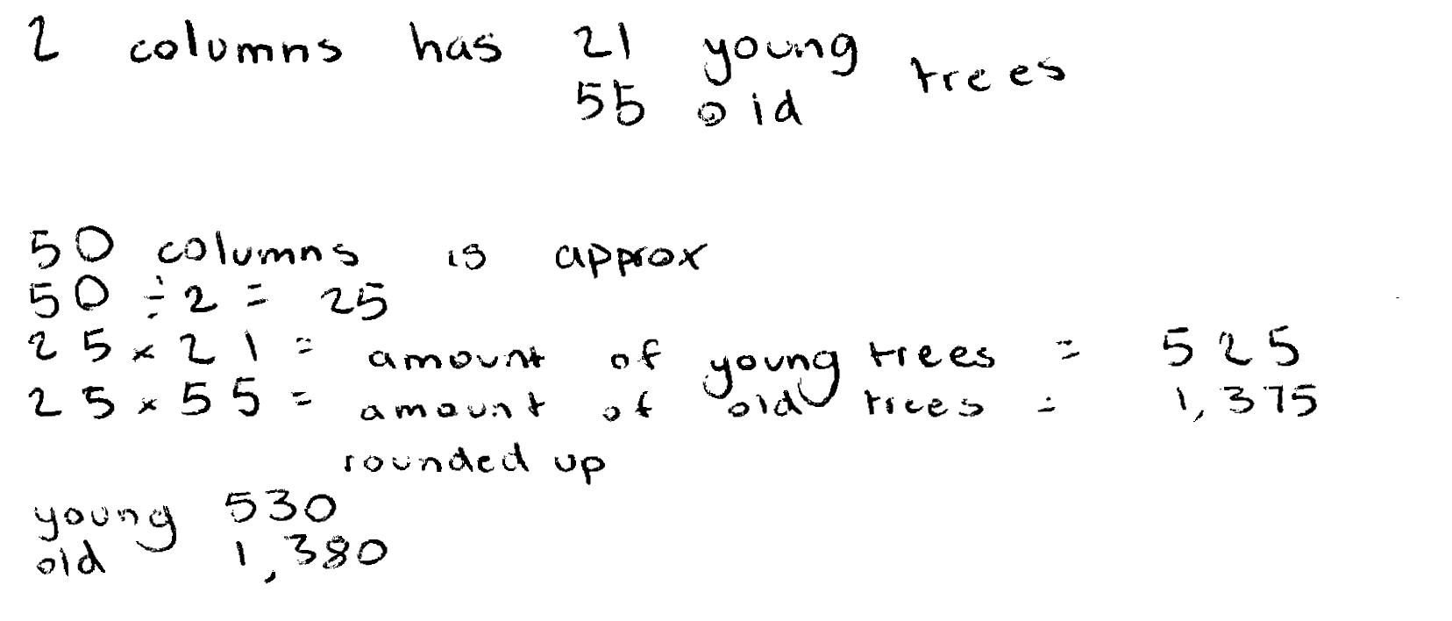

Sample response: Amber

Progression in key processes

 | Representing | Analysing | Interpreting and evaluating | Communicating and reflecting
PROGRESSION  I  ON | Chooses a method, but this may not involve sampling.  E.g. Counts all trees or multiplies the number of trees in a row by the number in a column. | Follows chosen method, possibly making errors.  E.g. Does not account for different numbers of old and young trees or that there are gaps. | Estimates number of new and old trees, but answer given is unreasonable due to method and errors. | Communicates work adequately but with omissions.
 | Chooses a sampling method but this is unrepresentative or too small.  E.g. tries to count the trees in first row and multiplies by the number of rows. | Follows chosen method, mostly accurately.  E.g. May not account for different numbers of old and young trees or that there are gaps. | Estimates number of new and old trees, but answer given is unreasonable due mainly to the method. | Communicates reasoning and results adequately, but with omissions.
 | Chooses a reasonable sampling method. | Follows chosen method, mostly accurately. | Estimates a reasonable number of old and new trees in the plantation.  The reasonableness of the estimate is not checked. E.g. by repeating with a different sample. | Explains what they are doing but explanation may lack detail.
 | Chooses an appropriate sampling technique. | Follows chosen method accurately.  Uses a proportional argument correctly. | Deduces a reasonable number of old and new trees in the plantation.  There is some evidence of checking the estimate. E.g. Considers a different sampling method. | Communicates reasoning clearly and fully.

