Text Messaging



- How many text messages are sent if four people all send messages to each other?

- How many text messages are sent with different numbers of people?
- Approximately how many text messages would travel in cyberspace if everyone in your school took part?
- Can you think of other situations that would give rise to the same mathematical relationship?

Follow-up task for students

Look carefully at the following extracts of work from other students. Imagine you are their teacher. Go through each piece of work and write comments on each one.
- Have they chosen a sensible method?
- Are the calculations correct?
- Are the conclusions sensible?
- Is the work easy to understand?
Name | Comments
Tom
Sam
Chris
Lily
Marvin

Now try to write out an answer that is better than all of them!

Tom’s answer

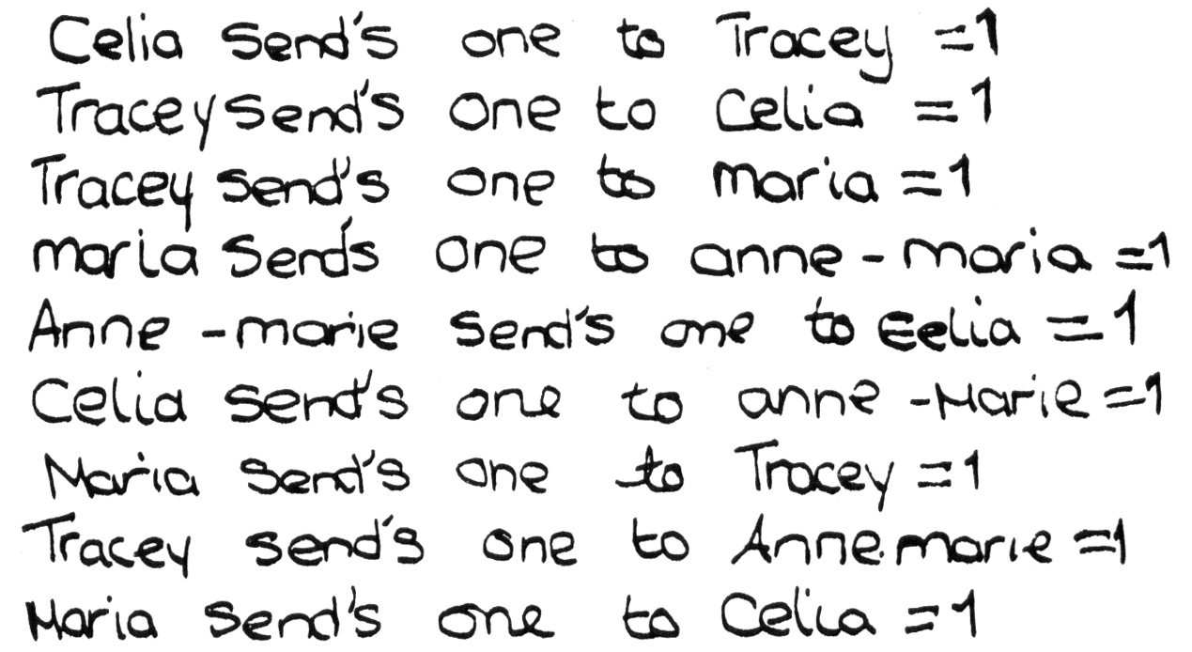

Sam’s answer
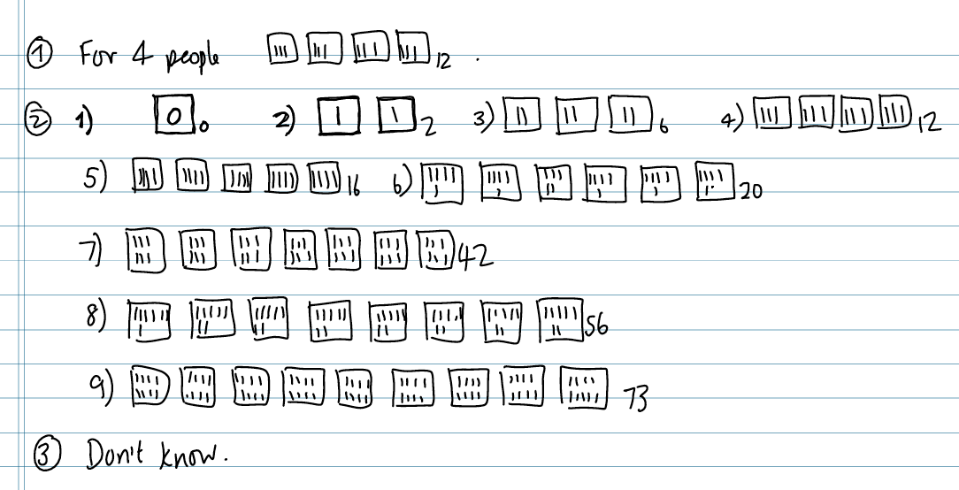

Chris’s answer
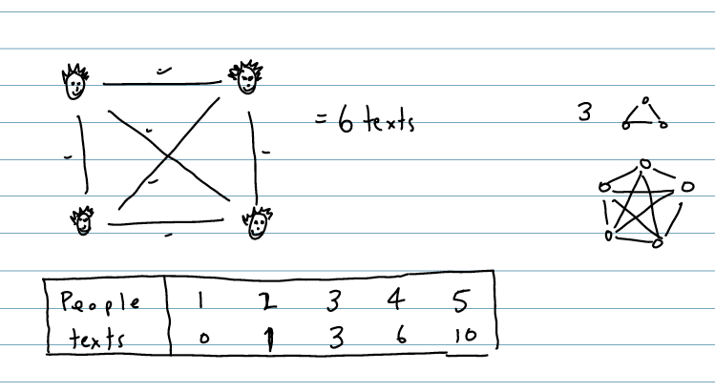

Lily’s answer
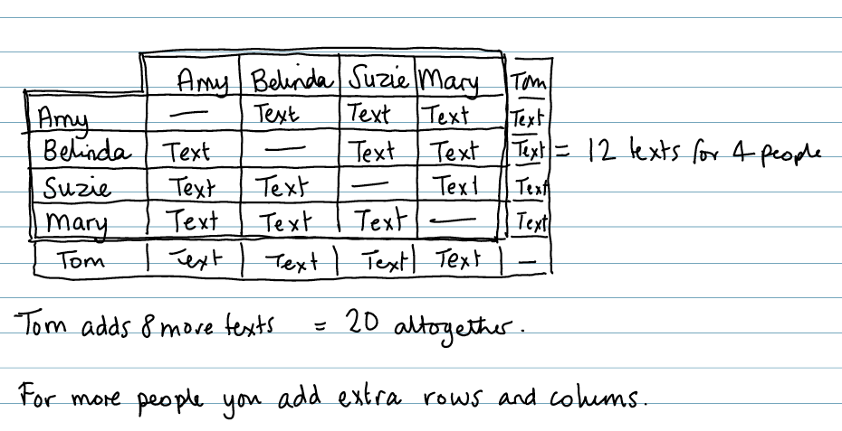

Marvin’s answer
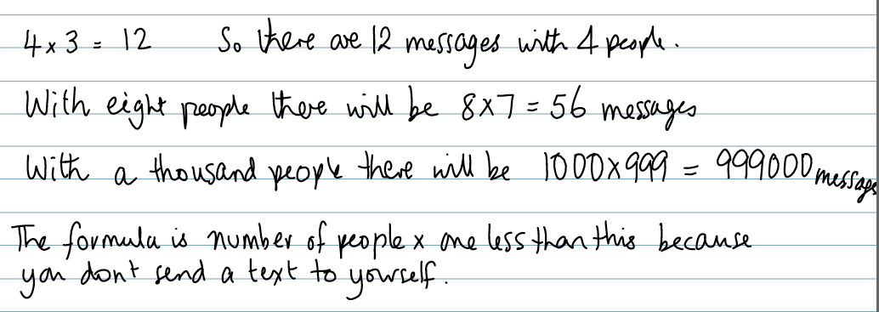

Progression in key processes

 | Representing | Analysing | Interpreting and evaluating | Communicating
PROGRESSION  I  ON | Represents some individual text messages that are sent. | Works out the number of text messages for four people correctly. | Says that everyone sends the same number of messages. | Shows how the answer was found.
 | Uses marks or diagrams to show the texts.  Chooses to use repeated addition. | Increases the number of people in an organised way.  Correctly works out the number of texts sent to different numbers of people. |  | Shows the method clearly and where the answers come from.
 | Chooses to use multiplication to work out the number of texts sent. | Finds a correct pattern in the results.  The reasoning is based on particular examples. | Explains the result for a number of people other than 4.  Finds a correct rule for calculating the number of texts. | Explains how the rule links to the context of sending texts.
 | Chooses to use algebra to show the general case. | The reasoning moves from looking at particular examples to more general cases. | Makes and justifies correct general statements relating the number of texts to the number of people.  Makes and justifies statements for large numbers of students. | Writes a complete and concise summary with clear links to the original context.  Discusses mathematical similarities and differences between sending texts and other contexts – e.g. matches in a football league.

