Golden Rectangles

In the 19th century, many adventurers travelled to North America to search for gold.  A man named Dan Jackson owned some land where gold had been found.  Instead of digging for the gold himself, he rented plots of land to the adventurers.  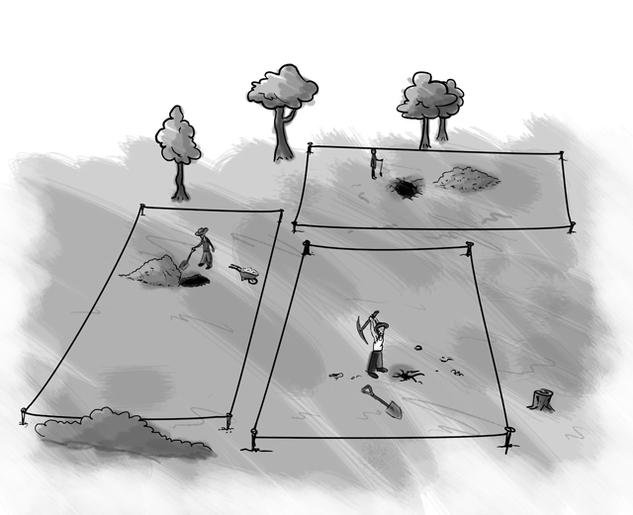 | 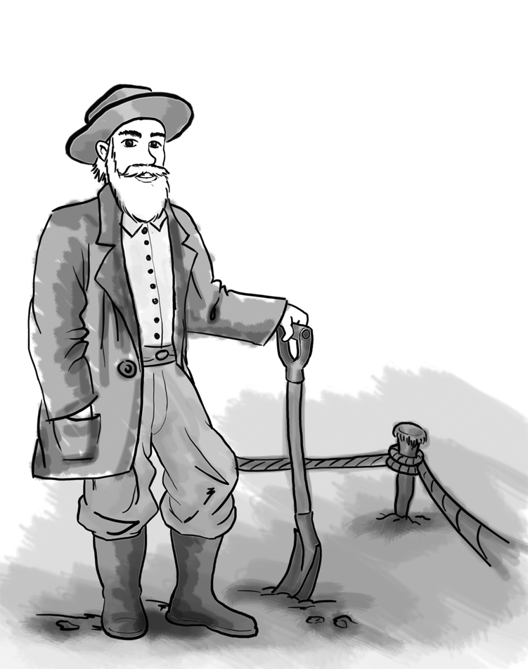  Dan gave each adventurer four wooden stakes and a rope measuring exactly 100 metres.  Each adventurer had to use the stakes and the rope to mark off a rectangular plot of land.

- Assuming each adventurer would like to have the biggest plot, how should he place his stakes?
Explain your answer.

Read the following proposition:

“Tie the ropes together! You can get more land if you work together than if you work separately.”

- Investigate whether the proposition is true for two adventurers working together, still using four stakes.

- Is the proposition true for more than two people?
Explain your answer.

Follow-up task for students

Look carefully at the following extracts of work from other students. Imagine you are their teacher. Go through each piece of work and write comments on each one.
- Have they chosen a sensible method?
- Are the calculations correct?
- Are the conclusions sensible?
- Is the work easy to understand?
Name | Comments
Alvin
Bernie
Chris
Danny
Elsie

Now try to write out an answer that is better than all of them!

Alvin’s answer
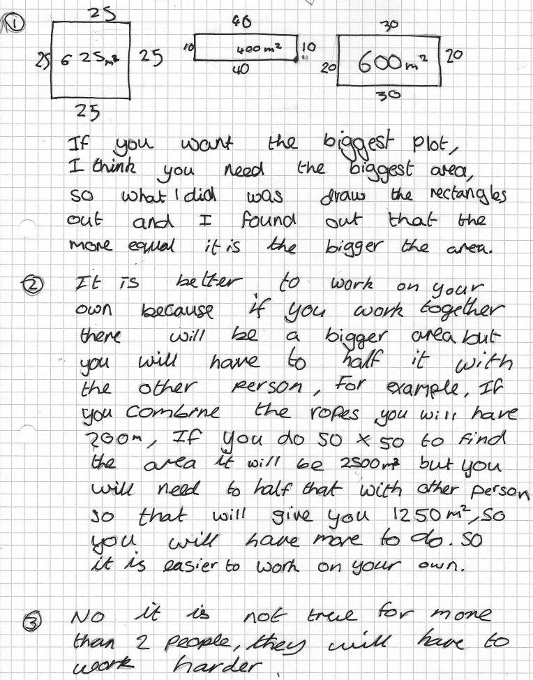

Bernie’s answer
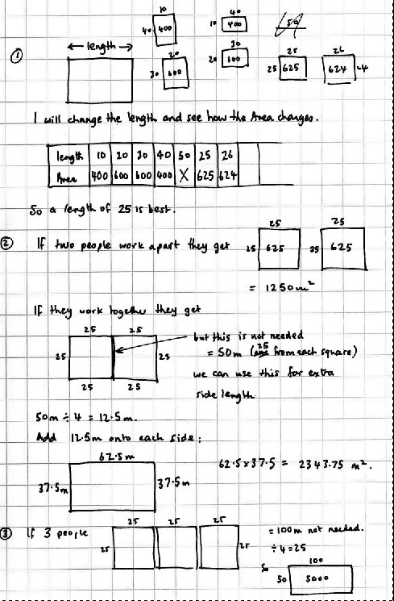
Chris’s answer
Danny’s answer
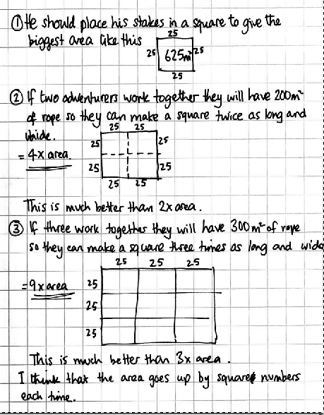

Elsie’s answer

Progression in key processes

 | Representing | Analysing | Interpreting and evaluating | Communicating
PROGRESSION  I  ON | The student draws one or two rectangles with a perimeter of 100m. | The student works out the areas of their rectangles correctly. | The student draws several rectangles but not a square and the justification is incorrect or omitted. | The work is communicated adequately, but there are gaps and/or omissions.
 | Draws several rectangles. | Calculates the areas of their rectangles and attempts to come to some generalisation. | Realises that different shapes have different areas but comes to incorrect or incomplete conclusion. | The work is communicated clearly and the reasoning may be followed.
 | Draws several, correct rectangles for an adventurer working alone and for 2 working together. May draw far too many rectangles. | Calculates the areas correctly and finds that a square is best for 1 adventurer and that 2 working together do better than alone. | Attempts to give some explanation for their findings. | The work is communicated clearly and the reasoning may be easily followed.
 | Draws an appropriate number of rectangles and collects the data in an organised way. | Calculates the correct areas, finds that a square is best for 1 adventurer and that 2 working together do better than alone. Finds a rule or pattern in their results. | Gives reasoned explanations for their findings. | Explains work clearly and may consider other shapes.

