2 Three assessment tasks and five sample responses on each

Text Messaging



- How many text messages are sent if four people all send messages to each other?

- How many text messages are sent with different numbers of people?
- Approximately how many text messages would travel in cyberspace if everyone in your school took part?
- Can you think of other situations that would give rise to the same mathematical relationship?

This was adapted from Sending texts – a task from the Nuffield Foundation's Applying Mathematical Processes project – see http://www.nuffieldcurriculumcentre.org/

Follow-up task for students

Look carefully at the following extracts of work from other students. Imagine you are their teacher. Go through each piece of work and write comments on each one.
- Have they chosen a sensible method?
- Are the calculations correct?
- Are the conclusions sensible?
- Is the work easy to understand?
Name | Comments
Tom
Sam
Chris
Lily
Marvin

Now try to write out an answer that is better than all of them!

Tom’s answer

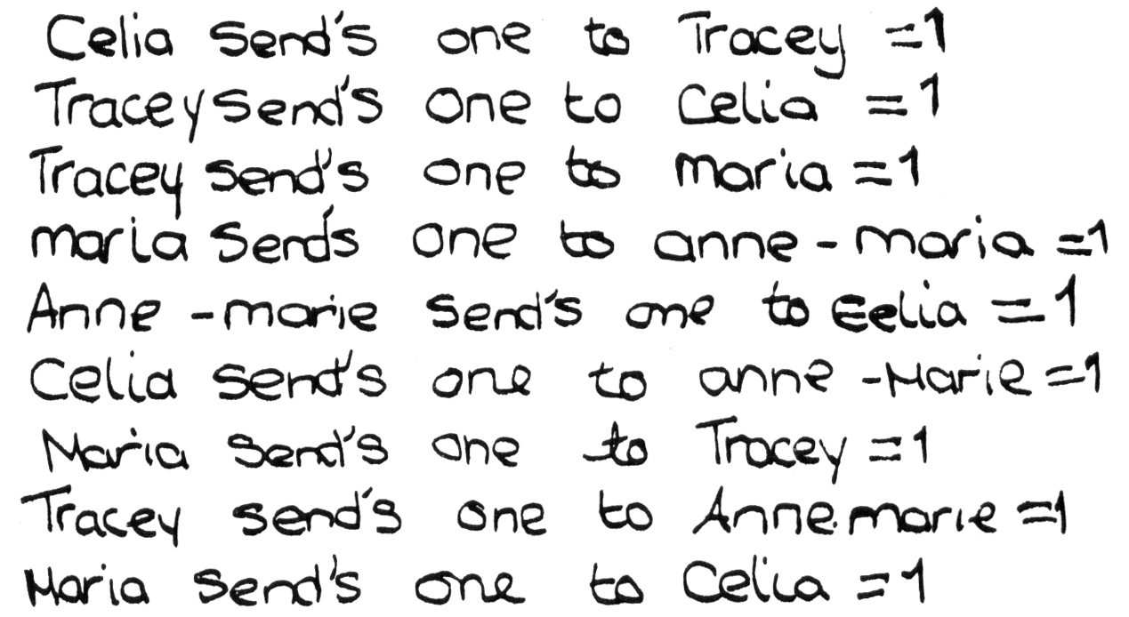

Sam’s answer
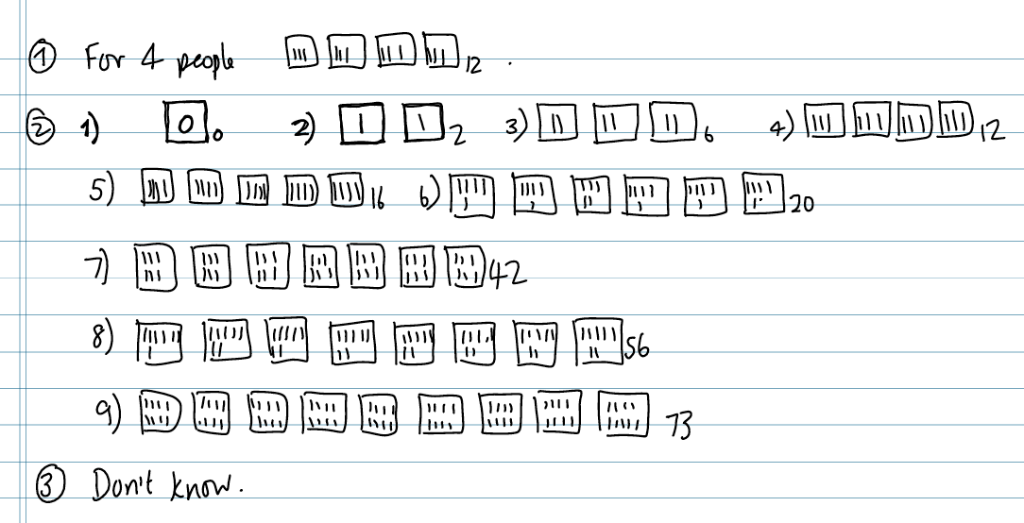

Chris’s answer
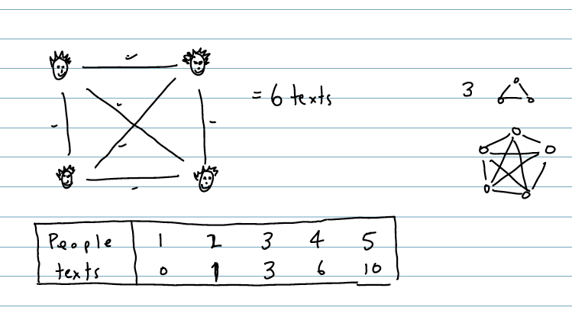

Lily’s answer
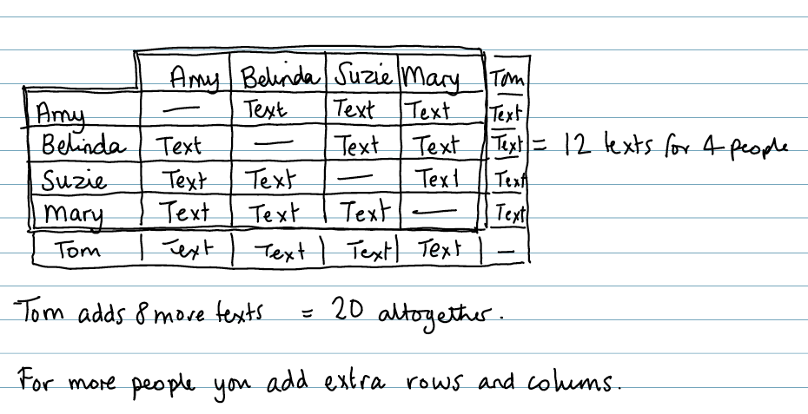

Marvin’s answer
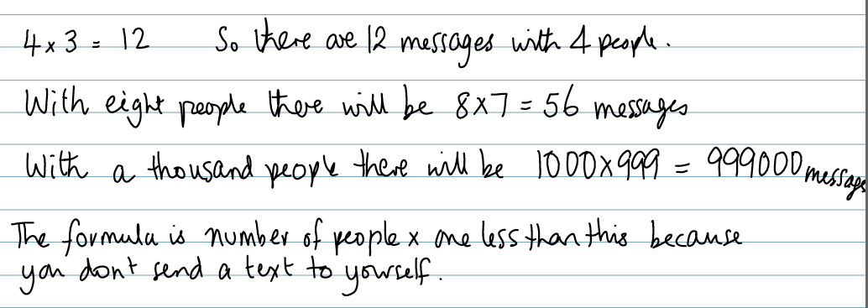

Progression in key processes

 | Representing | Analysing | Interpreting and evaluating | Communicating
PROGRESSION  I  ON | Represents some individual text messages that are sent. | Works out the number of text messages for four people correctly. | Says that everyone sends the same number of messages. | Shows how the answer was found.
 | Uses marks or diagrams to show the texts.  Chooses to use repeated addition. | Increases the number of people in an organised way.  Correctly works out the number of texts sent to different numbers of people. |  | Shows the method clearly and where the answers come from.
 | Chooses to use multiplication to work out the number of texts sent. | Finds a correct pattern in the results.  The reasoning is based on particular examples. | Explains the result for a number of people other than 4.  Finds a correct rule for calculating the number of texts. | Explains how the rule links to the context of sending texts.
 | Chooses to use algebra to show the general case. | The reasoning moves from looking at particular examples to more general cases. | Makes and justifies correct general statements relating the number of texts to the number of people.  Makes and justifies statements for large numbers of students. | Writes a complete and concise summary with clear links to the original context.  Discusses mathematical similarities and differences between sending texts and other contexts – e.g. matches in a football league.

Golden Rectangles

In the 19th century, many adventurers travelled to North America to search for gold.  A man named Dan Jackson owned some land where gold had been found.  Instead of digging for the gold himself, he rented plots of land to the adventurers.  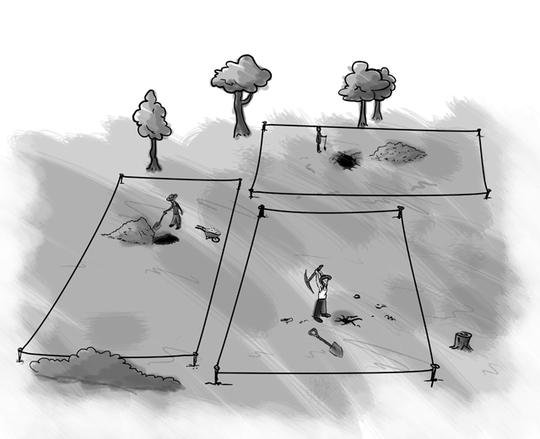 | 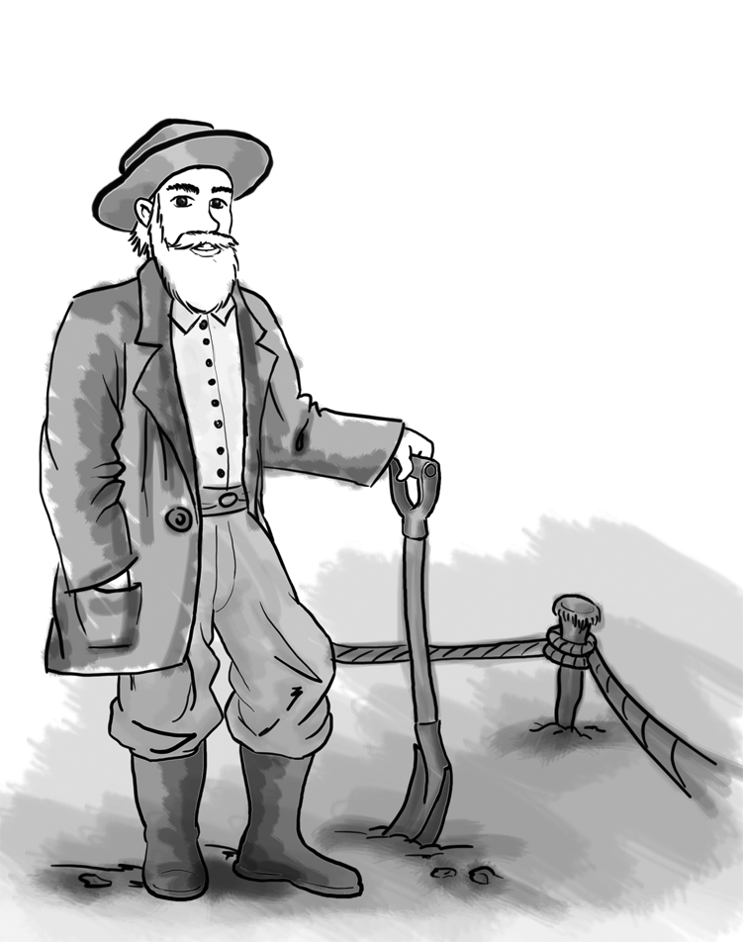  Dan gave each adventurer four wooden stakes and a rope measuring exactly 100 metres.  Each adventurer had to use the stakes and the rope to mark off a rectangular plot of land.

- Assuming each adventurer would like to have the biggest plot, how should he place his stakes?
Explain your answer.

Read the following proposition:

“Tie the ropes together! You can get more land if you work together than if you work separately.”

- Investigate whether the proposition is true for two adventurers working together, still using four stakes.

- Is the proposition true for more than two people?
Explain your answer.

Follow-up task for students

Look carefully at the following extracts of work from other students. Imagine you are their teacher. Go through each piece of work and write comments on each one.
- Have they chosen a sensible method?
- Are the calculations correct?
- Are the conclusions sensible?
- Is the work easy to understand?
Name | Comments
Alvin
Bernie
Chris
Danny
Elsie

Now try to write out an answer that is better than all of them!

Alvin’s answer
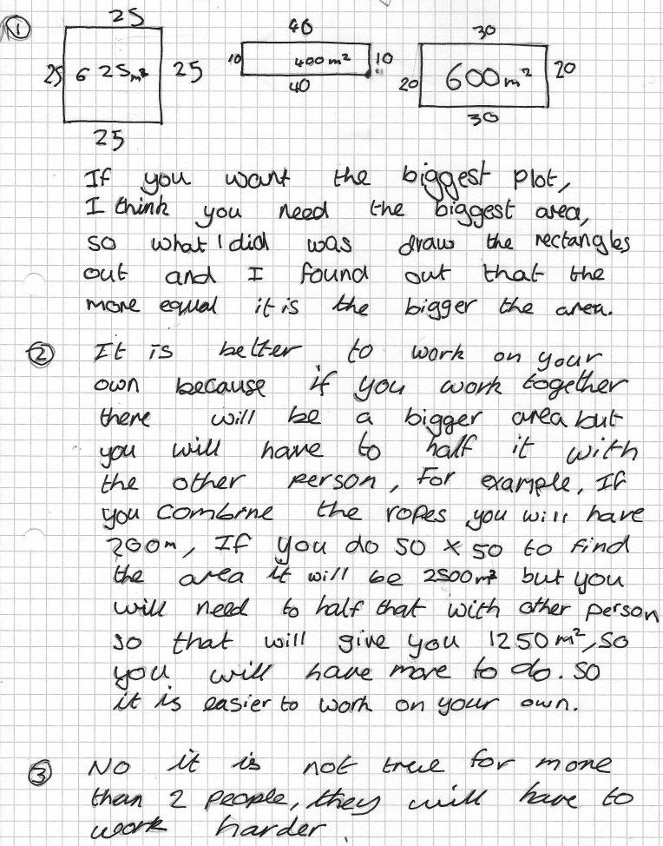

Bernie’s answer
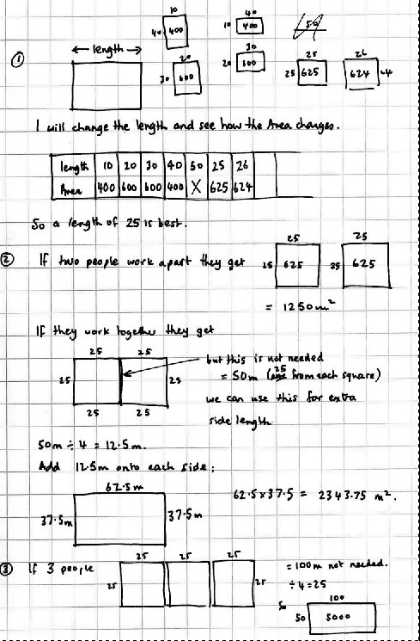
Chris’s answer
Danny’s answer
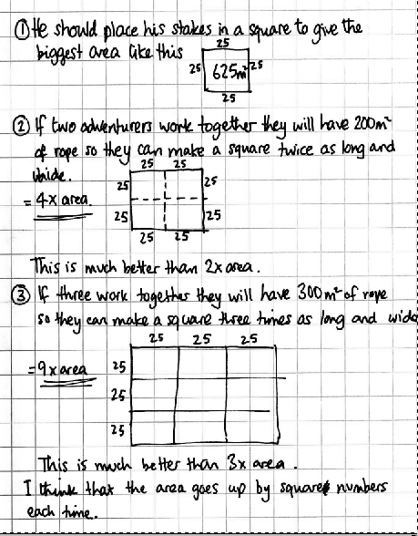

Elsie’s answer

Progression in key processes

 | Representing | Analysing | Interpreting and evaluating | Communicating
PROGRESSION  I  ON | The student draws one or two rectangles with a perimeter of 100m. | The student works out the areas of their rectangles correctly. | The student draws several rectangles but not a square and the justification is incorrect or omitted. | The work is communicated adequately, but there are gaps and/or omissions.
 | Draws several rectangles. | Calculates the areas of their rectangles and attempts to come to some generalisation. | Realises that different shapes have different areas but comes to incorrect or incomplete conclusion. | The work is communicated clearly and the reasoning may be followed.
 | Draws several, correct rectangles for an adventurer working alone and for 2 working together. May draw far too many rectangles. | Calculates the areas correctly and finds that a square is best for 1 adventurer and that 2 working together do better than alone. | Attempts to give some explanation for their findings. | The work is communicated clearly and the reasoning may be easily followed.
 | Draws an appropriate number of rectangles and collects the data in an organised way. | Calculates the correct areas, finds that a square is best for 1 adventurer and that 2 working together do better than alone. Finds a rule or pattern in their results. | Gives reasoned explanations for their findings. | Explains work clearly and may consider other shapes.

Counting Trees

This diagram shows some trees in a plantation.
The circles show old trees and the triangles show young trees.
Tom wants to know how many trees there are of each type, but says it would take too long counting them all, one-by-one.

- What method could he use to estimate the number of trees of each type?
Explain your method fully.

- On your worksheet, use your method to estimate the number of:
  - Old trees
  - Young trees

Follow-up task for students

Look carefully at the following extracts of work from other students. Imagine you are their teacher. Go through each piece of work and write comments on each one.
- Have they chosen a sensible method?
- Are the calculations correct?
- Are the conclusions sensible?
- Is the work easy to understand?
Name | Comments
Sarah
Laura
Jenny
Woody
Amber

Now try to write out an answer that is better than all of them!
Sample response: Sarah
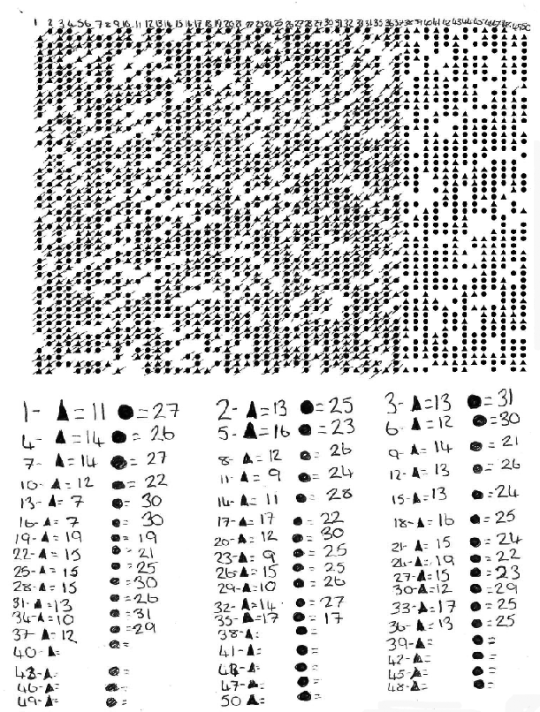
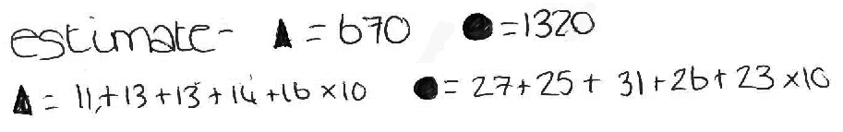

Sample response: Laura

Sample response: Jenny
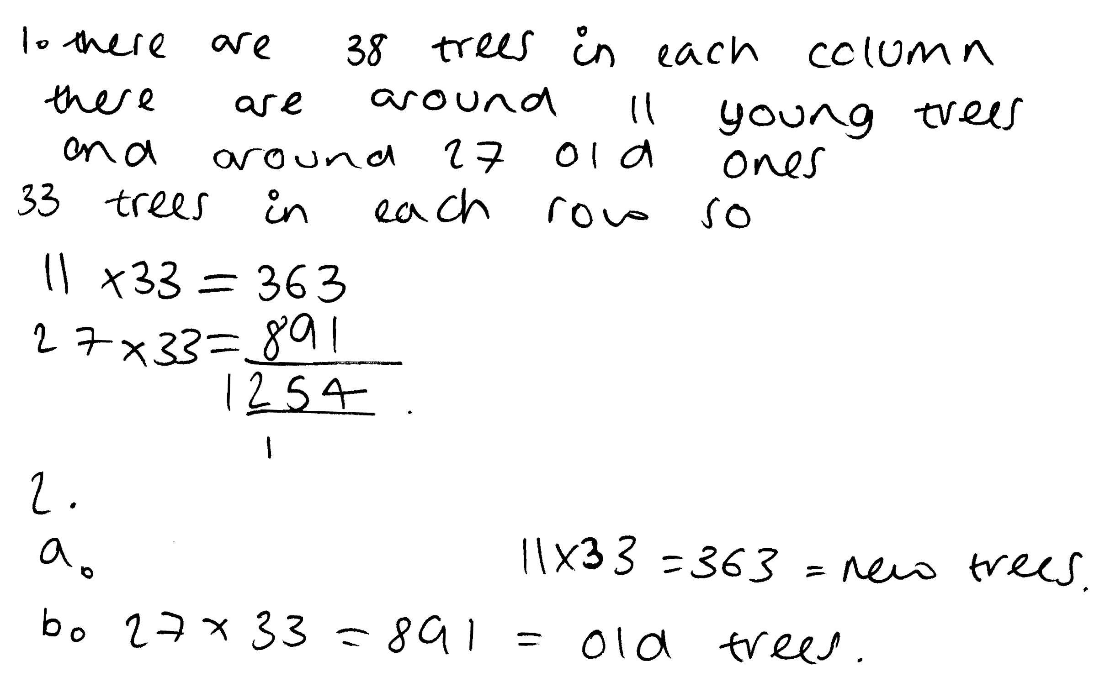

Sample response: Woody

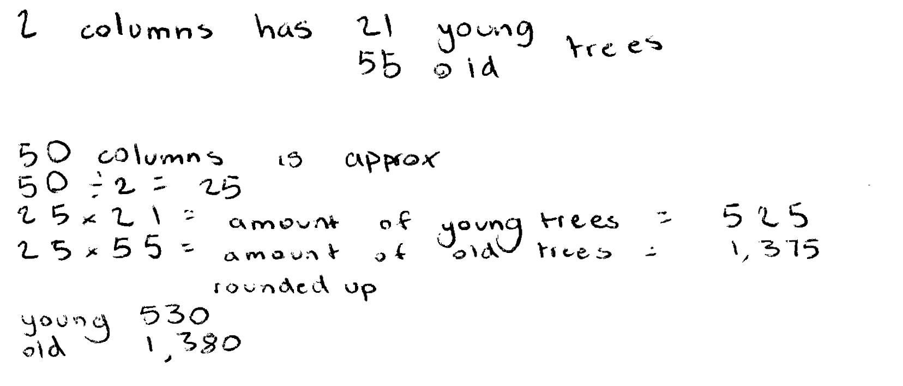

Sample response: Amber

Progression in key processes

 | Representing | Analysing | Interpreting and evaluating | Communicating and reflecting
PROGRESSION  I  ON | Chooses a method, but this may not involve sampling.  E.g. Counts all trees or multiplies the number of trees in a row by the number in a column. | Follows chosen method, possibly making errors.  E.g. Does not account for different numbers of old and young trees or that there are gaps. | Estimates number of new and old trees, but answer given is unreasonable due to method and errors. | Communicates work adequately but with omissions.
 | Chooses a sampling method but this is unrepresentative or too small.  E.g. tries to count the trees in first row and multiplies by the number of rows. | Follows chosen method, mostly accurately.  E.g. May not account for different numbers of old and young trees or that there are gaps. | Estimates number of new and old trees, but answer given is unreasonable due mainly to the method. | Communicates reasoning and results adequately, but with omissions.
 | Chooses a reasonable sampling method. | Follows chosen method, mostly accurately. | Estimates a reasonable number of old and new trees in the plantation.  The reasonableness of the estimate is not checked. E.g. by repeating with a different sample. | Explains what they are doing but explanation may lack detail.
 | Chooses an appropriate sampling technique. | Follows chosen method accurately.  Uses a proportional argument correctly. | Deduces a reasonable number of old and new trees in the plantation.  There is some evidence of checking the estimate. E.g. Considers a different sampling method. | Communicates reasoning clearly and fully.

