 | Involving pupils in self- and peer-  assessment  How can pupils help each other to use the Key Processes?

Follow-up session

Activity 1 Report and reflect on the assessment lesson 20 minutes
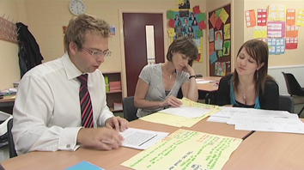 | Take it in turns to describe your experiences of using self- and peer- assessment.  - How did your pupils perform on the task, unaided?  - How did pupils assess the provided responses and the work of their peers?  What aspects did they attend to?  - How did pupils make use of the ‘progression steps’?  Did these help pupils to understand the Key Processes?  - How well did pupils react to and use the evidence to improve their own work?  - What are the implications of this lesson for your future lessons?

Activity 2 Discuss strategies for differentiation 10 minutes
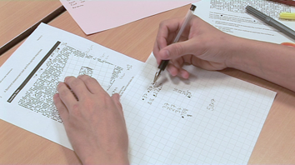 | Reflect on your normal teaching practices. When you assess classes, you begin to realise the considerable individual differences in pupils and they have very different learning needs. Some pupils need more support, while others need a greater challenge.  - How do you normally deal with range of different learning needs of your pupils?  - Discuss the advantages and disadvantages of the four strategies shown on  Handout 3  - Compare your views with the comments given on  Handout 4

The strategies suggested on the handout are:

- Differentiate by quantity? When pupils appear successful, you provide them with a new problem to do
- Differentiate by task? You try to give each pupil a problem that is matched to their capability
- Differentiate by outcome? You use open problems that encourage a variety of possible outcomes
- Differentiate by level of support? You give all pupils the same problem, but then offer different levels of support, depending on the needs that become apparent

The first two of these approaches are unhelpful, particularly when developing Key Processes, for the reasons identified in Handout 4. Bowland tasks are 'open' in the sense that they encourage a variety of approaches. Their difficulty is not merely related to their apparent mathematical 'content', but is also related to the familiarity of the context, the complexity of information within the problem, the connections that need to be made, the length of the chains of reasoning required, and so on. Where one pupil chooses algebra, another may choose a numerical approach and the demands of each method will be different.

Activity 3 Discuss ways of helping pupils that struggle 10 minutes
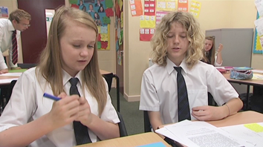 | As well as finding the tasks challenging, pupils may find the whole idea of self and peer assessment difficult. They are being asked to reflect on the methods and processes that they and others have used. Think again about your lessons using the Bowland assessment tasks.  - How might you help those who struggle with the task?  - How can you help those who struggle with the whole idea of peer assessment?

Teachers have found that when pupils get stuck with a task, then they may be considerably helped by:

- discussing their difficulty with a partner (not necessarily their neighbour);
- looking at some samples of other pupils' attempts (however rough) - these will suggests new ways to access and approach the task.

As soon as the teacher gives detailed guidance on what to do, the pupils are unable to make strategic decisions for themselves. Such guidance should therefore only be given as a last resort, after pupils have been allowed to struggle and help each other.

We have found that most pupils enjoy and value self and peer assessment. Some however, may be unused to revisiting tasks and reflecting on earlier work and may not therefore appreciate the value of discussing different solution methods in depth. "When I know the answer, what point is there in discussing the problem further and looking at other people's work?" Such pupils prefer to 'get on' and tackle new tasks. We have found that it is important to carefully explain the purpose of peer assessment to pupils meeting it for the first time.

Activity 4 Discuss ways of stretching pupils that succeed 10 minutes
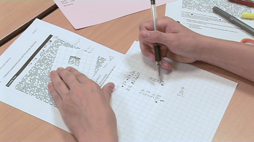 | Some pupils may have done very well at the problems, even at the very beginning. Others may have worked well and finished quickly. It is a good idea to plan for such eventualities.  Think back to your own lesson:  - When pupils succeeded, how did you extend their thinking?  - What alternative approaches to the task did you, or could you suggest?  - What extensions to the task did you, or can you suggest?  If you wish, you can watch a video of Shane, Emma and Sheena discussing this issue.

Even if pupils succeed in the problems, they can still learn a great deal by revisiting them. Emma, Sheen and Shane suggest that pupils may be encouraged to:

- find alternative or more elegant ways of representing and tackling the task;
- make up their own variants or extensions to tasks
- devise their own "progression steps", to develop their understanding of Key Processes.
You may be like to suggest your own possible extensions to the tasks. For example:

- Text Messaging: How long would it take to spread a piece of news around the school if each person sends a text message to four other people?
- Counting Trees: What method would you use if you were asked to estimate the number of beans in a jar?
- Golden rectangles: Suppose the adventurers were only given three stakes each?
(and rename the task: Golden triangles).

Activity 5 Plan assessment strategies for future lessons 10 minutes
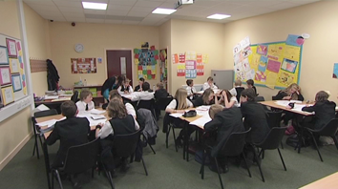 | - How might you apply what you have learned about assessment to your other mathematics lessons?  - How might you embed peer assessment strategies in your scheme of work?  You may like to watch the video showing the teachers discussing the wider implications of assessing Key Processes.

Further Reading

See Handout 5 for suggested further reading.

