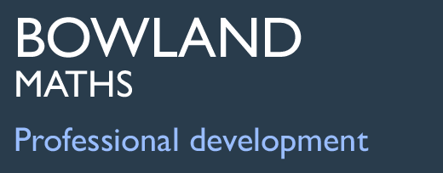 | Involving pupils in self- and peer-  assessment  How can pupils help each other to use the Key Processes?

Module overview

“... self-assessment by pupils, far from being a luxury, is in fact an essential component of formative assessment. Where anyone is trying to learn, feedback about their efforts has three elements—the desired goal, the evidence about their present position, and some understanding of a way to close the gap between the two. All three must to a degree be understood by anyone before they can take action to improve their learning” (Black & Wiliam, 1998).

This is particularly true when the focus of the assessment is on Key Processes. Many pupils do not understand the nature and importance of these processes in mathematics. If a pupil’s goal is only to get ‘the right answer’, then she will not attend to the deeper purposes of the lesson.
This module encourages discussion of the following issues:
- How can we help pupils to become aware of the Key Processes, and their importance in problem solving?
- How can we encourage pupils to take more responsibility for their own learning of Key Processes?
- How can pupils be encouraged to assess and improve each other’s work?

Introductory session 1 hour
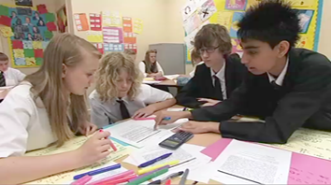 | - Explore how pupils may become aware of Key Processes  - Discuss how pupils can learn from sample responses  - Discuss how pupils can assess their own work  - Consider how pupils can collaboratively improve work  - Plan to use peer and self-assessment strategies

Into the classroom 1 hour
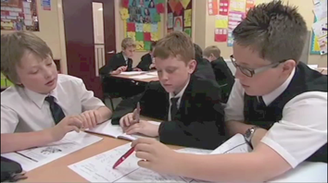 | - Pupils work on the problem on their own  - Teacher assesses their work  - Pupils work together improving their work or sample work  - Pupils receive further help from other groups and from provided ‘progression steps’  - Plenary discussion on approaches used and changes made

Follow-up session 1 hour
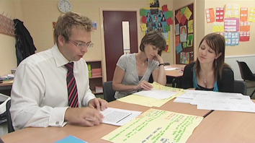 | - Report and reflect on the assessment lesson  - Discuss strategies for differentiation  - Discuss ways of helping pupils that struggle  - Discuss ways of stretching pupils that succeed  - Plan assessment strategies for future lessons

Resources needed

 Handout 1: Strategies for helping pupils to become more aware of Key Processes
Handout 2: Three assessment tasks and five sample responses on each
Handout 3: Meeting the needs of all pupils
Handout 4: Meeting the needs of all pupils – some comments to consider
Handout 5: Suggestions for further reading

Involving pupils in self- and peer- assessment

How can pupils help each other to use the Key Processes?

Introductory session

Introduction Involving pupils in self- and peer- assessment
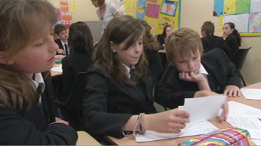 | This module explores how students can assess and develop their own abilities to use the Key Processes when problem solving. Self and peer assessment have the potential to help pupils become more aware of the goals of their learning and of the ways in which they can improve their own work to achieve these goals. As this awareness grows, pupils become more autonomous learners.  In this module, we follow three teachers: Sheena, Emma and Shane, from Arthur Terry School in Sutton Coldfield, as they explore different ways of helping pupils to assess and improve their own work.

Activity 1 Explore how pupils may become aware of Key Processes 10 minutes
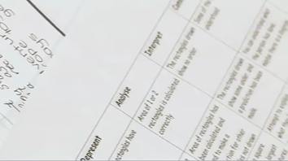 | Handout 1 presents a number of suggestions for making pupils more aware of their own progress in understanding and working on Key Processes.  - Discuss the advantages and disadvantages of each suggestion  - Can you think of any other ways of making pupils more aware of the objectives of these tasks?  - Can you think of any other ways of engaging pupils in peer assessment?  This module considers some of these suggestions in more depth.

Activity 2 Consider how pupils can learn from sample responses 20 minutes
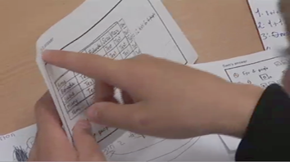   | In an earlier lesson, Sheena's pupils worked individually on the task Text Messaging from Handout 2. The video for this activity shows the follow-up lesson in which pupils compare their own work with carefully selected samples of other pupils’ work, also provided on the handout.  Before watching the video clip, familiarise yourself with the task, and with the sample work. Try to anticipate the issues that will arise as this work is discussed by pupils.  Now watch the pupils as they assess the sample work, and then go on to improve their own work.  - What aspects of the provided work do pupils attend to?  - What criteria do pupils use as they assess the sample work?  - What are pupils learning from the sample work?

Teachers sometimes comment that some pupils attend more to the neatness of the sample work than to the quality and communication of the reasoning employed. Other teachers are concerned that pupils will uncritically copy sample work.
- How do you respond to these concerns?
- What criteria would you use for choosing sample work to use with pupils?

It is important that pupils spend time developing their own approaches before seeing sample work and that this work is chosen to suggest alternative representations and approaches that students have not previously considered. In addition it is helpful if the sample work illustrates common errors that will prompt discussion. If the sample work is chosen carefully in this way, and pupils are encouraged to be critical, then they will learn a great deal from discussing it.

Activity 3 Discuss how pupils can assess their own work 20 minutes
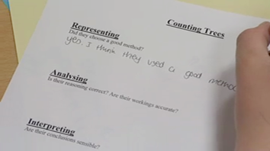 | Often when pupils have finished a piece of work, they want to move on. They don’t want to re-examine it, polish it, or present it so that other people can understand and follow their reasoning.  In the video, both Emma and Shane ask their pupils to assess and improve each other's work. Emma uses the Golden Rectangles task and has collated a selection of her own pupils' work on this task into a poster. She has also prepared a simplified version of the progression steps to help her pupils analyse this work. The task and the original progression steps may be found on Handout 2. Note that pupils may be heard referring to a 'traffic lights' scheme that Emma uses in her Mathematics lessons: here, 'green', 'amber' and 'red' refer to decreasing levels of understanding.  Shane used the Counting Trees task and has prepared a less structured sheet to help his pupils assess each other's work. This sheet contains the names of the Key Processes.  Familiarise yourself with the tasks and then watch the video extracts of Shane's and Emma's lessons.  - What observations do pupils make about each other's work?  - How might this help them to improve their own work?  - Compare Emma's simplified progression steps with Shane's less structured sheet.  - Compare the use of work from within the pupils' own class to the use of the sample responses used in activity 2.

The progression steps may help pupils to develop an awareness of how Key Processes relate to particular tasks, and recognise how they can improve their responses. For the steps to be used in this way the language will need to be adapted to the class and specific 'answers' will need to be removed. The less structured approach already assumes that pupils have some understanding of what the Key Processes mean and that pupils can apply these to the task in hand.

Teachers have commented that pupils are sometimes more able to be critical of sample responses that are taken from sources outside the classroom, when they cannot be identified. When giving feedback to members of their own class, personal relationships come into play. Classroom cultures may need to be developed where ideas and work may be criticised without individuals feeling threatened and exposed.

Activity 4 Plan to use peer and self-assessment strategies 10 minutes
Plan when you will allow pupils time to tackle one of the assessment problems, individually or in pairs, without your guidance.

Plan how and when you will revisit the task and allow pupils to assess other pupil's work - either work from their classmates or from the sample responses in Handout 2.

Make sure pupils have an opportunity to discuss the importance of the Key Processes, and sufficient time to revise their own work in the light of the comments.

If you have time, it may help your planning if you watch at least one of the videos showing more of Emma, Shane and Sheena's lessons.
When planning your lesson, you may find it helpful to watch the video lesson summaries for Shane, Emma and/or Sheena for ideas.

If you are working on this module with a group, it is helpful if each participant chooses the same assessment task, as this will facilitate the follow-up discussion.

This is the end of the Introductory session. After you have tried out your lesson with your own pupils, return for the Follow-up session. Resources to support the lessons, and suggested lesson plans, can be found in the Into the classroom session.

Reference:

Black, P., & Wiliam, D. (1998). Inside the black box: raising standards through classroom assessment. London: King's College London School of Education 1998.

