Counting Trees

This diagram shows some trees in a plantation.
The circles show old trees and the triangles show young trees.
Tom wants to know how many trees there are of each type, but says it would take too long counting them all, one-by-one.

- What method could he use to estimate the number of trees of each type?
Explain your method fully.

- On your worksheet, use your method to estimate the number of:
  - Old trees
  - Young trees

Counting Trees: sample responses

Sample response: Laura

Sample response: Jenny
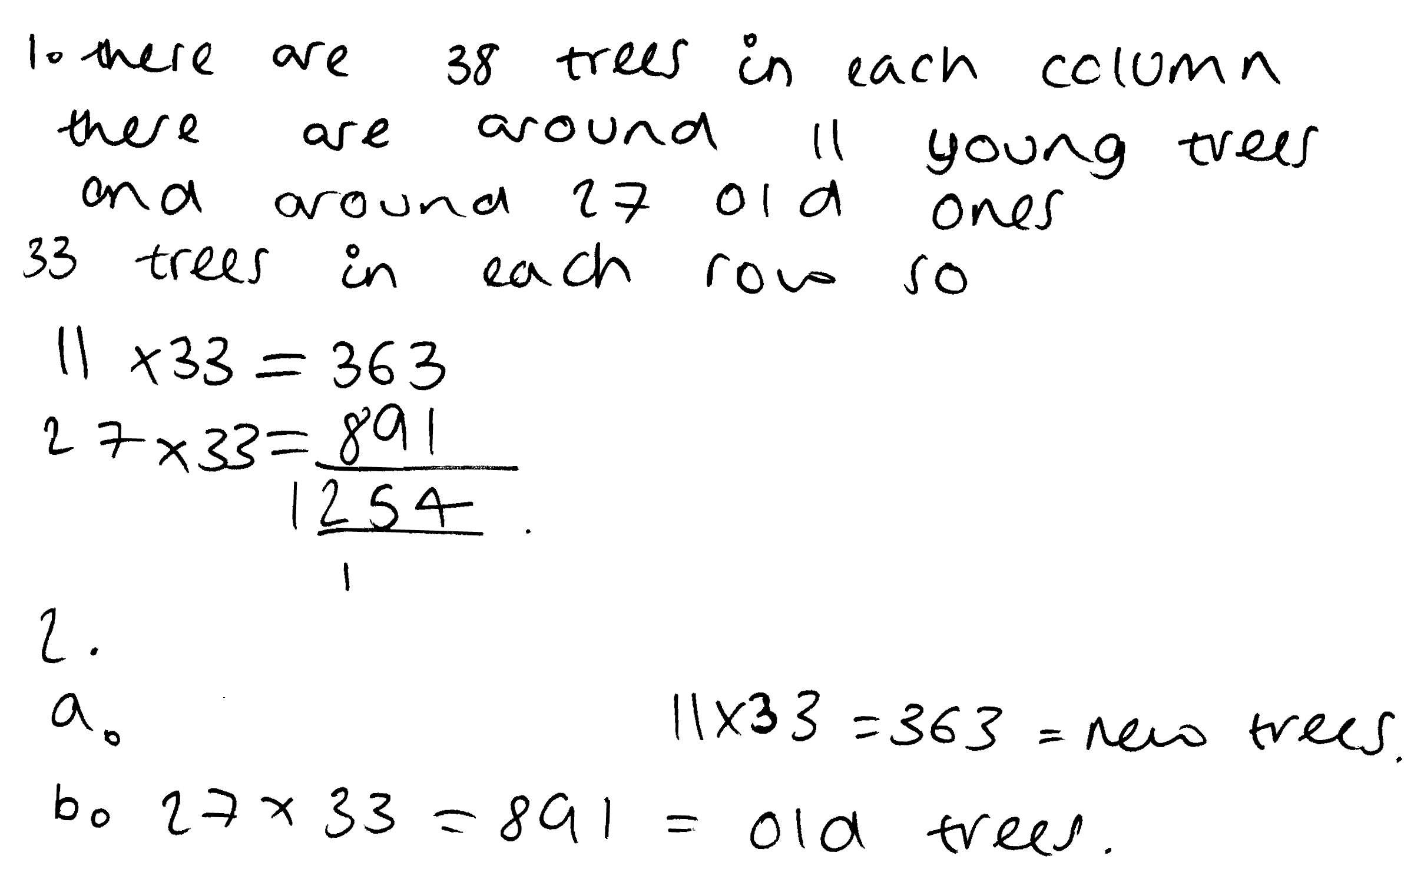

Sample response: Woody

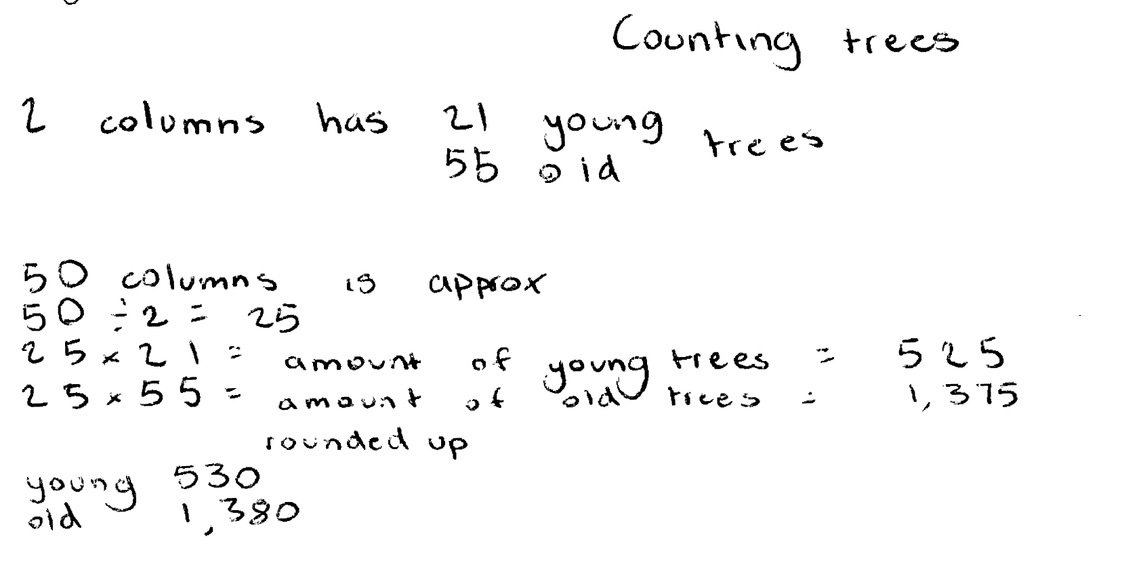

Sample response: Amber

Counting Trees: assessing the sample responses

Sample response: Laura

Laura attempts to estimate the number of old and new trees by multiplying the number along each side of the whole diagram and then halving. She does not account for gaps nor does she realise that there are an unequal number of trees of each kind.

What questions could you ask Laura that would help her improve her response?

Sample response: Jenny
Jenny realises that sampling is needed, but she multiplies the number of young trees and old trees in the left hand column by the number of trees in the bottom row. She ignores the columns with no trees in the bottom row, so her method underestimates the total number of trees. She does, however, take account of the different numbers of old and new trees.

What questions could you ask Jenny that would help her improve her response?

Sample response: Woody
Woody uses a sample of two columns and counts the number of old and young trees. He then multiplies by 25 (half of 50 columns) to find an estimate of the total number.

What questions could you ask Woody that would help him improve his response?

Sample response: Amber
Amber chooses a representative sample and carries through her work to get a reasonable answer. She correctly uses proportional reasoning. She checks her work as she goes along by counting the gaps in the trees. Her work is clear and easy to follow.

What questions could you ask Amber that would help her improve her response?

