2 Three assessment tasks and four sample responses on each

Counting Trees

This diagram shows some trees in a plantation.
The circles show old trees and the triangles show young trees.
Tom wants to know how many trees there are of each type, but says it would take too long counting them all, one-by-one.

- What method could he use to estimate the number of trees of each type?
Explain your method fully.

- On your worksheet, use your method to estimate the number of:
  - Old trees
  - Young trees

Sample response: Laura

Sample response: Jenny
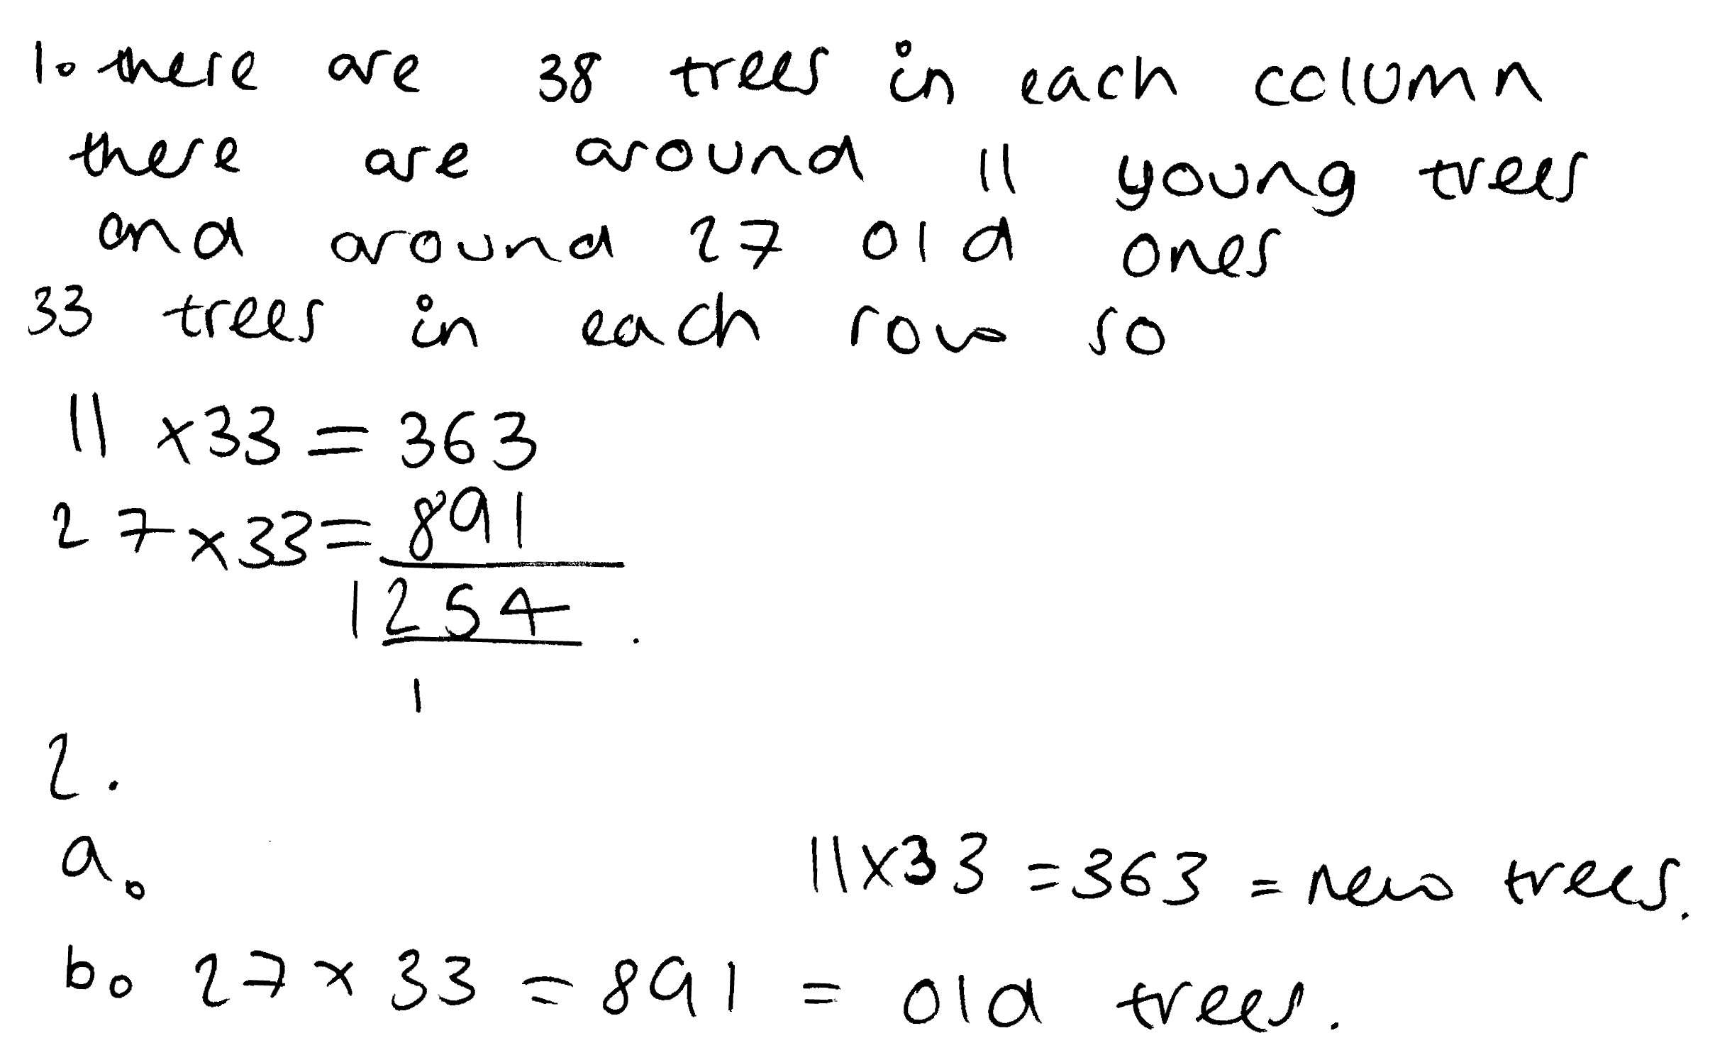

Sample response: Woody

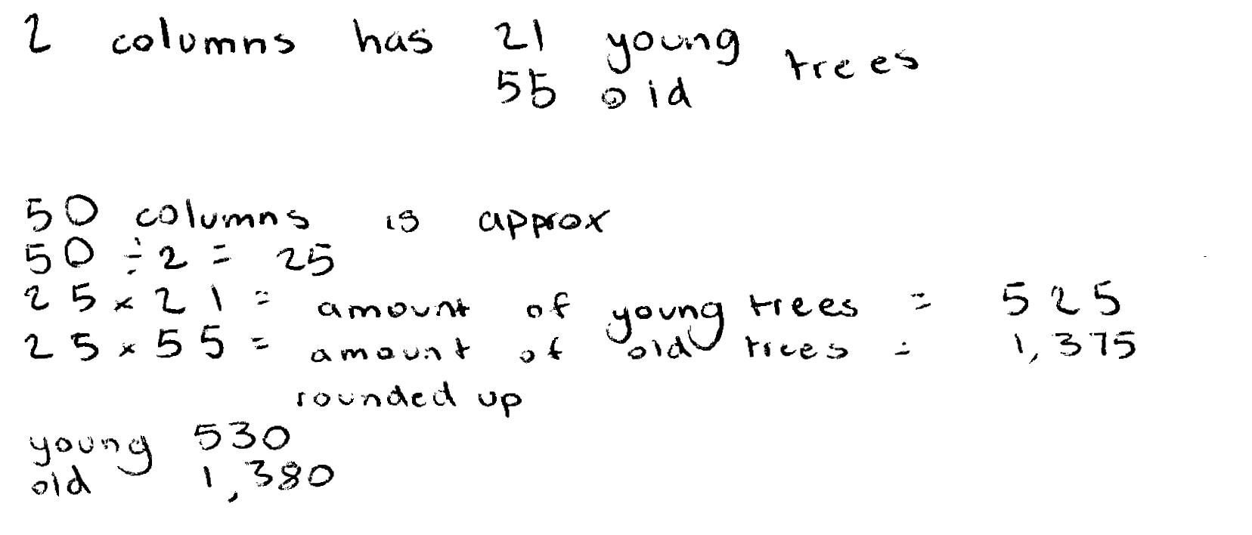

Sample response: Amber

Security Camera

A shop owner wants to prevent shoplifting.
He decides to install a security camera on the ceiling of his shop.
The camera can turn right round through 360°.
The shop owner places the camera at point P, in the corner of the shop.
The plan below shows ten people are standing in the shop.

Plan view of the shop

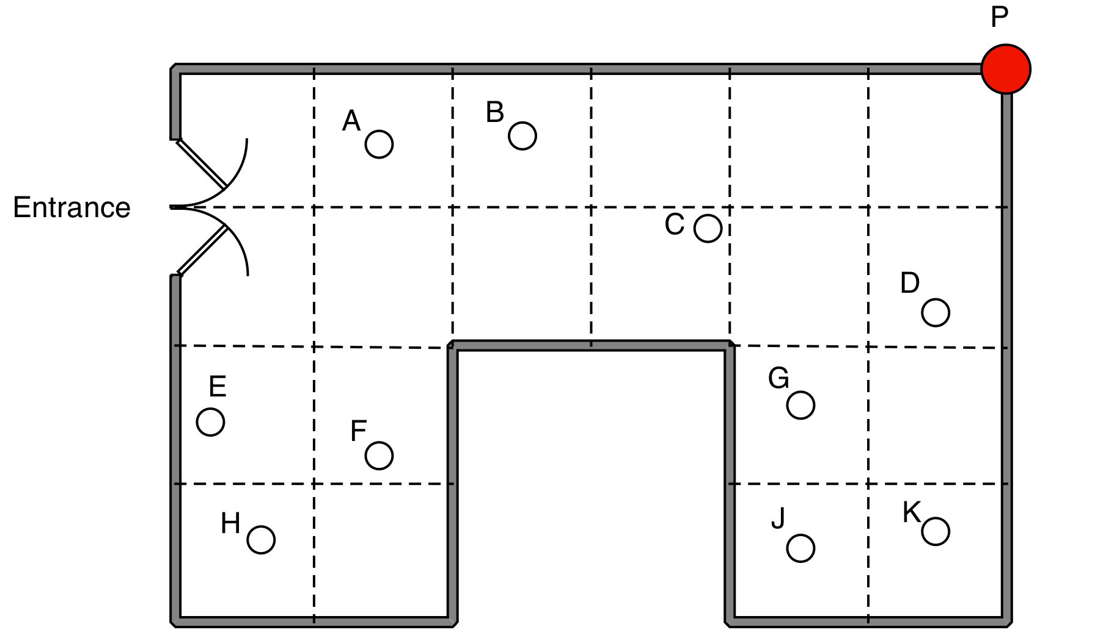

1. Which people cannot be seen by the camera at P?

2. The shopkeeper says that "15% of the shop is hidden from the camera"
Show clearly that he is right.

3. (a) Show the best place for the camera, so that the it can see as much of the shop as possible.

(b) Explain how you know that this is the best place for the camera.
Sample response: Max

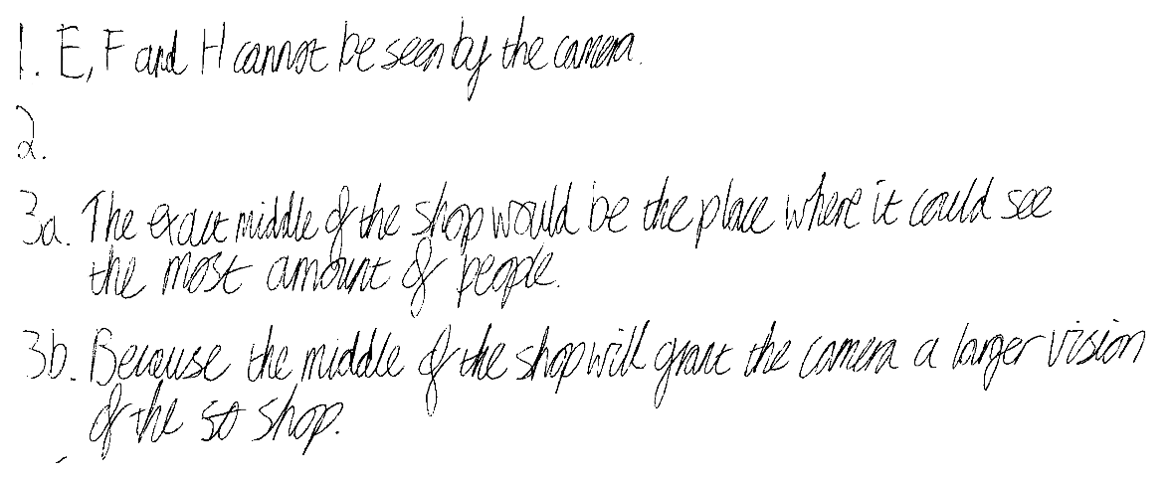

Sample response: Ellie

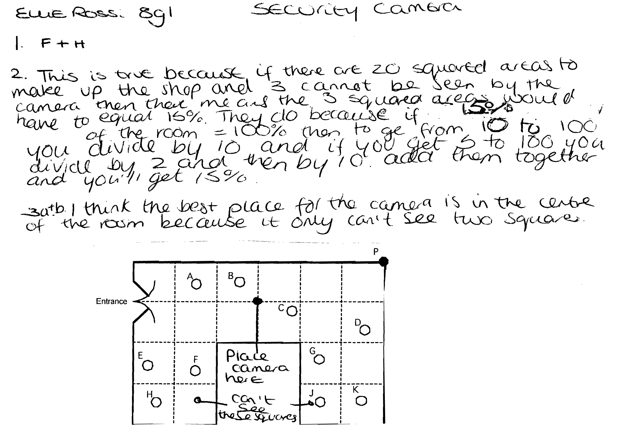

Sample response: Simon

Sample response: Rhianna

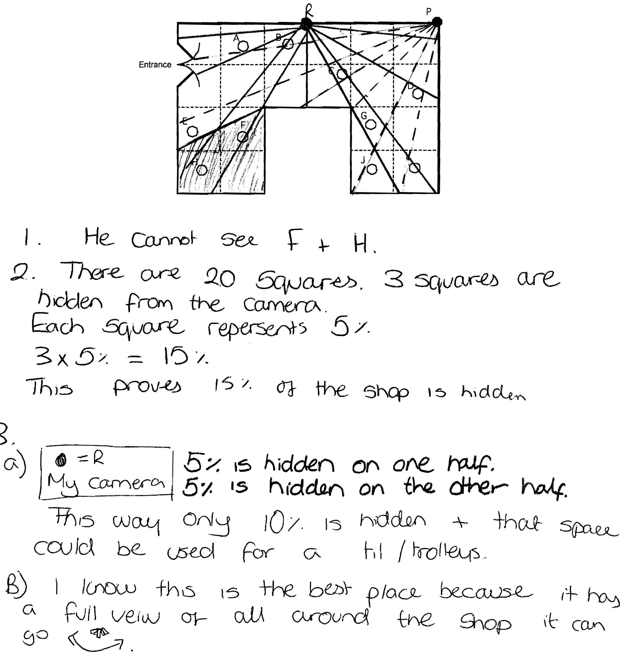

Cats and kittens

Here is a poster published by an organisation that looks after stray cats.

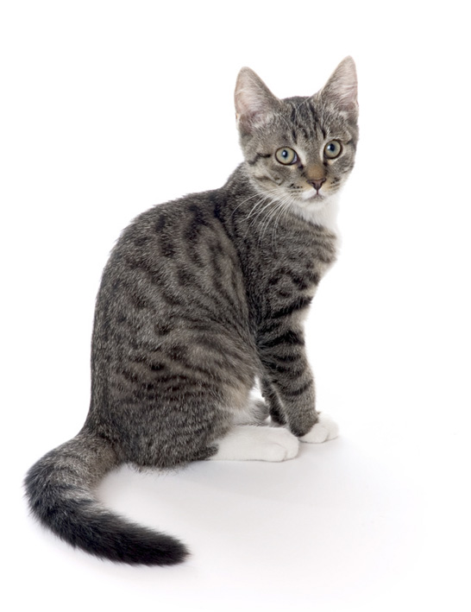

Make sure your cat cannot have kittens.

Cats can’t add but they do multiply!

In just 18 months, this female cat
can have 2000 descendants.

Work out whether this number of descendants is realistic.
Here are some facts that you will need:

Sample response: Alice

Sample response: Ben

Sample response: Wayne

Sample response: Sally and Janet
Two pupils worked on this task, discussing and sharing their methods.
They used a spreadsheet.

We think 2000 is a bit much in 18 months because even if each litter was 6 and nothing dies there would be 1860 though that rounds to 2000 so maybe its OK. The cat people want owners to have their cats newtured so that they use the bigger number so that people say that is a lot of cats and rush to the vets.

