Cats and kittens

Here is a poster published by an organisation that looks after stray cats.

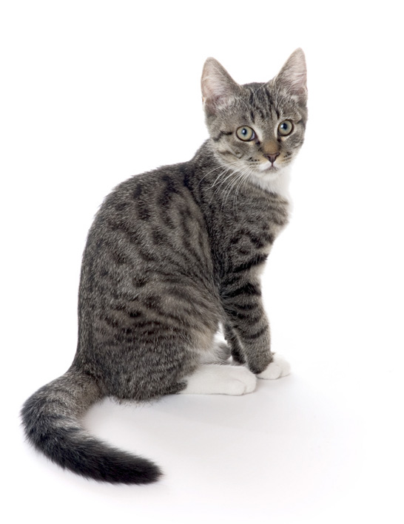

Make sure your cat cannot have kittens.

Cats can’t add but they do multiply!

In just 18 months, this female cat
can have 2000 descendants.

Work out whether this number of descendants is realistic.
Here are some facts that you will need:

Cats and Kittens: sample responses
Sample response: Alice

Sample response: Ben

Sample response: Wayne

Sample response: Sally and Janet
Two pupils worked on this task, discussing and sharing their methods.
They used a spreadsheet.

We think 2000 is a bit much in 18 months because even if each litter was 6 and nothing dies there would be 1860 though that rounds to 2000 so maybe its OK. The cat people want owners to have their cats newtured so that they use the bigger number so that people say that is a lot of cats and rush to the vets.

Cats and Kittens: assessing the sample responses

Sample response: Alice

Alice chose to represent the task using a timeline. She has only considered the number of kittens from the original cat. The computation required is accurate.

What questions could you ask Alice that would help her improve her response?

Sample response: Ben
Ben has decided to draw a ‘cat tree’, and tries to control for time (with some errors). The communication is reasonably clear, allowing the reader to follow the argument, but the value of 9846 is not explained and does not follow from the reasoning, since, again, only the kittens from the original cat are considered. The number of kittens per litter is made explicit.

What questions could you ask Ben that would help him improve his response?

Sample response: Wayne
Woody appears to favour a minimalist approach! He starts with what would be a time consuming pictorial representation which he then abandons in favour of a numerical representation.

What questions could you ask Wayne that would help him improve his response?

Sample response: Sally and Janet
Sally and Janet used a spreadsheet to control for both time and multiplication and their method is clear and effective.

What questions could you ask Sally and Janet that would help them improve their response?

