Security Camera

A shop owner wants to prevent shoplifting.
He decides to install a security camera on the ceiling of his shop.
The camera can turn right round through 360°.
The shop owner places the camera at point P, in the corner of the shop.
The plan below shows ten people are standing in the shop.

Plan view of the shop

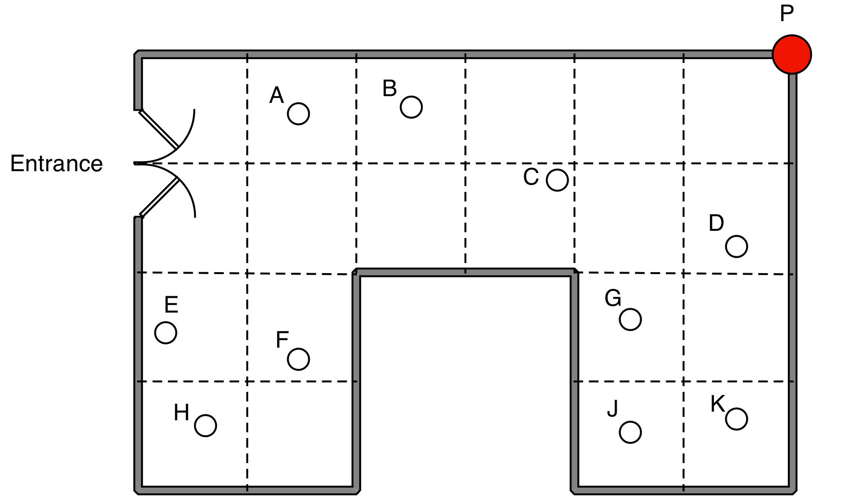

1. Which people cannot be seen by the camera at P?

2. The shopkeeper says that "15% of the shop is hidden from the camera"
Show clearly that he is right.

3. (a) Show the best place for the camera, so that the it can see as much of the shop as possible.

(b) Explain how you know that this is the best place for the camera.

Security Camera: sample responses
Sample response: Max

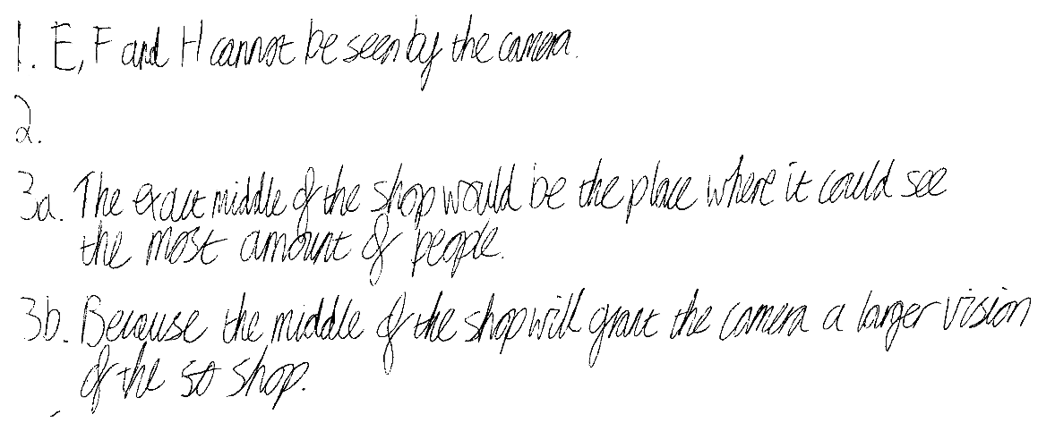

Sample response: Ellie

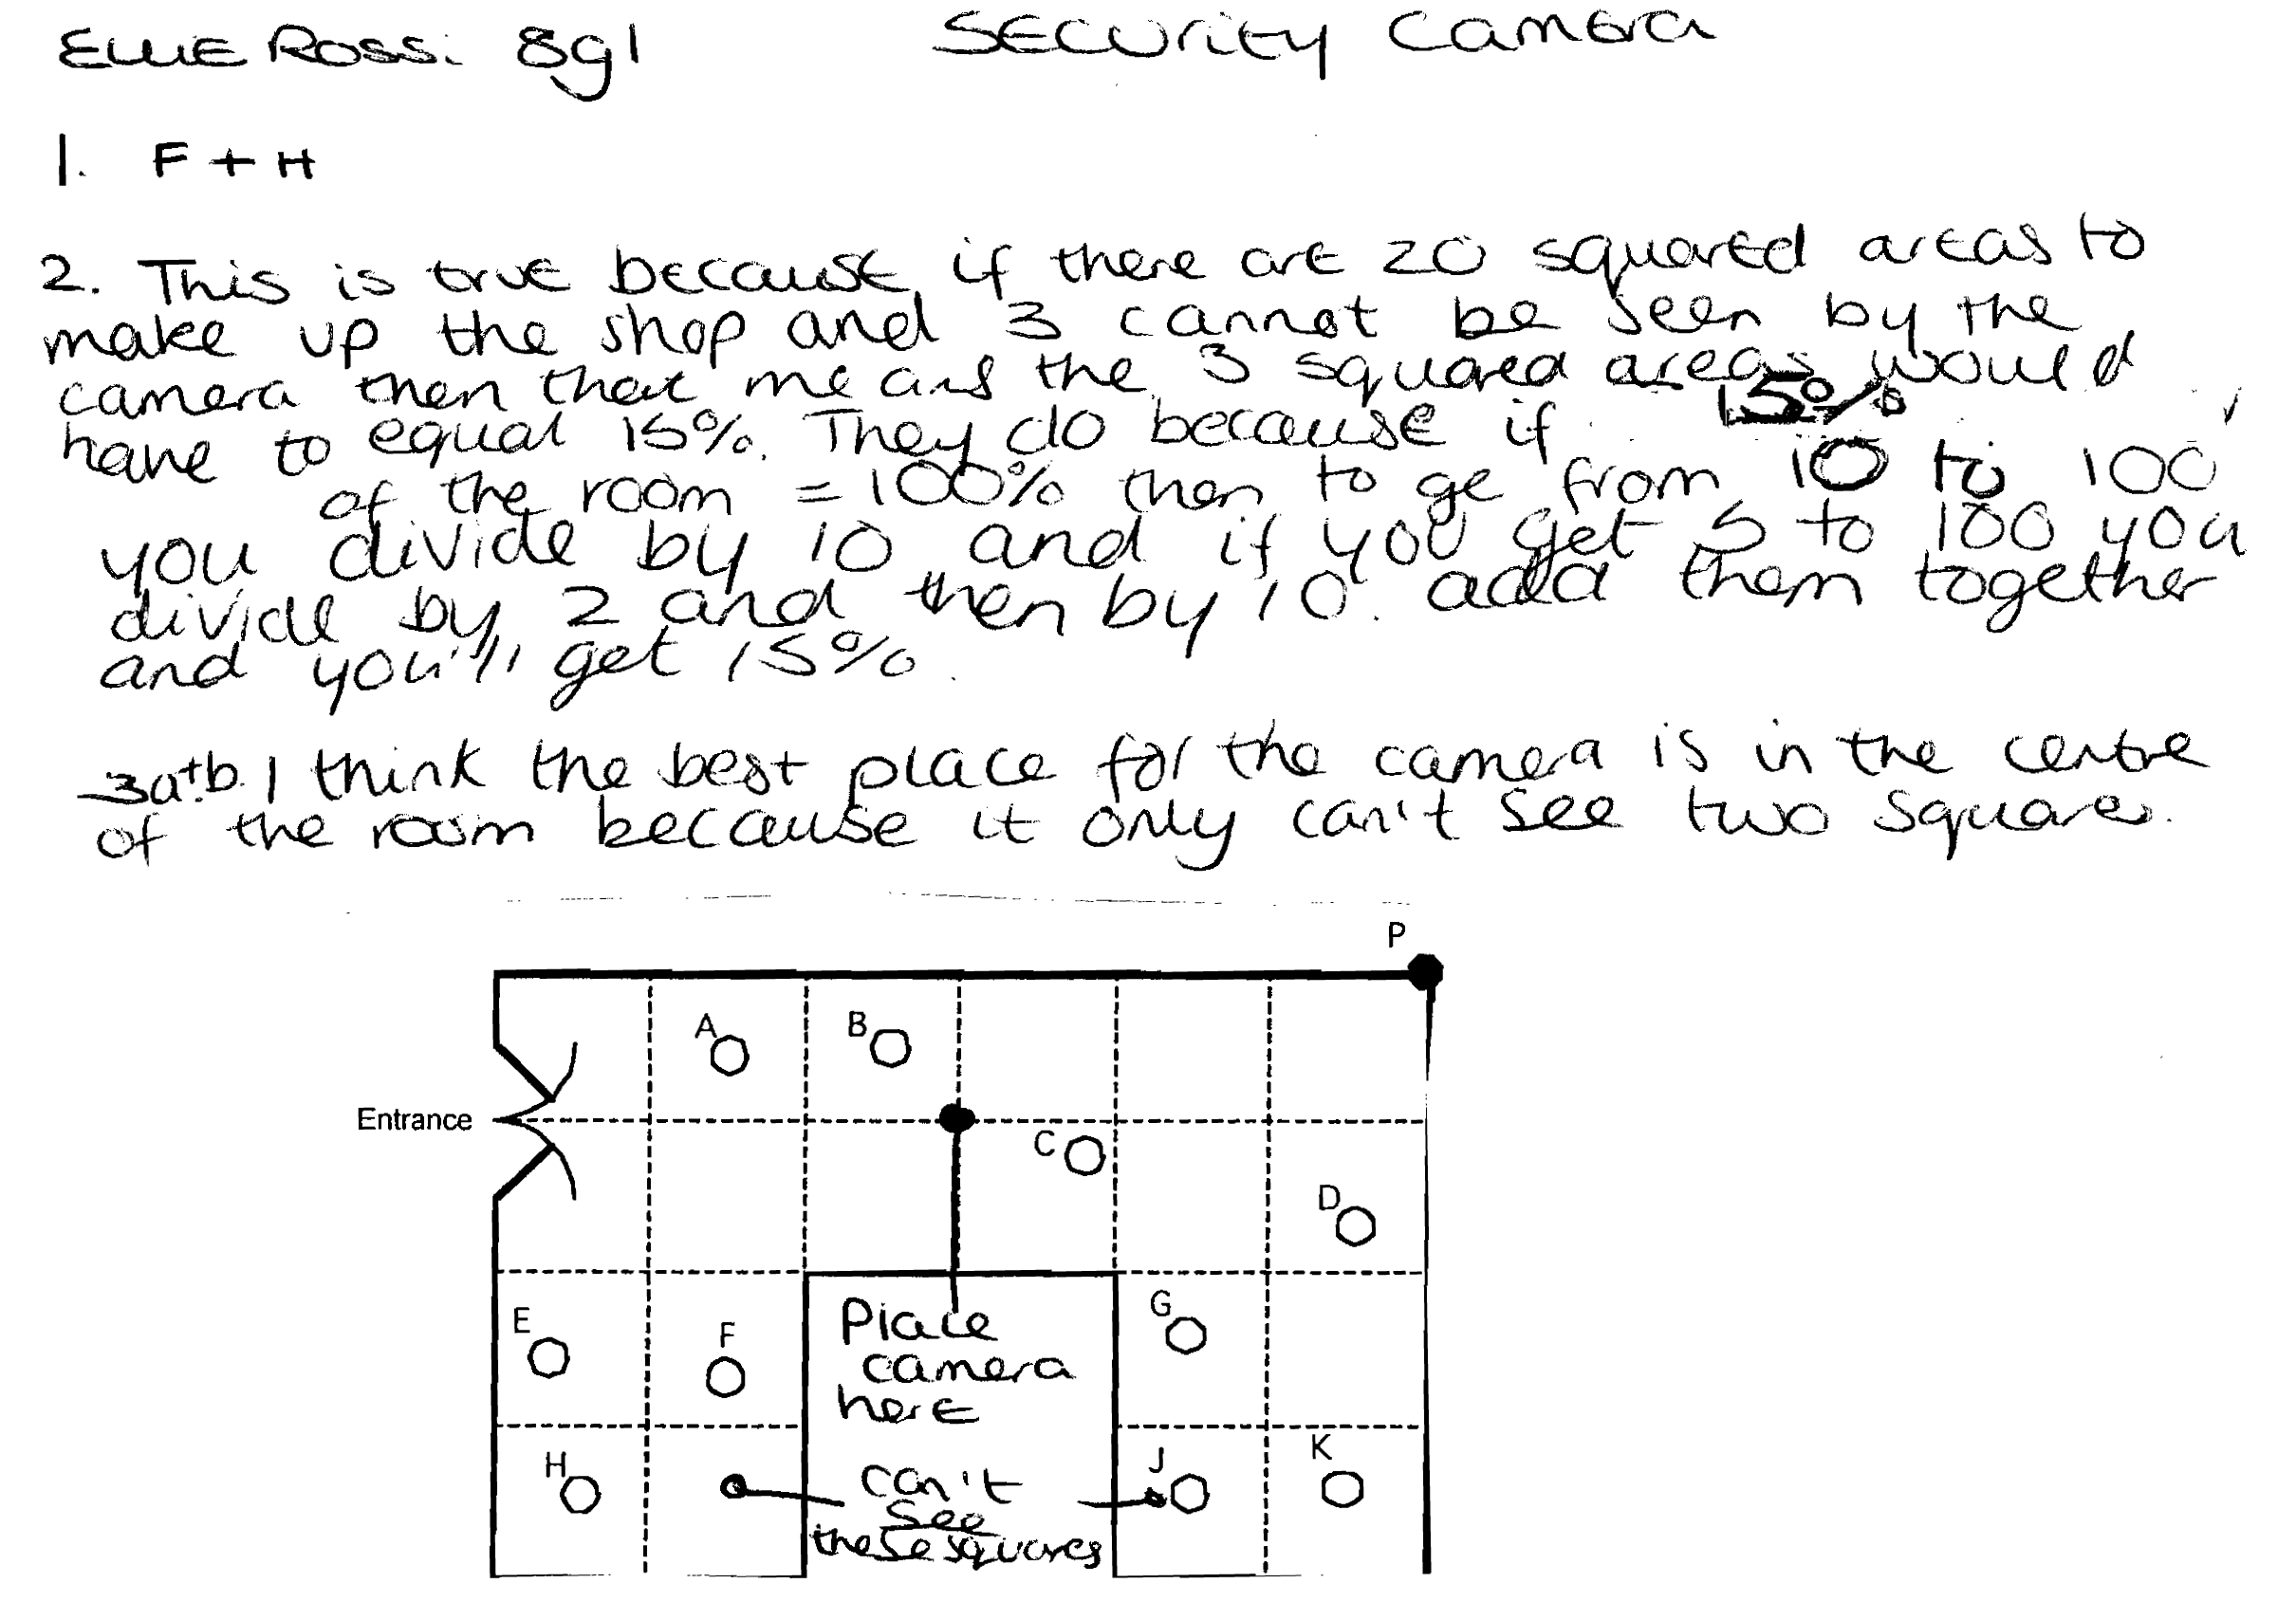

Sample response: Simon

Sample response: Rhianna

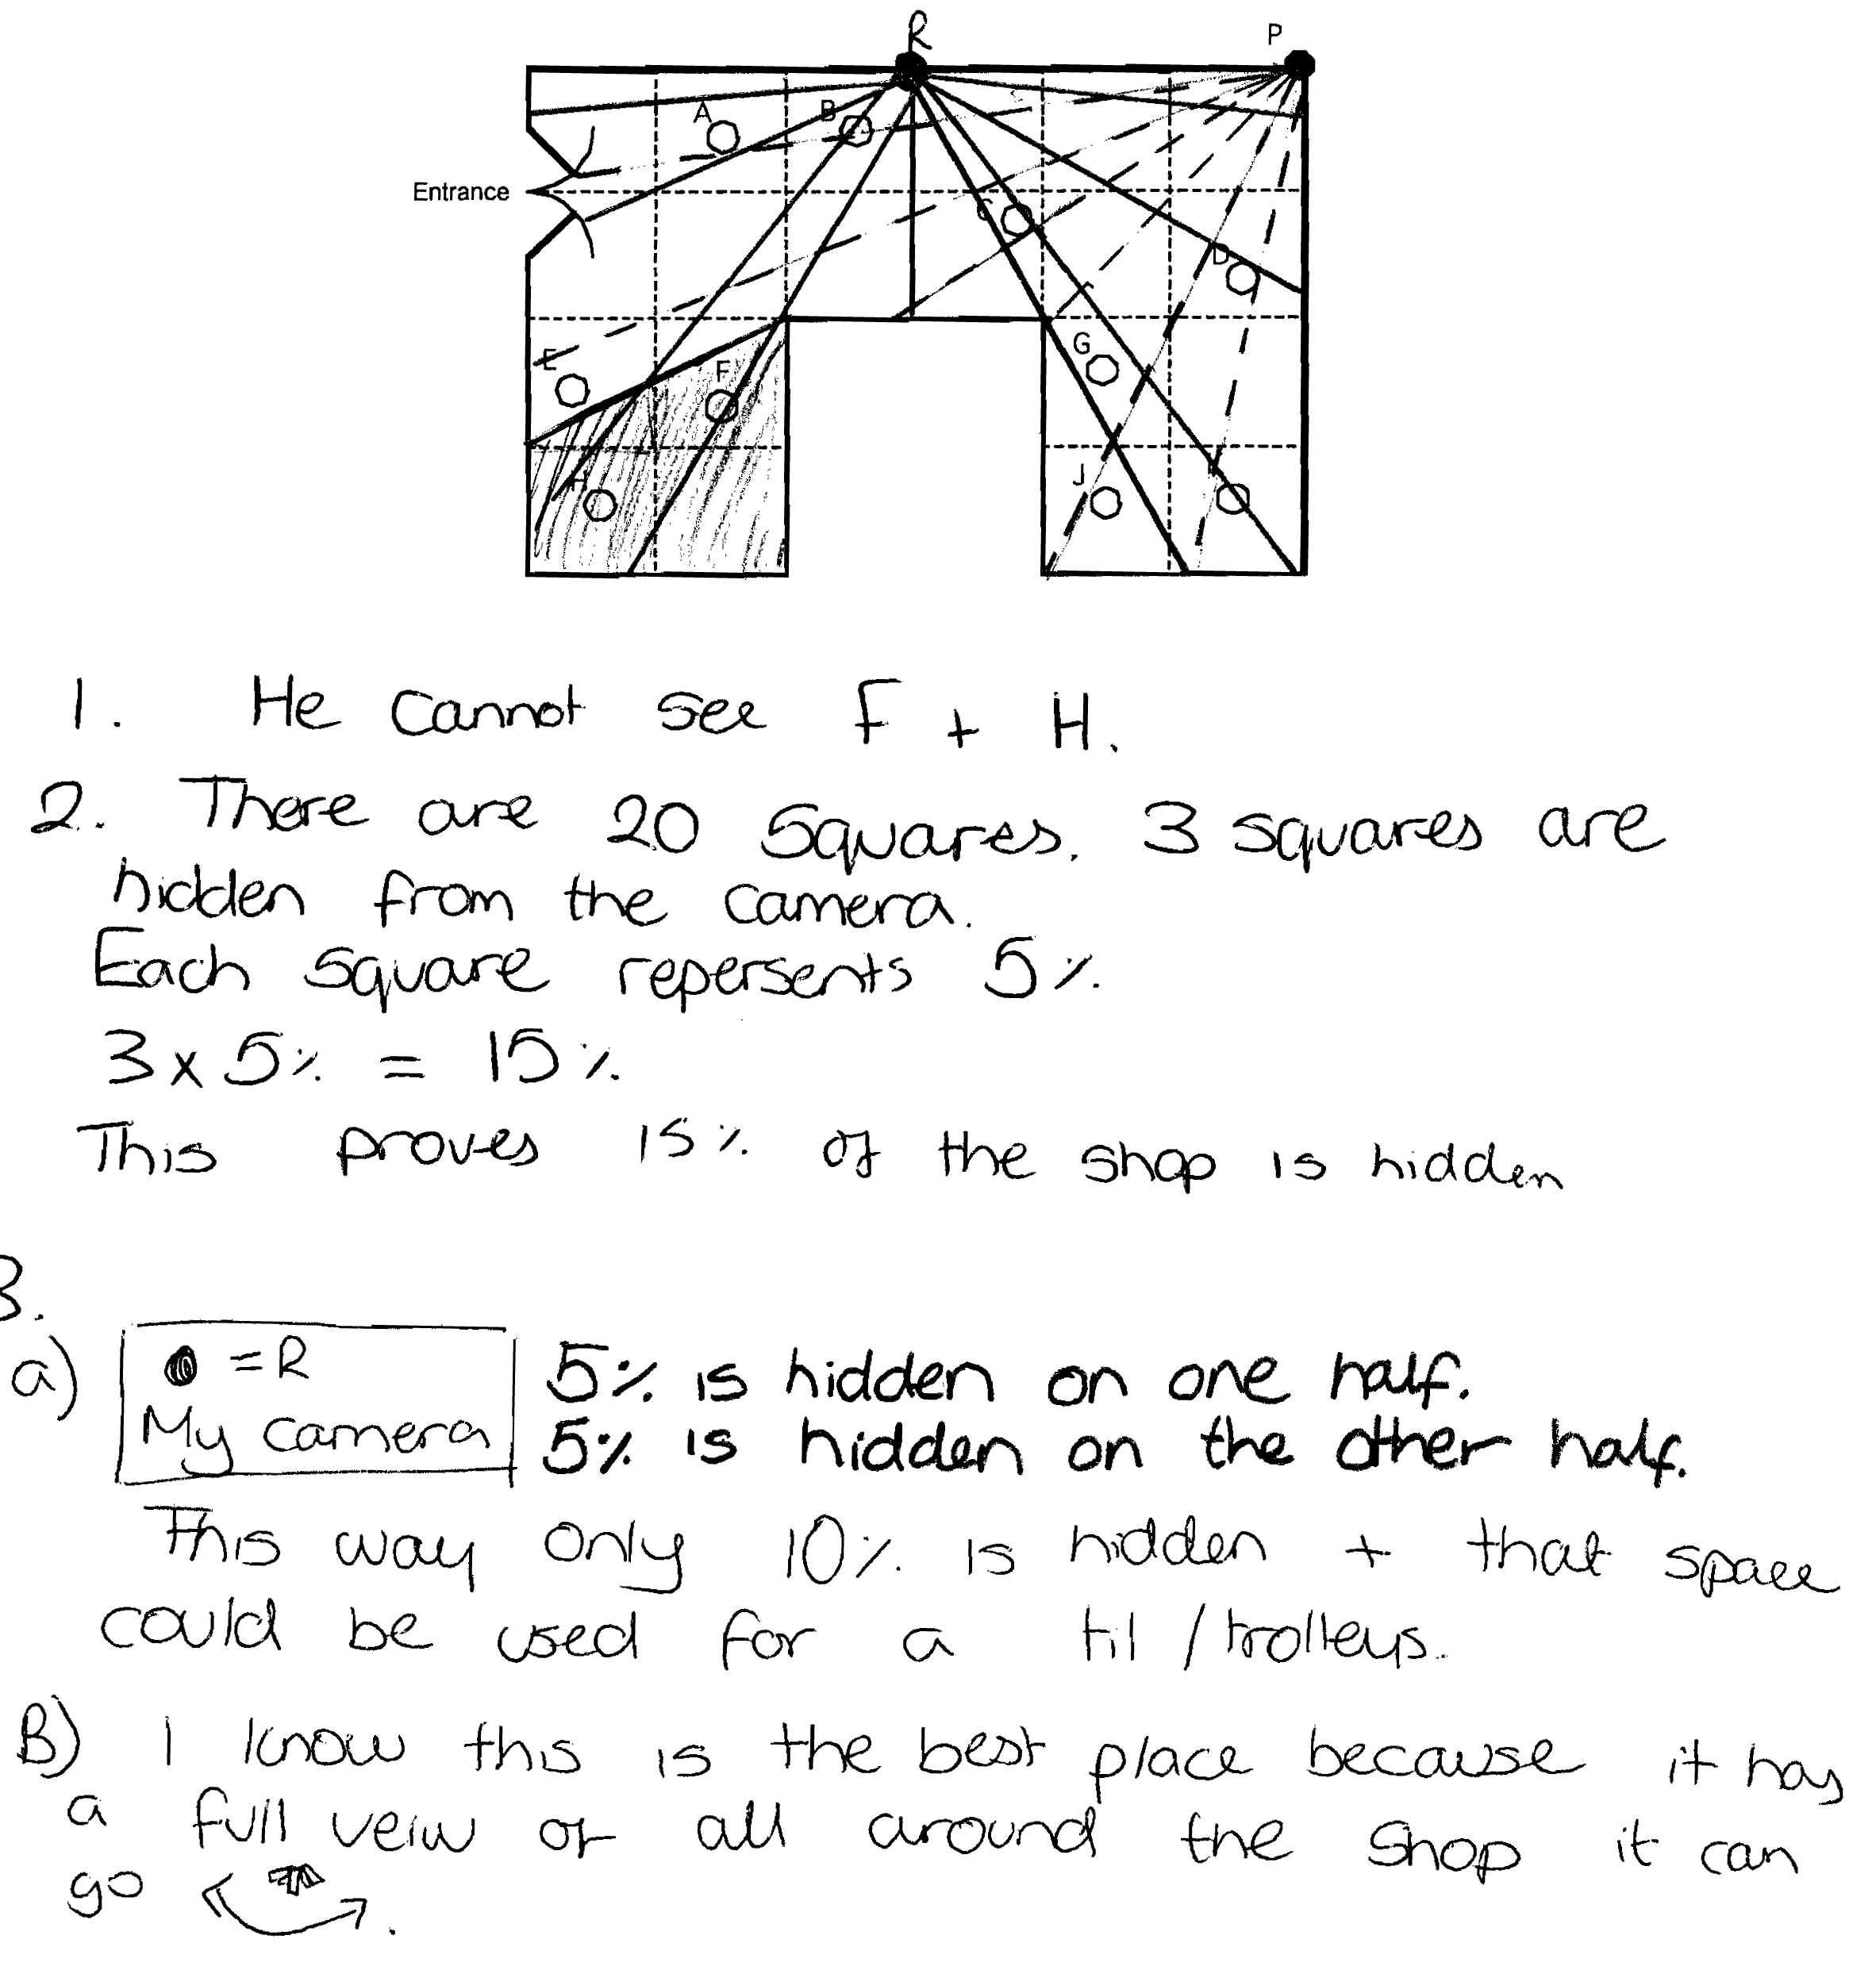

Security Camera: assessing the sample responses
Sample response: Max

Max realises that F and H cannot be seen, but incorrectly thinks that E cannot be seen. He does not show any work to justify his thinking and his further statements are incorrect.
Laura attempts to estimate the number of old and new trees by multiplying the number along each side of the whole diagram and then halving. She does not account for gaps nor does she realise that there are an unequal number of trees of each kind.

What questions could you ask Max that would help him improve his response?

Sample response: Ellie
Ellie does not show any sightlines to justify her answers. However, she correctly states that F and H cannot be seen and that 3 squares cannot be seen. However, she may be thinking of whole squares rather than areas,. Her justification for the 15% is incomplete and poorly explained. She seems to have some understanding that 5% is one twentieth and 10% is one tenth.

What questions could you ask Ellie that would help her improve her response?
Sample response: Simon
Simon correctly states that F and H cannot be seen and that 3 squares = 15% of the area cannot be seen. However, it is possible that he thinks that 3 whole squares are hidden from the camera. He investigates the best place for the camera, and shows that the centre of a side is good but he does not investigate further. No calculations are shown.

What questions could you ask Simon that would help him improve his response?
Sample response: Rhianna
Rhianna correctly shows that F and H cannot be seen and that 3 squares = 15% of the area cannot be seen. She investigates the best place for the camera, and shows that the centre of a side is good. Rhianna clearly shows diagrams with sightlines and calculations that justify her findings.

What questions could you ask Rhianna that would help her improve her response?

