 | Assessing Key Processes to inform learning  How can I assess and build on what pupils are learning?

Follow-up session

Activity 1 Report and reflect on the assessment lesson 10 minutes
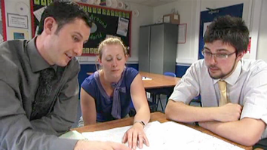 | Take it in turns to share stories of the assessment strategies you used in your lessons. The sample work you have brought along will be discussed in Activity 3, below.  - How did you collect and assess evidence of pupils’ use of the Key Processes?  - What did you learn from this evidence?  - What did pupils learn from the follow-up lesson?  - What are the implications for you mathematics teaching more generally?

Activity 2 Consider the effects of feedback on pupils' learning 15 minutes
   | So far we have focused on the teachers’ role in providing assessment feedback to pupils. In this activity we will consider the use pupils make of different types of feedback and the impact this has on their learning.  Watch the video of Andrew's pupils as they discuss the impact of assessment feedback on their learning.  - Which of their comments strike you as particularly perceptive and important?  - What are the implications of their comments?  Compare their comments with the research quotes given on   Handout 5.  - What are the implications of these findings for your own practice?  - What would happen if you stopped giving marks or levels on pupils’ work? Why are so many teachers resistant to making this change?  - What are the implications of giving qualitative feedback that “concentrates on specific problems with their work, and gives them both a clear understanding of what is wrong and achievable targets for putting it right”?  - Does this kind of feedback necessarily take much longer to give?

Handout 5 presents some results of research from Black and Wiliam (1998) into the relative merits of feeding back assessment information to pupils in different forms. In particular it compares the effects of feeding back quantitative information in the form of marks, levels and rankings with the effects of offering qualitative information in the form of specific, content-focused feedback.

Research shows that learners benefit most from feedback that:
- Focuses on the task, not on levels or marks.
- Is detailed rather than general.
- Explains why something is right or wrong.
- Is related to objectives
- Makes clear what has been achieved and what has not
- Suggests what the learner may do next
- Offers specific strategies for improvement

Activity 3 Using the 'Progression Steps' to assess learning 15 minutes
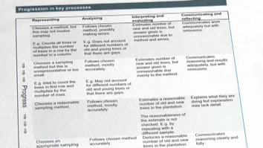 | Look at Handout 6. For each task, we have provided progression steps that provide a framework for assessing pupils' use of the Key Processes. When solving a problem, the four processes are interrelated and need not be considered separately, but the framework approach is useful in helping us see how each process is embodied in the task.  - Try using the progression steps to assess your own pupils' work.  - How else might you use this framework to develop your pupils' understanding of the Key Processes?  If you have been unable to collect this work, then you may like to use the sample work provided in Handout 2 for this activity.

Teachers have found these progression steps useful when constructing feedback questions and comments on pupils' work. They have also been simplified and used directly with pupils to assist them in peer assessment. This will be discussed in the later module: Involving pupils in self and peer assessment.

Activity 4 Discuss the use of periodic reviews in planning 15 minutes
 | Day-to-day assessment provides a wide range of evidence of learning, in specific contexts, which shapes immediate next steps.  Periodic review of this evidence gives a clear profile of pupils’ achievement across a whole subject and informs and shapes future planning and targets for improvement. (DCSF, 2008, p. 6)  - Consider how you might incorporate the Bowland assessment tasks into your normal scheme of work.  - How will you periodically collect evidence of your pupils' progress?  - How will you use this evidence to inform future planning and target setting?
On the video, Amy describes how one might, over time, collect a portfolio of each pupil's work on the Bowland tasks, and relate each to the progression steps. In this way both pupils and teachers can monitor the qualitative development of pupils' ability to represent, analyse, interpret and communicate. One might use this information to help select further problems that focus on the learning needs that become apparent. For example, if the pupil shows a consistent difficulty in communicating their reasoning, then a problem may be selected where this process is central.

Activity 5 Plan assessment strategies for future lessons 5 minutes
 | Conclude this module by discussing some ways of applying what you have learned in this PD module to the other mathematics lessons that you teach.  - How could you involve pupils in improving your assessment practices?  Assessment should go beyond the teacher giving guidance and feedback. It should be two-way. The final video clip shows the end of Amy's lesson in which she asks pupils to tell her the kinds of feedback that they have found most helpful.

Further Reading

See Handout 7 for suggested further reading.

References:

