 | Assessing Key Processes to inform learning  How can I assess and build on what pupils are learning?

Module overview
Assessing pupils' progress as they develop the Key Processes is far from straightforward. This module considers the different ways this can be done and discusses the following questions:
- How can Bowland assessment tasks be used to assess performance and progression in the Key Processes?
- How can this assessment be used to promote learning?
- What kinds of feedback are most helpful for pupils and which are unhelpful?
- How can assessment information be used to provide evidence for periodic assessment?

As questioning is a vital component to formative assessment, we recommend that you work on the CPD module Questioning and reasoning, before tackling this one.

Introductory session 1 hour
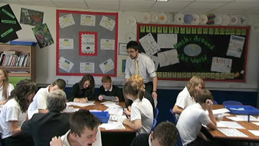 | - Consider principles for assessment  - Analyse pupils’ responses to an assessment task  - Observe formative assessment in action  - Plan an assessment lesson

Into the classroom 1 hour
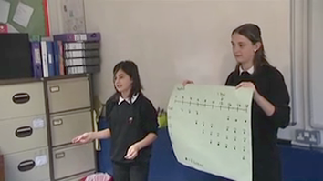 | - Before the lesson, pupils attempt the task unaided.  - Prepare constructive feedback for pupils  - Pupils work alone, responding to the feedback  - Pupils work in pairs to improve their solutions  - Pupils share their approaches with the class  - Pupils continue with the problem or an extension of it

Follow-up session 1 hour
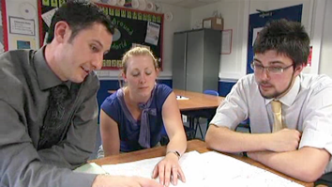 | - Report and reflect on the assessment lesson  - Consider the effects of feedback on pupil learning.  - Use "Progression Steps" to assess learning  - Discuss the use of periodic reviews in planning.  - Plan assessment strategies for future lessons

Resources needed
 Handout 1 Some principles for assessing Key Processes
Handout 2 Three assessment tasks and four sample responses on each
Handout 3 Improving pupils’ responses through questioning
Handout 4 Questioning that will help improve responses
Handout 5 The effects of feedback on pupils' learning
Handout 6 Progression steps in the Key Processes
Handout 7 Suggestions for further reading

Assessing Key Processes to inform learning

How can I assess and build on what pupils are learning?

Introductory session

Introduction How can we assess pupils’ use of the Key Processes? 5 minutes
Pupils enjoy the challenge of tackling tasks that develop Key Processes, but attempting to assess and describe their progress is difficult. Processes are less well defined than content, and pupils’ success in applying them will vary considerably from problem to problem.

In this module, three teachers, Amy, Andrew and Dominic, explore how the Bowland assessment tasks may be used to help assess pupils' progress and provide feedback that promotes learning.

Activity 1 Consider principles for assessment 10 minutes
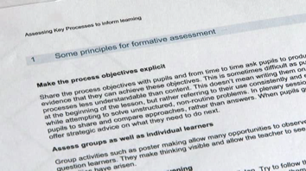 | Handout 1 presents some principles that have been found helpful in assessing processes.  - Which of these principles do you most frequently use?  - Which of these principles do you neglect? Why is this?

Activity 2 Analyse pupils’ responses to an assessment task 20 minutes
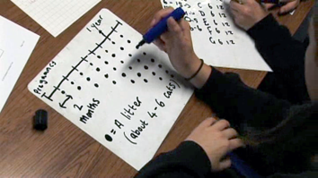 | Handout 2 presents three Bowland Assessment tasks together with four pupil responses on each. The tasks are: Counting Trees, Cats and Kittens, Security Cameras.  Read through all three tasks then choose one task that will be most suitable for a class you will soon teach. If you are working on this module in a group, it will be helpful if each participant chooses the same problem, as this will facilitate the follow-up discussion.  Consider the four pupil responses.  - What does each pupil’s response tell you about his or her capacity to use each of the Key Processes: represent, analyse, interpret and evaluate, communicate and reflect?  Handout 3 offers some comments on pupils’ responses to each of the tasks.  - If you were the teacher of these pupils, what feedback would you give them, to help them improve their responses? Try to frame this help in the form of oral questions you could ask in the classroom. You may find it helpful to refer to the generic questions given on Handout 4 .

Activity 3 Observe formative assessment in action 15 minutes
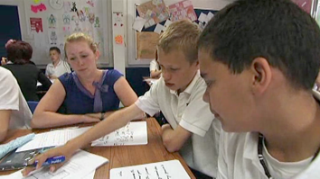 | In this activity, you are provided with video extracts of Amy, Andrew and Dominic exploring how formative assessment may be used to promote pupils' learning. They are using the three tasks from Activity 2.

In an earlier lesson, these teachers had asked pupils to sit in different places and attempt one of the tasks individually, with no help. They then collected in their pupils' responses, assessed the work qualitatively and prepared written feedback in the form of questions. The film clips you are about to see are taken from the follow-up lesson. Pupils have returned to their normal places and most have solutions that are different to those of their partners.

 | Watch the video and consider:  - What different kinds of assessment can you see?  - What is the purpose of each kind of assessment?  - What do both the teachers and pupils learn?
In the video, you will see:
- Andrew exploring how pupils respond to his feedback on the "counting trees" problem;
- Amy listening to, then questioning individuals as they try to share their ideas and produce joint solutions to the "security camera" problem;
- Dominic listening to presentations from pupils on their methods and reasoning for the "cats and kittens" problem;
- Amy concluding her lesson by asking pupils to describe how they have used her feedback to improve their work.

Activity 4 Plan an assessment lesson 10 minutes
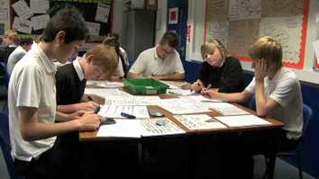 | You may now like to plan your own lesson using one of the problems.  - Plan a time for pupils to tackle the problem on their own without help.  - Plan how you will assess this work, give feedback and conduct a follow up lesson.  - Collect samples of pupils' work to show how their thinking has changed. These will be discussed at the follow-up session.  To help you plan your lesson, you may find it helpful to watch the video clips and refer to the lesson plan provided.

This is the end of the Introductory session. After you have tried out your lesson with your own pupils, return for the Follow-up session. Resources to support the lessons, and suggested lesson plans, can be found in the Into the classroom session.

