6 Comments on the problems

Modelling and explaining: Sharing petrol costs

Links to Case Studies
In the Case Studies, pupils are sometimes asked to create a method for sharing a resource. For example, in Water availability, pupils are asked to find a fair way to distribute water among different countries. This invites them to create a mathematical method (or model) and discuss its validity. In this short 'sharing petrol' task, pupils are asked to find alternative models and decide which is best. This can be difficult as there is often a tendency to see 'lock onto' one method very quickly and resist the invitation to search for alternatives.
Sample solution
Two reasoned methods are shown below. Which do you consider better?
Method 1:
This is to share the cost in the proportion to the road distance people live from school: 2: 5: 8: 10. So:
Anne pays £8
Ben pays £20
Chris pays £32
Dan pays £40
Method 2:
Assume that, altogether, people will need to pay £10 per mile. Costs are shared out as follows:
 | Anne | Ben | Chris | Dan
Last 2 miles £20 | £5 | £5 | £5 | £5
Next 3 miles £30 |  | £10 | £10 | £10
Next 3 miles £30 |  |  | £15 | £15
First 2 miles £20 |  |  |  | £20
Anne pays £5
Ben pays £15
Chris pays £30
Dan pays £50

Solving logic puzzles: Multiplication grids
Links to Case Studies
There are a number of Case Studies that contain logic problems that are quite abstract in nature. These are often situated in the context of computer games. The essence here is to proceed logically and systematically.
Sample solution
Two versions of the Multiplication Grid puzzle are included, one that is based on placing the numbers 0 to 8 and one that involves placing 1 to 9. As the puzzles are generated randomly, pupils will need to develop general strategies. They may discover that the zero (when used) and the primes 5 and 7 are the easiest to place. When these are placed, other numbers may often be deduced. Sometimes there is more than one correct answer!
For example, we must place 1 to 9 in the puzzle shown below.
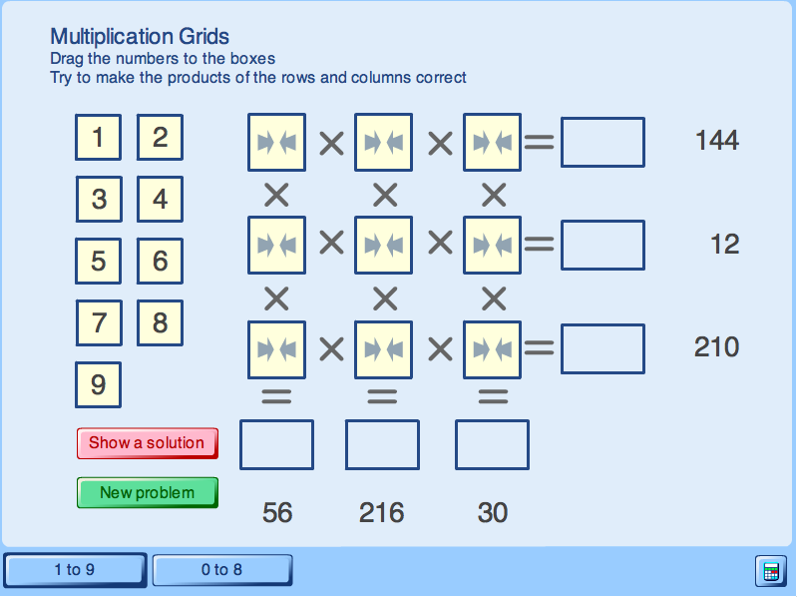

- 5 must go in the third row and the third column, because only 30 and 210 are divisible by 5.
- 7 must go into the third row and first column (only 56 and 210 are divisible by 7)
- 6 must now go in between (to make the product 210).
- Now 216÷6=36. So the middle column must contain 9 and 4. Since 12 is not divisible by 9, 9 must go into the centre of the first row and 4 must go into the central box.
- We are now left with only 1,2,3,8. The only two remaining products divisible by 8 are 144 and 56, so 8 must go in the first row, first column. This forces 1 into the second row, first column. The remaining two numbers are now easy to place. This results in the unique solution (in this case):

8 9 2
1 4 3
7 6 5

Planning and organising: Aircraft turn-round time

Links to Case Studies
There are a number of Case Studies that require planning in order to find an optimal solution. Examples are:
- Outbreak
- Product wars
- Mystery tours
- Highway link design

Sample solution
Pupils are likely to begin this problem by simply adding all the times together. Some may then notice that some jobs may be done simultaneously.

This kind of problem is more easily solved if a helpful representation is found. Mathematicians will recognise this is as a critical path analysis problem and use networks. Others may prefer to use a table or other representation (for example, by having each job on a different scrap of paper and arranging these). A suitable table is shown below:

Time completed | Jobs being done inside the plane | Jobs being done outside the plane | Jobs being done in the cargo hold
0 | A: Get passengers out of the cabin and off the plane | C: Refuel the plane | D: Unload the baggage
5 | A: Get passengers out of the cabin and off the plane | C: Refuel the plane | D: Unload the baggage
10 | A: Get passengers out of the cabin and off the plane | C: Refuel the plane | D: Unload the baggage
15 | B: Clean the cabin | C: Refuel the plane | D: Unload the baggage
20 | B: Clean the cabin | C: Refuel the plane | D: Unload the baggage
25 | B: Clean the cabin | C: Refuel the plane | D: Unload the baggage
30 | B: Clean the cabin | C: Refuel the plane | F: Load the new baggage
35 | E: Get new passengers on the plane | C: Refuel the plane | F: Load the new baggage
40 | E: Get new passengers on the plane | C: Refuel the plane | F: Load the new baggage
45 | E: Get new passengers on the plane | Finished | F: Load the new baggage
50 | E: Get new passengers on the plane | Finished | F: Load the new baggage
55 | E: Get new passengers on the plane | Finished | F: Load the new baggage
60 | Wait | Finished | F: Load the new baggage
65 | F: Final safety check | Finished | Finished

This table shows that the plane will be ready in 65 minutes. Even if the people could get off in a shorter time, it would not speed things up as the final safety checks couldn't take place until after all the baggage had been loaded.

