Making and selling a magazine 1 of 2
Some teenagers want to raise money by making and selling a new magazine.
They conduct a survey to find out how the selling price might affect the number of people that will buy it.
They ask the following question to 100 people:
"How much would you be prepared to pay for this magazine?"

This is what they find:
Selling price (£) | 0 | 0.50 | 1.00 | 1.50 | 2.00 | 2.50
Number of people who would buy it at this price. | 100 | 82 | 60 | 42 | 18 | 0

Each magazine costs 10 pence to make.
What should the selling price be in order to make the most money?
Suppose production costs increase... how will this affect your answer?

Making and selling a magazine 2 of 2

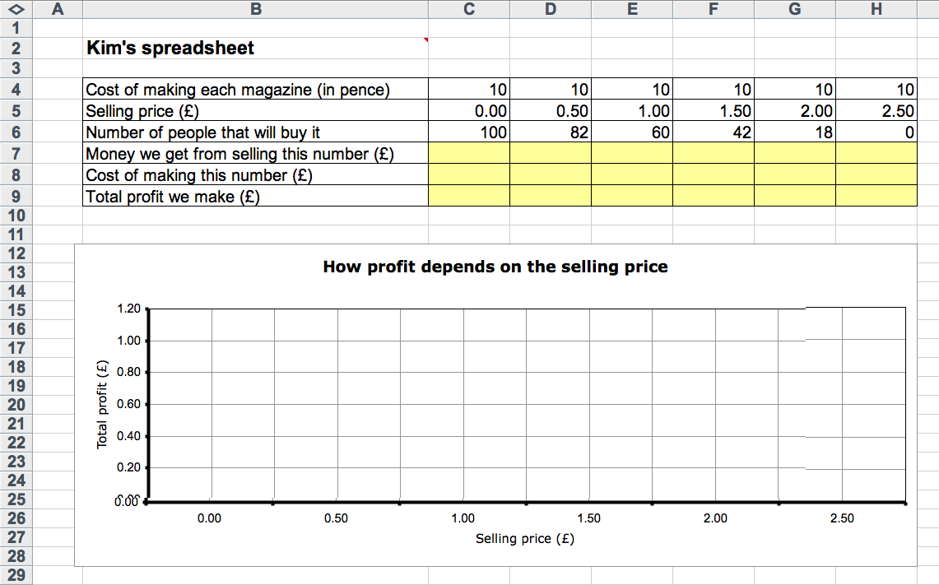
Kim has started to solve this problem with a spreadsheet.
See if you can work out what she has done and use the spreadsheet to solve the problem.
(Start by changing Kim's name to your own!)

