7 Notes on the problems

Spirolaterals

This is an example of a microworld that only takes a few seconds to learn how to use, but is rich in mathematical possibilities. The computer version allows you to explore the relationship between the input numbers and the diagrams obtained.
Pupils may discover many things empirically. Explaining why these patterns work is of course an important, more advanced challenge:

- When a single number a is entered, a square with side length a is obtained.
- When two numbers a, b are entered, a rectangle with sides a, b is obtained:
- Any cyclic reordering of the three numbers: (a,b,c); (b,c,a); (c,a,b) gives the same design, but start in different places:
(1,2,3) 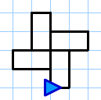 (2,3,1)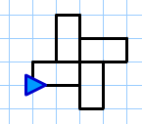 (3,1,2)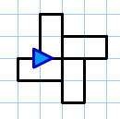

- Changing the cyclic order of the three numbers (a,b,c) to (a,c,b) produces a reflection:
(4,5,2) 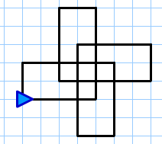 (4,2,5) 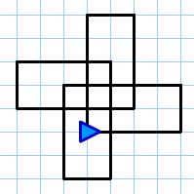

- Three numbers where one or more is repeated (a,b,b) or (a,b,a) give patterns with lines of symmetry:
(1,4,1)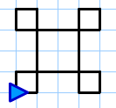 (4,4,1)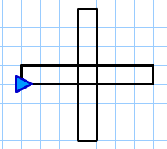

- Patterns with 4 different numbers (a,b,c,d) tend to "walk off" the screen...
  - if a>c, then walk is to the right;
if a<c, then walk is to the left;
  - if b>d, then walk is upwards;
if b<d, then walk is downwards;
  - if one pair are equal, a=c or b=d then the walk is vertical or horizontal, respectively.
  - if a=c and b=d the we get a rectangle.

So, (1,2,3,4) is to the left and downwards; (1,4,3,2) is to the left and upwards;

(1,2,3,4) 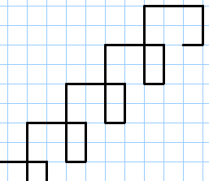 (1,4,3,2)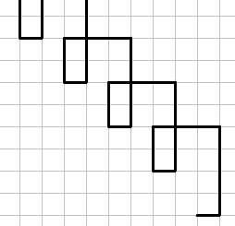

(1,3,4,3) is horizontal to the left; (1,3,1,4) is vertical downwards;

(1,3,4,3) 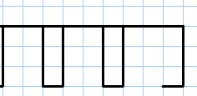 (1,3,1,4) 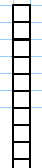

(2,3,2,3) is a rectangle:

(2,3,2,3) 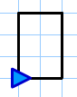

7 Notes on the problems (continued)

Dance moves

We first identify some of problems that may be asked:

- What effect does each button have? (It creates a movement and a new state).
- How many beats does each move take?
- What final positions can the dancers get to?
- Which positions are impossible?
- How many beats are needed to go through all the possible positions?
What is the smallest number?
- Suppose you don't repeat the same move twice running.
What is the quickest way to get to all the positions?
- Is it possible to design a dance that lasts 64 beats, goes through all positions and returns to the start position?

To begin with we might ignore the actual movements made by the people and will just consider starting and finishing positions after each movement. We can represent different moves by the letters S, C and I respectively (we use I because the overall effect is to leave the positions unchanged and I is conventionally used for the identity operation) :

- Partner swing (S) (4 beats)
Dancers swing their partners through 180°. This results in the four dancers changing places in pairs and so the formation is 'reflected' in a vertical mirror line.

- Circle right (C) (6 beats)
Dancers link hands in a star and rotate 270° anticlockwise.

- Diagonal swing (I) (8 beats)
A diagonally opposite pair holds hands and swings 360° returning to starting position while the other two dancers turn through 360° on the spot.

The final positions of dancers Red, Pink, Green, Blue may be recorded in many ways. We will represent positions and transformations as shown below, using the initial letters of the colours.

The diagram below shows the 8 possible configurations of the dancers and the moves that take them from one to another. These positions could be arranged on the corners of cube!

We have also attached a number of beats to each of the moves. This reduces the problem of finding patterns of moves that take a given number of beats to finding different pathways round the diagram. The diagonal swing has not been shown as this does not change the final positions, though it does add 8 to the number of beats.

7 Notes on the problems (continued)

- The final positions are shown on the diagram. Others are impossible - as the diagram proves!

- The diagram shows that the following sequences go through all positions in order and return to the starting position:
CCSCCCSC;
CSCCCSCC;
SCCCSCCC;
CCCSCCCS
These all take 44 beats.

- Separating repeated calls by a diagonal swing gives:
CICSCICICSC;
CSCICICSCIC as the quickest way without repeating moves.
These take 68 beats.

- The design task is therefore impossible!

Mathematicians will recognise that the two operations S and C generate a dihedral group of order 4. (Here CC is represented by C² for example). As the diagram shows, SC≠CS

 |  | Do this second
 |  | I | C | C² | C³ | S | SC | SC² | SC³
Do this first | I | I | C | C² | C³ | S | SC | SC² | SC³
Do this first | C | C | C² | C³ | I | SC³ | S | SC | SC²
Do this first | C² | C² | C³ | I | C | SC² | SC³ | S | SC
Do this first | C³ | C³ | I | C | C² | SC | SC² | SC³ | S
Do this first | S | S | SC | SC² | SC³ | I | C | C² | C³
Do this first | SC | SC | SC² | SC³ | S | C³ | I | C | C²
Do this first | SC² | SC² | SC³ | S | SC | C² | C³ | I | C
Do this first | SC³ | SC³ | S | SC | SC² | C | C² | C³ | I

For an analysis of country dancing we suggest you visit
http://www.edmath.org/copes/contra/.

7 Notes on the problems (continued)

Producing a magazine

This is an example of a problem where a generic piece of software (a spreadsheet) can be used as a tool for solving an everyday problem.

The initial problem may be solved graphically. It looks like the best selling price will be between £1.30 and £1.40, generating a profit of £60 from the people interviewed.

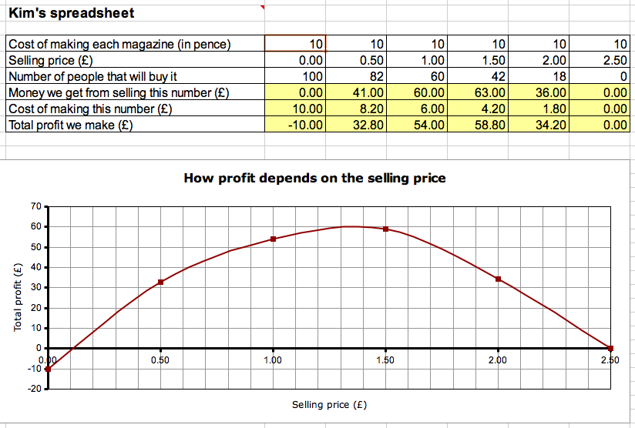

By varying the cost price and examining the graphs obtained, one may deduce that
as production costs rise, then so does the optimum selling price - but not by much.

