1 Two microworlds to explore

Spirolaterals

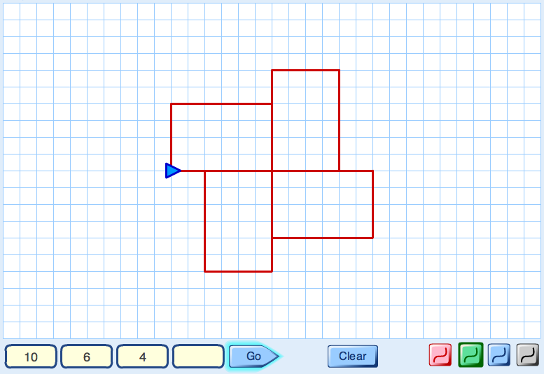

Type some numbers into the Spirolaterals machine.
Press "Go" and watch what happens.

- How do the numbers control what is drawn on the screen?

- List some questions to explore.
These might start like this:
"How can we make the computer draw ....?"
"What will happen if we .....?"
Try and answer your own questions!
- Make up some conjectures. These might start like this:
" When you use three numbers then ..."
" When you repeat a number then ..."
" If you change the order of the numbers then ..."
Can you prove your conjectures?

1 Two microworlds to explore (continued)

Dance Moves

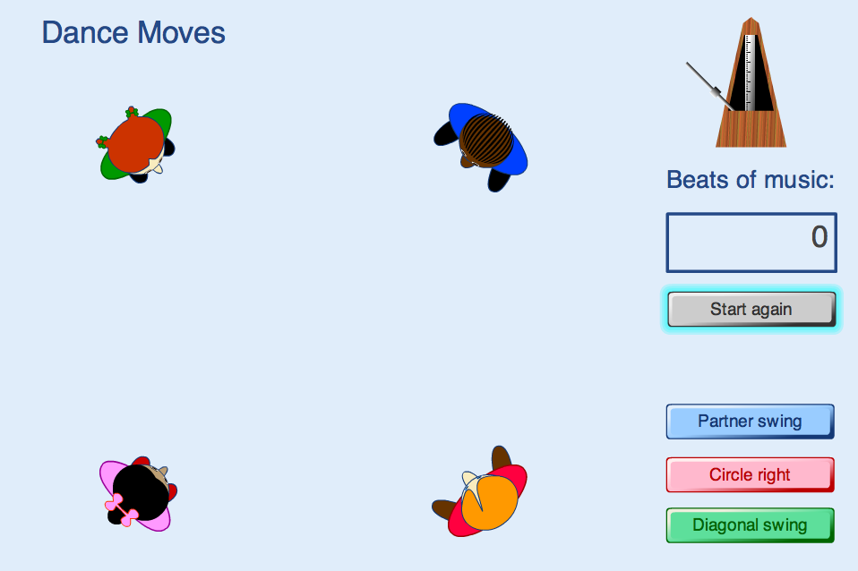

Try clicking the different buttons on the software:

- Describe, as precisely as you can, what each button does.
- Write down some problems that occur to you.
These might start like this:
"How many different ways...?"
"How can I make the dancers move so that...?"
"How many beats would....?"
"Can I get the dancers to do .... in .... beats?"
Now try to solve your own problem.
- Make up some conjectures.
These might start like this:
" You can make the dancers reach every position in ..."
" It is impossible to ..."
Can you prove your conjectures?

