Exploring a microworld Dance moves

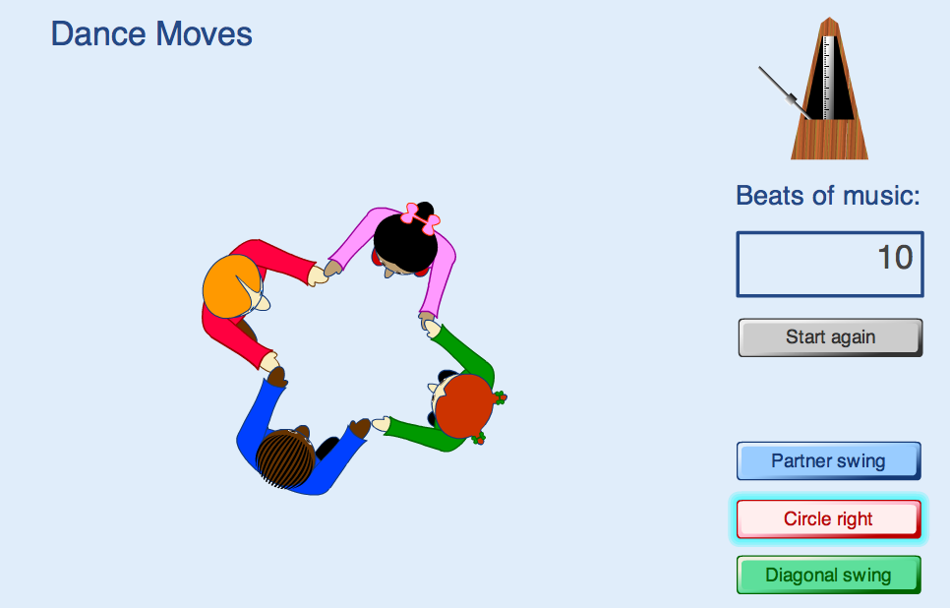
Try clicking the different buttons on the software:

Describe what you notice.

Write down some mathematical problems that occur to you.

Now try to solve one problem!

