9 Photographs for mathematical discussion
Look at each of the photographs below and, for each one:

- Make a list of things you notice.
- Write down some mathematical problems that occur to you. They might, for example, start like this:

How could I describe ..... ?
How many ...?
What would happen if I changed ....?

Now do some mathematics based on the photograph!

Dominoes

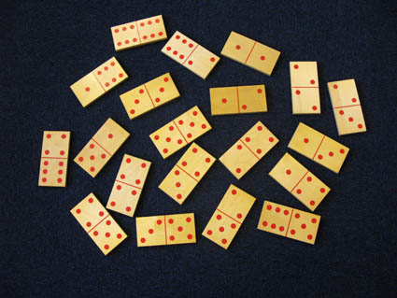

Calendar

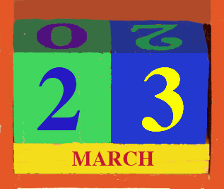

Stack of barrels
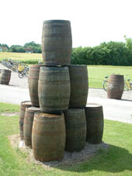

A pavement in Germany

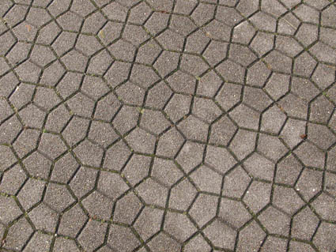

Trike with square wheels
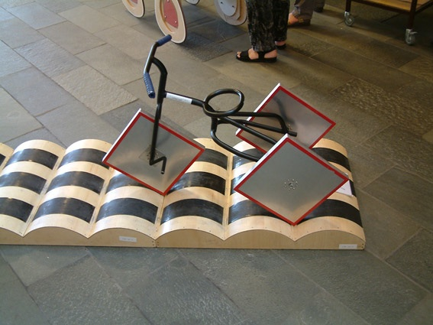

Russian dolls

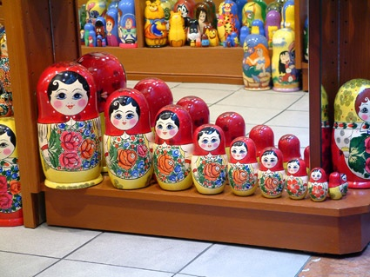

These photographs were taken by Malcolm Swan.

Further photographs leading to interesting mathematical discussions may be obtained from Richard Phillips at http://www.problempictures.co.uk/

