1 Building a school with bottles in Honduras
Look at the pictures and:
- Make a list of things you notice.
- Write down some mathematical problems that occur to you.
- Now try to solve one problem!

First we collect old plastic bottles ..... and fill them with sand.

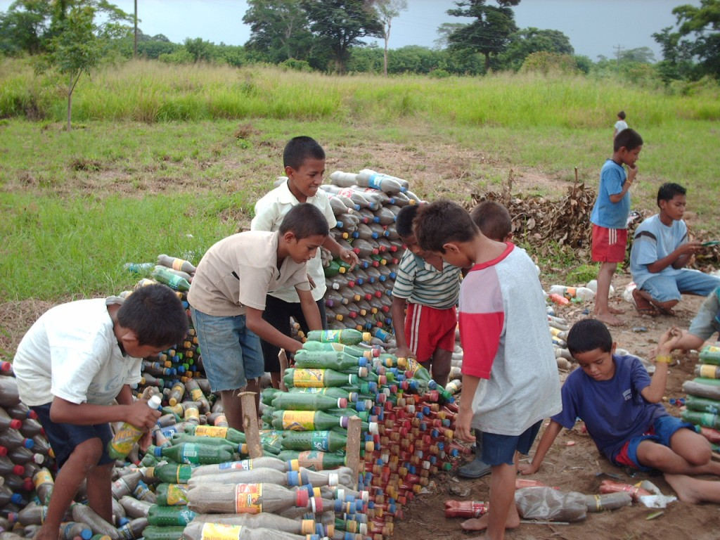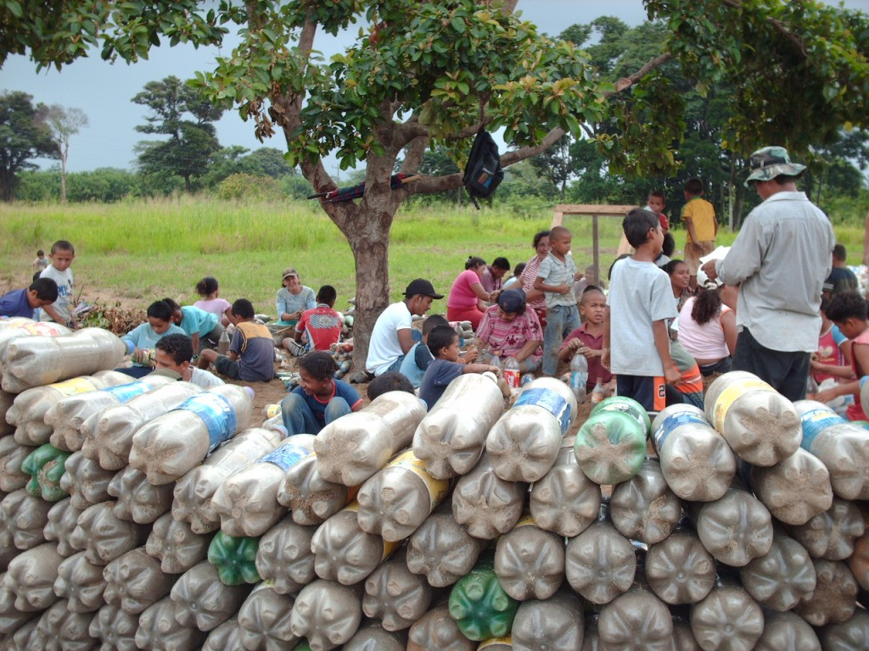

and make some foundations with rocks.... and start to build....

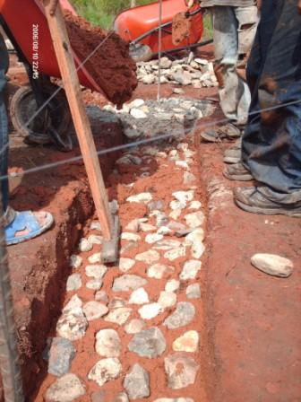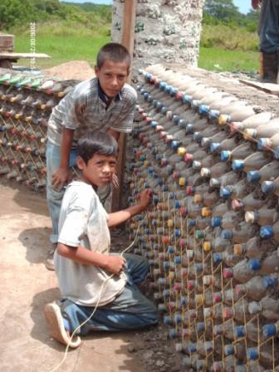

and build.... and build....

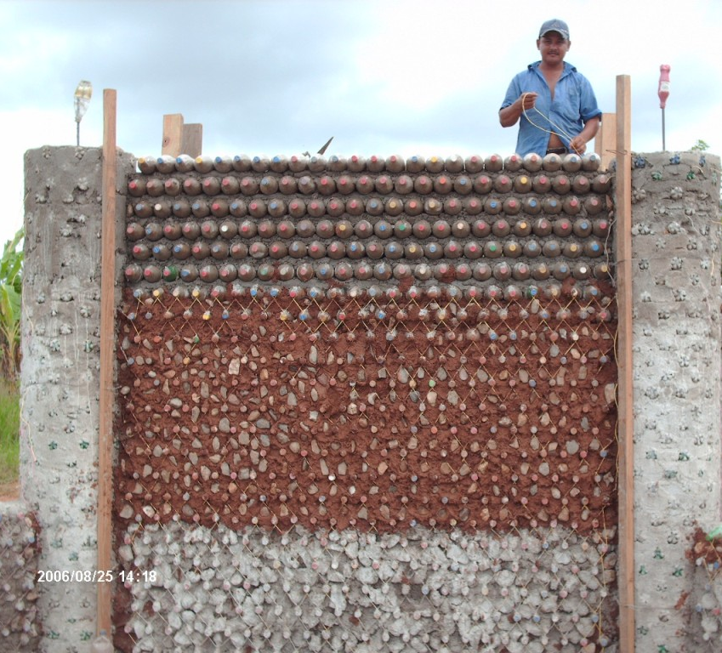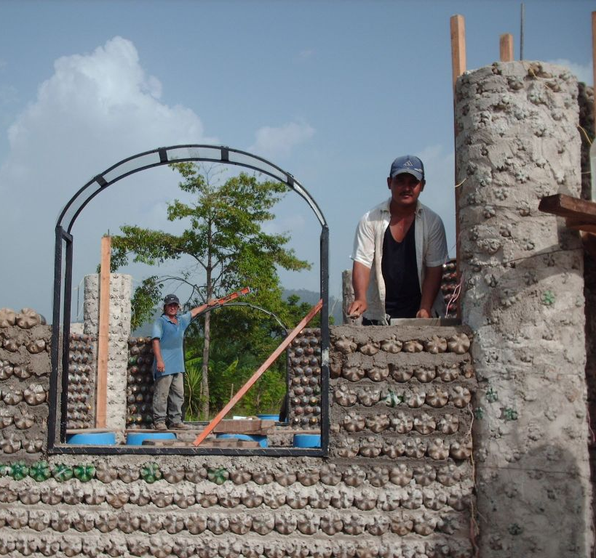

Add windows... and plaster the walls.

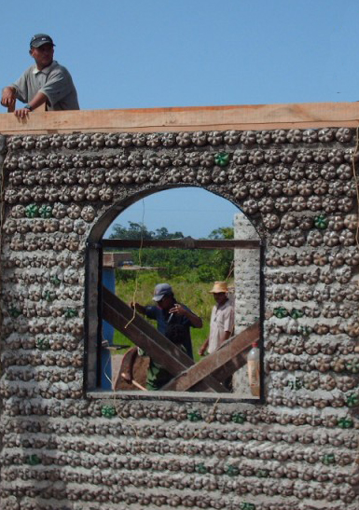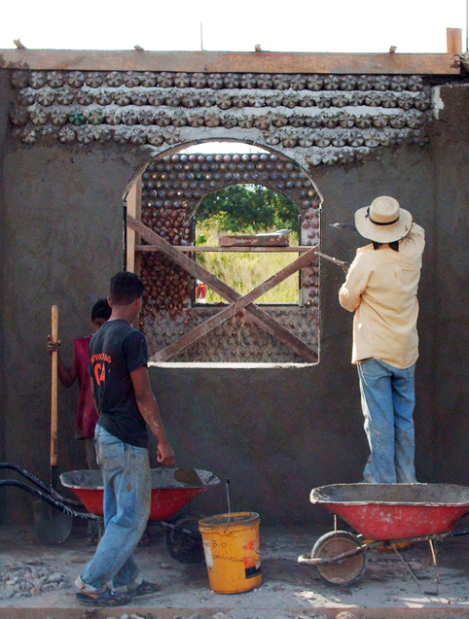

This building is in Honduras and is now a centre for a secondary education programme that is designed to equip and motivate young people to help their communities and to reduce poverty. The programme is particularly designed to help students develop a capacity for problem solving.

Photographs with kind permission from:
Bayán Asociación de Desarollo Socio-Económico Indígena, La Ceiba, Honduras.

