Solving logic puzzles Treasure hunt
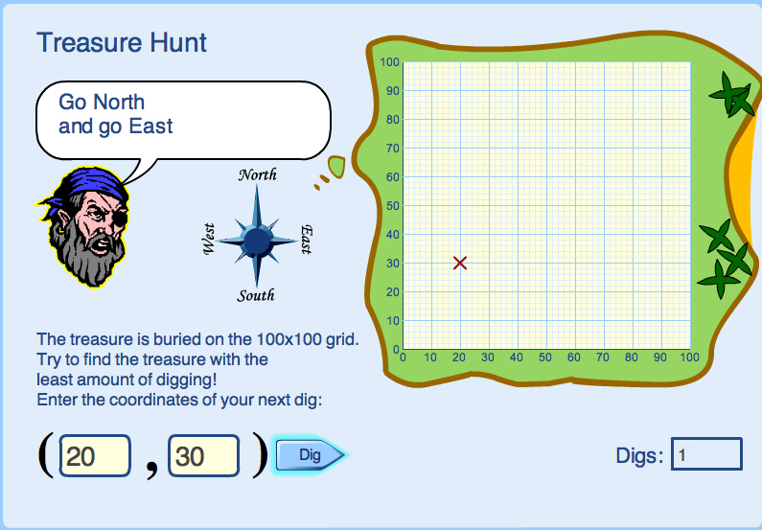
Type coordinates into the yellow spaces to find the treasure, using the clues given by the pirate.

What advice would you give someone to help them find the treasure with the least amount of digging?

