Modelling and explaining Sharing office space
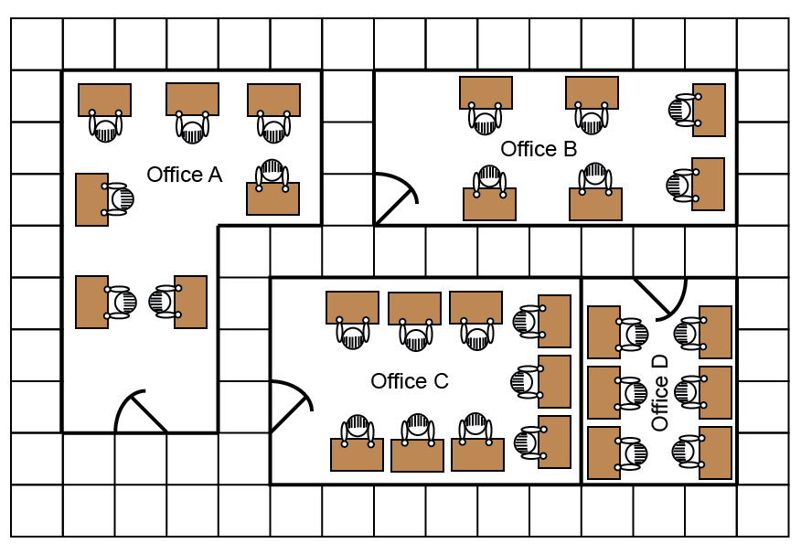
This drawing shows four offices in a factory. The workers complain that some offices are more crowded than others. How could the workers be rearranged with the minimum of fuss, so that the offices are equally crowded?

