1 Problems for discussion

Estimating and interpreting: Schoolteachers and dentists


There are about 60 million people in the UK.

- About how many school teachers are there?
- About how many dentists are there?

Estimate some other facts and check them out!

Modelling and explaining: Sharing office space

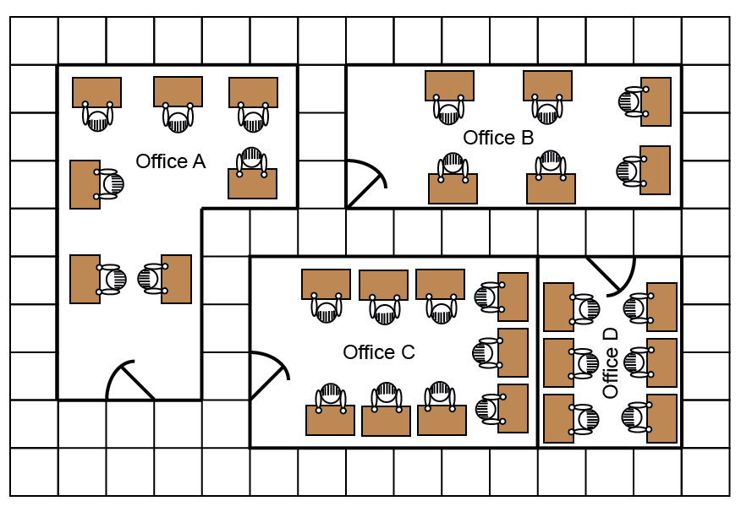
This drawing shows four offices in a factory. The workers complain that some offices are more crowded than others. How could the workers be rearranged with the minimum of fuss, so that the offices are equally crowded?

Solving logic puzzles: Treasure hunt
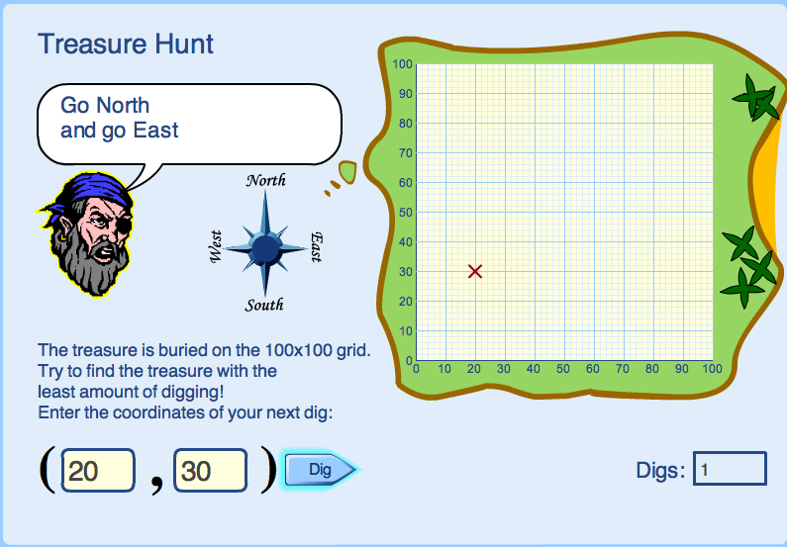
Type coordinates into the yellow spaces to find the treasure, using the clues given by the pirate.

What advice would you give someone to help them find the treasure with the least amount of digging?

