2 Three unstructured versions of the problems

Planning and organising Organising a table tennis tournament

You have the job of organising a table tennis league.

- 7 players will take part
- All matches are singles.
- Every player has to play each of the other players once.
- There are four tables at the club.
- Games will take up to half an hour.
- The first match will start at 1.00pm.

Plan how to organise the league, so that the tournament will take the shortest possible time. Put all the information on a poster so that the players can easily understand what to do.

Designing and testing Designing a box for 18 sweets

You work for a design company and have been asked to design a box that will hold 18 sweets.
Each sweet is 2 cm in diameter and 1 cm thick.
The box must be made from a single sheet of A4 card with as little cutting as possible.

Compare two possible designs for the box and say which is best and why.

Make your box.

Exploring and discovering Calculating Body Mass Index

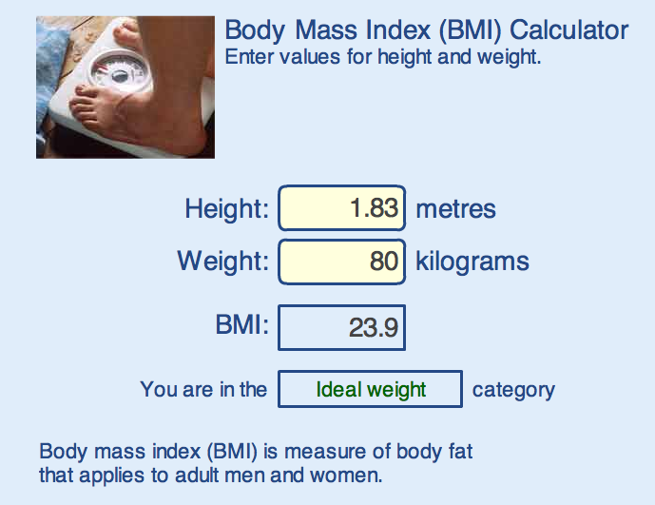
This calculator shown is used on websites to help an adult decide if he or she is overweight.
What values of the BMI indicate
whether an adult is underweight,
overweight, obese, or very obese?

Investigate how the calculator works
out the BMI from the height and weight.

Note for pupils: If you put your own details into this calculator, don’t take the results too seriously! It is designed for adults who have stopped growing and will give misleading results for children or teenagers!

