1 Three structured problems

Organising a table tennis tournament

You have the job of organising a table tennis tournament.

- 7 players will take part
- All matches are singles.
- Every player has to play each of the other players once.

1. Call the players A, B, C, D, E, F, G
Complete the list below to show all the matches that need to be played.
A v B B v C ....
A v C B v D ....
.... ....

2. There are four tables at the club and each game takes half an hour.
The first match will start at 1.00pm.

Copy and complete the poster below to show the order of play,
so that the tournament takes the shortest possible time.
Remember that a player cannot be in two places at once!
You may not need to use every row and column in the table!

Start Time | Table on which the game will be played
 | 1 | 2 | 3 | 4
1.00 | A v B
1.30
2.00
2.30
3.00
3.30
4.00
4.30

1 Three structured problems (continued)

Designing a box for 18 sweets

You work for a design company and have been asked to design a box that will hold 18 mints.
Each mint is 2 cm in diameter and 1 cm thick.
The box must be made from a single sheet of A4 card with as little cutting as possible.

On the grid paper below, show clearly how the card can be folded up and glued together to make the box.

Make your box to check.

1 Three structured problems (continued)

Calculating Body Mass Index

This calculator is used to help adults find out if they are overweight.

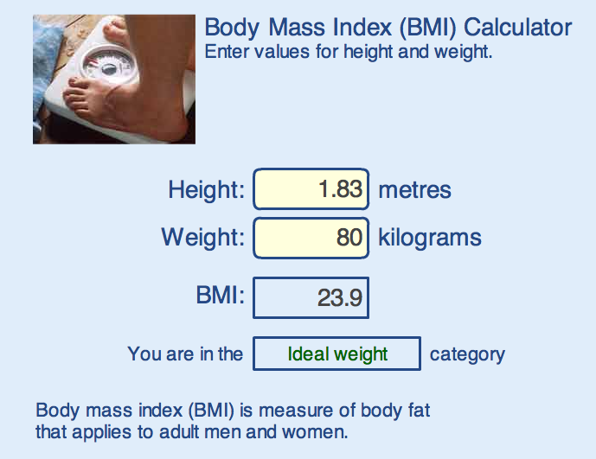

1. Fix the height at 2 metres - a very tall person!
Complete the table below and draw a graph to show your results.
Weight (kg) | 60 | 70 | 80 | 90 | 100 | 110 | 120 | 130 | 140
BMI

(a) What is the largest BMI for which someone is underweight?
(b) What is the smallest BMI for which someone is overweight?
(c) When you double the weight, what happens to the BMI?
(d) Can you find a rule for calculating BMI from the weight?
2. Fix the weight at 80 kilograms and try varying the height.
(a) When you double the height, what happens to the BMI?
(b) Can you find a rule for calculating BMI from the height?
(c) Draw a graph to show the relationship between the height and the BMI.

For more information on BMI visit:

http://www.nhsdirect.nhs.uk/magazine/interactive/bmi/index.aspx

Note for pupils: If you put your own details into this calculator, don’t take the results too seriously! It is designed for adults who have stopped growing and will give misleading results for children or teenagers!

