Exploring and discovering Calculating Body Mass Index
This calculator shown is used on websites to help an adult decide if he or she is overweight.
What values of the BMI indicate
whether an adult is underweight,
overweight, obese, or very obese?

Investigate how the calculator works
out the BMI from the height and weight.

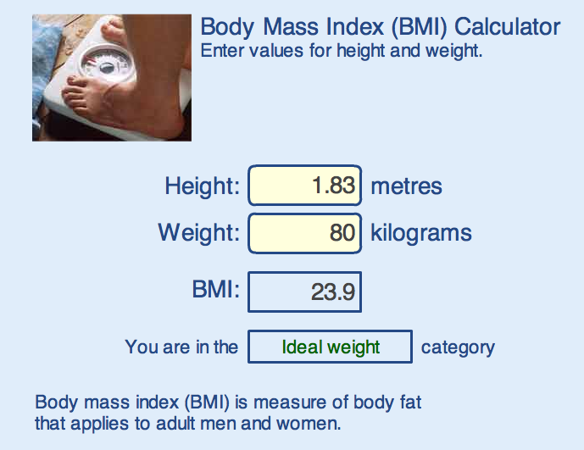
Note for pupils: If you put your own details into this calculator, don’t take the results too seriously! It is designed for adults who have stopped growing and will give misleading results for children or teenagers!

