 | Youth Hostel

Task description

Pupils work out the best way of allocating dormitories at a Youth Hostel to a group of children and adults.
Suitability National Curriculum levels 5 to 6

Time 30 minutes to 1 hour

Resources Ruler, pencil, calculator and 1 cm squared paper.

Key Processes involved

- Representing: Consider the total number of males and females staying at the Youth Hostel and the dormitories available.
- Analysing: Work out the total number of males and females and how the numbers 12, 8 and 6 could be added to make the totals, taking into account the constraints.
- Interpreting and evaluating: Check that all the requirements are covered and consider whether other arrangements are possible.
- Communicating: Show clearly that their solution works.

Teacher guidance

Check that pupils understand the context, for example with questions such as:

- Have you ever stayed at a Youth Hostel?
- What is a ‘dormitory’ – or ‘dorm’?

Pupils can tackle this task in different ways, but they might be expected to:

- add together the girls and women, and the boys and men
- work out dorm numbers for the males and females separately
- lay the results out clearly

Youth Hostel

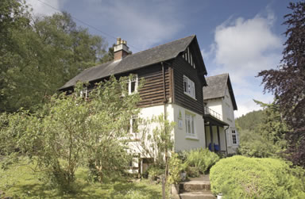
Sports and Games is a company that organizes summer camps for children.

Forty-six children (26 girls and 20 boys) have registered to go, and eight adults (4 men and 4 women) have volunteered to organise them.

The group will stay in a youth hostel that has 7 dorms, one has 12 beds, two have 6 beds and the others have 8 beds each.

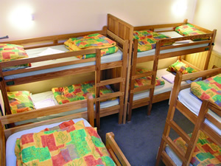
The hostel regulations are that:

- Boys and girls must sleep in separate dorms

- No dorm can be only children – there must be at least one adult in each

- Male adults sleep in boys’ dorms, female adults in the girls’ dorms

How can the adults and children be divided into groups to sleep in the dorms?

Assessment guidance

Progression in Key Processes

Representing | Analysing | Interpreting and evaluating | Communicating
Approach to the problem | Account taken of the requirements and given numbers | Quality of solution in relation to the problem | Clarity and completeness of written work
Starts to put groups of children and teachers into dorms.  PROGRE  S  S  I  ON  Pupil A | Notes that at least one adult needs to be in each dorm.  Pupil A | Produces an incomplete solution.  Pupil A | Communicates the work adequately, but with gaps and/or omissions.
Puts the children and adults into the dorms.  Pupil B | Takes most of the requirements into account, but with at least one error or omission.  Pupil B | Produces a complete solution, but with at least one omission or error.  Pupil B | Communicates the work clearly with reasoning that can be followed.  Pupil B
Correctly puts the children and adults into dorms. | Takes all the requirements into account.  Pupil C | Covers all the requirements with a solution, but it is not optimal.  Pupil C | Communicates the work clearly with reasoning that can be followed easily  Pupils C and D
Correctly puts the children and adults into dorms.  Pupils C and D | Takes all the requirements into account and produces a sensible solution.  Pupil D | Covers all the requirements with an optimal solution.  Pupil D | Explains work clearly and considers alternative solutions

Sample responses

Pupil A

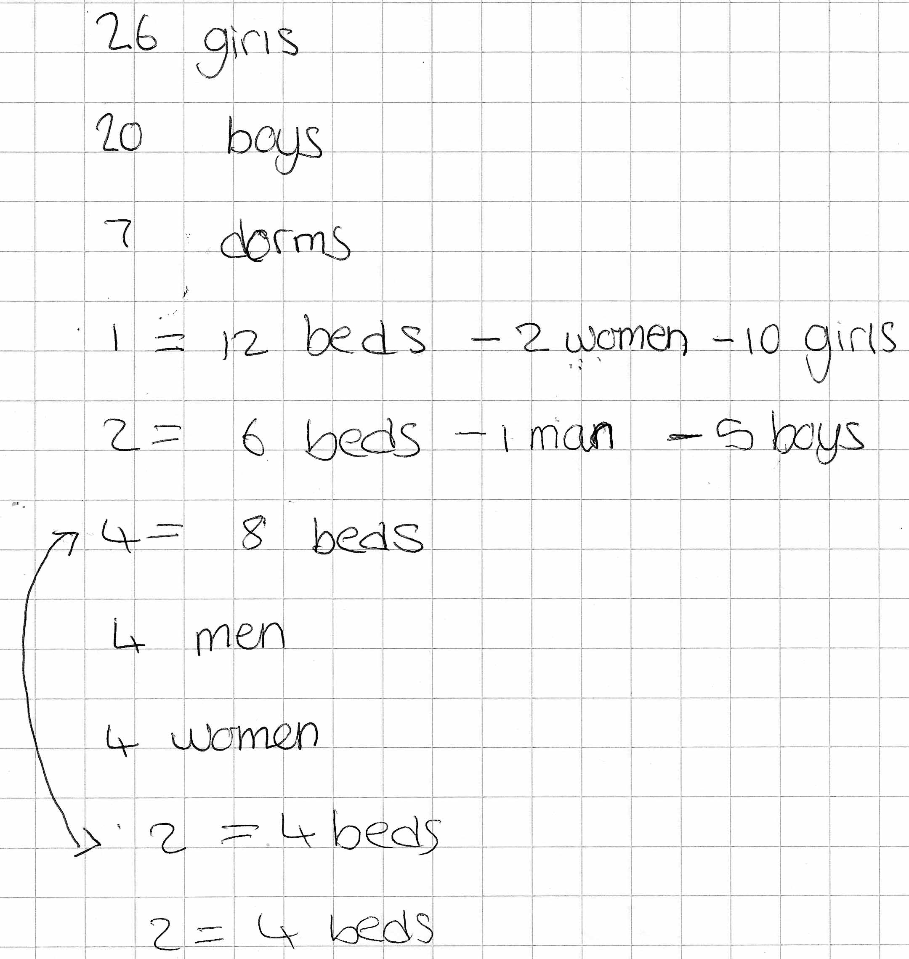
Comments

Pupil A has started to sort out the dorm groups and has put at least one adult in with groups of just boys and just girls.

Probing questions and feedback

- Do you mean that both the dorms with 6 beds have 1 man and 5 boys in?
How many boys and men still need dorms?
- How many girls, boys, women and men still need dorms?
- Can you fit the rest into the dorms available?

Pupil B

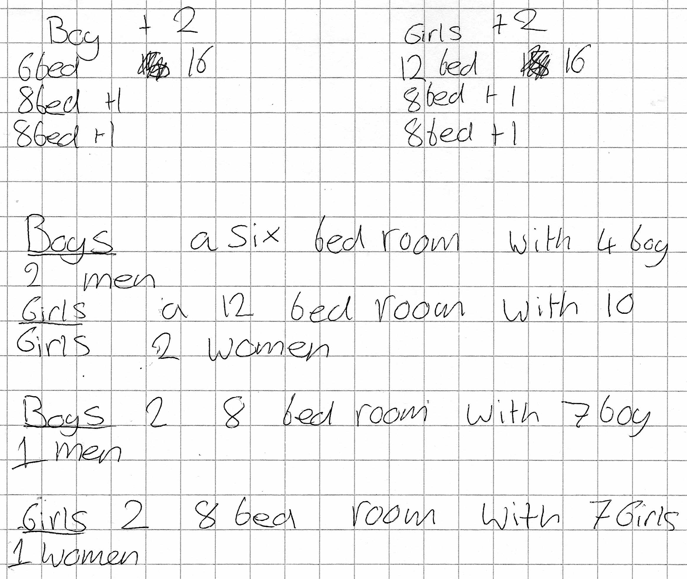
Comments

Pupil B’s solution looks good but the boys and girls add up to only 18 and 22 instead of 20 and 24. At the top of the page, Pupil B has only added two to the boys and girls when they needed to add four for each of the four adults.

Probing questions and feedback

Pupil B could be encouraged to improve their response by asking the following questions:

- How many men and women were there at the Youth Hostel?
Have you added in the correct number?
- Do your numbers of girls and boys in the dorms add up to the numbers given?

Pupil C

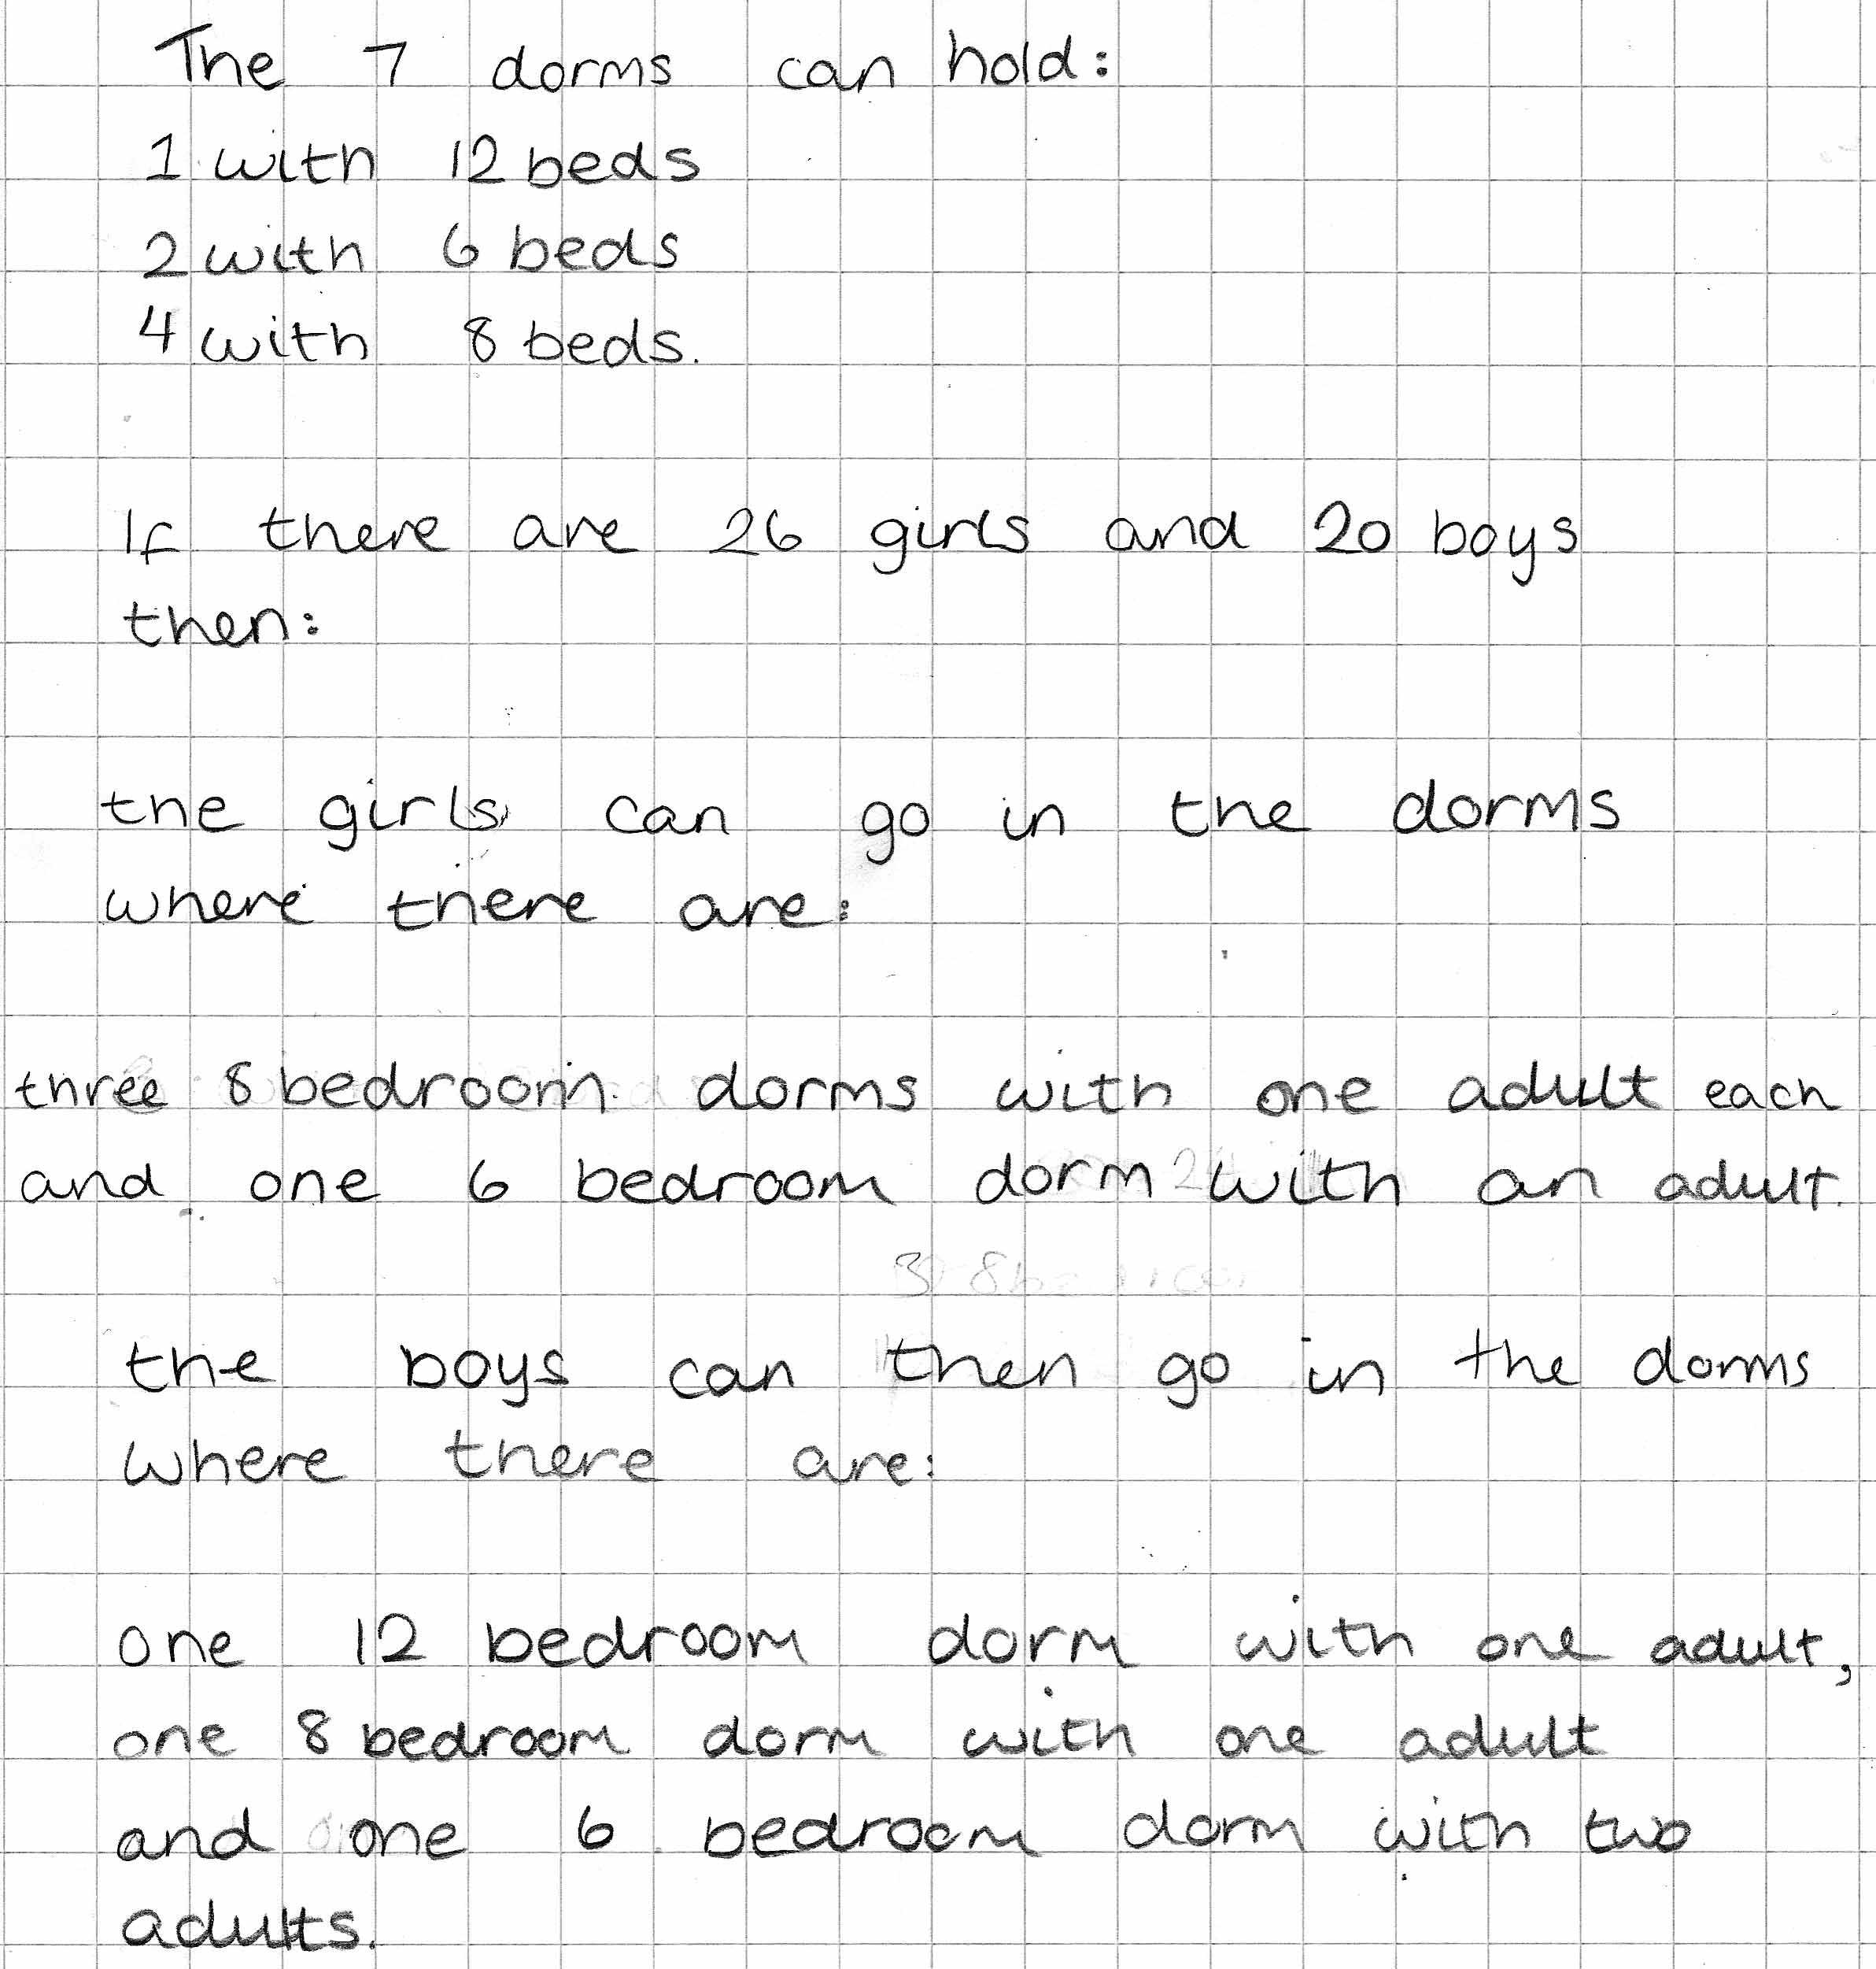

Comments

Pupil C has produced an accurate solution, allocating adults to children in a way that meets the constraint – although not optimally. He shows no working or explanation of how he arrived at his answer.

Probing questions and feedback

- Can you find a way of displaying your results that would make them easier to understand at a glance?
- Do you think the adults are spread out in the best way?
- Are the empty beds in the best place and why?

Pupil D

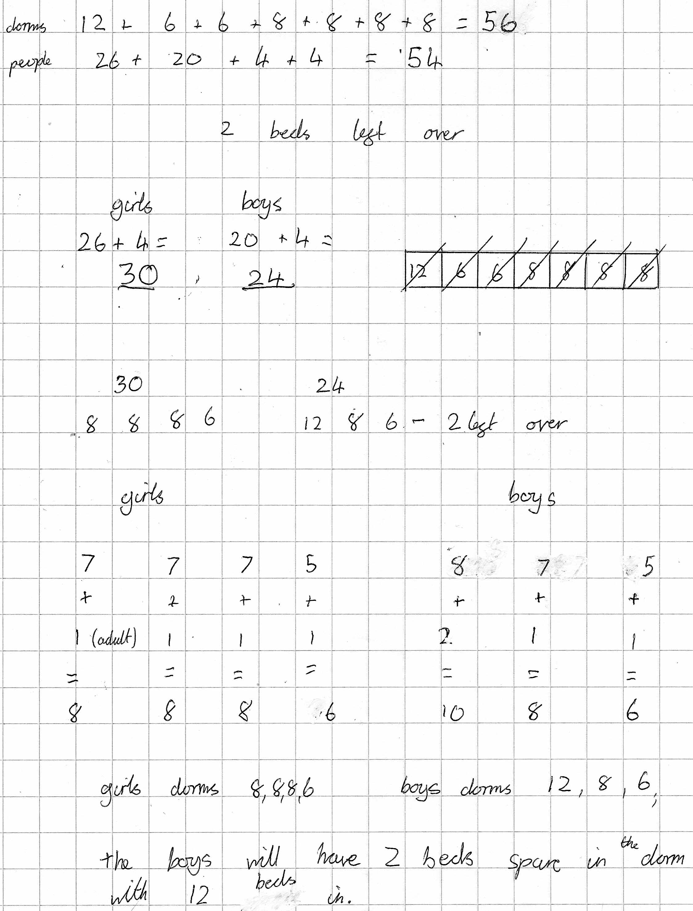
Comments

Pupil D’s solution is correct and it is easy to see both the working out and the solution. The extra adult and two spare beds are sensibly in the largest room.

Probing questions and feedback

- Is this the only possible solution? Are you sure it is the best – why?
- Why might alternative solutions be useful to the organisers?

