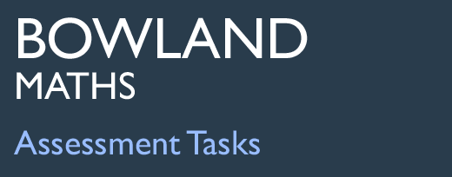 | Tuck Shop

Task description

Pupils draw graphs to represent data and critique an incorrect interpretation of the data.

Suitability National Curriculum levels 4 to 5

Time 30 minutes to 1 hour

Resources Ruler, pencil and graph paper

Key Processes involved

- Representing: Choose a way of representing discrete data using a chart or graph and an appropriate method for evaluating a conclusion about the data.
- Analysing: Compare two proportions and make deductions.
- Interpreting and evaluating: Engage with someone else's reasoning and identify errors.
- Communicating and reflecting: Communicate their findings clearly.

Teacher guidance

Check that pupils understand the context before they begin, for example, issue the task and ask questions such as the following:
- What is the purpose of this survey?
- What was the survey question?
- Why would they want to ask this question?
- How many people responded?
Pupils can tackle this task in different ways, but they might be expected to:

- solve simple problems involving ratio and direct proportion
- understand and use the mean of discrete data
- group data into equal class intervals where appropriate
- represent collected data in frequency diagrams
- interpret graphs and diagrams and draw conclusions

Tuck Shop

Chris and his friends are planning to sell chocolate bars at the school tuck shop.
They conduct a small survey among 30 people, asking the question:
How many chocolate bars do you eat in a typical week?
Here are their results:

Draw graphs or charts to compare the results for males and females.


Chris says:
We have found that the total number of bars eaten by the males is 183 and by the females is 92. In general, this means that boys eat more chocolate than girls.”

Give two reasons why Chris is wrong in his reasoning.

Help Chris by writing down one useful conclusion (comparing males and females) that is supported by the data. He must be convinced, so make sure he can understand your thinking.

Assessment guidance

Progression in Key Processes

Representing | Analysing | Interpreting and evaluating | Communicating and reflecting
Choice of how to represent the data and about methods for comparison. | Analysis of data; accuracy and technical demand of representations and calculations | Evaluation of Chris’s reasoning and measures taken to address the errors | Clarity, accuracy and completeness of communication
Tabulates the data, but with no suitable graph or chart for comparing it. No method for making comparisons.  PROGRE  S  S  I  ON  Pupil A | Makes a simple analysis of raw male and female data eg tabulates data and/or checks totals.  Pupil A | Makes a valid criticism of the reasoning eg “Only 30 people were asked”. | Communicates limited findings in an understandable way, but with errors and/or omissions.  Pupils A and B
Represents the data with a chart or graph eg comparative bar charts, stem and leaf plots. No method for making comparisons.  Pupil C | Sorts the data and draws accurate charts to compare data or to calculate values for comparison | Makes a valid criticism of the reasoning. Makes a start on comparing male and female data eg “More males than females in sample”.  Pupil B | Communicates two valid reasons why Chris is wrong.
Represents the data with a chart or graph eg comparative bar charts, stem and leaf plots. Appropriate method for making comparisons (eg means).  Pupil D | Draws charts or graphs to compare data and calculates comparable values for the chocolate eaten.  Pupil D | Identifies valid error in reasoning eg “Survey asked 20 boys but only 10 girls”. Makes valid and complete comparison between male and female data eg “Means are about equal.”  Pupil D | Communicates two valid reasons why Chris is wrong; writes a clear conclusion supported by the data eg “Boys and girls eat about the same”.  Pupil D

Sample responses

Pupil A

Comments

Pupil A tabulates the numbers of bars of chocolate for males and females. She does not draw a graph or chart. She checks the difference in the total bars for males and females, but does not comment that there are more males than females in the sample.

Probing questions and feedback

- If Chris had asked more females than males, might your answer have changed?
- Can you think of a method to take account of the fact that there were different numbers of males and females in the sample?

Pupil B
. 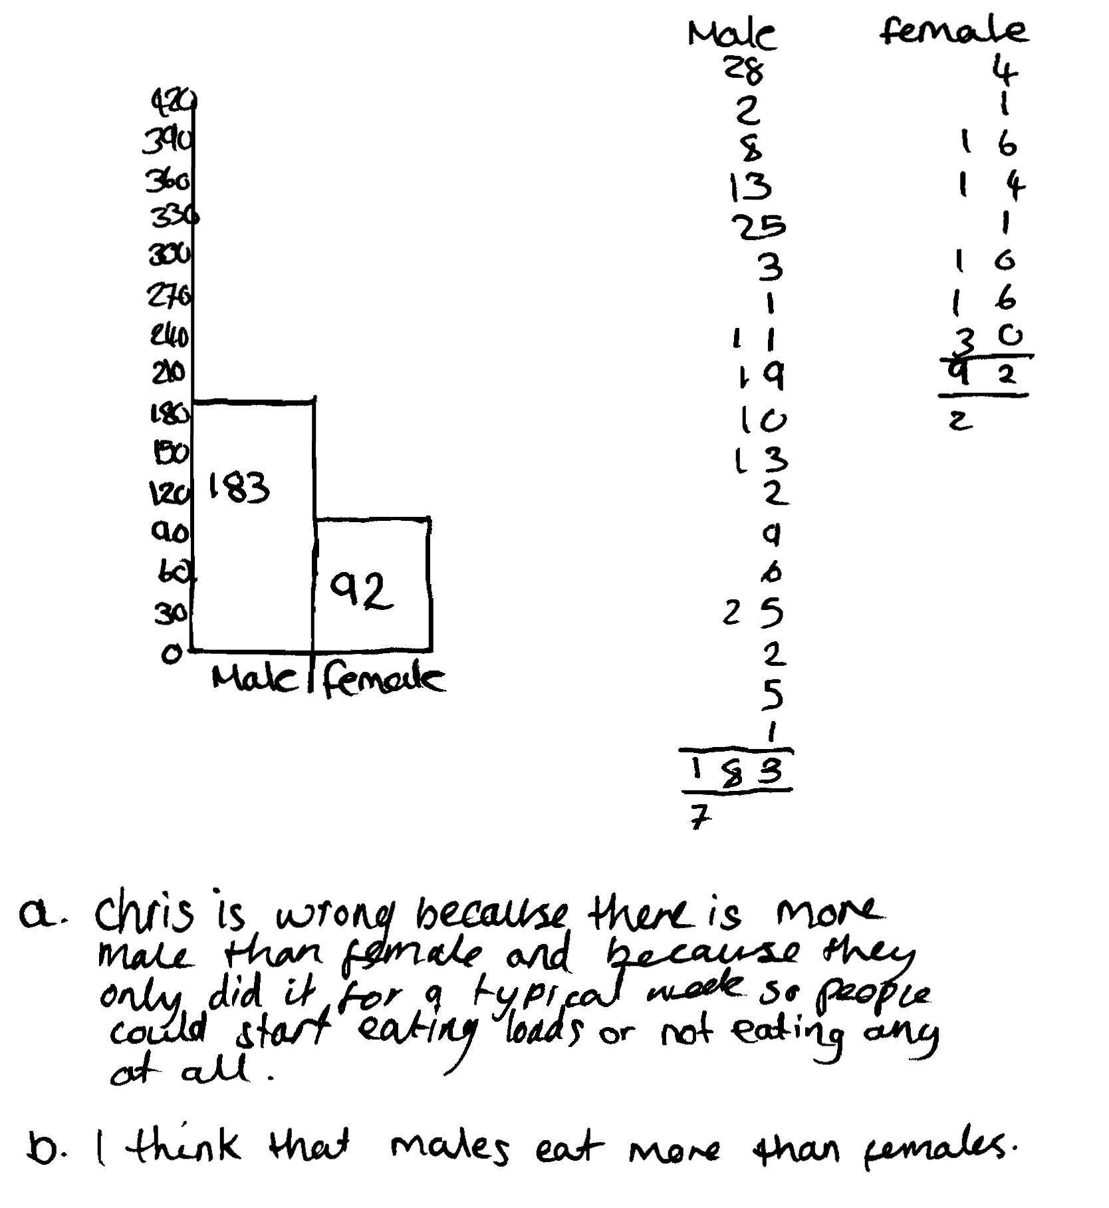
Comments

Pupil B sorts the data into males and females in a block graph – but using only the total, which is misleading. She correctly comments that more males than females were surveyed and that the sample was only for one week. Her communication is clear.

Probing questions and feedback

- How many males ate less than 5 bars of chocolate? How does this compare with females? Can you draw a chart or graph to show the data grouped in some way, so that you can compare males and females?
- You note that there are more males than females. What were the numbers?
- How could you compare the data from males and females that takes accounts of the different number of males and females being asked?

Pupil C

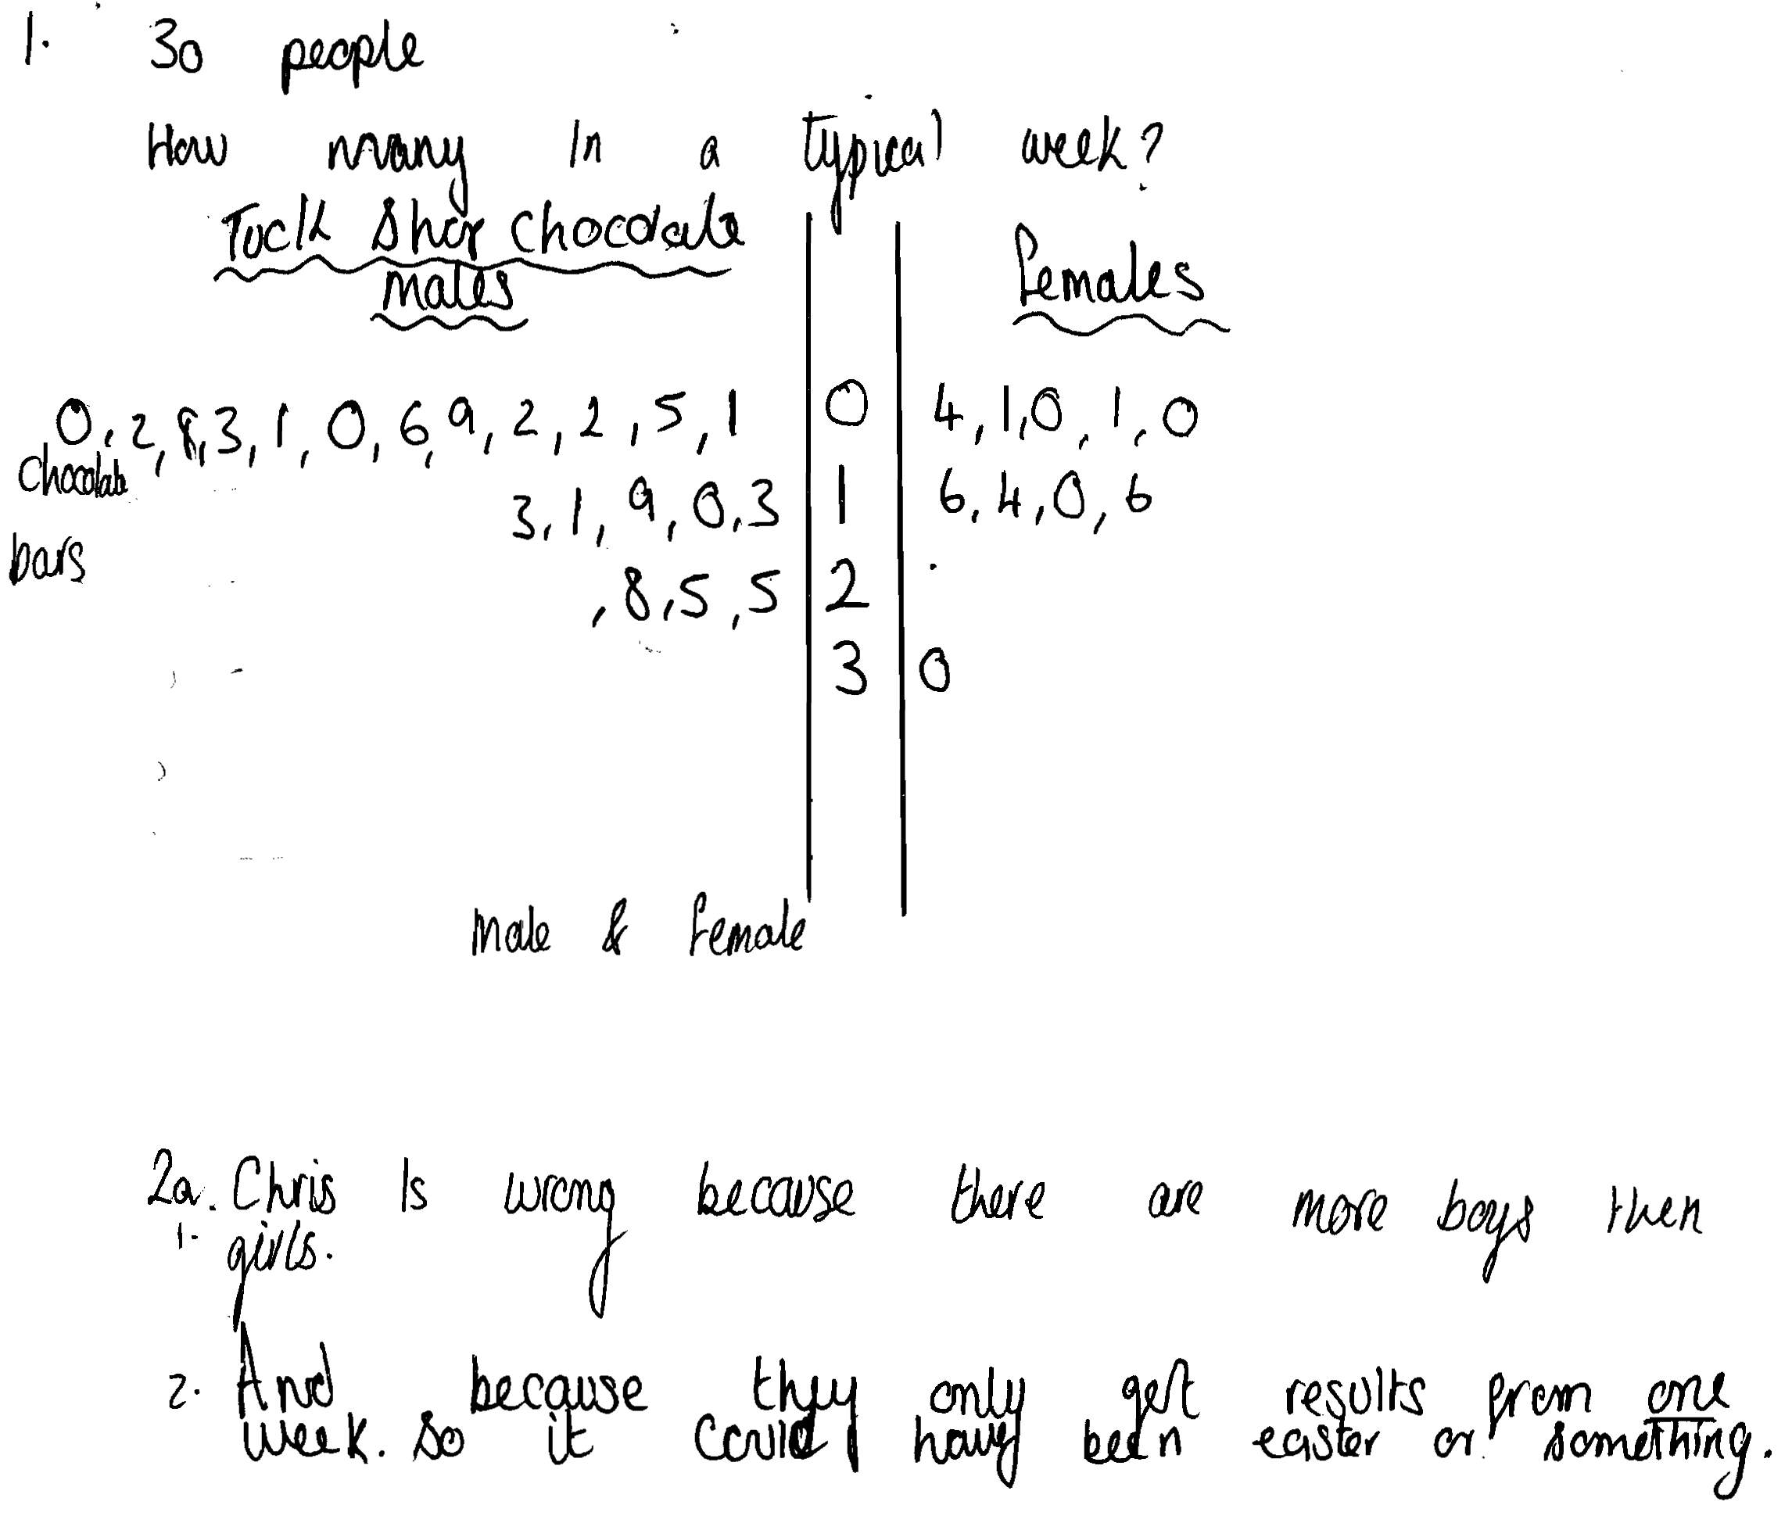
Comments

Pupil C draws an accurate stem and leaf graph but reaches no conclusion from it except to note that more males than females were surveyed. States that the results were gathered for only one week.

Probing questions and feedback

- What can you deduce from your stem and leaf diagram
- You note that there are more males than females were asked in getting the totals of 183 and 92 bars of chocolate. What were the separate numbers of males and females?
- What would you expect the results to be if the same number of males and females were asked?
- What valid conclusion (comparing males and females) does the data support?

Pupil D

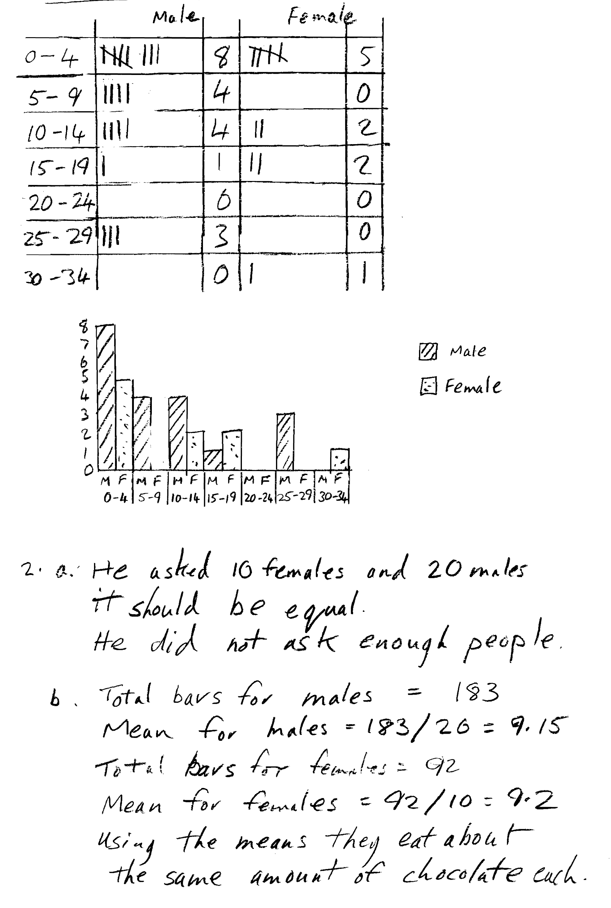
Comments

Pupil D makes tally charts and bar graphs showing males and females separately. She notes that there were more males than females and that the sample was small. She calculates the mean number of bars eaten, showing that males and females eat about the same average number of bars. Her work is clear and easy to follow.

Probing Questions and feedback

- You mention that not enough people were asked. What number of people would you recommend?
- How much do you feel that the results might vary from week to week?
- What other changes would improve the survey?

