 | Three of a Kind

Task description

Pupils use their knowledge of geometry to describe a pattern.

Suitability National Curriculum levels 3 to 8

Time 30 minutes to 1 hour

Resources Ruler and perhaps additional paper, plain or squared; they may also request an angle measurer and/or a pair of compasses.

Key Processes involved

- Representing: Use mathematics, including angles and symmetry, to describe the shapes.
- Analysing: Consider the relationship between the lengths of the edges of the shapes, between the areas within the shapes, and between the positions of the shapes.

Teacher guidance

Check that pupils understand the task; show it on the whiteboard and comment:

- This task is about a picture of some shapes.
- Think about what is the same and what is different about the shapes; think especially about why the hexagons might be where they are.
- Write down everything you can think of so that I can tell what you know.

The task requires geometric skills such as reflection and properties of shapes, but can also be extended to higher level skills such as enlargement. During the work, the following probing questions may be useful:
- What do you know about regular hexagons?
- Are the two black outside lines that connect the three shapes important? What do they tell you?
- Why do you think the hexagons are placed where they are?
- How would you go about drawing the next hexagon in the sequence?

As in any open ended activity, pupils respond in different ways, but in general, pupils working at the lower levels tend to describe the shapes. More able pupils will see connections between the shapes, with the most able generalising and quantifying the relationships in ways which enable a prediction of how the pattern could continue.

Three of a kind

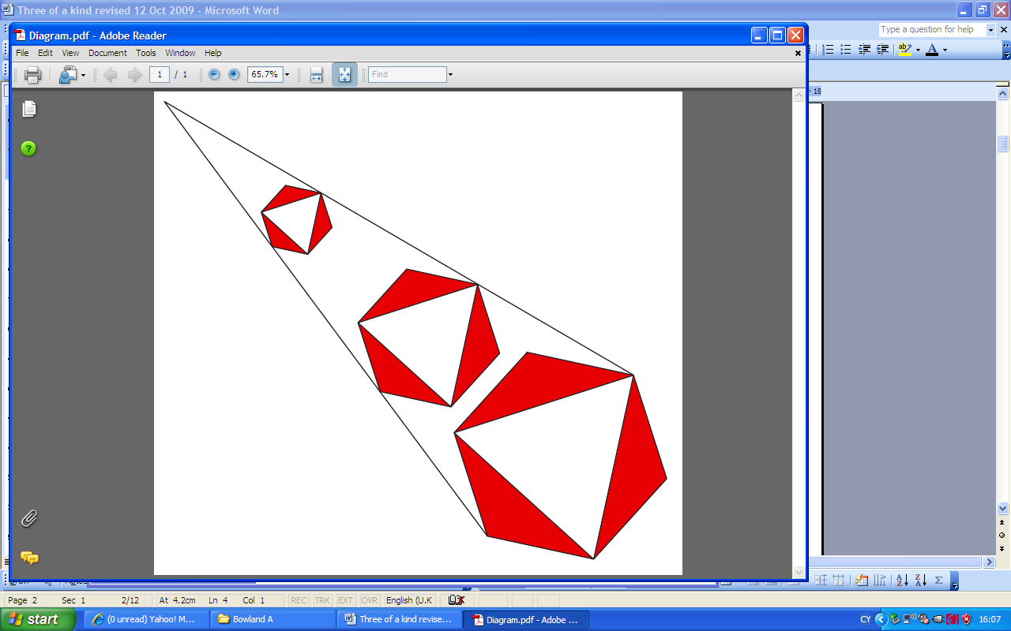

The picture shows three regular hexagons.
What is the same and what is different about them?
What can you say about the lengths, angles, sizes, areas, symmetry?
Anything else?

Assessment guidance

Progression in Key Processes

Representing (i) | Representing (ii) | Analysing (i) | Analysing (ii)
Mathematical description of the shapes | Description of the symmetries of the shapes and the angles | The relationship between the lengths of the edges of the shapes | The relationship between the areas within the shapes, and/or the positions of the shapes
Uses language such as triangle and hexagon  PROGRE  S  S  I  ON  Pupil A | Recognises each hexagon has reflection symmetry  Pupil A | Gives side lengths, with units, eg hexagons 1cm, 2cm, 3cm | Gives a simple description of size and positions, eg ‘Smallest at top, next is down a bit, and so is the next’  Pupil A
Recognises that the white triangle is equilateral and the red triangles are isosceles  Pupil B | Gives the number of lines of symmetry or notes the shapes have rotational symmetry. Recognises that the angles in each shape are the same | Describes simple patterns, eg ‘The side lengths go up 1cm each time’ | Recognises that the areas are increasing (or decreasing)  Pupil B
Describes how the shapes connect,  eg ‘The edges of each hexagon are parallel to the edges of the other hexagons’  Pupil C | Gives the order of rotational symmetry. Gives some correct angle measurements, eg hexagon 120°, isosceles ∆ 120°, 30°  Pupils B and C | Describes multiplicative relationships, eg ‘The side length of the biggest one is 3 × the smallest’  Pupils B and C | Calculates a correct area
Recognises that the transformation linking all three shapes is enlargement | Gives geometric reasons to support angle measurements | Recognises the significance of the centre of enlargement and quantifies the enlargements,  eg 2×, 3x | Describes the multiplicative relationship between the areas, eg 4×, 9×

Sample responses

Pupil A

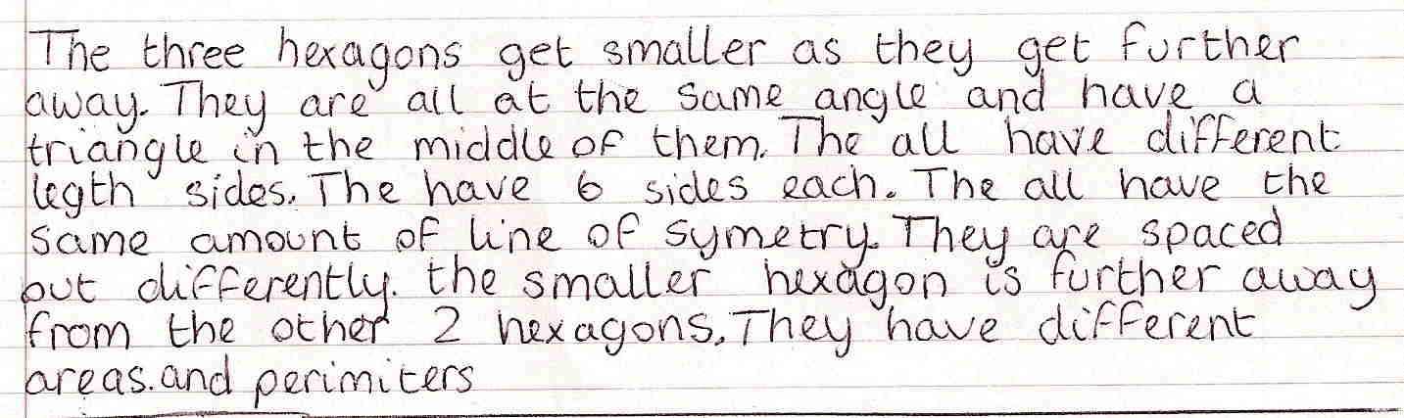

Comments

Pupil A attempts to describe some features of the diagram, but only simple mathematical language is used. He notes reflection symmetry, but does not describe it, nor attempt to discover how the lengths, areas and perimeters of the shapes change. He describes the positions and sizes of the shapes in a very simplistic way. He appears to be at the stage of describing, rather than analysing, what he sees.

Probing questions and feedback

- When you are writing about shapes, try to describe them as fully as you can – for example, what type of triangle is in the hexagon?
- When you write about different sizes, it’s a good idea to give measurements to explain what you mean.

This pupil would benefit from further opportunities to explore shapes and relationships, and to explain his findings. Practising this type of activity should encourage him to understand the scope of what is required and enable him to show the full extent of his learning.

Pupil B

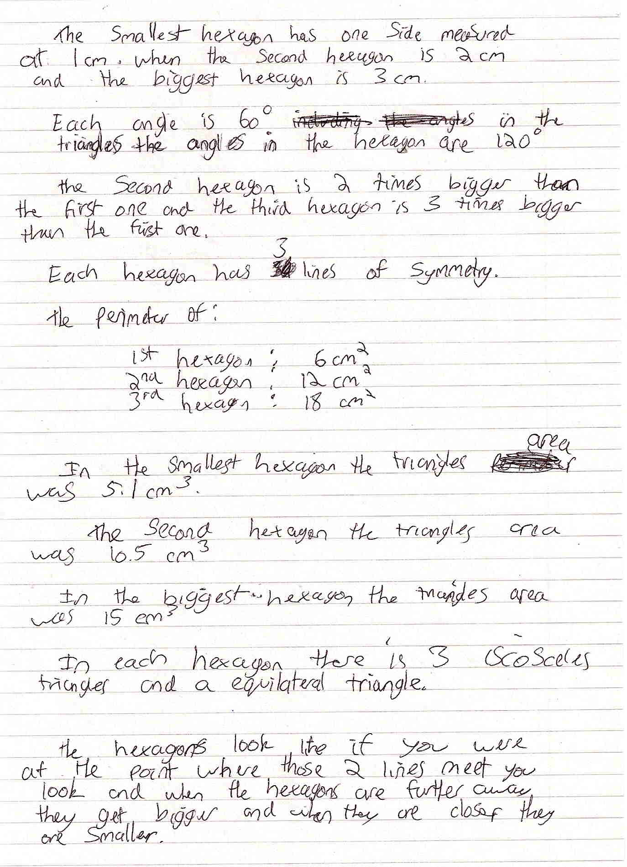

Comments

Pupil B names the equilateral and isosceles triangles, gives correct angles for the equilateral triangles and the hexagon, and identifies reflection symmetry of the hexagonal diagram. She notes the relations between the side lengths of the shapes; the areas are wrong, but the perimeters are right – but with wrong units. The reference to relative positions and sizes is quite simplistic. She shows some understanding of enlargement.

Probing questions and feedback
- Finding rules or patterns is often important, so try to apply this to the positions of shapes within the diagram, as well as to the shapes themselves.
- Remind yourself about how to find the area of a triangle.

Opportunities to create and describe her own spatial patterns will help her understand which geometric features are of importance and how to describe them.
Pupil C

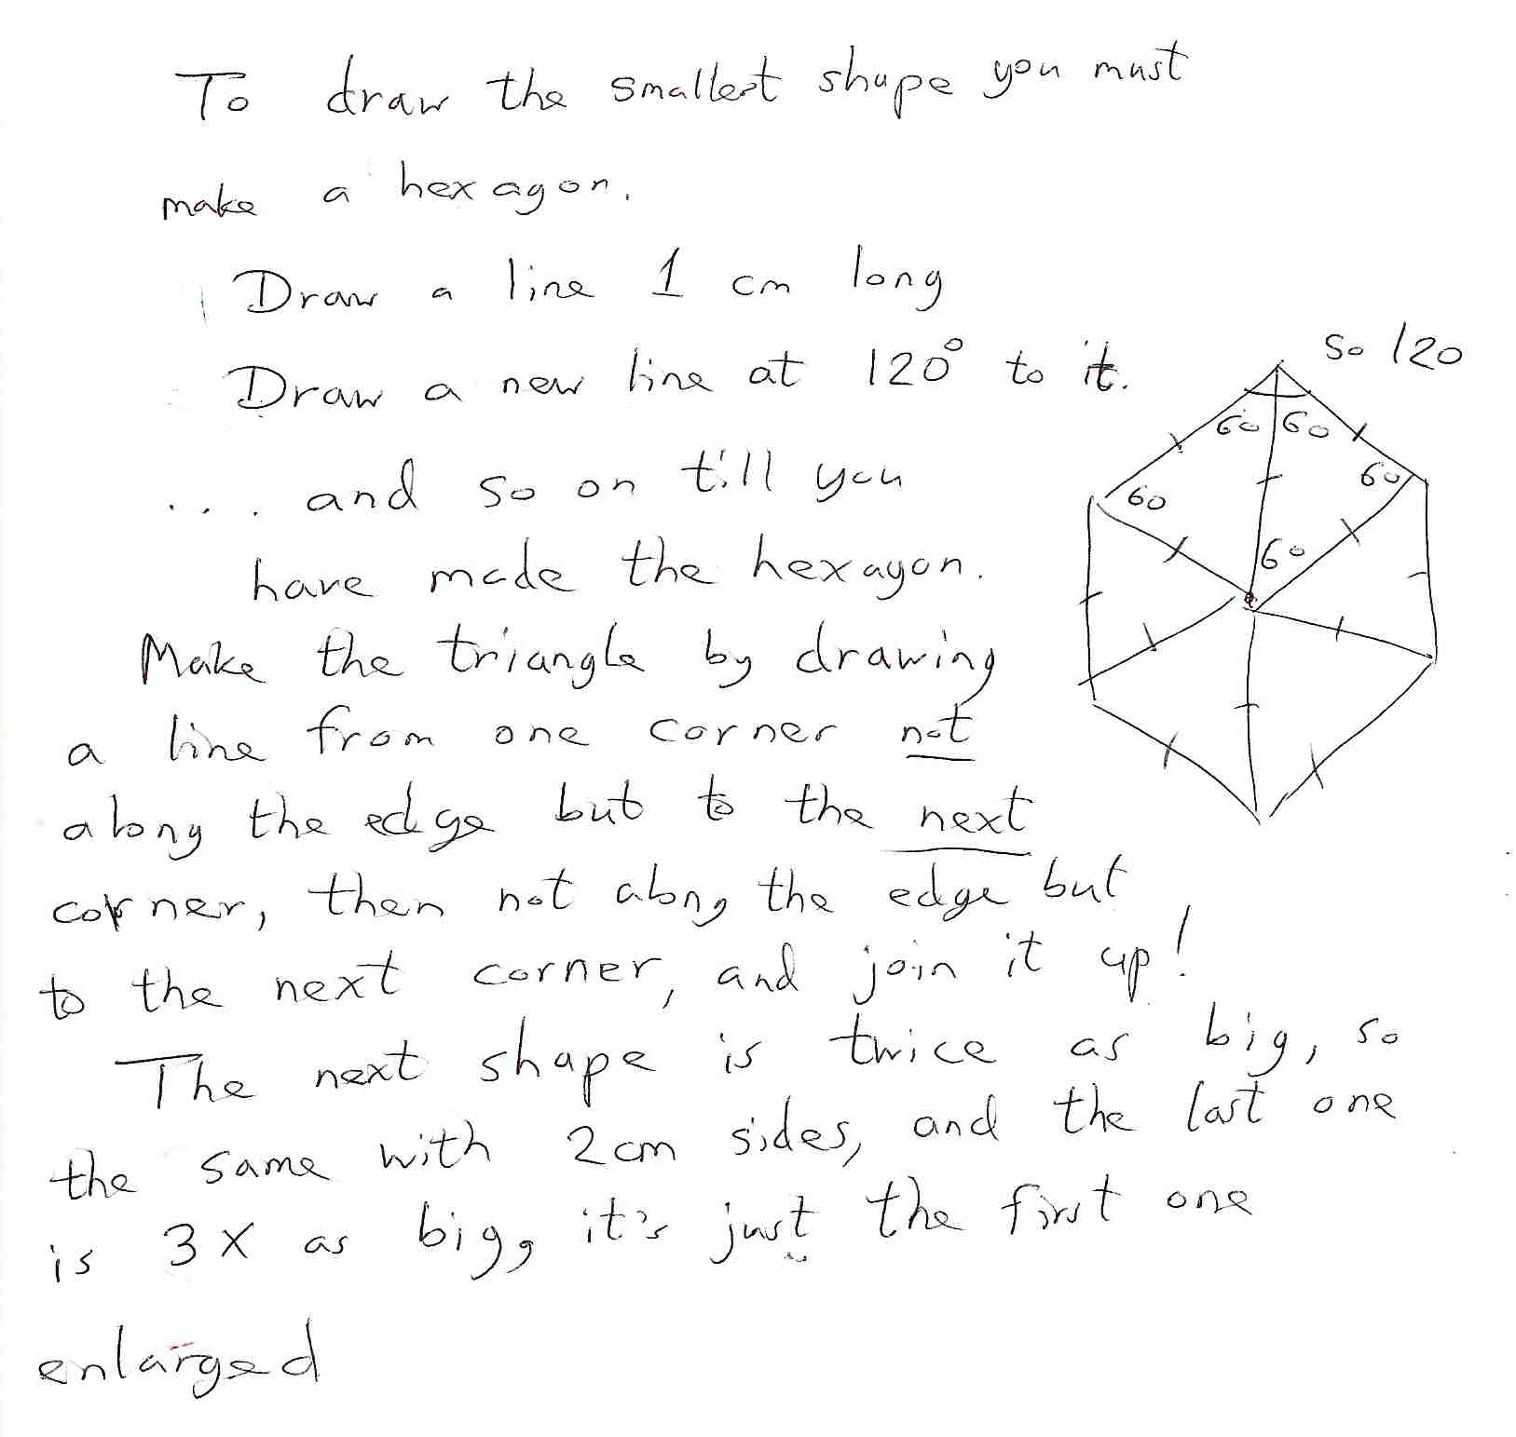

Comments

Pupil C draws the diagram and shows evidence of understanding aspects of the geometry, for example, the position of the equilateral triangle within the hexagon. He recognises the multiplicative relationship between the sides. He uses the word ‘enlarged’, but with no evidence that he knows the relevant transformation. He begins to explore the relationship between the hexagons, but stops. Probing questions would have been useful both to determine understanding and to prompt further thinking about the positions of the shapes.

Probing questions and feedback

- Check that you have considered all the aspects of a task before you decide that you have finished. For example, how do the areas of the shapes change?

Pupil C would benefit from further opportunity to explore the relationship between shapes and to communicate his findings. He would also benefit from creating and describing his own geometric diagrams.

