 | The Z Factor

Task description

Pupils determine how long it would take a panel of judges if they saw every act that auditioned for the ‘Z factor’ programme.

Suitability National Curriculum levels 3 to 8

Time 45 minutes to 1 hour

Resources Paper and calculator

Key Processes involved

- Representing: Simplify the problem by making appropriate assumptions.
- Analysing: Combine assumptions and work logically to solve the problem.
- Communicating and reflecting: Throughout, present arguments and reflect on findings, recognising the impossibility of the scenario presented.

Teacher guidance

You could start by showing pupils relevant pictures or videos from http://xfactor.itv.com/

- For the TV programme, there are thousands of people wanting to audition. How do they decide which acts get through this first set of auditions?
- To answer the question, you will need information that is not given, so you will have to make assumptions (sensible guesses) – and explain them.

The task requires multiplicative calculations involving time.

The following probing questions may be helpful:
- What do you need to know? As you work through the problem, write down the questions for which you need answers
- Make sensible guesses for the answers; what assumptions are you making? Why?
- Have you decided to ignore any factors? Why?
- What does your solution tell you about the auditions for the Z Factor?

Two key assumptions are needed: 1) How long an audition lasts; 2) The number of hours in a judges’ working week. Pupils’ assumptions should be vaguely realistic! Pupils might work backwards, assuming all auditions are seen and finding how long each one would need to be; this does not answer the question asked, but it does show insight into the situation and the mathematics is equally complex.

The Z Factor

There is a very popular talent show on television. Four judges vote on each act they see.
Last year, about 182 000 people (or acts) auditioned for the first round of the show.



If the judges saw every person who auditioned (which they don’t!), about how many weeks would this take?
What other information do you need to answer the question?
Make this information up, by making sensible guesses. Explain your guesses

Assessment guidance

Progression in Key Processes

Representing | Analysing | Communicating and reflecting
Relevance of approach and quality of assumptions made  PROGRE  S  S  I  ON | Accuracy and technical demand of calculations | Quality and clarity of communication of all aspects of the problem, including methods and answers
Shows some insight by considering a key question, eg ‘How many auditions in a day?’  Pupils A+B | Shows a relevant calculation  Pupils A+B | Writes question(s) and answers clearly, even if it is difficult to follow the calculation(s)  Pupils A+B and D
Makes both key assumptions, even if there is irrelevant other work | Calculations are accurate and relevant, even if simplistic | States assumptions clearly and shows methods and reasoning sufficiently clearly for them to be followed
Makes both key assumptions realistically, and with little or no irrelevant other work  Pupils C and D | Show multi-step calculations which are effective  Pupil C | States assumptions clearly, with methods that are explicit and ‘flow’  Pupil C
Throughout the task there is clear, effective and concise communication that builds to an effective solution. In addition, there is evidence of reflection or additional insight (Pupil D), eg the implication of the number of weeks being greater than one year although the show is held yearly, or thinking of alternative approaches such as group auditions

Sample responses

Pupils A and B
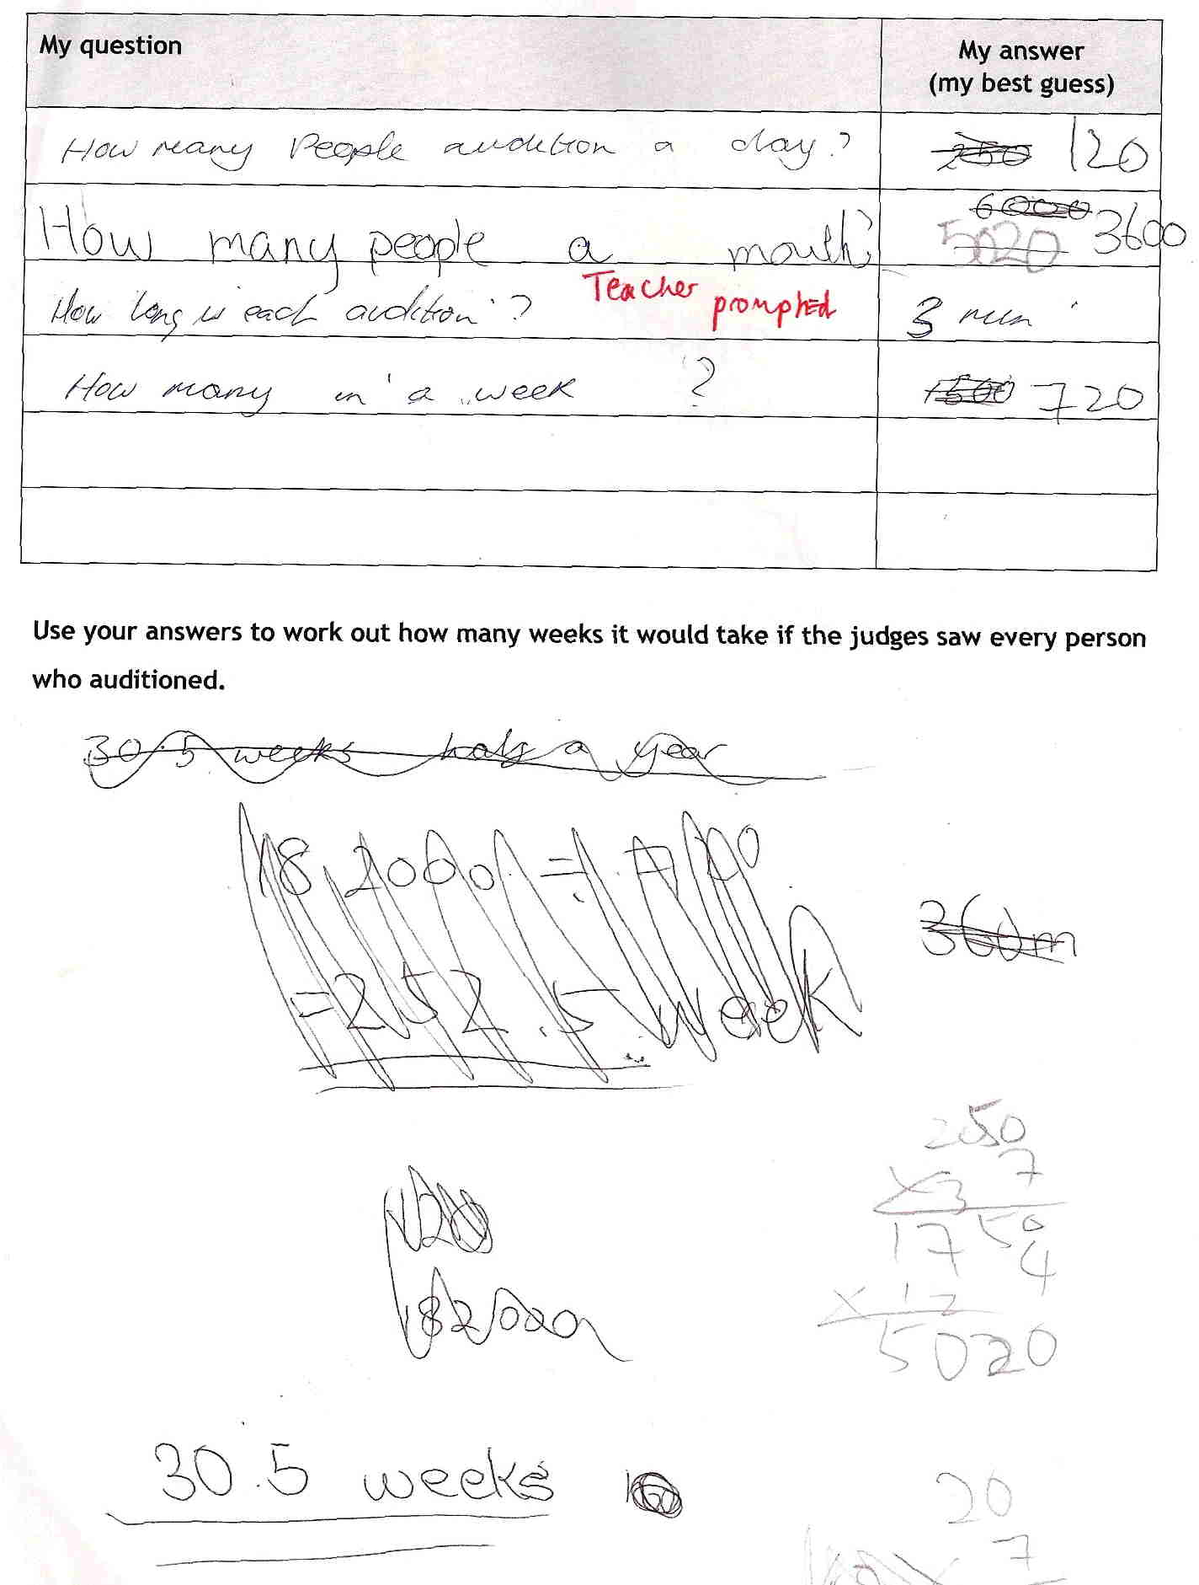

Comments

Pupils A and B made unsupported assumptions, first of 250 then of 120 auditions/day. People per month has been reworked, even though this is irrelevant to the task. Their correct working of 182000 ÷ 720 has been crossed out to be replaced by an unsupported 30.5 weeks. Although the pupils show some arithmetic skill, they struggle with the complexity of the problem and its multi-step nature.

Probing questions and feedback

- When you work on a problem, think about what you know … and then think about what you can work out from that. Break the task down into little steps.
- You said each audition lasts 3 minutes. So how many auditions in one hour? Then how many hours a day do you think the judges work? … and so on …

The pupils would benefit from further opportunities to apply mathematics within a real-life scenario. They should also work on problems that are complex enough to need to be broken down into steps.

Pupil C

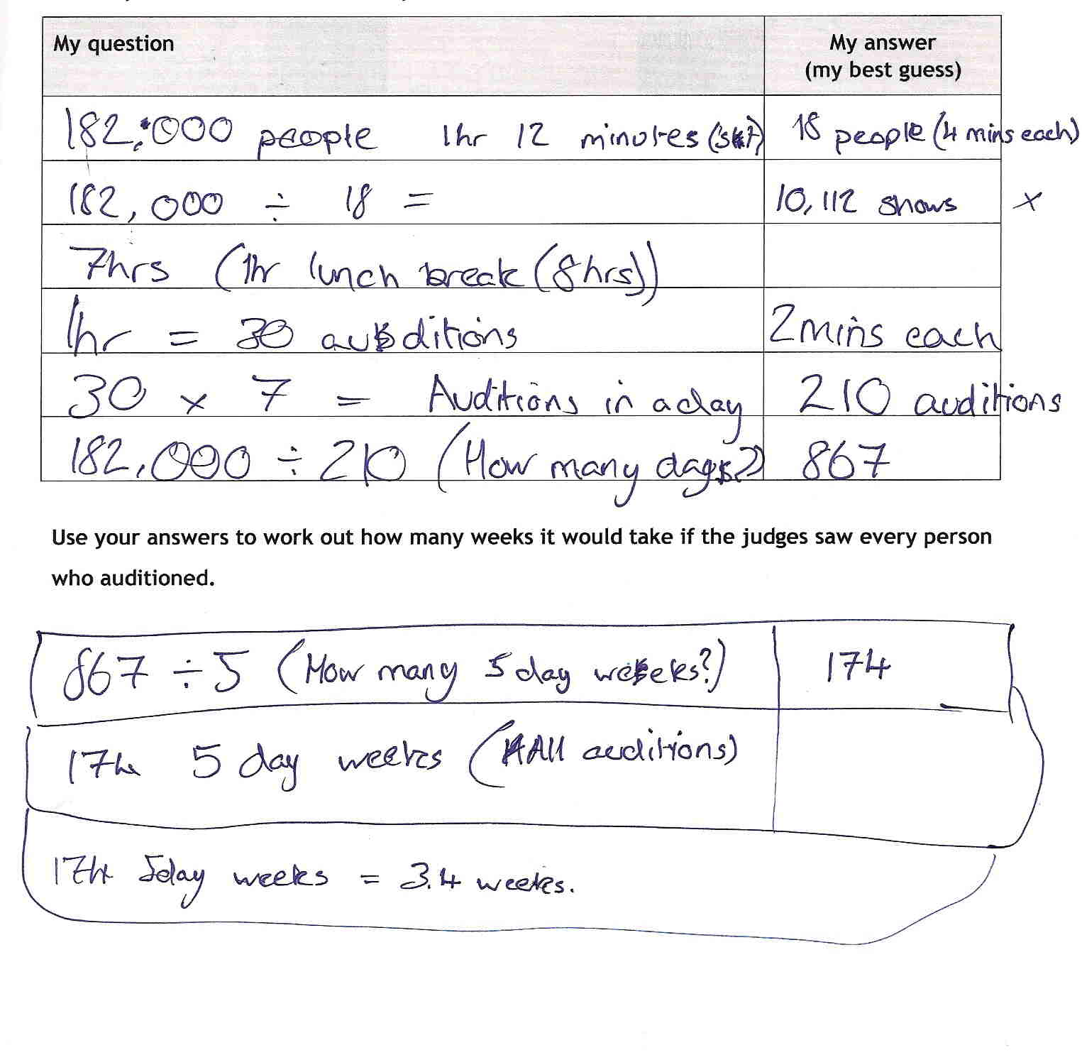

Comments

Pupil C began by considering the number of auditions per television show, but abandoned that without prompting. From then on, his assumptions are appropriate and stated and he communicates his working clearly - although the questions are not listed. The calculations are accurate, rounding up in each case (which could be appropriate given the context). His logic is mostly identifiable from his working and, apart from his slip in recording years as weeks for his final value, he reaches a realistic conclusion. This slip may explain why he did not reflect on the impossibility of his answer.

Probing questions and feedback

- You wrote 3.4 weeks, but your calculations gave 3.4 years! What do you think that means? Is it possible for the auditions to take 3.4 years? If not, why not?
- In general, always reflect on the realism of your answer to a real problem.

Pupil C would benefit from another opportunity to reflect on outcomes, interpreting solutions in different contexts to realise that maths is more than finding ‘the right answer’.

Pupil D
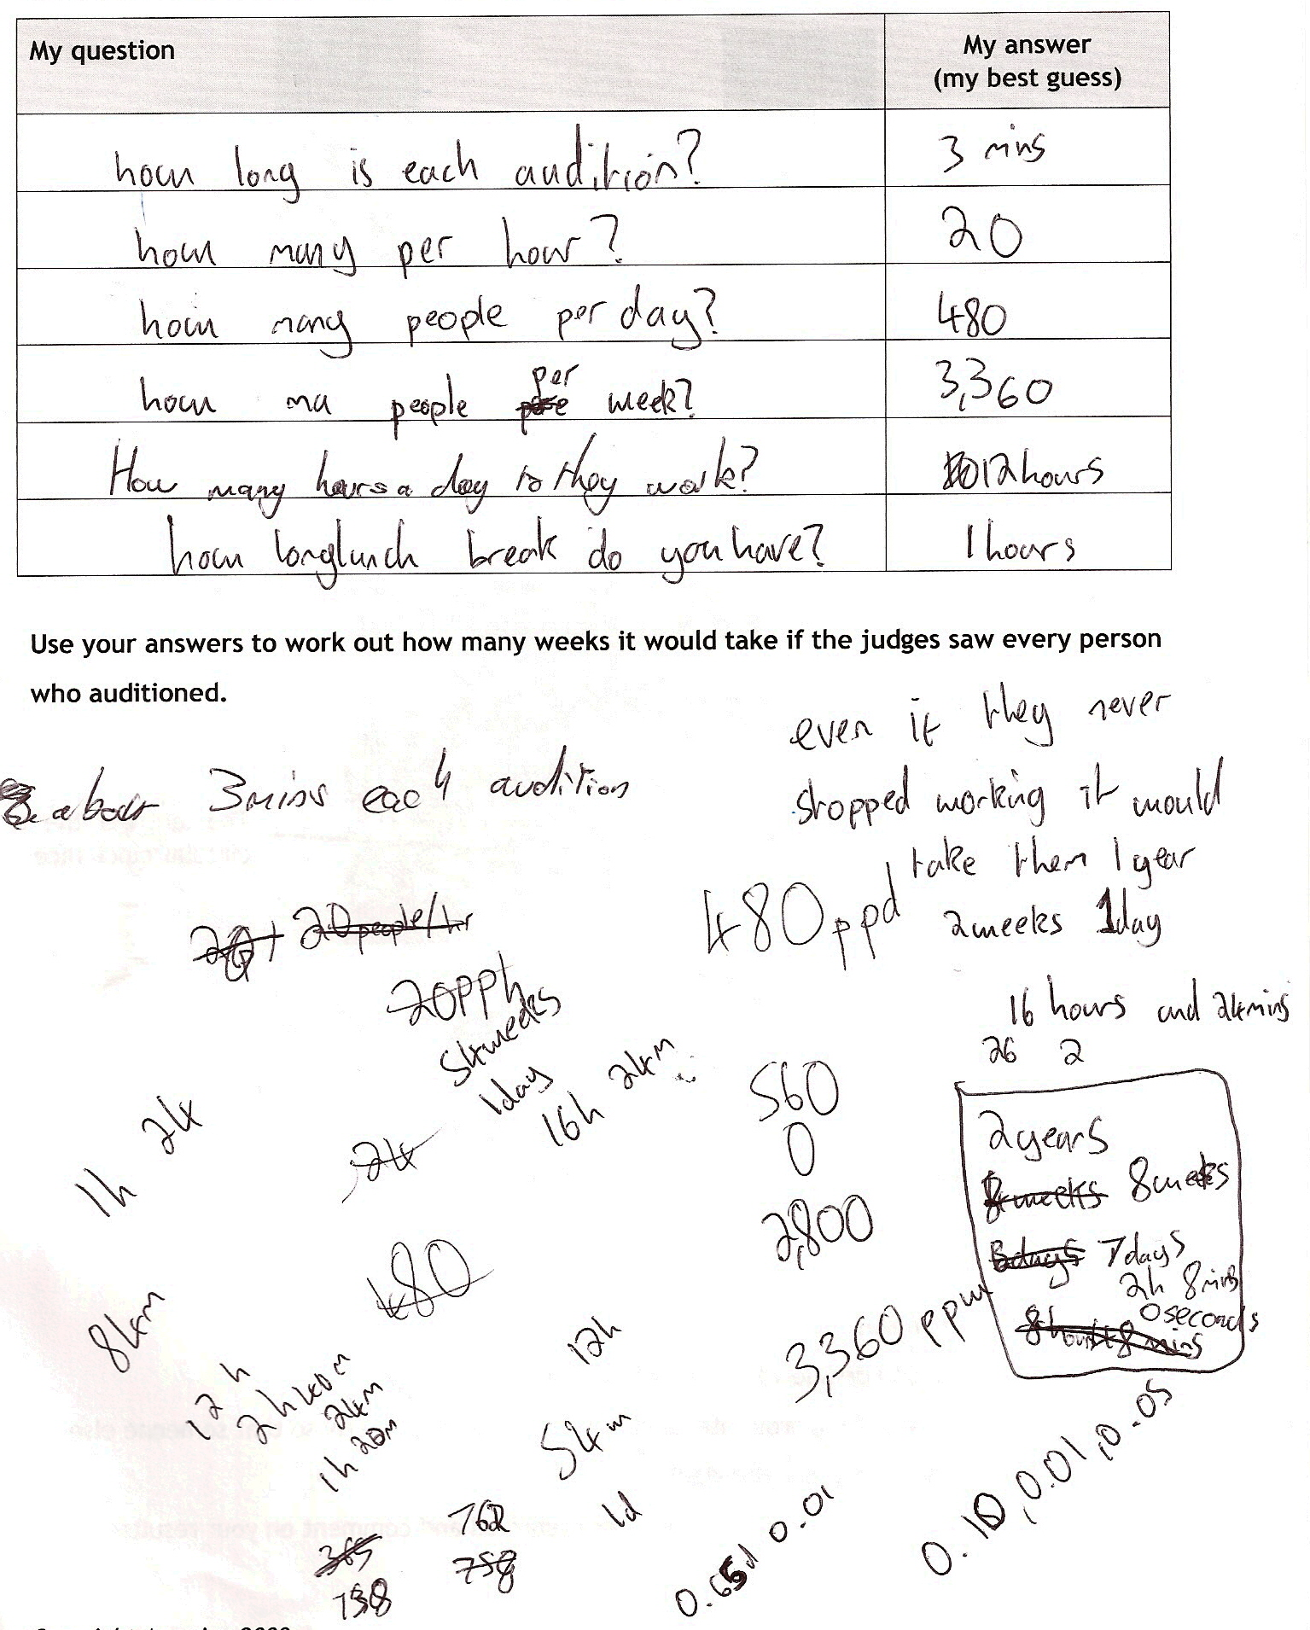

Comments

The first four rows of the table show that Pupil D considered how long it would take to see all the auditions if the judges ‘never stopped working’; this suggests a deliberate strategy which shows insight into the task. Although the working of 182000 ÷ 3360 is not shown, she correctly converts weeks into years, weeks and days. She then appears to make more realistic assumptions about the working day, but she does not show how she gets to 2 years, 8 weeks etc. She is clearly comfortable with range and content, but her process skills are not as good; in particular, her communication skills are so poor that it is difficult to form an effective judgement on her performance.

Probing questions and feedback

- Think how to set out your work more effectively. In real life, solutions need to be clear so that others can understand what you have done and why. Your rough work is mixed up with your solution, making it hard to understand your thinking.

Pupil D would benefit from further opportunities to present her maths clearly. Several of the Bowland tasks, eg Product Wars and Reducing Road Accidents, require presentation skills and would create an audience for effective communication.

