 | Taxi Cabs

Task description
Pupils plan a trip for a large party using two kinds of taxi. They decide how many of each type of taxi they need to minimise the overall transport costs.
Suitability National Curriculum levels 5 to 6

Time 20 to 40 minutes

Resources Pencil, calculator and paper

Key Processes involved

- Representing: Select a suitable representation (e.g. symbols or a table) to record their analysis.
- Analysing: Explore the effect of varying the values in the problem, bearing in mind the constraints; calculate costs systematically.
- Interpreting and evaluating: Consider the assumptions and the context and look for an optimum solution.
- Communicating and reflecting: Communicate their conclusion and reasoning clearly and effectively.

Teacher guidance

Check that pupils understand the context, with an introduction such as:
- Max and Liz need to get a party of 75 people to the airport.
- Taxis charge either by using a meter or for a fixed price for a journey. The taxis that they will use charge fixed prices for the journey.
- What size taxis are available and how many people can each type hold?
- The aim is to transport 75 people to the airport as cheaply as possible

Pupils can tackle this task in different ways, but they might be expected to:

- solve simple problems involving ratios and direct proportion

Taxi Cabs

Max and Liz are organising a trip to the airport for a party of 75 people.

They can use two types of taxi:
- A small taxi costs £40 for the trip and holds up to 4 people.
- A large taxi costs £63 for the trip and holds up to 7 people.

Max says they should order 6 large taxis

1. (a) So how many small taxis will they need?
(b) How much will the total cost be?
Liz thinks that they can organise the journey more cheaply than this!

2. Is Liz right? How many taxis of each type should they order, to get the cost as low as possible?

Assessment guidance

Progression in Key Processes

Representing | Analysing | Interpreting and evaluating | Communicating and reflecting
Selection of data and of means of representation | Calculations and use of variables | Determination of costs and numbers of taxis in relation to the context | Completeness, clarity and accuracy of written record
Selects some of the data for the calculations but with errors e.g. number of seats in taxi.  PROGRE  S  S  I  ON  Pupil A | Performs some calculations for finding the cost of taxis for 75 people.  Pupil A | Finds the cost of taxis for 75 people but with errors of calculation or interpretation.  Pupil A | Communicates the number of small taxis and the costs, but with omissions or inaccuracies.  Pupil A
Selects data for the calculations of taxis required for 75 people.  Pupil B | Performs calculations to find the number of small taxis needed and the cost for 75 people.  Pupil B | Correctly finds the number of small taxis needed and the cost of taxis for 75 people. (9 small taxis, £738)  Pupil B | Communicates clearly the number of small taxis and the costs  Pupil B
Selects a suitable representation to record the analysis eg symbols or a table  Pupils C and D | Makes an attempt to explore the effect of varying the numbers of small and large taxis, within the constraints.  Pupil C | Finds a combination of small and large taxis with a low cost, but not the lowest.  Pupil C | Communicates the conclusion and reasoning clearly.  Pupils C and D
 | Systematically explores the costs of varying the numbers of small and large taxis within the constraints.  Pupil D | Finds the combination of small and large taxis with the lowest possible cost. (9 large and 3 small taxis, £687)  Pupil D | Communicates the conclusion and reasoning clearly and effectively, with a convincing case for the lowest cost.

Sample responses

Pupil A

Comments

Pupil A shows some calculations towards finding the cost of taxis for 75 people, but there are errors. He rounded down his calculation for the number of small taxis. No work was shown for the remainder of the task.

Probing questions and feedback

- How many people will 8 small taxis and 6 large taxis transport?
How many spare seats will there be?
- Can you find a different number of large and small taxis that can still transport 75 people?
- Can you list some more possibilities in an organised way?
- Now calculate the costs for each of these possibilities.

Pupil B
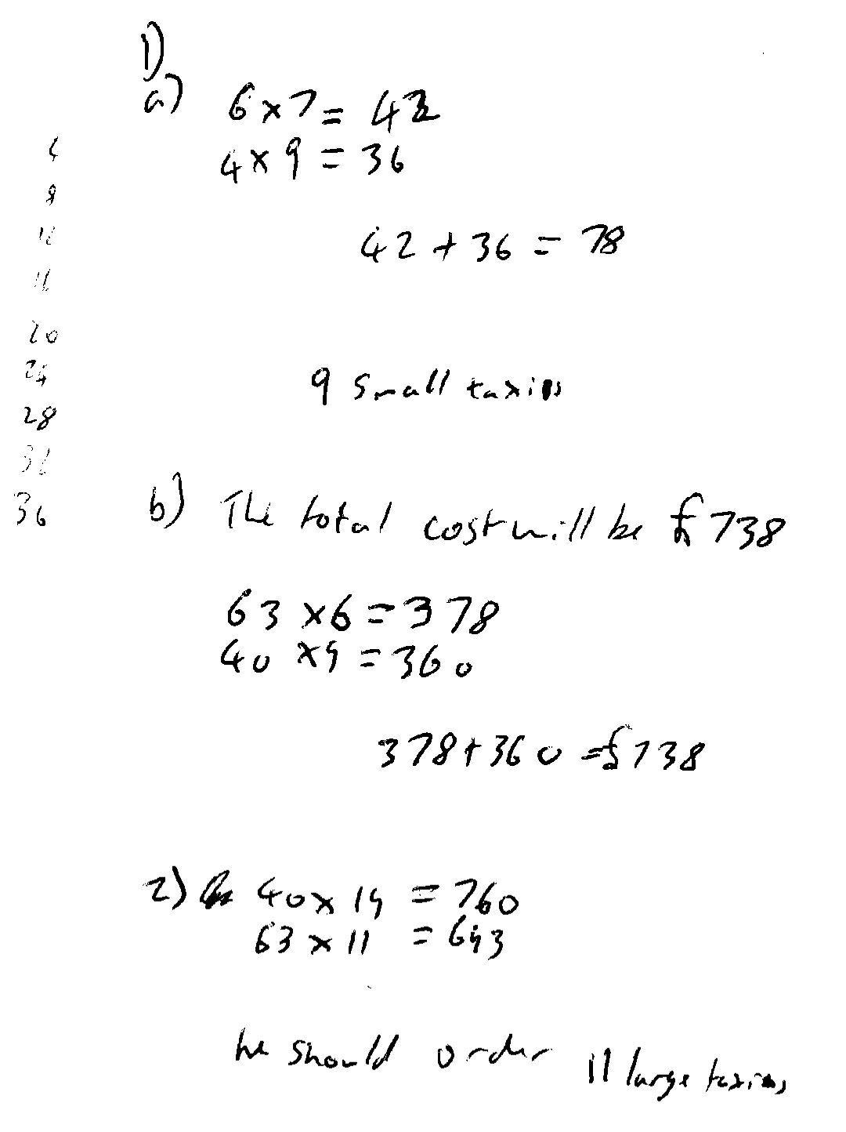
Comments

Pupil B correctly shows that 9 small taxis with 6 large taxis are needed, with a cost of £738. He then finds the cost of using either all small or all large taxis and concludes that 11 large taxis would be cheaper (£693). He does not look at other combinations.

Probing questions and feedback

- You have said that he should order 11 large taxis. How could you check if you have reached the cheapest solution?
- How could you best present your reasoning and results to convince Max and Liz that you have found the minimum cost?

Pupil C
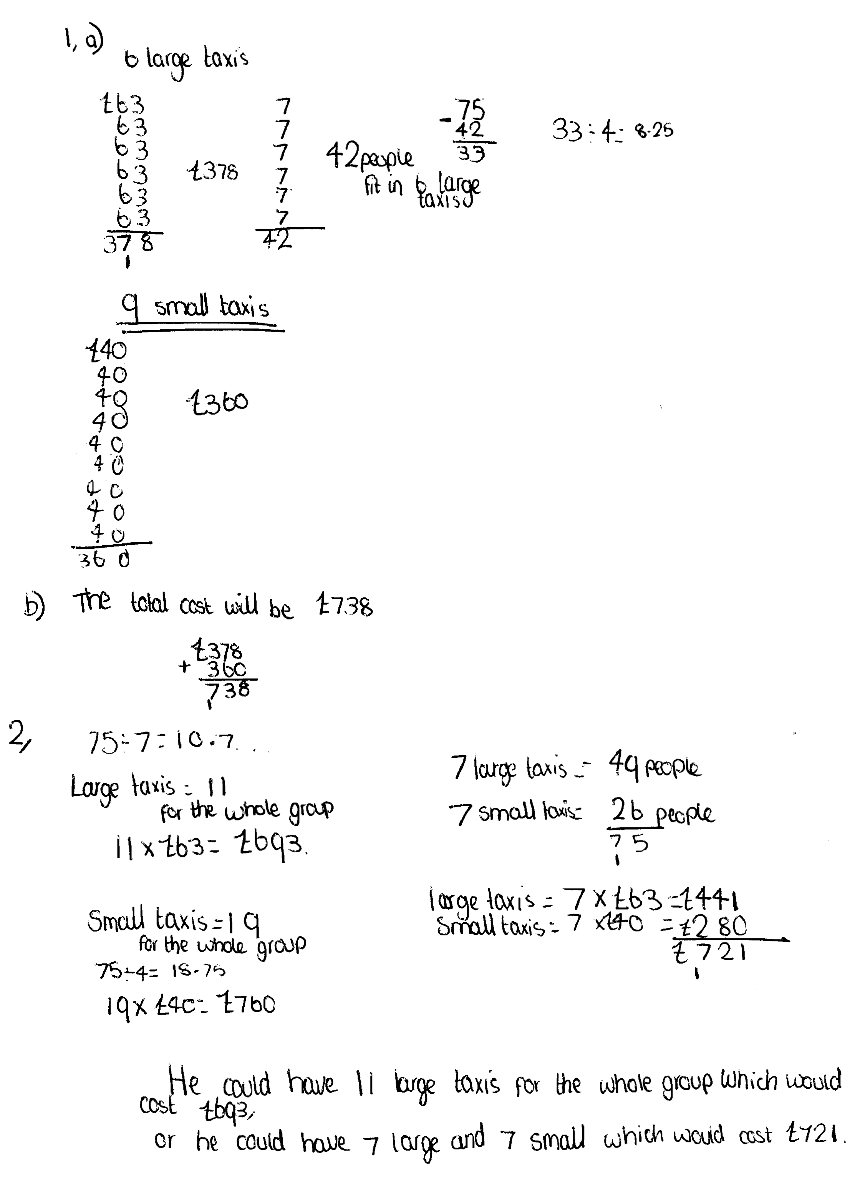
Comments

Pupil C correctly shows that 9 small taxis with 6 large taxis are needed, with a cost of £738. She begins to find the cost for different combinations of large and small taxis, but although her costs are correct, she does not find the cheapest solution.

Probing questions and feedback

- You have correctly worked out the cost for 11 large taxis and for 7 small and 7 large taxis? How can you be sure you have found the cheapest solution?

Pupil D

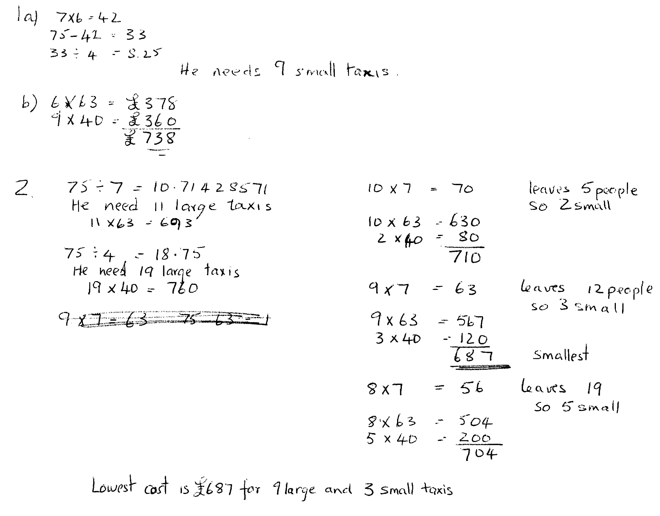
Comments

Pupil D correctly shows that 9 small taxis with 6 large taxis are needed, with a cost of £738. He finds the cost of using different combinations of large and small taxis and correctly finds the cheapest at £687. His work is clear, but he could offer more explanation to show how he knows that he has found the cheapest solution.

Probing questions and feedback

- How can you be sure that you have found the cheapest solution? Write down your explanation.
- How could you communicate your results and reasoning so that they are as clear and convincing as possible?

