 | Sports Bag

Task description

Pupils design a sports bag, and show all the measurements they need to make. They also plan how to minimise waste material.
Suitability National Curriculum levels 5 to 6

Time 20 to 40 minutes

Resources Ruler, pencil, calculator and paper

Key Processes involved

- Representing: Simplify the problem by identifying the pieces from which the bag is constructed and sketching them; choose appropriate methods to calculate missing dimensions.
- Analysing: Make connections between dimensions, for example: recognise that the material for the body of the bag needs to be the same length as its circumference; vary the positions of the pieces to determine the best way of using the cloth to minimise waste.
- Interpreting and evaluating: Consider assumptions and interpret the constraints in making the bag, for example: take note of the additional material needed for a seam.
- Communicating and reflecting: Describe their method and solution effectively and accurately, using words and sketches.

Teacher guidance

Check that pupils understand the context, for example, you could show a real example of this type of sports bag to help pupils visualise it and ask questions such as:
- Do you know what seams are? What instructions have been given about seams?
- The components of the bag are to be cut out of material 1 metre wide.
- What are you trying to do with the layout of the components of the bag?

Pupils can tackle this task in different ways, but they might be expected to:

- convert one metric unit to another
- recognise and use common 2D representations of 3D objects
- understand and use appropriate formulae for finding circumferences of circle

Sports Bag

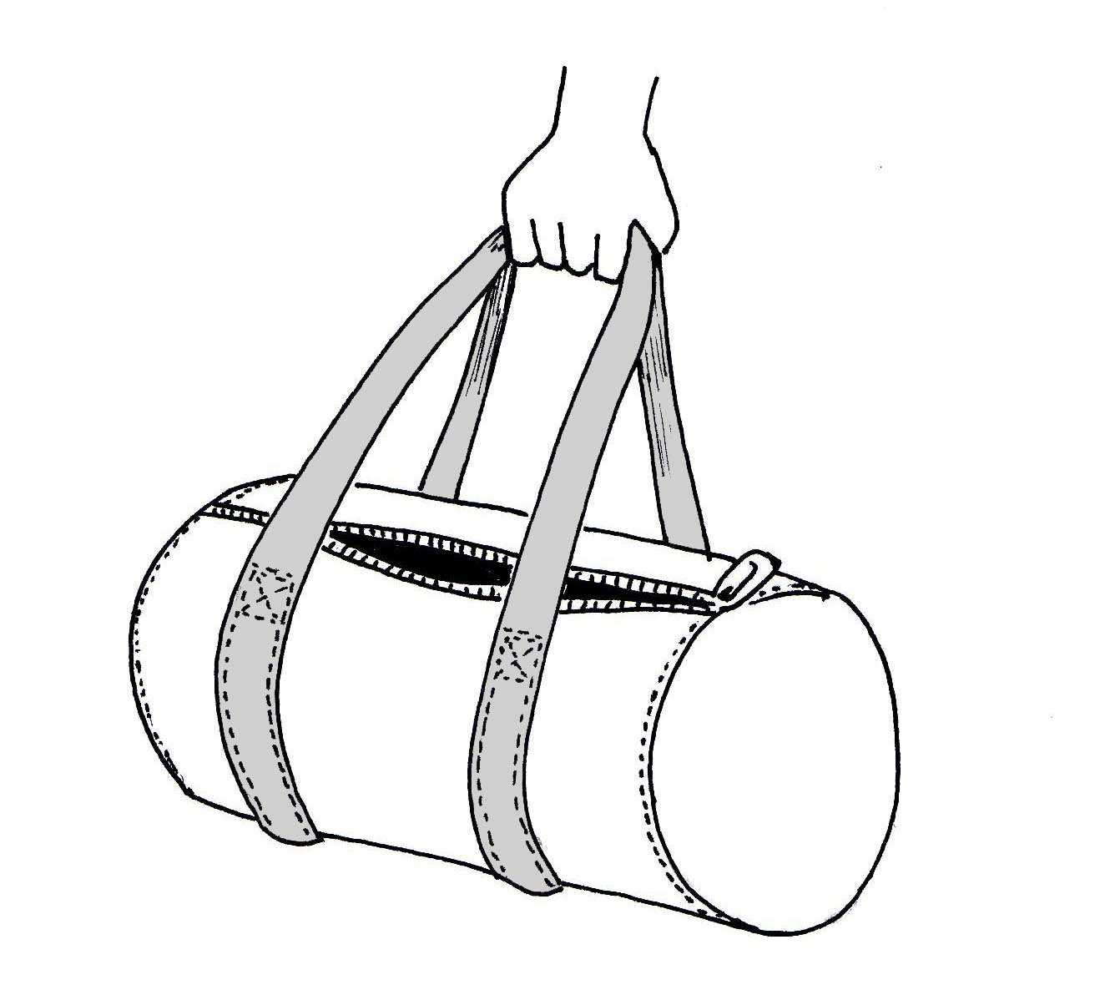
You have been asked to design a bag for a sports company, Nikidas.

- Nikdas want the bag to be 60 cm long, with circular ends of diameter 25 cm.

- The main body of the bag is to made from 3 pieces of material: one piece for the curved body, and the two circular end pieces.

- Each piece will need to have an extra 2 cm all round it to make the seams - so that the pieces can be stitched together.

- Nikdas is asking a different designer to do the handles, so you don’t need to bother with them

- Make a sketch of the pieces you need to cut for the body of the bag. Your sketch does not have to be to scale, but you must show all the measurements you need.

Nikdas buys cloth for the bags in rolls 1 metre wide.

- What is the shortest length of cloth you need to cut to make one bag? Nikdas must understand how you get your answer, so remember to describe what you are doing - using words and sketches.

Assessment guidance

Progression in Key Processes

Representing | Analysing | Interpreting and evaluating | Communicating and reflecting
Simplification of the problem and choice of calculation methods | Sketch with dimensions; geometrical reasoning | Constraints and assumptions | Description of solution and method
Simplifies the problem by identifying and sketching the shapes of the pieces  PROGRE  S  S  I  ON  Pupil A | Transfers some dimensions of the bag to the sketch.  Pupil A | Ignores the assumptions and constraints in making the bag.  Pupil A | Shows some sketches, but incomplete and/or measurements are missing or wrong.  Pupil A
Simplifies the problem by identifying and sketching the shapes of the pieces, including seams.  Pupil B | Transfers some dimensions of the bag to the sketch. Connects between them (links side of rectangle to circumference).  Pupil B | Considers some of the assumptions and constraints in making the bag. | Sketches and labels the pieces required, with some inaccuracies.  Pupil B
Simplifies by identifying and sketching the pieces. Chooses appropriate methods to calculate missing dimensions. Shows how pieces fit on the roll of cloth.  Pupils C and D | Transfers all dimensions to the sketch. Connects between them. Tries to find best way to use cloth to minimise waste, with some errors.  Pupil C | Considers most of the assumptions and constraints in making the bag. Takes account of material needed for seams.  Pupils B and C | Describes method and solution effectively, using words and sketches but with some inaccuracies.  Pupil C
 | Transfers dimensions to the sketch. Connects them. Accurately determines the best way to use the cloth to minimise waste.  Pupil D | Considers all assumptions and constraints in making the bag. Takes account of material needed for seams.  Pupil D | Describes method and solution effectively and accurately, using words and sketches.  Pupil D

Sample responses

Pupil A

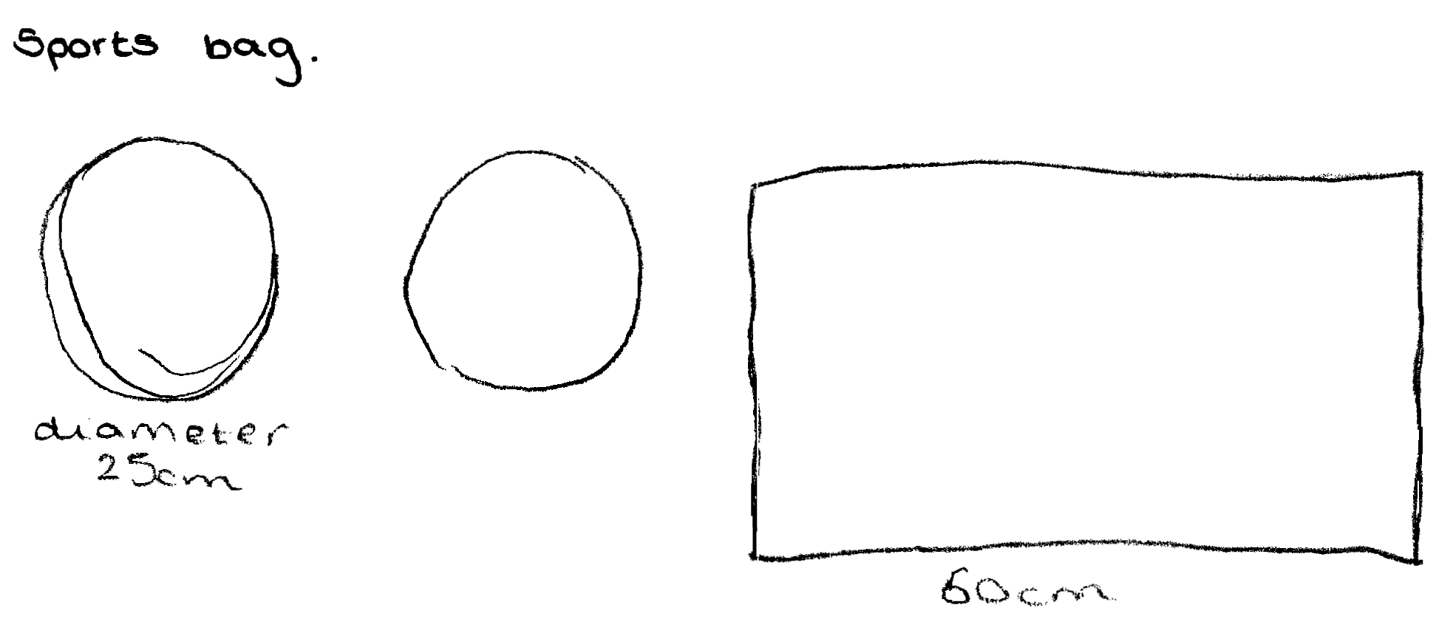
Comments

Pupil A draws a diagram showing the main pieces. He has shown the length of 60 metres, but may not know what ‘diameter’ means. No attempt made to consider seams nor to calculate missing dimensions.

Probing questions and feedback

- Where is the diameter of 25 cm?
- Can you work out the missing length on the rectangle? Do you have a method for doing this?
- Have you used all the information in the question?
- What about the seams? Where should they be on your drawings?

Pupil B
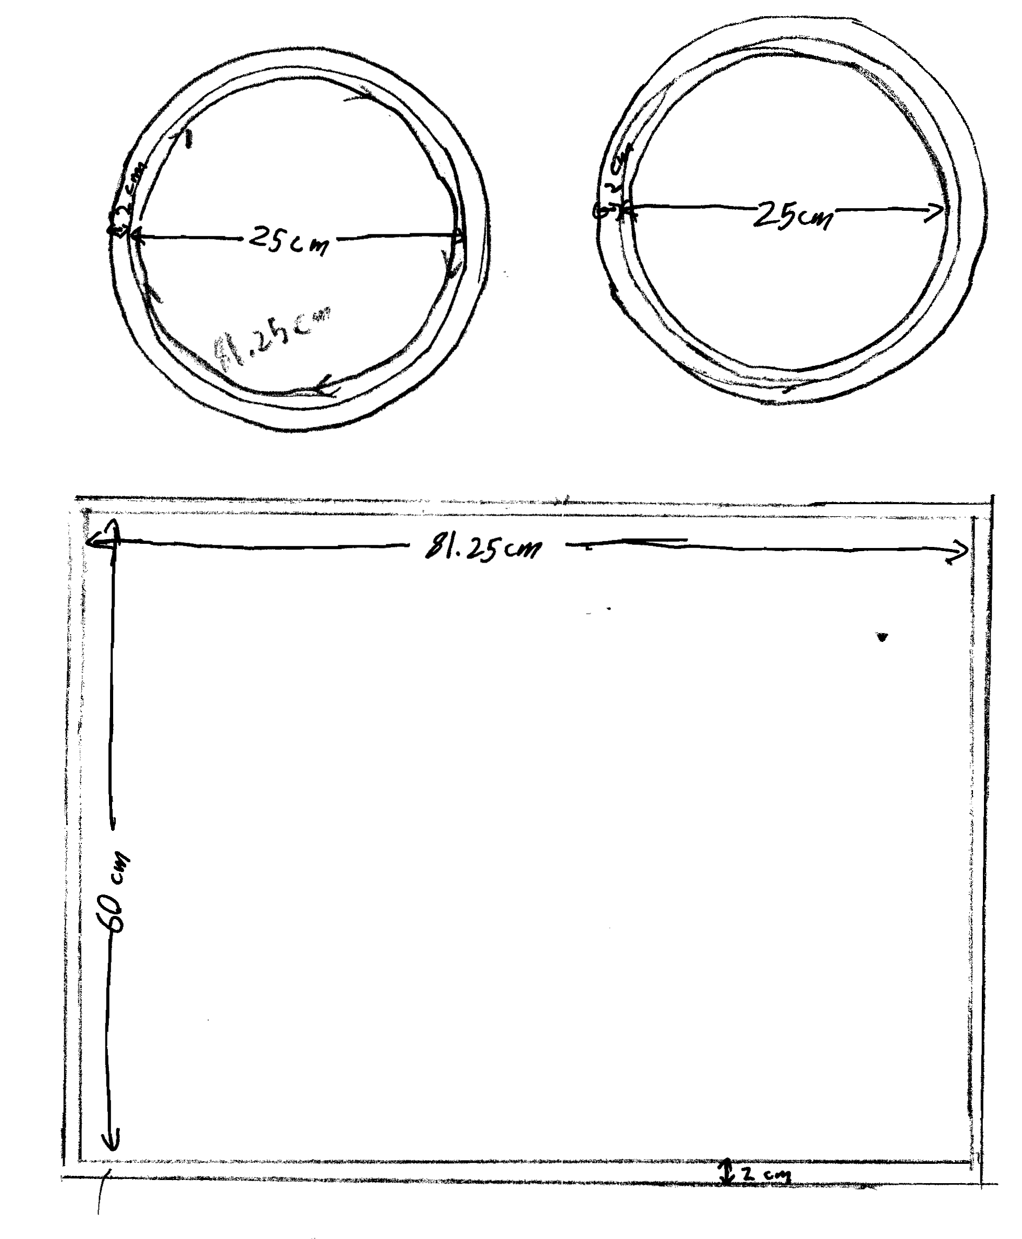
Comments

Pupil B draws a correct diagram with two circles and measurements allowing 2 cm for seams. No calculations are shown, but the diagram shows the (incorrect) circumference of the circle as equal to the length of the rectangle.

Probing questions and feedback

- Please explain how you have calculated the 81.25 cm length of the rectangular piece? Can you check your working for this?
- Calculate and show the measurements including the seams.
- How would you cut these pieces from a roll of cloth one metre wide, wasting the least material?

Pupil C
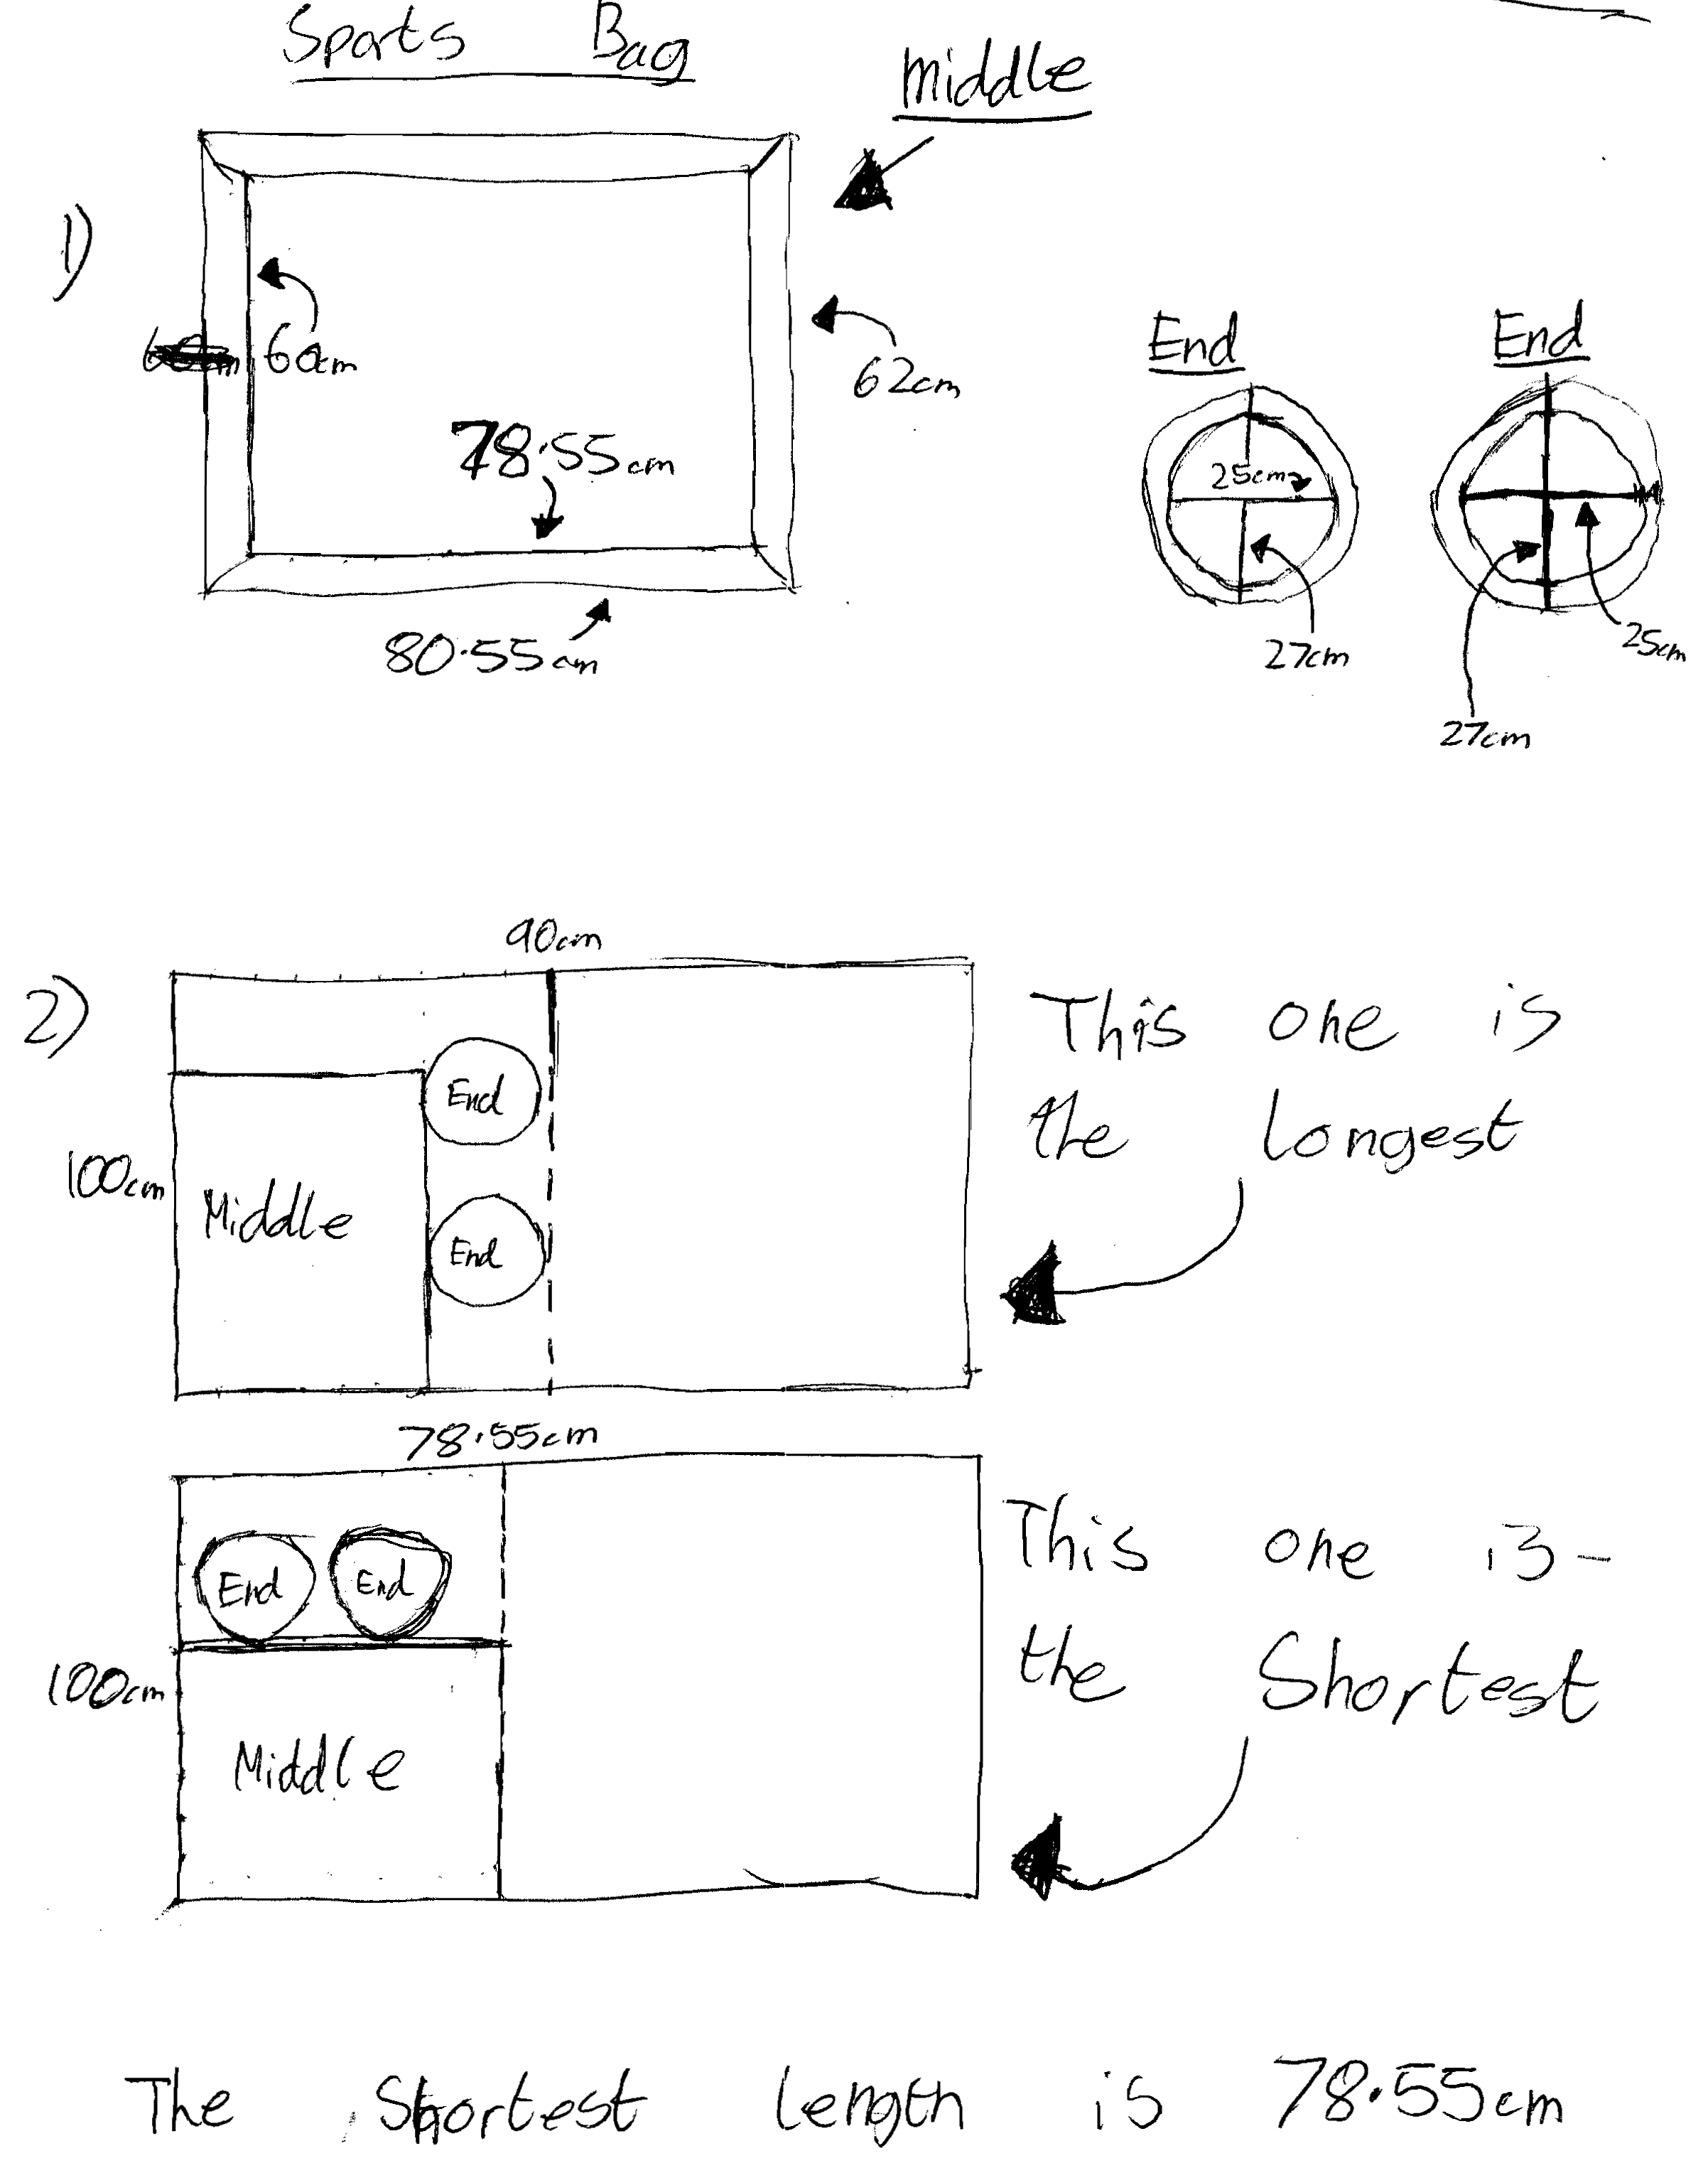
Comments

Pupil C correctly draws the pieces, calculates the missing dimension of the rectangle. He takes account of the seams, but forgets to add 2 cm to both sides of the rectangle. He tries two different arrangements of the pieces on the roll of cloth, and presents his reasoning clearly, but does not allow for the seams in his optimal solution.

Probing questions and feedback

- Please explain how you calculated the outside measurements of the rectangle, including the seams?
- You need to show more clearly how the different shapes fit on the roll of cloth - Nikdas will need more convincing that they fit, including the seams!
Pupil D
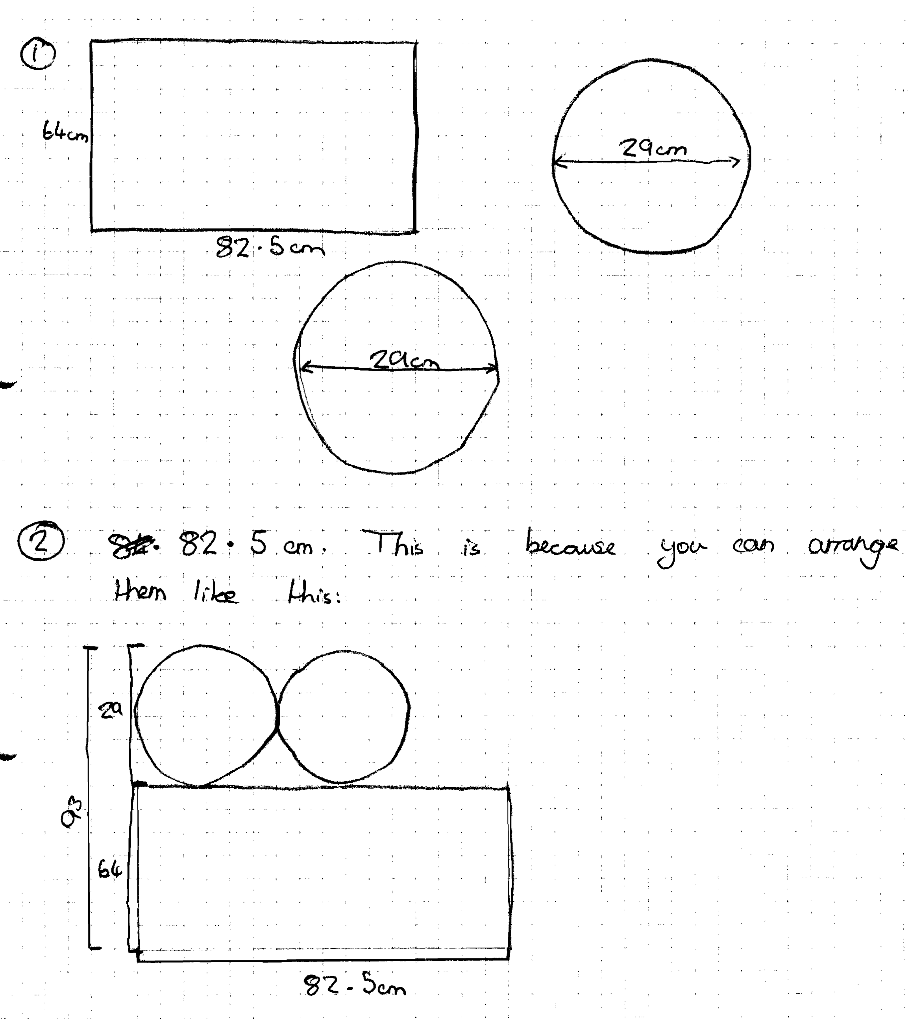
Comments

Pupil D shows two circles and a rectangle with correct dimensions (including the seam allowance). Missing dimensions have been calculated accurately. He correctly shows how the pieces can be arranged on a 1 metre roll of cloth. His work is clear and easy to follow, although some additional explanation would have been helpful.

Probing questions and feedback

- Please explain how you calculated the 82.5 cm and 29 cm dimensions?
- Nikdas will need to be sure that you have found the best possible arrangement, how can you convince them?

