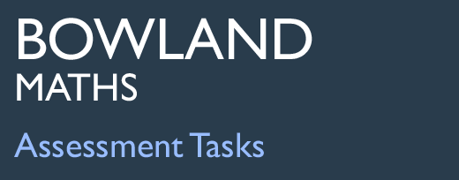 | Spinner Bingo

Task description

Pupils analyse a simple game and plan a winning strategy.

Suitability National Curriculum levels 6 to 8

Time 30 minutes to 1 hour

Resources Pencil and paper

Key Processes involved

- Representing: Select a systematic recording method when deciding how totals may be made in different ways.
- Analysing: Explore the different combinations that are possible; deduce that some totals are impossible and that some are more likely than others.
- Interpreting and evaluating: Relate their findings to the situation and deduce which totals give the best chance of winning.
- Communicating and reflecting: Communicate conclusions and reasoning clearly and effectively.

Teacher guidance

Check that Pupils understand the context, for example, you could show different ways of selecting a number at random including dice and spinners and ask the following questions:
- Who has played Bingo? What is the aim of the game?
- In Bingo numbers from 1 – 100 may be pulled out of a ‘hat’ and then called.
- In this Bingo game, the numbers called are obtained by adding the scores on two spinners. Each spinner gives a number (eg red with 2 and blue with 3) and the number called is the sum, 5.

Pupils can tackle this task in different ways, but they might be expected to:

- identify all the outcomes when dealing with two experiments combined
- understand how to calculate the probability of a compound event and use this in solving a problem

Spinner Bingo
Sally has made a Spinner Bingo game for her class.



Here are three Bingo cards the players made:
Write down 9 different numbers on your card.

I will spin both spinners and add the two numbers.
If you have that total on your Bingo card, cross it out.
The first person to cross off all their numbers wins the prize.

Card A Card B Card C

- Which of these cards has the best chance of winning? Why?
- Fill in your own card to give you the best chance of winning.
- Explain how you chose the numbers for your card.

Assessment guidance

Progression in Key Processes

Representing | Analysing | Interpreting and evaluating | Communicating and reflecting
Considering ‘likelihood’ and choice of method to determine results from two spinners  PROGRE  S  S  I  ON | Completeness of totals found and quality of reasoning | Rejection of card B, selection of card A and creation of own card | Clarity, completeness and elegance of communication of results and reasoning.
Considers the likelihood of some totals appearing, but incomplete and unsystematic.  Pupils A and B | Recognises the limits on the totals and/or  that some totals are more likely than others – but without valid reasons.  Pupil A | Rejects card B as impossible. Selects a preferred card with no good explanation. Creates a valid card but no reasons given for the numbers chosen.  Pupil A | Communicates results, but with errors and omissions.  Pupil A
 | Recognises the limits on the totals and/or that some totals are more likely than others. Some reasoning given, but incomplete or with errors.  Pupil B | Rejects card B as impossible. Selects Card A with some valid reasons. Creates a valid card with some, but insufficient reasons  Pupil B | Communicates conclusions and reasoning with some errors and/or omissions.  Pupil B
Selects a systematic method for deciding how totals can arise in different ways.  Pupils C and D | Explores different combinations that are possible but misses some possibilities. States the limits on the totals and that some are more likely than others.  Pupil C | Chooses Card A with valid reason. Deduces the totals that give the best chance. Designs card with a chance of winning but not optimal: all numbers are possible but at most two of the less likely: 2,3,4,14,15,16. | Communicates conclusions and reasoning clearly and effectively though with some errors.  Pupil C
 | Explores the different combinations that are possible. Recognises the importance of the order e.g. lists both (1+3) and (3+1). Deduces the limits on the totals and that some are more likely than others.  Pupil D | Chooses Card A with valid reasoning. Deduces which totals give the best chance. Designs an optimal card with all the numbers in the range 5 to 13.  Pupils C and D | Communicates conclusions and reasoning clearly and effectively.  Pupil D

Sample responses

Pupil A

Comments

Pupil A correctly states why Card B cannot win. She does not show any evidence of working out probabilities or possible scores; she seems to believe that numbers close together are less likely to be called (as do much of the adult population!). She creates a valid Bingo card but her explanation is unclear.

Probing questions and feedback

- What range of scores can you get from the pair of spinners?
- Which numbers are impossible to get?
- Why do you think that numbers close together have ‘less chance’.
- How can you systematically record all possible combinations of scores from the spinners?
- What does this tell you about the most likely and least likely totals?

Pupil B

Comments

Pupil B correctly states why Card B cannot win; he also correctly states that Card A is the best choice and gives a partial explanation. He designs a valid Bingo card and states that the numbers have lots of “adding factors”. This shows some understanding, but his argument is incomplete.

Probing questions and feedback

- Please explain what you mean by “they have lots of ‘adding factors”?
- How could you record all possible total numbers and the ways they can be obtained?
- How might this information help in producing a card that has the best chance of winning?

Pupil C
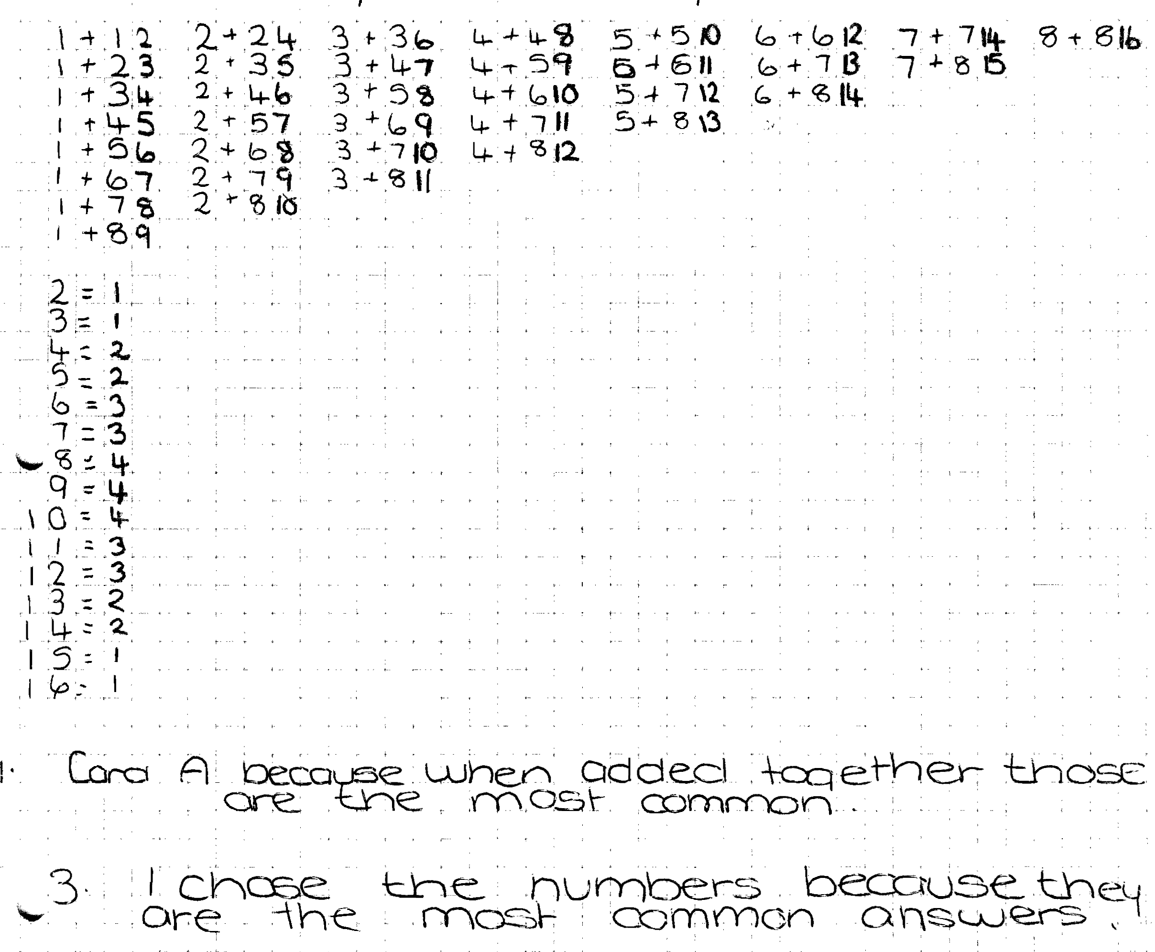
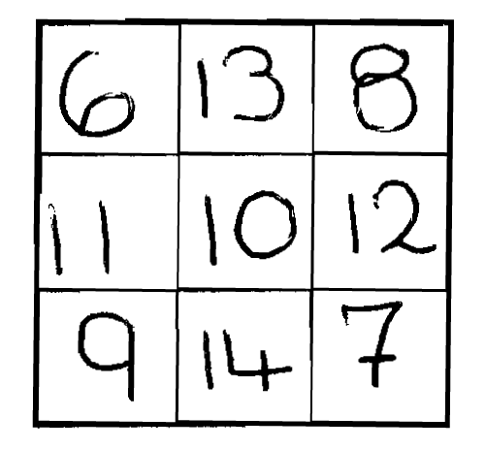
Comments

Pupil C shows evidence of working out possible total scores by listing, but she misses some, for example, she shows 1+2 but not 2+1 etc. She does not mention that Card B contains two impossible total scores – but that question was not asked and she correctly states that Card A has the best possible chance of winning because the numbers are most common. Then she designs a valid bingo card with correct explanation.

Probing questions and feedback

- What scores on the red and blue spinners would give a total score of 3?
- How does this answer affect the total number of different ways of scoring that you calculated?
- How could you attach a probability to each of the possible total numbers?

Pupil D

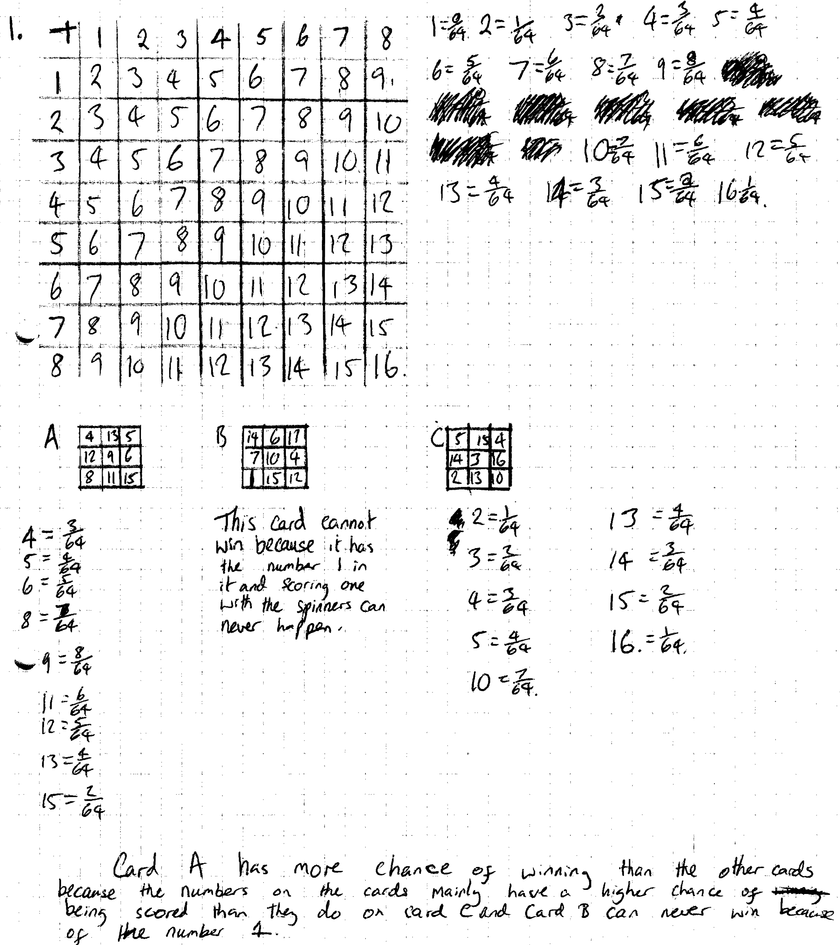
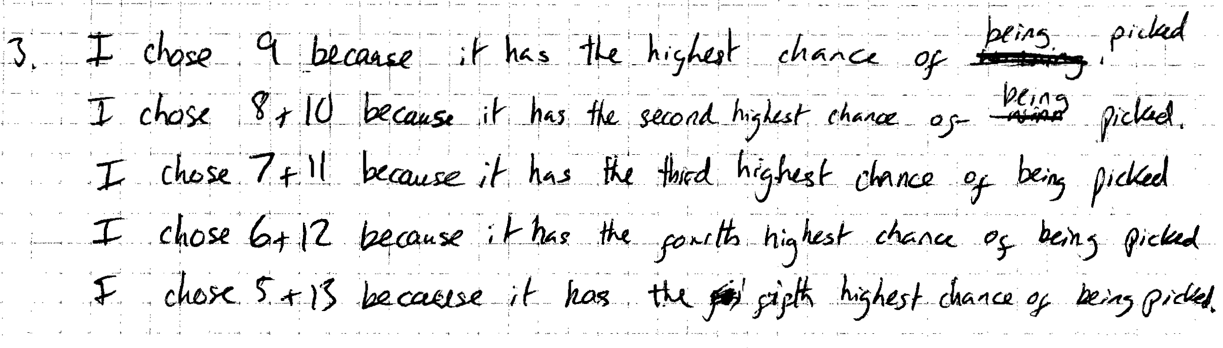
Comments
Pupil D works out the probabilities using a lattice diagram and a correct listing of the probabilities of possible scores. She correctly states why card B cannot win because it contains the number 1, although she does not mention that 17 is also impossible. She correctly selects Card A as having the best chance of winning using quantitative data. She designs an optimum bingo card with an explanation. Her work is clear and easy to follow.

Probing questions and feedback

- What other number on card B is not possible?

