 | Speedy Santa

Task description

Pupils determine the amount of time Santa can spend at each house in the UK when delivering presents on Christmas Eve.

Suitability National Curriculum levels 4 to 7

Time 30 minutes to 1 hour

Resources Calculator and paper

Key Processes involved

- Representing: Select information, make assumptions.
- Analysing: Use given and assumed facts to work towards a solution.
- Interpreting and evaluating: N/A
- Communicating and reflecting: Present arguments and reflect on findings, building towards a credible solution.

Teacher guidance

Check that pupils fully understand the context, for example with points such as:

- Think about the information you are given and ask yourself why it would be useful in helping you to work out the average amount of time Santa can spend at each house.
- Present your solution in a letter to Santa, so he understands it and how you arrived at it. Remember to show your working and your reasoning.

During the task the following probing questions may be useful

- Have you used all the information you have been given? If not, why not?
- What else do you need to assume?
- How many hours do you think can Santa work – while children are asleep?
- Will Santa understand what you have done and why?
- What does your solution tell you about Santa’s schedule?

For ease of teacher reference, there is an arithmetical annex at the end.

Speedy Santa



Have you ever thought just how busy poor Santa is on Christmas Eve?

He delivers presents to every child in the UK, but he can only start after children are asleep and he must be finished by daybreak. He needs organising!

As Santa’s new travel advisor, work out the average time he can spend at each house.

You will need some information:
Around one in five of the total population is under 16 years old

The total population of the UK is
60,975,000

Each woman in the UK has an average of about 1.9 children

Assessment guidance

Progression in Key Processes

Representing | Analysing | Communicating and reflecting
Mathematical modelling, including assumptions made | Calculations and solutions | Clarity of communication of method, reasoning and solution.
Makes a simple assumption,  e.g. by stating the number of hours during which Santa can deliver  PROGRE  S  S  I  ON | Makes some progress towards solving the problem, e.g. by finding the number of people under 16  Pupils A+B | Shows only basic communication, e.g. it is not easy to follow what they have done and why
Explains their assumption  Pupils A+B | Makes further progress towards solving the problem, e.g. by finding the number of houses for deliveries | Communicates effectively,  e.g. by showing sufficiently clear reasoning such that someone else can follow what they are doing and why  Pupils A+B
Shows understanding of how to use their assumption  Pupils C and D | Calculates an accurate answer but leaves it in the wrong form, e.g. by finding number of deliveries per second rather than number of seconds per house  Pupil D | Throughout the task, gives clear, effective and concise communication which builds to a solution, even if a partial one  Pupils C and D
Refines the mathematical model, e.g. by estimating the % of children aged 0 to 16 who would not expect a visit from Santa | Solves the problem, i.e. calculates an accurate answer for the time available per delivery  Pupil C | Throughout the task, gives clear, effective and concise communication which builds to a credible solution, with clear evidence of reflection, e.g. recognising how little time is available for delivery

Sample responses

Pupils A and B
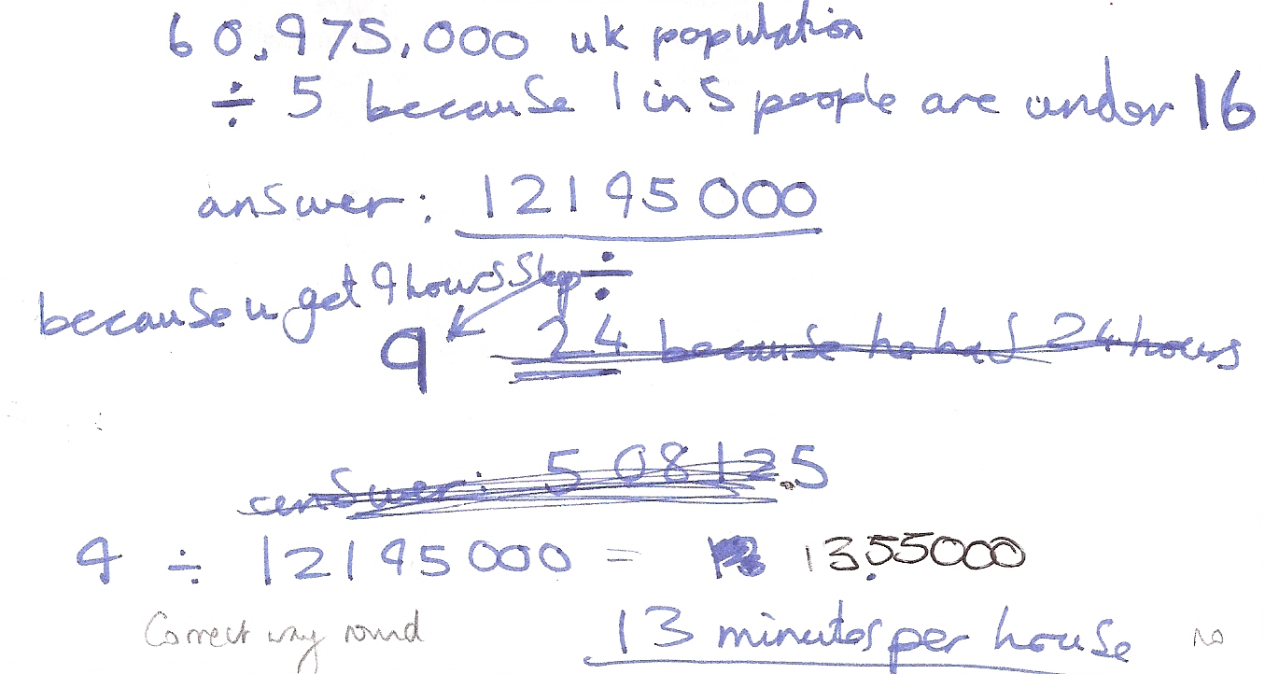

Comments

Pupils A and B used the proportion of the population under 16, but not the average number of children per mother. They explain the 9 available hours; the calculation shown would have given the correct time in hours (but they did 12,195,000 ÷ 9 instead and got to 13 minutes per house). There is no evidence of reflection by checking the reasonableness of their answer.

Probing questions and feedback

- Always check that you have used all the information given
- Think about how well your solution fits the situation (e.g. with so many houses to visit, is it reasonable that Santa could spend 13 minutes at each one?)
- Now write the letter to Santa (or make a presentation), explaining how long he can spend at each house, and how you got to your answer

This should encourage them to explore their answer and its reasonableness

Pupil C

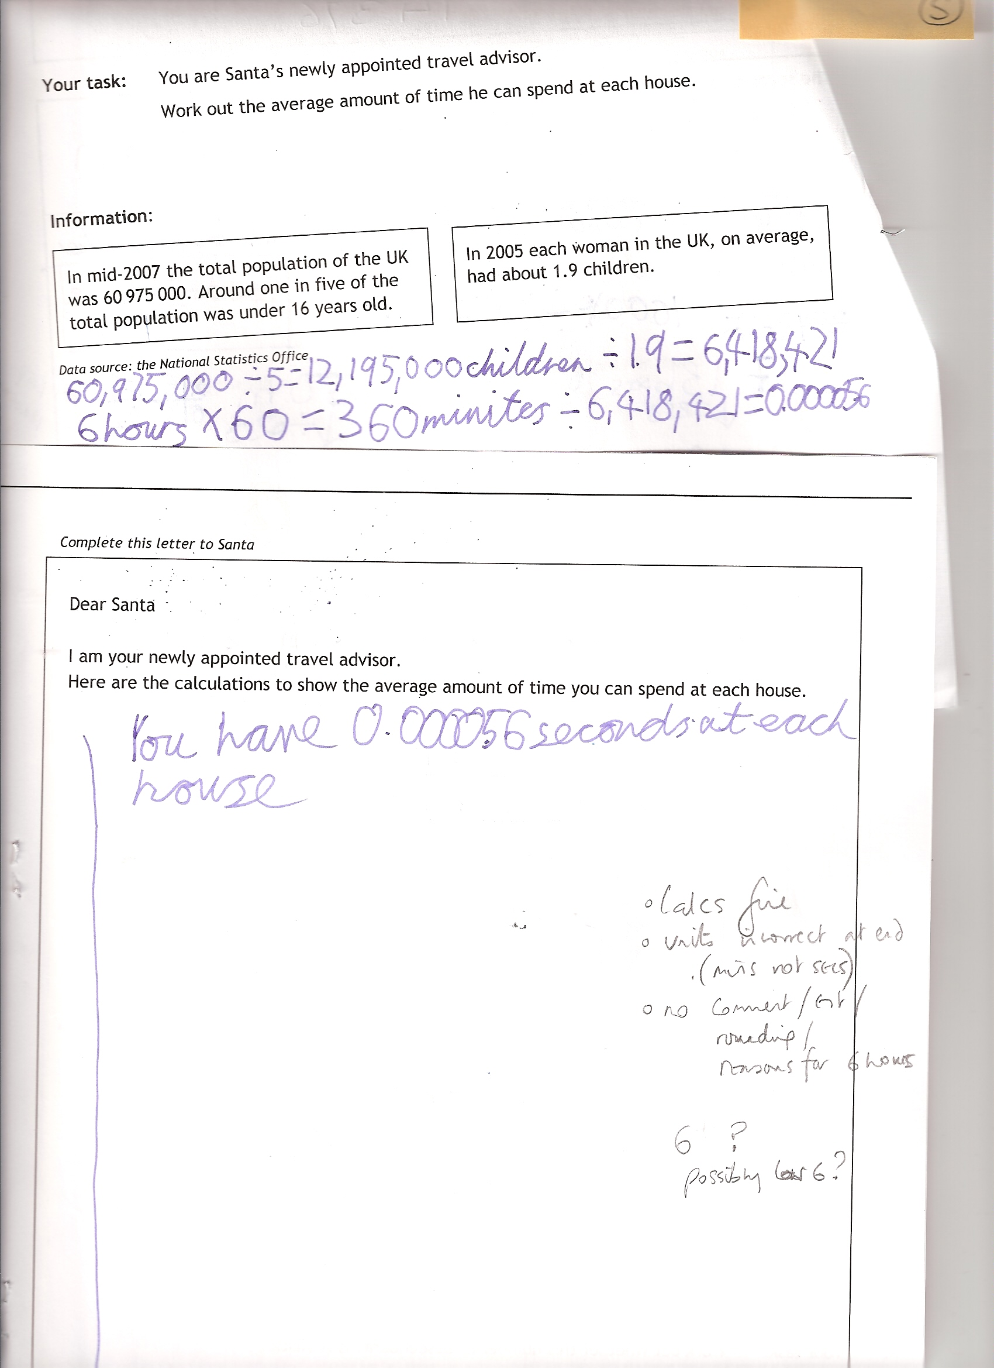
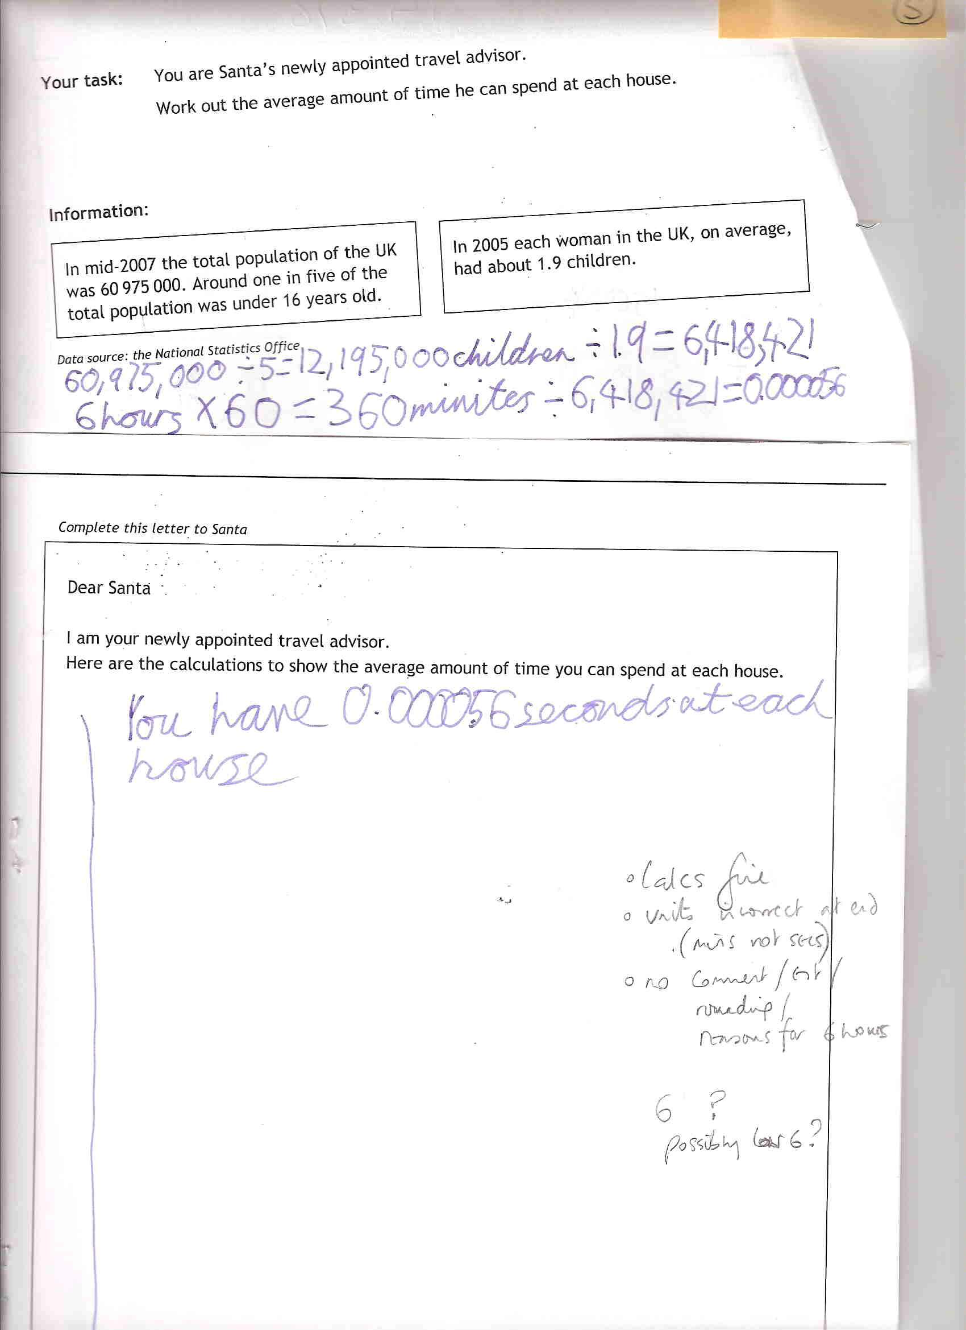

Comments

Pupil C has achieved an answer with only three lines of writing (albeit with incorrect use of = signs). He shows an ability to use and interpret all the information – albeit with no explanation about its relevance. He makes a reasonable assumption of 6 hours, but with no explanation, and uses a correct method to produce a solution (but given as seconds, when it should have been minutes). Shows no reflection on his solution and what it might mean.

Probing questions and feedback

- Your work is concise and shows your understanding, but you must always give more explanation, for example, why did you choose 6 hours, and what does the answer mean for Santa?
- Check that you have not made careless errors – your answer is in minutes, but your calculations were in seconds.

Pupil C would benefit from further opportunities to explain his reasoning and reflect on the meaning and relevance of his findings.

Pupil D

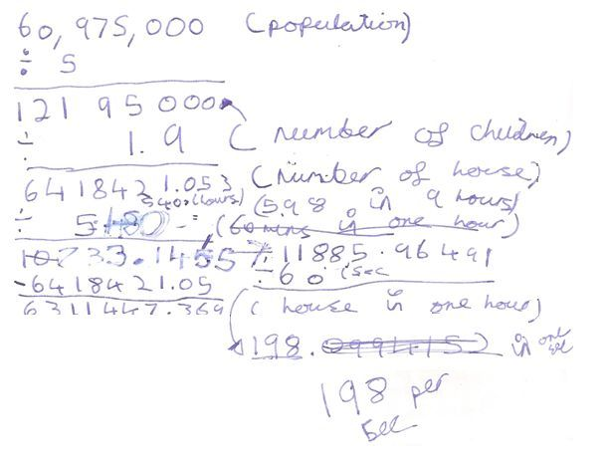

Comments

Pupil D starts with a clear method that shows correct use of both pieces of information. 9 hours is used without explanation; she continues to give units, but her working becomes muddled, partly because of corrections. She does ultimately reach a correct number of deliveries per unit time, with the units correctly given, but not the time per house which was what was requested. She shows good communication skills such as using words in brackets to explain each calculation.

Probing questions and feedback

- Make sure that you have answered the question that was asked (You worked out how many houses Santa could visit in one minute, but the question asked how much time Santa could spend at each house.

Further experience in exploring open-ended problems would benefit this pupil. Encouraging her to review her work, making sure she has answered the question and explained her reasoning, would also be beneficial.

Arithmetical annex

There are 60 975 000 ÷ 5 = 12 195 000 children under the age of 16;
They live in 12 195 000 ÷ 1.9 = 6 418 421 (or 12 195 000÷ 2 = 6 097 500) houses.
Assuming 6/8/10/12 hours of work for Santa:

 | 6 hours | 8 hours | 10 hours | 12 hours
Time per house, in secs | 0.0034 / 0.0035 | 0.0045 / 0.0047 | 0.0056 / 0.0059 | 0.0067 / 0.0071
Time per house, in mins | 0.000056 / 0.000059 | 0.000075 / 0.000079 | 0.000093 / 0.000098 | 0.00011 / 0.00012
Houses per second | 297 / 282 | 223 / 212 | 178 / 169 | 149 / 141
Houses per minute | 17829 / 16938 | 13372 / 12703 | 10697 / 10613 | 8914 / 8469

