 | Soft Drinks

Task description

Pupils compare two sets of data with different sample sizes and consider how a testing procedure could be improved.
Suitability National Curriculum levels 5 to 6

Time 30 minutes to 1 hour

Resources Ruler, pencil, calculator and 1 cm squared paper

Key Processes involved

- Representing: Understand why the tests were unfair and find a way to compare the data.
- Analysing: Calculate to make comparisons possible.
- Interpreting and evaluating: Explain how their results show that teenagers do not like the drink, but that adults do; suggest ways to make future tests fairer.
- Communicating: Show clearly what they have done and explain their ideas well.

Teacher guidance

Check that pupils understand the context, for example with questions such as:
- What does it mean ‘to defend your conclusion’?
- What does ‘reliable’ mean when we are talking about statistics?
- Show all your working so that the Pop Soda Company can understand your thinking.

Pupils can tackle this task in different ways, but they might be expected to:

- produce comparable statistics from the two sets of data,
- understand the shortcomings of the tests and suggest improvements

Soft Drinks

The Pop Soda Company has developed a new soft drink called Fruity, a cool drink with a fruity taste. The company expects it to be very popular with teenagers.

They plan to launch an advertising campaign just before the summer, but first they carry out two sets of taste tests to see if Fruity is liked by the target group. Each test is done in a testing booth and customers taste and compare Fruity with SoFruit, another brand of the Pop Soda Company.

Customer preferences are recorded. These are the fact sheets of the two tests.
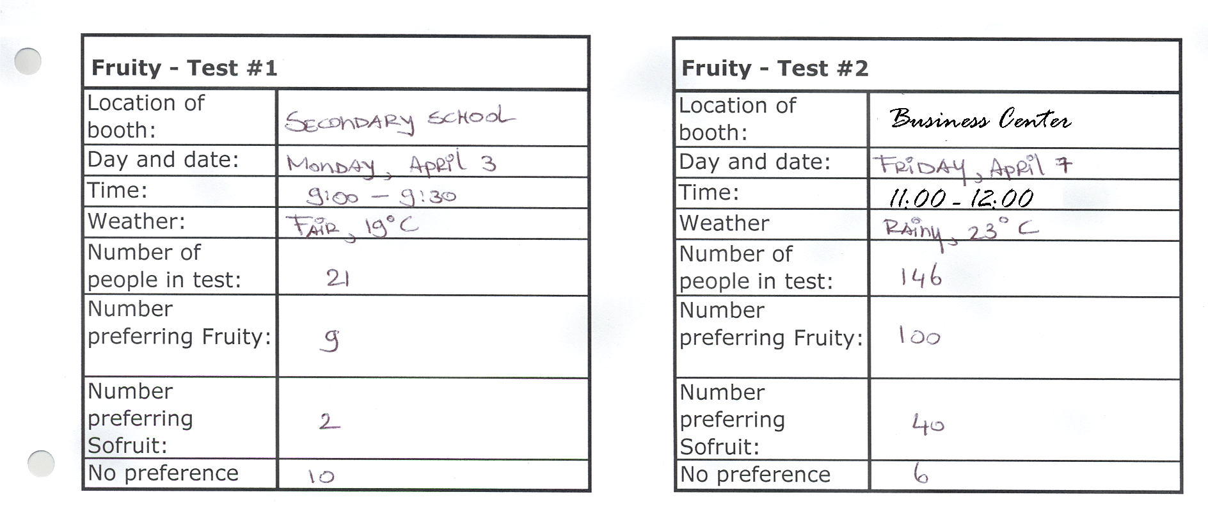

Based on these two tests, the marketing department concludes that teenagers do not like Fruity, but that adults do.

- How can the marketing department defend its conclusion?

They showed the results to the company director and he said:
‘This test isn’t reliable. Do the tests again to get a more reliable result.’

- Advise the marketing division how to set up new tests to get more reliable results.

Assessment guidance

Progression in Key Processes

Representing | Analysing | Interpreting and evaluating | Communicating
Choice of method for comparing the two sets of data  PROGRE  S  S  I  ON | Analysis of the data and quality of reasoning | Improvements suggested for the testing process | Clarity and completeness of communication
Uses a simplistic method or makes no attempt to compare the data.  Pupils A and B | Uses simple statements to compare the data.  Pupil A | Gives a few ideas for improvements.  Pupil A | Communicates the work adequately, but with gaps and/or omissions.  Pupil A
 | Explains why the data cannot be compared.  Pupil B | Has some reasoned ideas for how the tests could be improved | Communicates the work clearly and the reasoning can be followed.
Compares the two sets of data.  Pupil C | The data is used to defend the conclusion.  Pupil C | Has well argued ideas about improvements needed.  Pupils B and C | Communicates the work clearly and the reasoning may be easily followed easily.  Pupils B and C
Uses the data to make correct numeric comparisons.  Pupil D | The data is used correctly to defend the conclusion.  Pupil D | Gives good advice, for conducting future tests, which covers all the shortfalls of the previous tests.  Pupil D | Explains the work clearly and considers other possibilities.  Pupil D

Sample responses

Pupil A

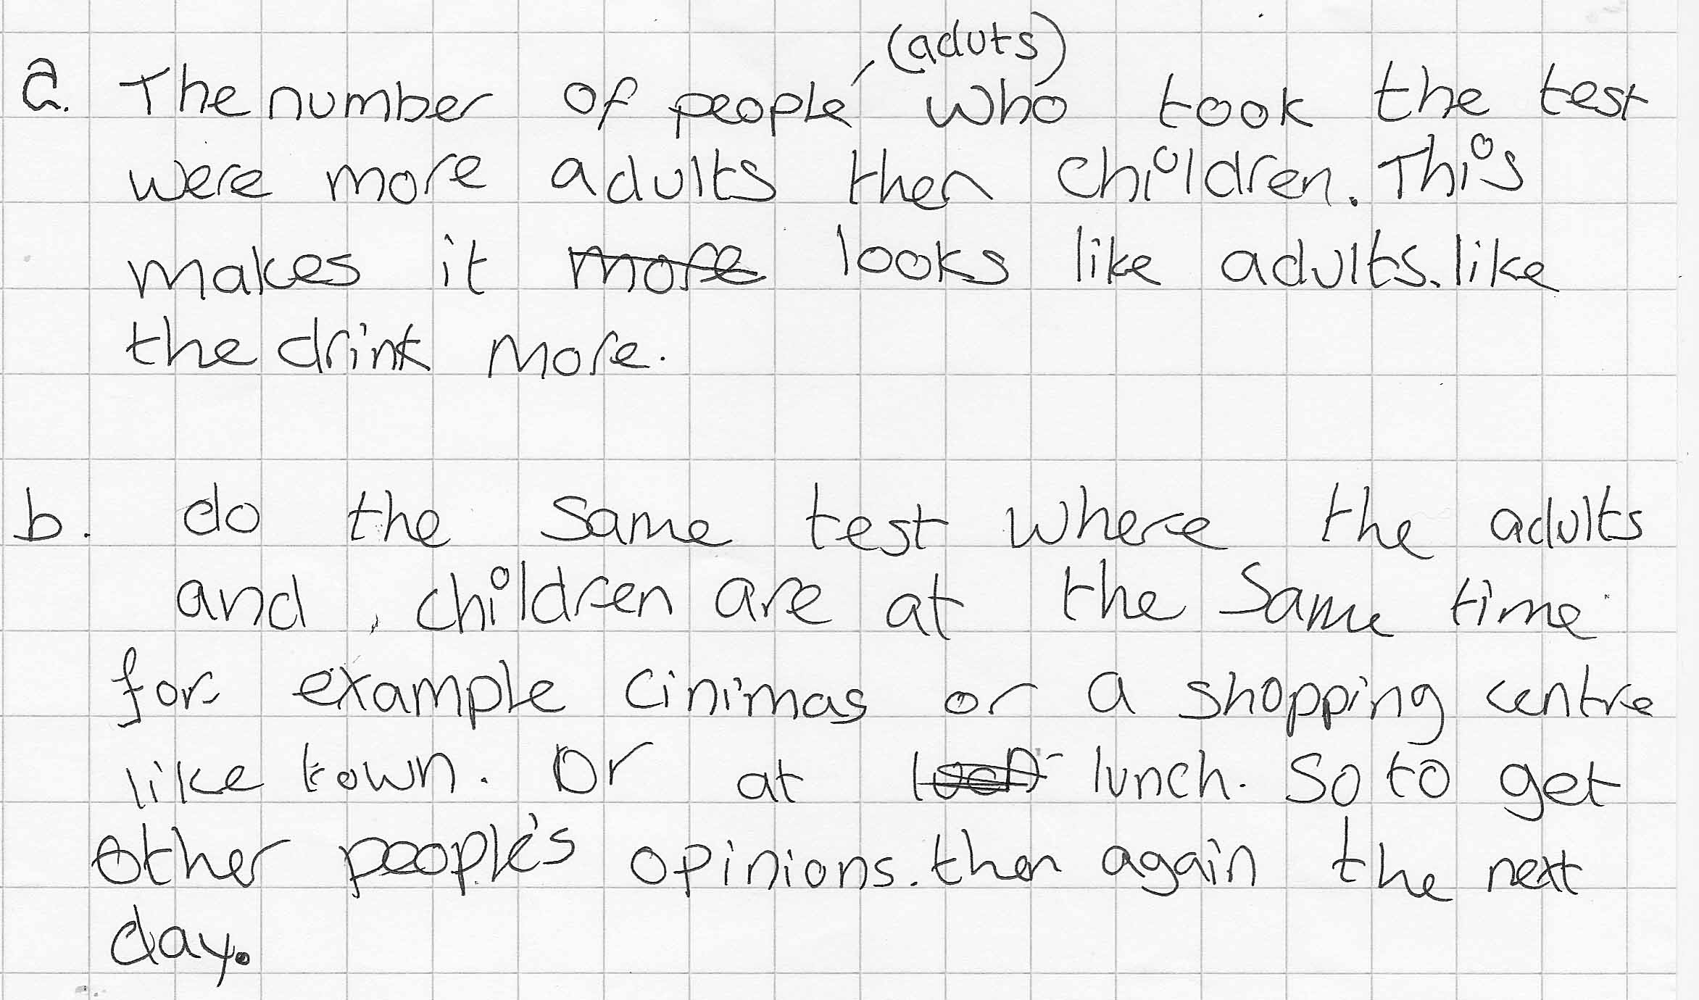

Comments

Pupil A realizes that more adults have done the test but does nothing to help make a proper comparison. She suggests testing adults and children at the same time and place but not that the same number of each be tested.

Probing questions and feedback

- You point out that there are more adults than children, so is there a way you could compare the results? For example, can you use ratios or percentages?
- Are there any other ways they could make the next test better?

Pupil B

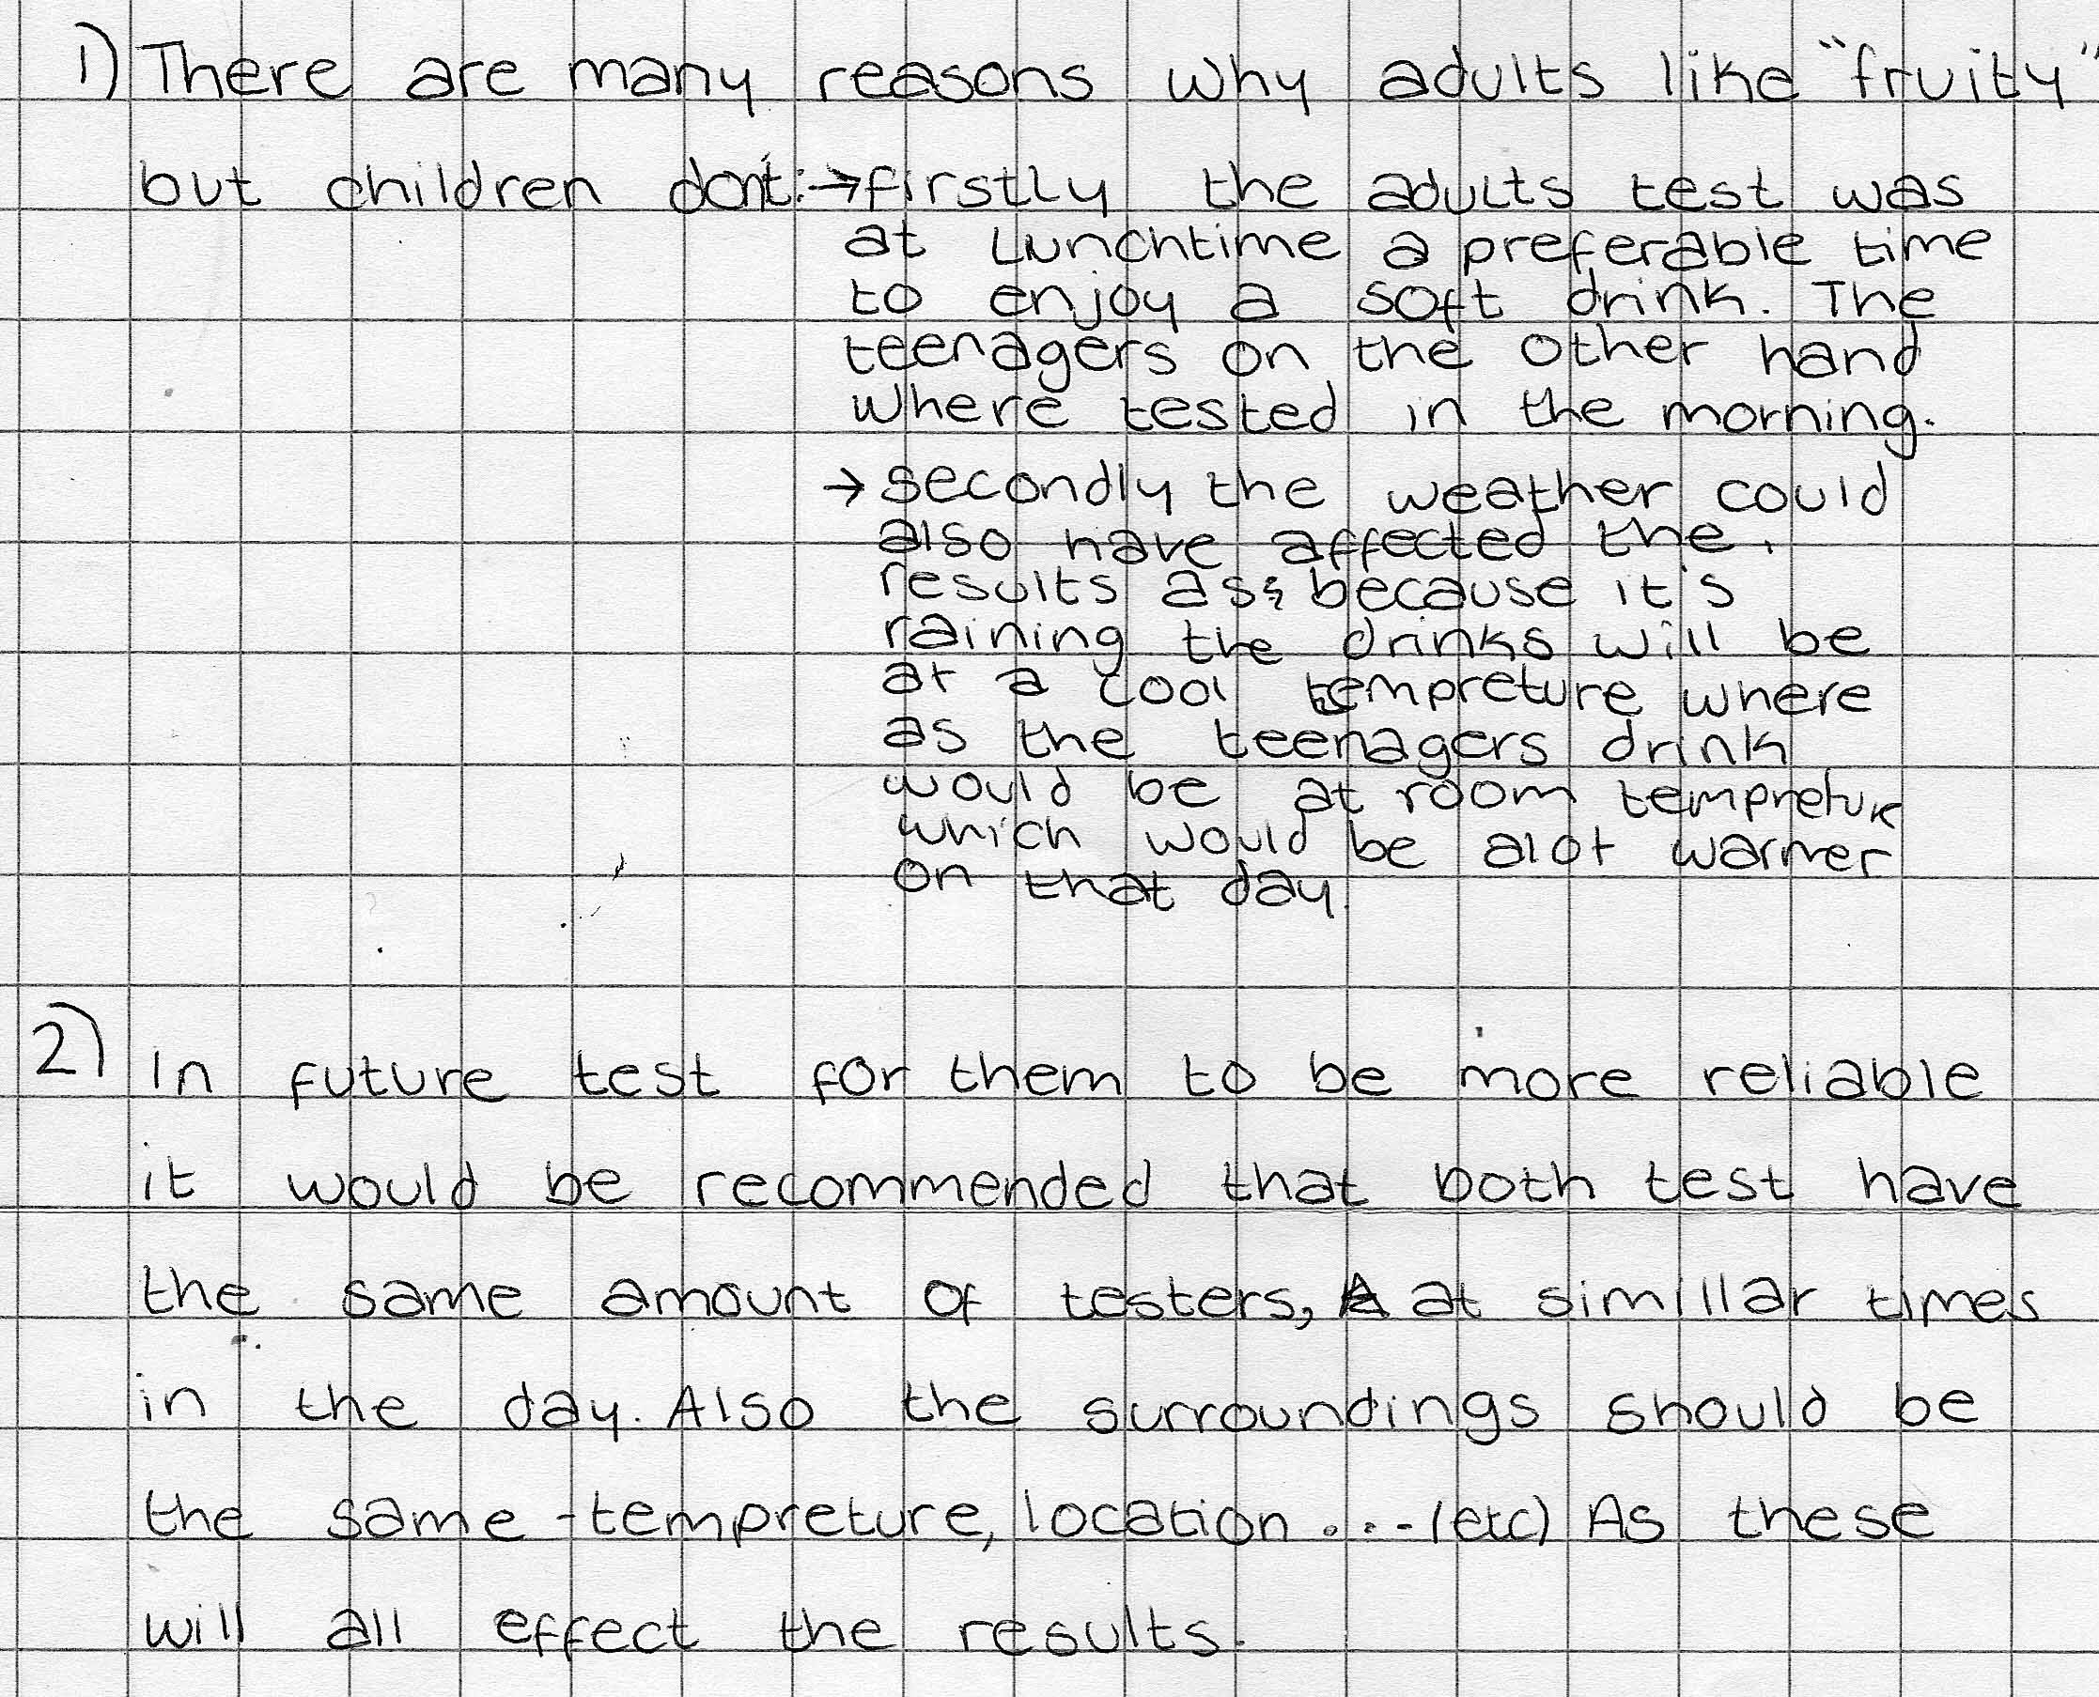

Comments

Pupil B understands why the tests are not reliable and explains the results but without comparing the data. He gives good recommendations for improving the reliability of future tests.

Probing questions and feedback

- Can you find a way of comparing the number of people who prefer ‘Fruity’ in the two groups?
- Could you use ratios or percentages?

Pupil C

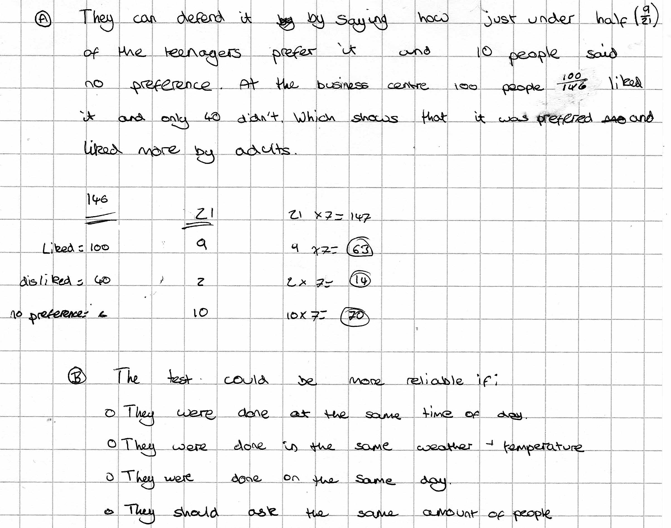

Comments

Pupil C has used an approximate method to compare the data but did not explain clearly what he is doing. He has given a good list of improvements for future tests.

Probing questions and feedback

- Please explain why you multiplied by 7? Now can you write that down?
- Your comparison is approximate, so can you find a way of giving an exact comparison?
- You make good suggestions for improving the tests

Pupil D

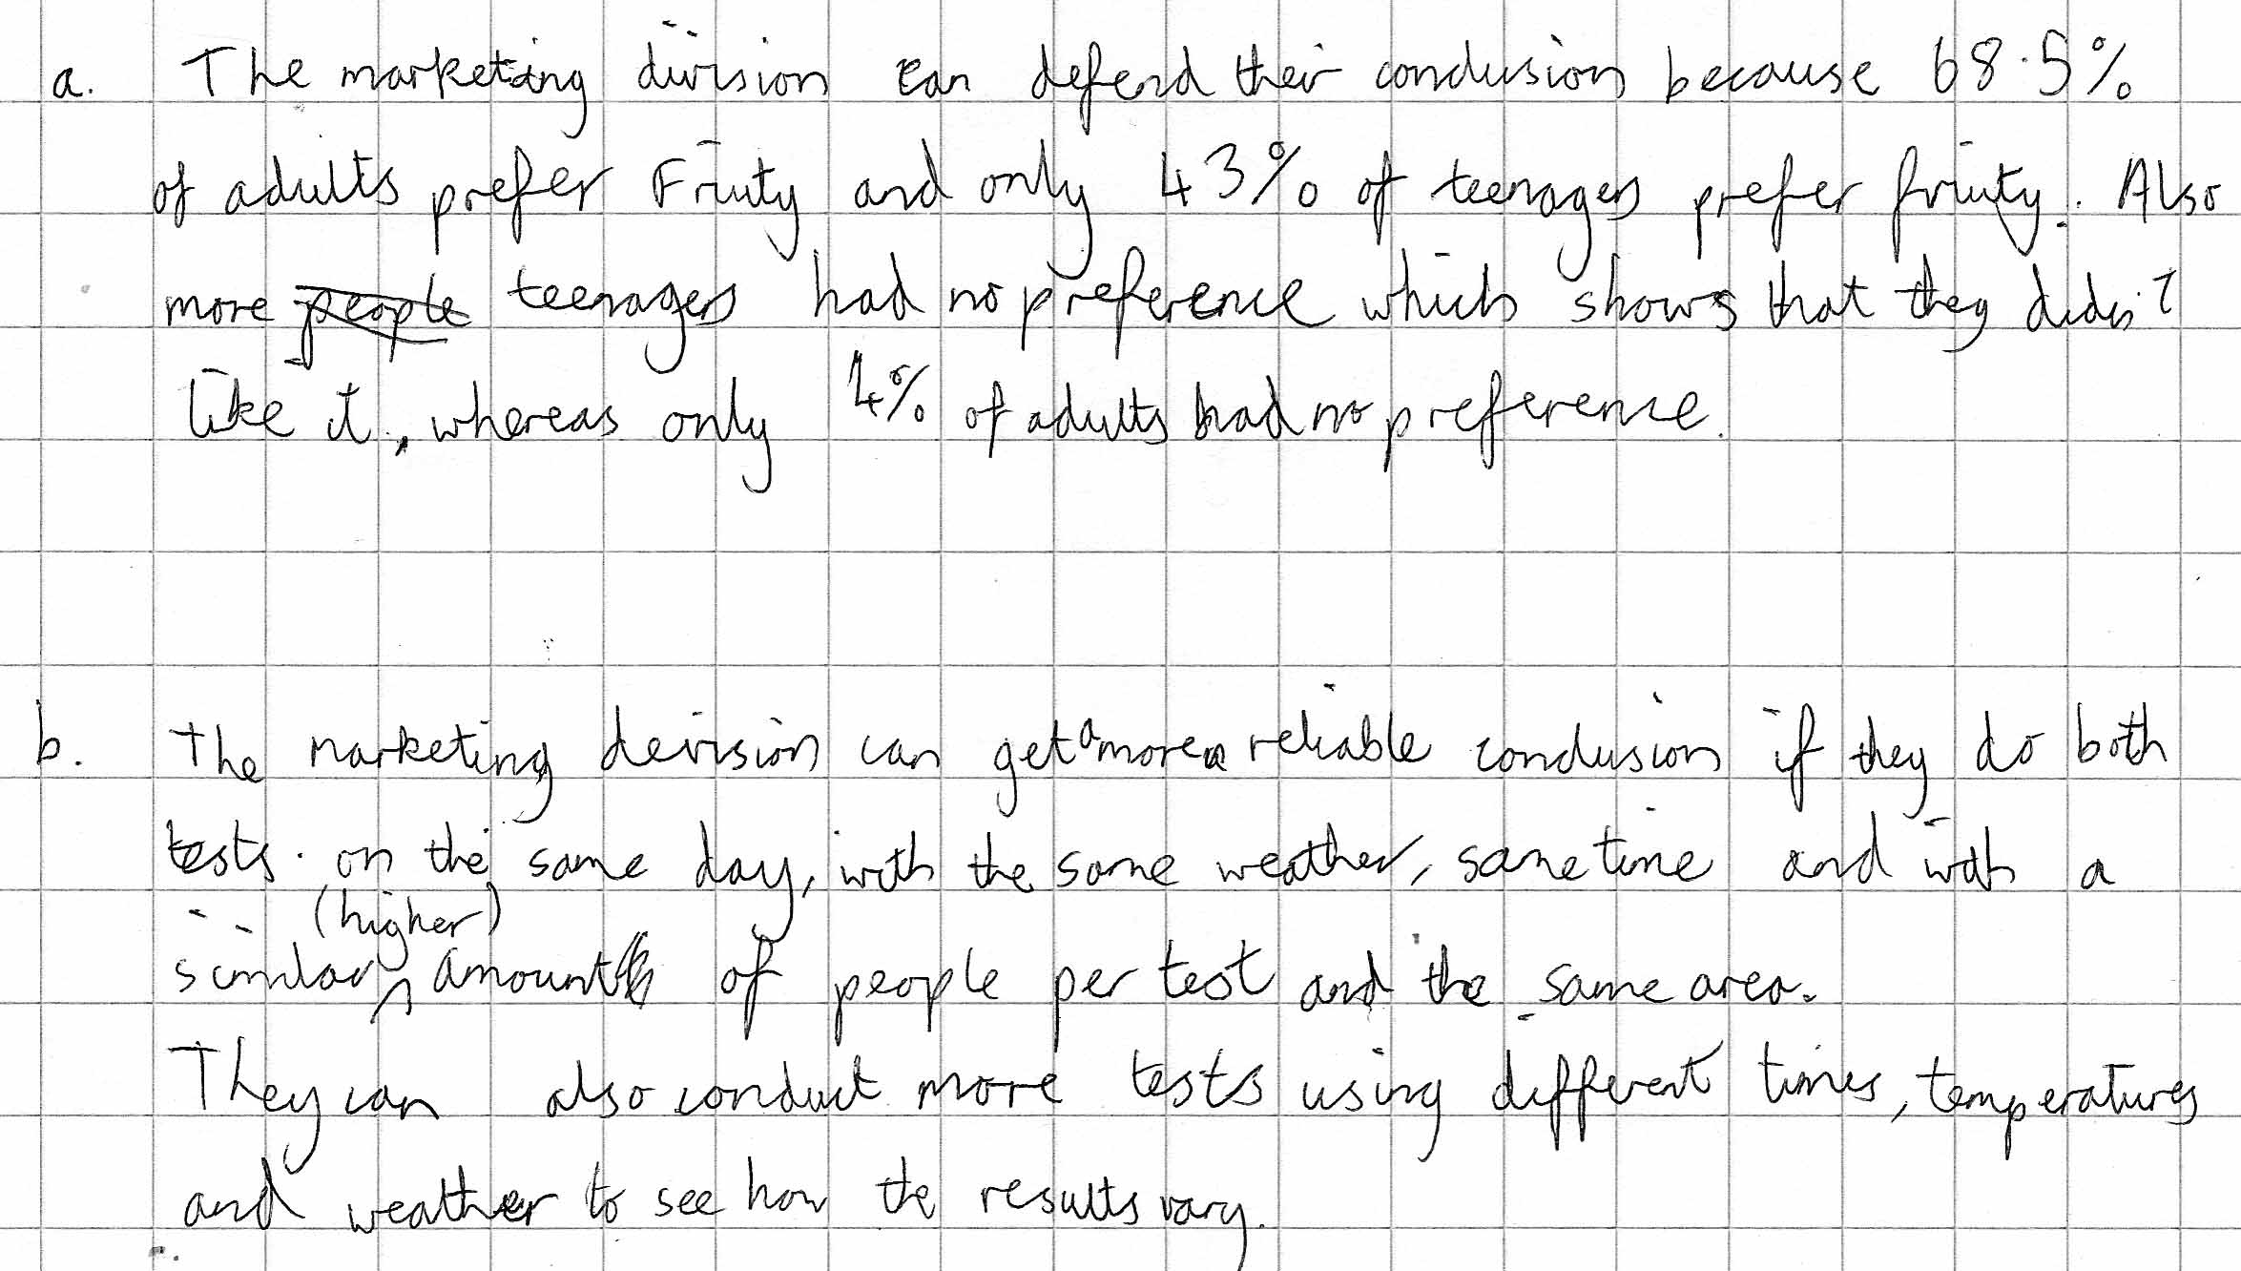

Comments

Pupil D has calculated the percentages from the data so was able to give direct comparisons. In part b he has not only covered all the shortfalls in the tests but has gone on to suggest that more tests be carried out under different conditions.

Probing questions and feedback

- Do you think your work would be easier to follow if you had shown the calculations you used?
- In part b, it would have been easier to see the (good) improvements you suggest if you had put them in a list rather than a long sentence
- Could you write a list of instructions to the people who will conduct the next tests to explain when, where and with what sample size you suggest they should use for the survey?

