 | Smoothie Box

Task description

Pupils measure a bottle and then design a box that will hold 12 of them.

Suitability National Curriculum levels 6 to 7

Time 30 minutes to 1 hour

Resources Ruler, pencil, and paper; scissors available (if requested by pupils)

Key Processes involved

- Representing: Identify the significant parts of the bottle to measure and formulate a suitable box design.
- Analysing: Translate the appropriate measurements to a net.
- Interpreting and evaluating: After designing the net, imagine it folded
- Communicating and reflecting: Draw the box design clearly and label it well

Teacher guidance

Check that pupils understand the context, for example, you could bring in a bottle to help them visualise the problem. It may also be helpful to have some rectangular boxes folded from nets. Comments could be as follows:

- The diagrams on your sheet show two views of the bottle drawn accurately full size
- The left hand diagram shows a view of the bottle from the top.
- What is the diameter of the cap?
- The diagram shows the bottle from one side. Why is there no diagram of the bottle from another side?
- What is a net?

Pupils can tackle this task in different ways, but they might be expected to:

- recognise and use common 2D representations of 3D objects

Smoothie Box

Mrs. Grundy wants to pack her special home-made smoothies into boxes. The pictures show the top and side views of the bottles. They are drawn accurately and full size.

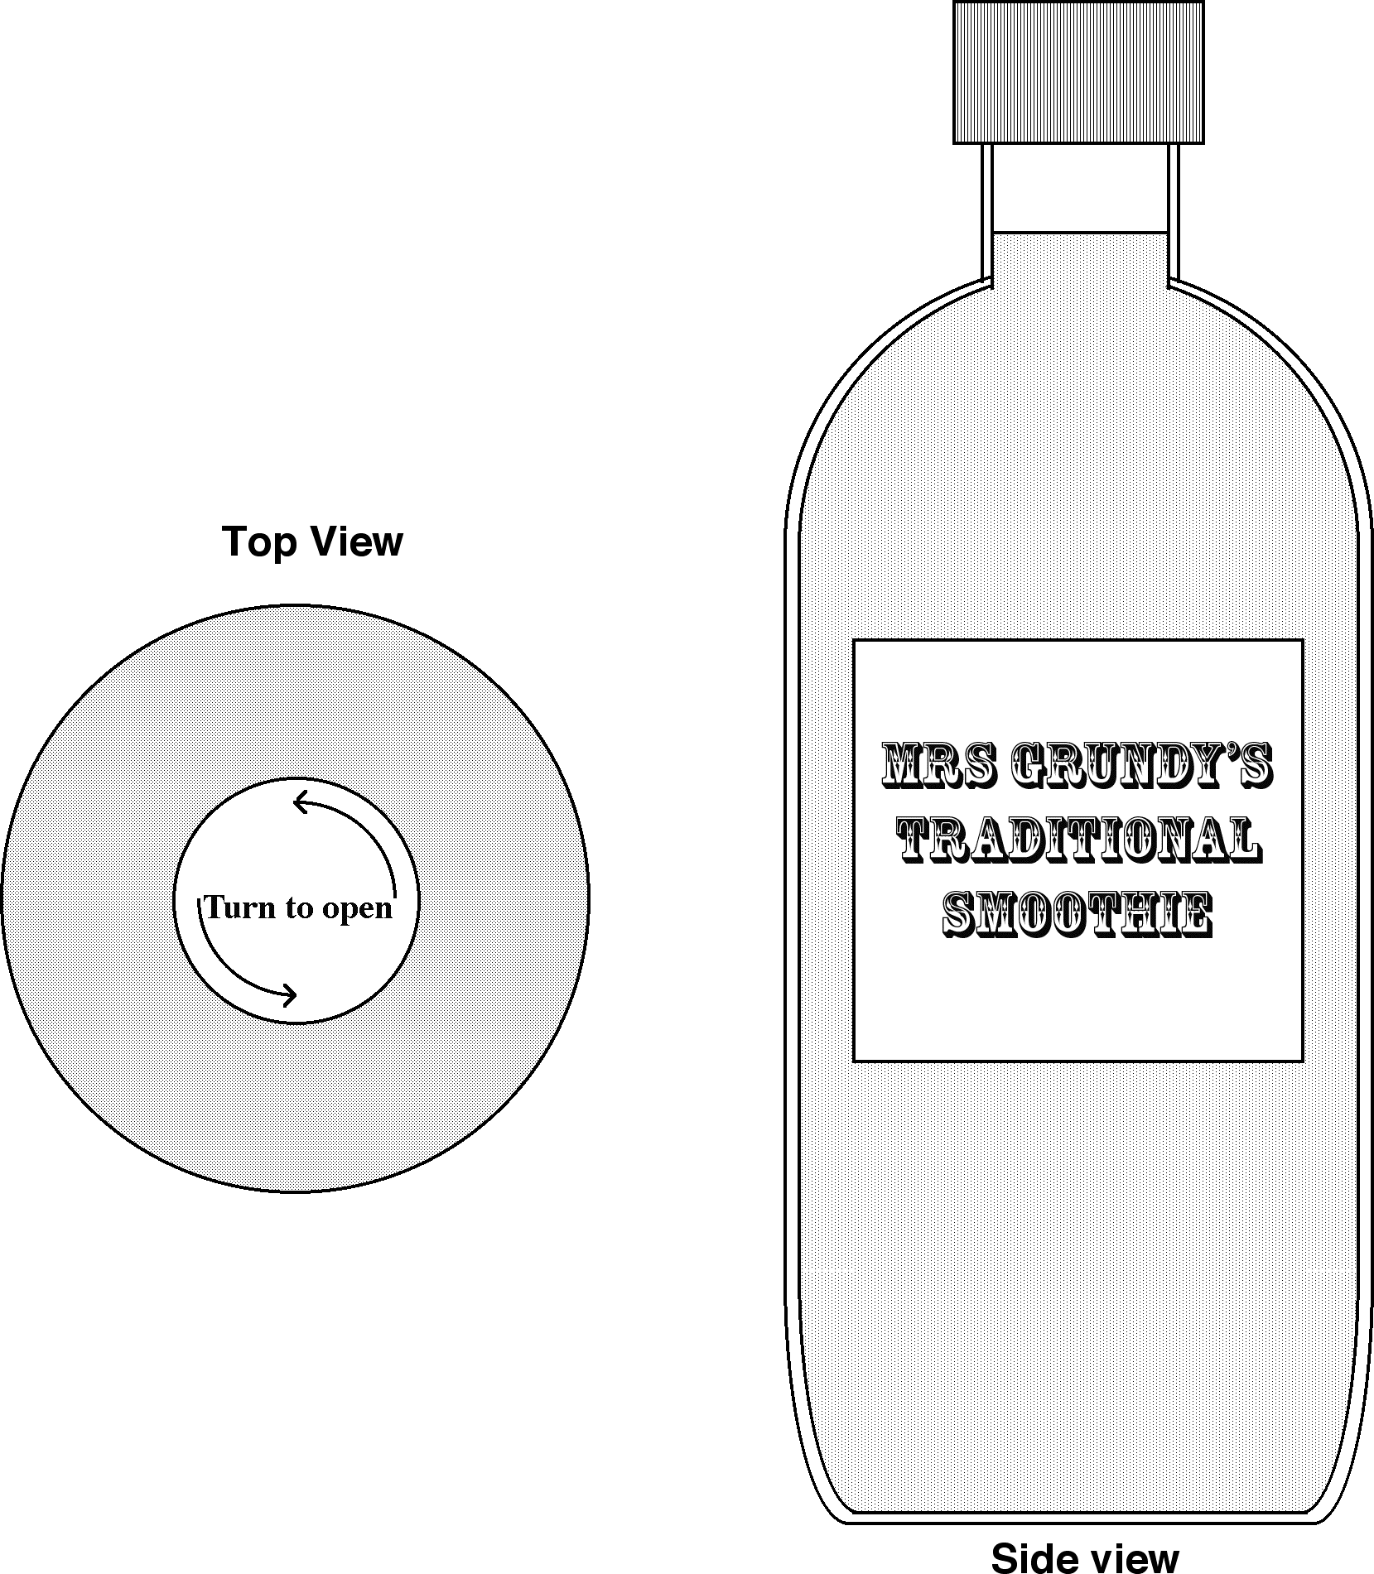

Design a net for a box that will hold twelve of these bottles. It should be a tight fit, so the bottles do not rattle about, and it also needs a lid.

You do not need to draw the net accurately, but label it to show all the measurements.

Assessment guidance

Progression in Key Processes

Representing | Analysing | Interpreting and evaluating | Communicating and reflecting
Choices about what to measure and to draw | Appropriateness and completeness of measurements made and transferred to box design | Quality of visualisation in two and three dimensions | Completeness and clarity of drawing including labels
Draws a simple view of the box from the side or top  PROGRE  S  S  I  ON  Pupil A | Takes measurements of the bottle and transfers some of them e.g. to a plan view  Pupil A | Visualises the box from the top or side  Pupil A | Draws a simple diagram with some measurements added  Pupil A
Identifies the parts of the bottle to measure and formulates some of the parts of a box design e.g. plan and side view  Pupil B | Transfers most of the measurements to a net e.g. to top and side view  Pupil B | Visualises the box from the top and side  Pupil B | Draws and labels a diagram but not a complete net  Pupil B
Identifies the parts of the bottle to measure and formulates most of the box design (eg may omit the lid)  Pupil C | Translates the appropriate measurements to a net, but with one or more wrong sizes  Pupil C | Net design suggests that it was not visualised folded - and may be missing a part such as a lid  Pupil C | Draws and labels a net, but not complete  Pupil C
Identifies all the parts of the bottle to measure and formulates a suitable net for the box  Pupil D | Translates the appropriate measurements to the net for the box  Pupil D | After designing the net, imagines it folded as a box  Pupil D | Completes a drawing of the net which is well labelled  Pupil D

Sample responses

Pupil A

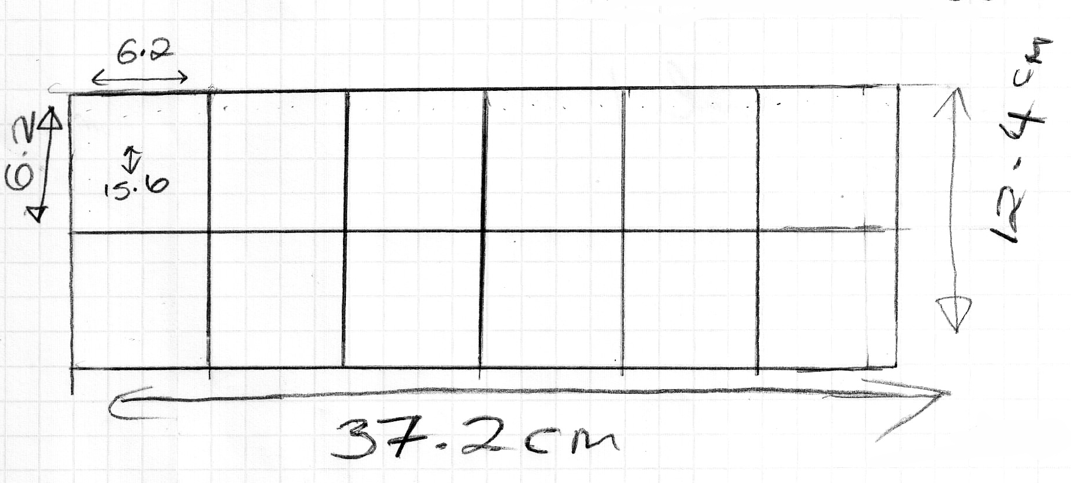

Comments

Pupil A has drawn a plan view of a suitable box. The measurements on the plan show that she has correctly measured the bottle. She does not attempt to draw a net.

Probing questions and feedback

- Look at one of the boxes I have brought in. How many sides does the box have?
- Now unfold the box so that it lies flat. How many different sides does it have?
- Imagine a box that can hold 12 bottles. Which part of the net have you drawn? Now draw the other parts of the box to complete your net.

Pupil B
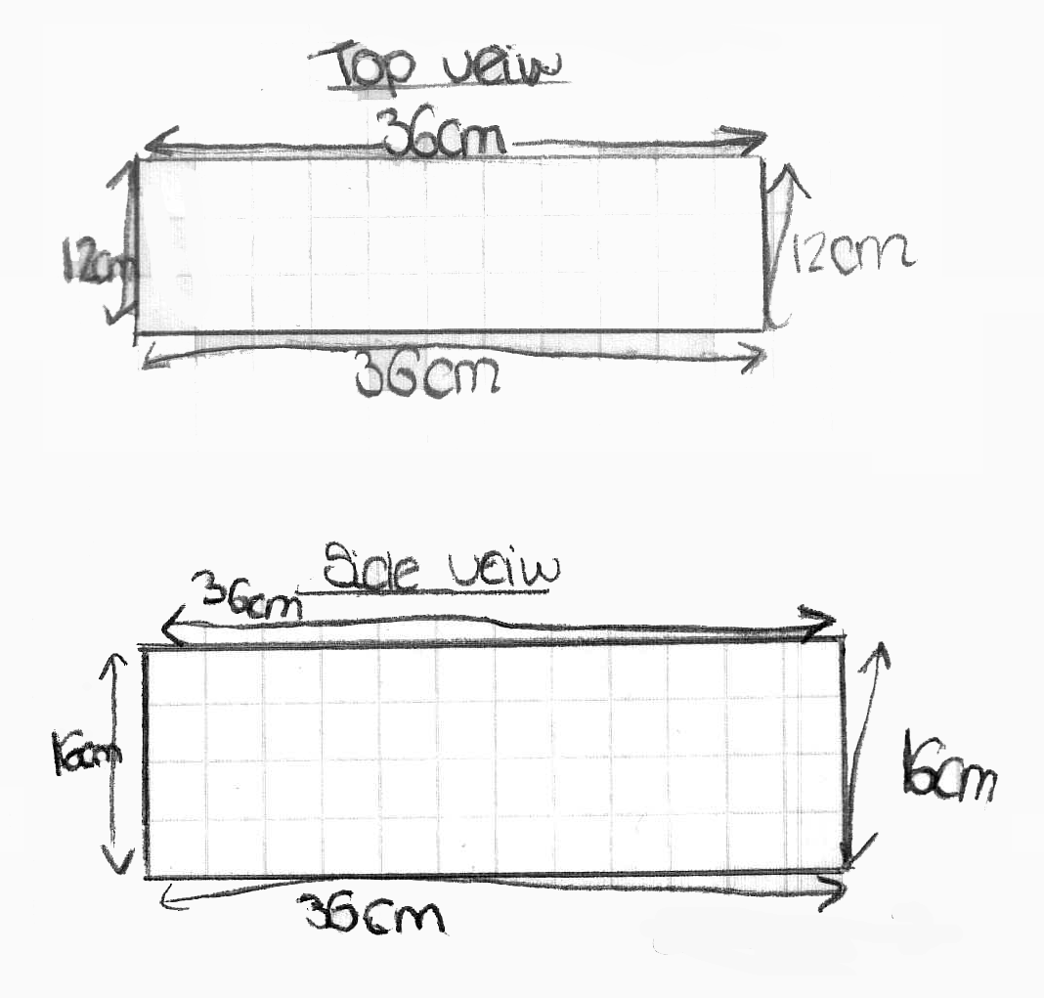

Comments

From the measurements of the top view and the side view, we can see that Pupil B has correctly measured the diagram of the bottle. She does not attempt to draw a net.

Probing questions and feedback
- Imagine a box with the top view and side view you have drawn. How many more sides do you need to draw to complete the net?
- How many different sides does a box have?

This pupil would benefit from unfolding a box so that she can see that the net of a box consists of six rectangles.

Pupil C

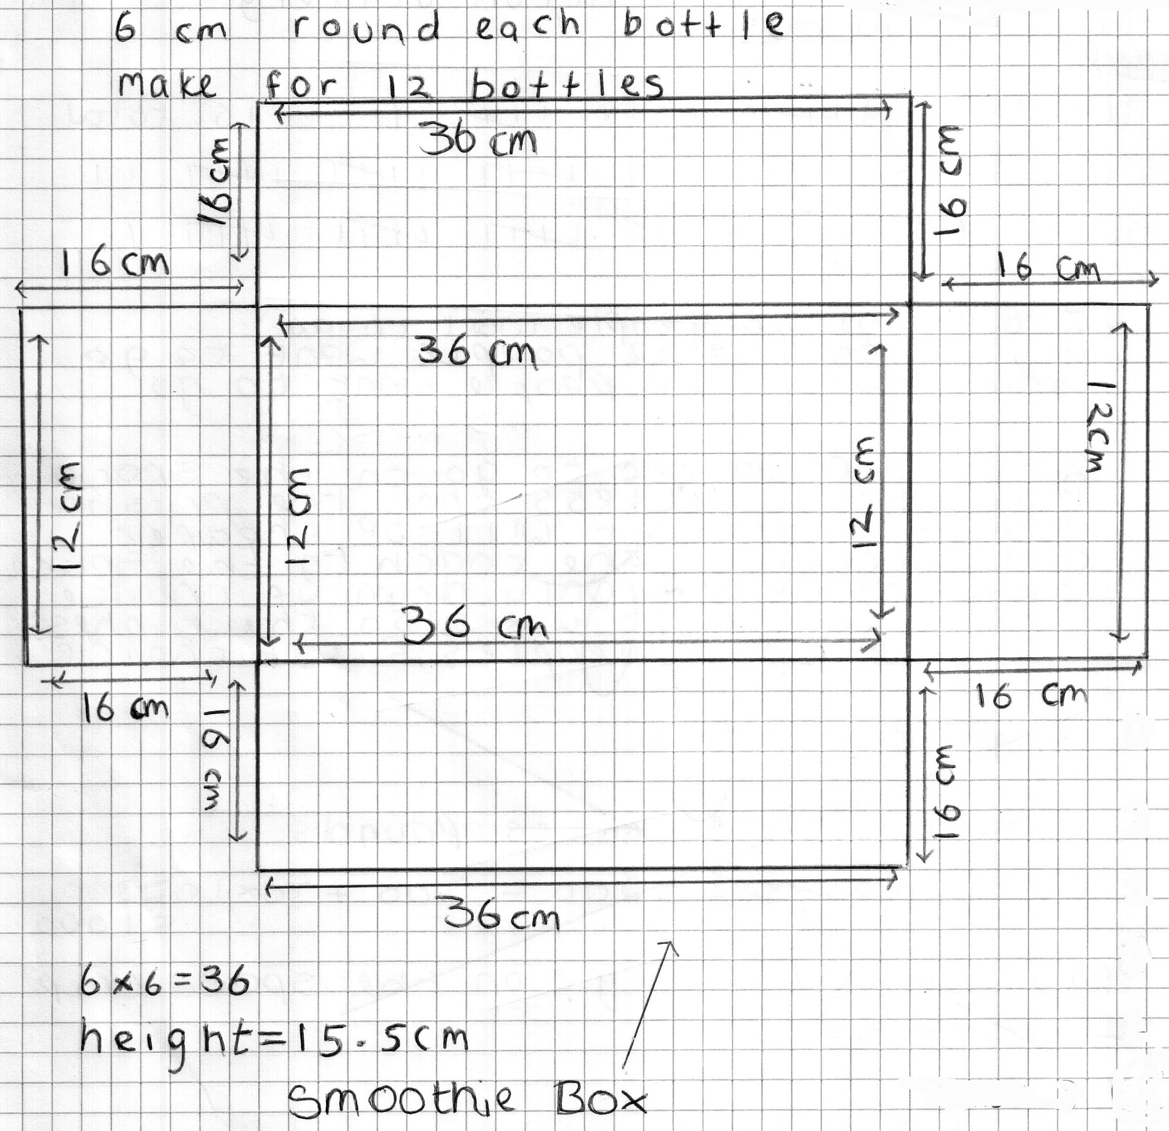

Comments

From his net of an open box, we can see that Pupil C has correctly measured the diagram of the bottle. He has arranged the bottles in a 2 by 6 array, but his box does not have a lid.

Probing questions and feedback
- Imagine your net folded. Is there a bit missing? What must be added to the net to complete it?
- What other arrangement of bottles could you have used?
- Would this use more or less material?

Pupil D

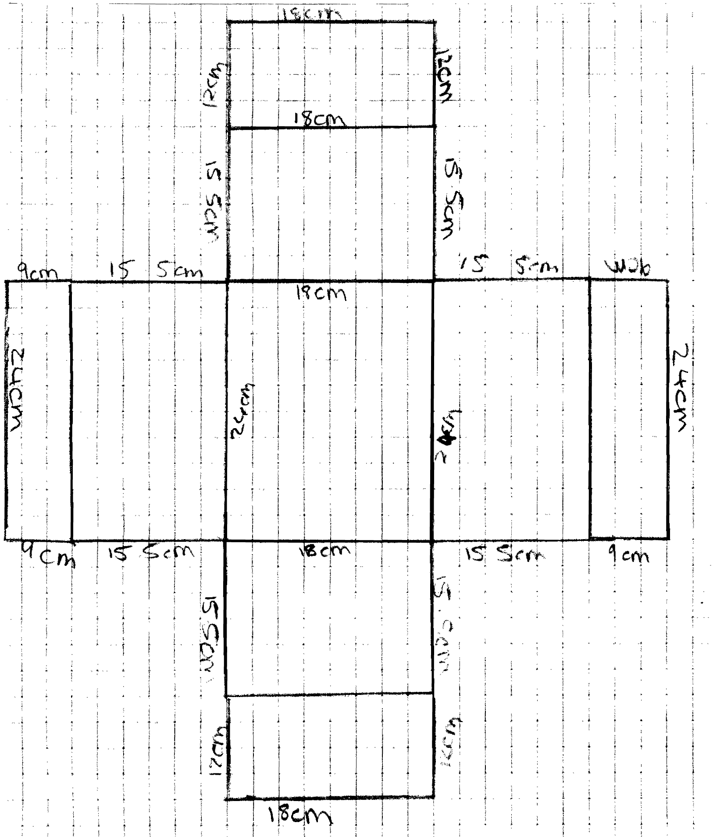

Comments

This pupil’s net of a closed box, shows that Pupil D has correctly measured the bottle. His closed box has two tops; one overlaps the other. He has arranged the bottles in a 3 by 4 array. His diagram clearly shows the dimensions of his net.

Probing questions and feedback
- If the box needed flaps so that it could be glued together, where would you put the flaps on the net?
- Would more or less material be needed for an array of 2 by 6 bottles?

