 | Security Camera

Task description

Pupils select the best position to put a security camera in a shop.
Suitability National Curriculum levels 4 to 7

Time 30 minutes to 1 hour

Resources Ruler, calculator, 1cm squared paper; spare copies of shop plan

Key Processes involved

- Representing: Draw correct sight lines to identify which parts of the shop are visible and which are hidden.
- Analysing: Find the percentage of the shop that is hidden and compare hidden areas from various viewpoints.
- Interpreting and evaluating: Vary the position of the camera systematically and evaluate each position, trying to minimise the hidden area.
- Communicating: Explain how they know that this is the best position.

Teacher guidance

Check that students understand the context, eg with pictures of security cameras from the internet and with questions such as:
- Have you ever seen a security camera in a shop or a bus? What did it look like?
- Some may not look like cameras at all, but like small hemispheres. .
- The drawing shows a plan view of the shop, which means we are looking down on the shop from above.

Pupils can tackle the task in different ways but they might be expected to:

- construct sight lines
- find the areas of triangles and quadrilaterals
- calculate fractions and percentages of areas

Security Camera

A shop owner wants to prevent shoplifting.

- He decides to install a security camera on the ceiling of his shop.
- The shop owner places the camera on the ceiling in the corner of the shop (at the point P).
- The camera can turn through 360°.
- The diagram below shows a plan view of the shop with ten people standing in it.

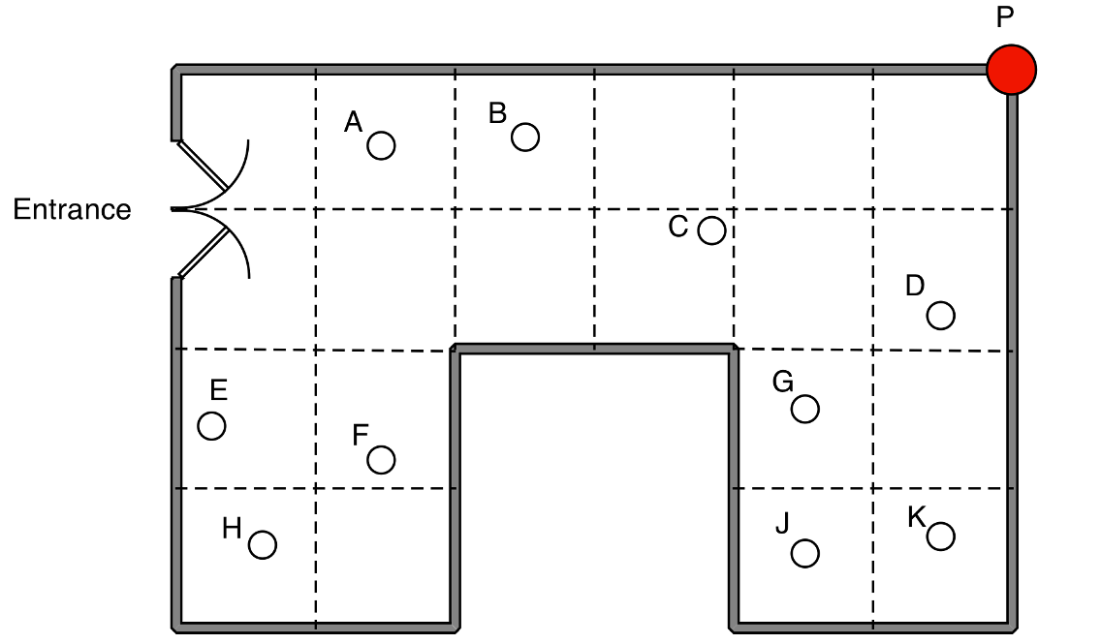

- Which people can the camera NOT see?

- The shopkeeper thinks that 15% of the shop is hidden from the camera.
Is he right or not? Explain.

- (a) What do you think is the best place for the camera, so that it can see as much of the shop as possible?
(b) How you know that this is the best place for the camera?

Assessment guidance

Progression in Key Processes

Representing | Analysing | Interpreting & Evaluating | Communicating & Reflecting
Use of sight lines or other approaches | Analysis of what the camera can ‘see’ | Choice of camera position | Quality of written communication of reasoning and solution
Does not draw sight lines; shows little evidence of selecting other suitable approaches  PROGRE  S  S  I  ON  Pupil A | Realises that the camera at P cannot see some people or squares, possibly with errors | Considers another place for the camera but it is not optimal. Gives no reason - or a reason that does not involve numbers.  Pupil A | Adequately communicates the method and solution, but not completely.  Pupil A
May not draw sight lines may but shows some evidence of selecting other suitable approaches  Pupil B | Gives a partially correct analysis with some justification, but with errors. May realise that F and H cannot be seen but may also think that E cannot be seen  Pupil A | Has some idea where a better place for the camera is e.g. ‘above B on ceiling’ | Clearly communicates the work, with reasoning that can be followed  Pupil B
Uses sight lines in some parts of the work.  Pupil C | Gives a mostly correct justification for why 15% of the room cannot be seen from P. May think 3 whole squares, rather than an area equal to 3 squares, cannot be seen from P  Pupil B | Correctly finds a better place for the camera, but justification incomplete  Pupil B | Clearly communicates the work, with reasoning that can easily be followed
Selects and uses sight lines in all parts of the work to get accurate answers  Pupil D | Finds the correct percentage of the shop that is hidden using parts of squares accurately.  Pupil C | Successfully compares areas from various viewpoints and finds an optimal point.  Pupil D | Explains work clearly and considers alternative solutions  Pupil D

Sample responses

Pupil A

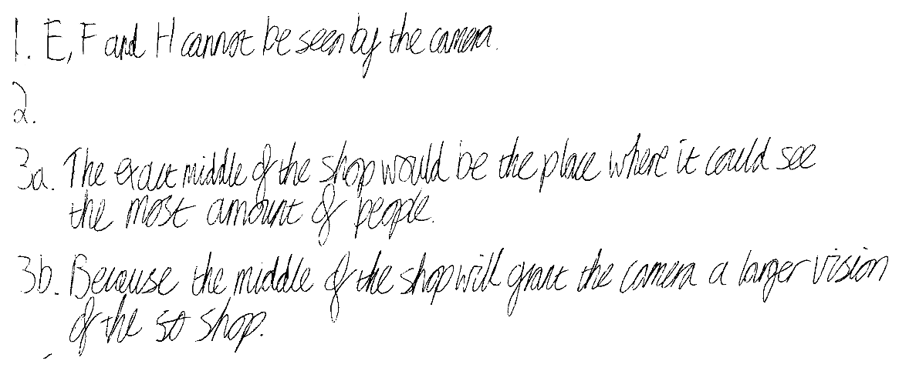

Comments

Pupil A realizes that F and H cannot be seen, but incorrectly thinks that E also cannot be seen. He does not show any work to justify his thinking and his further statements are incorrect.

Probing Questions and feedback

- How do you know which parts of the shop cannot be seen by the camera?
Can you shade this part on the plan somehow?
- When the camera is in the middle of the shop, which parts cannot be seen now? Can you shade this part on the plan?
- What fraction of the shop is hidden in both cases? Which fraction is bigger?
- Can you now find a better place for the camera?

Pupil B

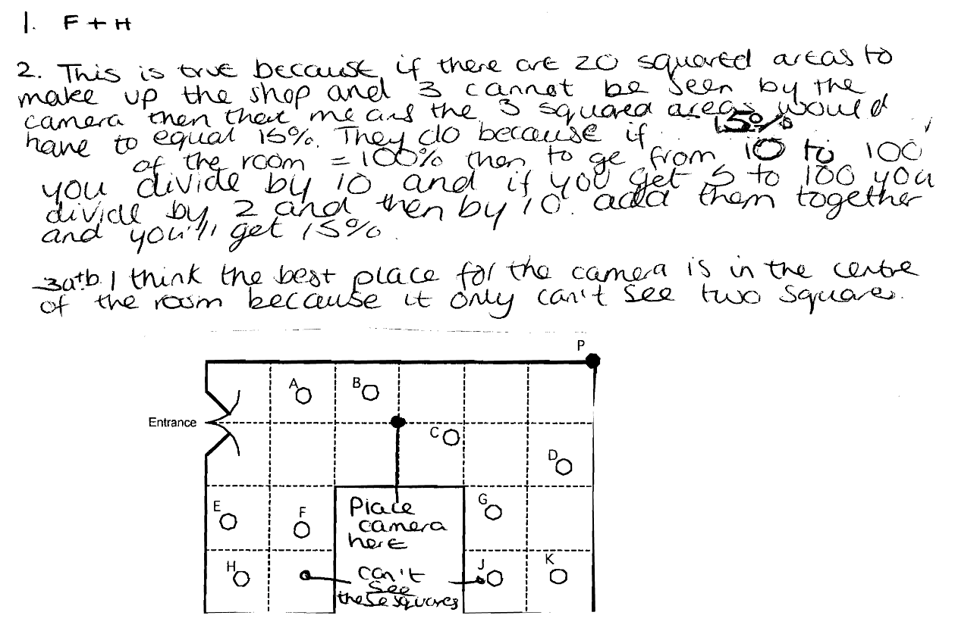

Comments
Pupil B does not show any sightlines to justify her answers. She correctly states that F and H cannot be seen and that 3 squares cannot be seen – although she may be thinking of whole squares rather than areas. Her justification for 15% is incomplete and poorly explained. She seems to have some understanding that 5% is one twentieth and 10% is one tenth.

Probing questions and feedback

- Which parts of the shop cannot be seen by the camera at P?
Can you shade these parts on the plan somehow?
- Can you explain your thinking about the 15%?
- Can you shade in the parts of the shop that cannot be seen from the centre of the room? What fraction of the shop is this?

Pupil C
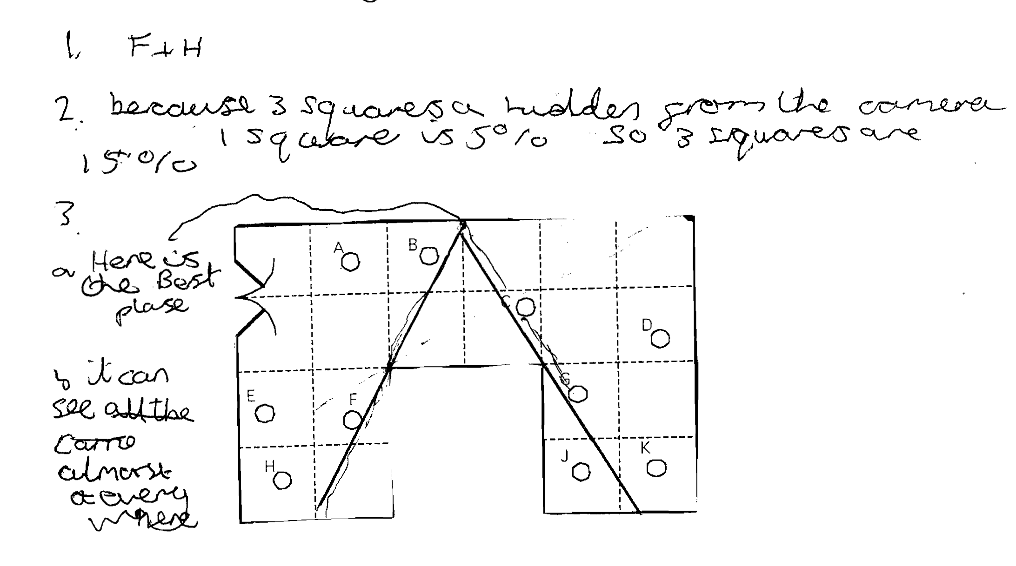

Comments
Pupil C correctly states that F and H cannot be seen and that 3 squares ( = 15% of the area) cannot be seen. It is possible that he thinks that 3 whole squares are hidden from the camera. He investigates the best place for the camera, and shows that the centre of the long side is good but he does not investigate further. No calculations are shown.

Probing questions and feedback
- Why do you think that exactly 3 squares cannot be seen by the camera?
- Can you explain your thinking about the 15%?
Now please write that reasoning down?
- How can you be sure you have found the best place for the camera? Are there any other better places better - or at least as good?
- If you drew a more accurate diagram it would help you.

Pupil D

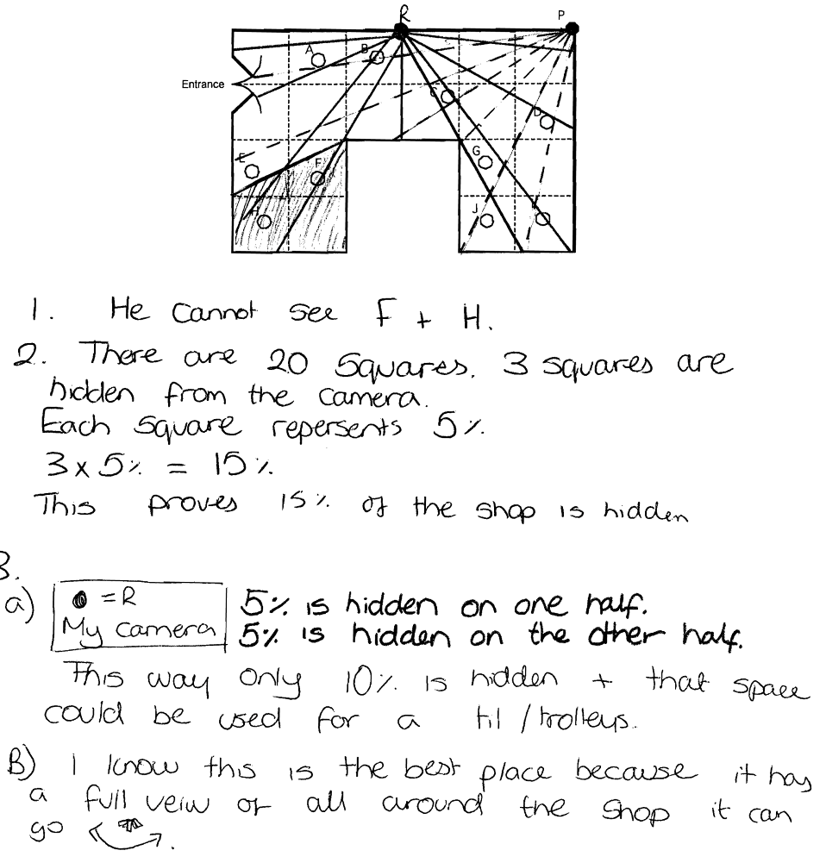

Comments
Pupil D correctly shows that F and H cannot be seen and that 3 squares = 15% of the area cannot be seen. She investigates the best place for the camera, and shows that the centre of a side is good. She shows diagrams with sightlines and calculations that justify her findings.

Probing questions and feedback

- Please explain why you think that 3 squares are hidden from the camera at P
- How can you be sure you have found the best place for the camera?
- Are there any other places that are equally as good?
- What would happen if you moved R along the back wall?
- Would the hidden percentage vary?

