 | Royal Liver Clock

Task description
Pupils apply their knowledge of circles and show their ability to estimate appropriately.

Suitability National Curriculum levels 6 to 8

Time About 45 minutes

Resources Paper and calculator

Key Processes involved

- Representing: Show their understanding of the problem.
- Analysing: Use logical reasoning and make calculations.
- Interpreting and evaluating: Consider the appropriateness and accuracy of their solution in the context of the task.
- Communicating and reflecting: Present their arguments clearly.

Teacher guidance

You may wish to set the scene by showing the slides on a whiteboard, with the comments:

- This task is to estimate the numbers of people who could sit round the two large clock faces of the Royal Liver Building in Liverpool and Big Ben in London.
- You are given some facts to help you and some clues on where to start.

The task requires proportional reasoning and knowledge of circumference of circles. During the work, the following probing questions may be useful:

- How can you work out how much space you need to allocate to each person? Are there different ways?
- How confident are you that your estimate of the number of people is realistic?
Pupils could estimate the proportion of the face shown in the photograph and use that to estimate the number of people round the whole clock face, or they could use the photograph to estimate directly the number of people per metre or per foot. In addition, pupils should show appropriate rounding and consider accuracy.

The information below may be helpful when assessing pupils’ work.
 | Diameter (m) | Diameter (feet) | Circumf. (m) | Circumf. (feet)
Royal Liver | 7.62 m | 25 ft (given) | 23.94 m | 78.53 ft
Big Ben | 7 m (given) | 22.97 ft | 21.99 m | 72.16 ft

Royal Liver Clock

This task is about two large circular clocks on famous buildings.

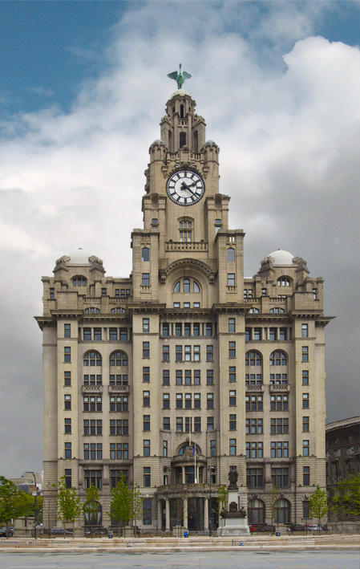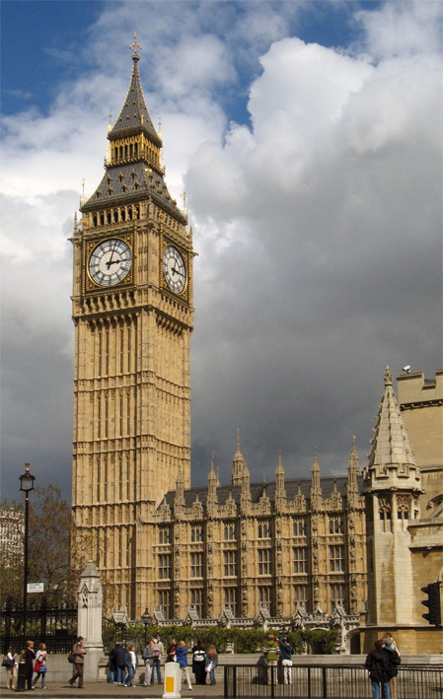
Royal Liver, Liverpool
Big Ben, London

Over 100 years ago, one of the clock faces of the Royal Liver building was used as a dining table.
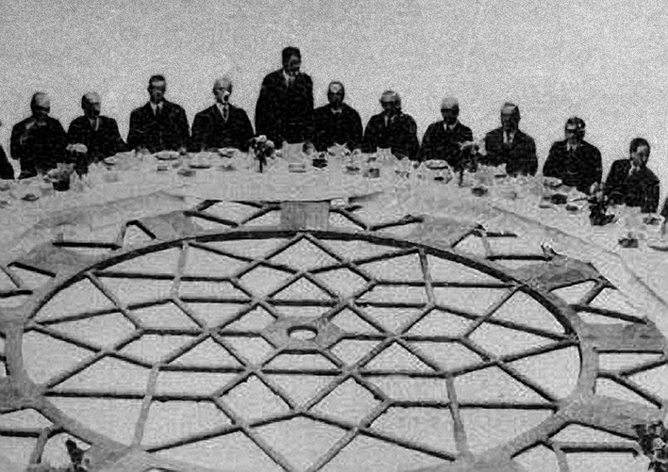
The centre of the
circular clock face.

This is a photograph of some of the people who sat round the table.

Estimate how many people you think could sit round the complete face of the Royal Liver clock. Why do you think your estimate is roughly right?

Now use your answer to estimate the number of people who could sit around Big Ben.

Facts: The diameter of the clock face of the Royal Liver is 25 feet.
The diameter of the clock face of Big Ben is 7m.
10 feet = 304.8 centimetres

Assessment guidance

Progression in Key Processes

Representing | Analysing | Interpreting and Evaluating | Communicating and reflecting
Understanding the problem | Logical reasoning, calculations | Appropriateness and accuracy of their solution | Clear communication and presentation of arguments
Makes a reasonable estimate of a length or an angle in the clock picture  PROGRE  S  S  I  ON | Correctly converts between metres and feet (any length except 10 feet)  Pupil A | Shows an awareness that their answer is not an accurate result  Pupil B | Shows methods, using correct units, so that their reasoning can be followed  Pupil A
Uses simple proportional reasoning,  eg to find the total number of people round the Liver clock  Pupils A and B | Correctly calculates the circumference of either clock face as part of their solution  Pupil B | Checks the reasonableness of their answer | Shows methods clearly in a solution that ‘flows’, using correct mathematical language and correct units  Pupil B
Uses their answer for one clock face as the basis of their (correct) calculation for the other  Pupil C |  | Compares their answers for both clocks in an attempt to check reasonableness  Pupil C | Explains their methods using appropriate diagrams, symbols and text  Pupil C
Uses an efficient method, eg uses the ratio of diameters to find the answer for Big Ben |  | Shows insight,  eg relates the accuracy of their answer to the accuracy of their original estimates, or attempts to calculate maximum and minimum bounds | Notes that the number of people is proportional to the diameter as well as to the circumference, and explains why

Sample responses

Pupil A
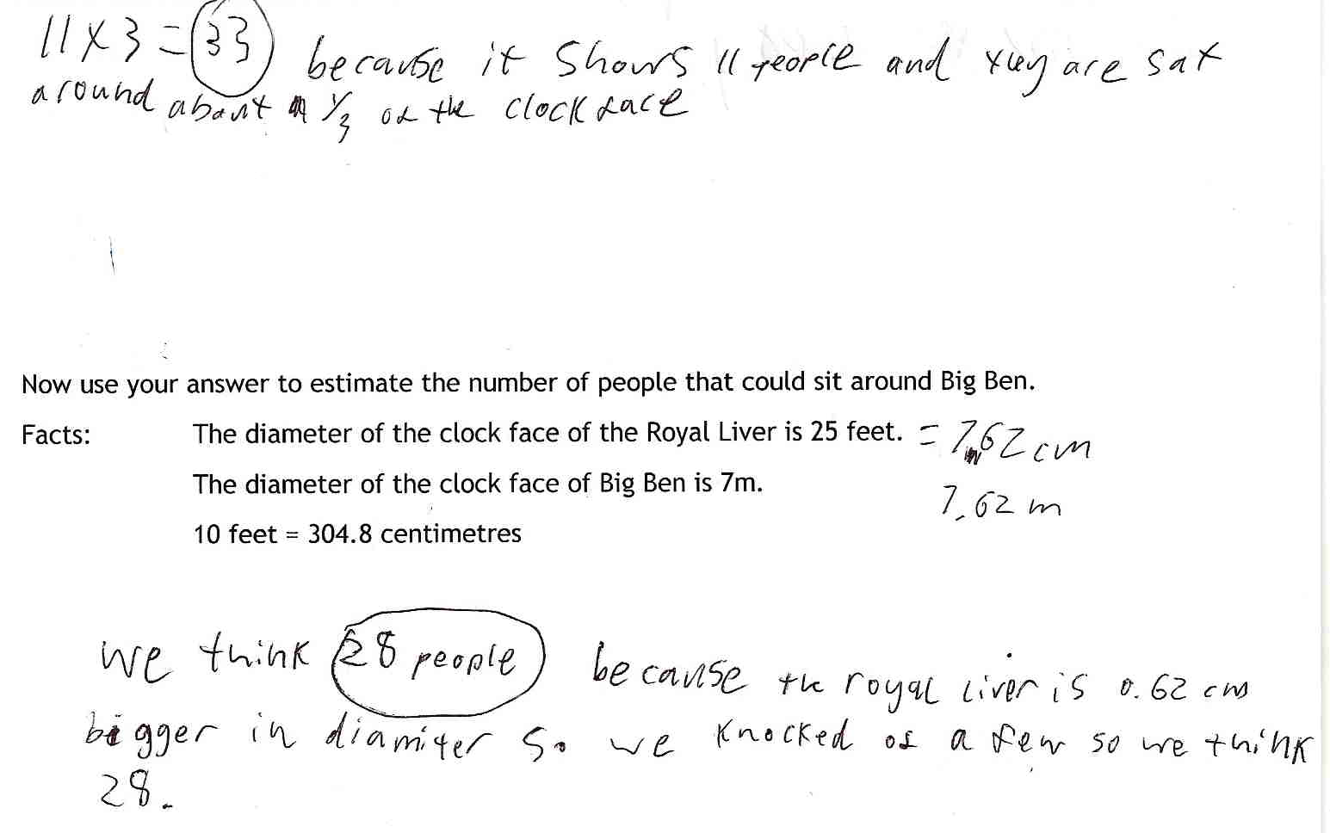

Comments

Pupil A shows clear engagement with the problem; he correctly converts 25 feet to 7.62 metres and then uses it. His work on the first question uses simple proportionality, but the solution for Big Ben is more of a guess, suggesting a lack of confidence with more complex proportional reasoning. He shows his reasoning for each answer and units are correct; diameter is used for circumference, suggesting more work is needed with circles.

Probing questions and feedback

- How accurate do you think your first answer is?
- You reached your second answer by ‘knocking off a few’ to get the value 28. What other way could you use to get a better estimate?

Further work needed on proportional reasoning as well as on circles.

Pupil B
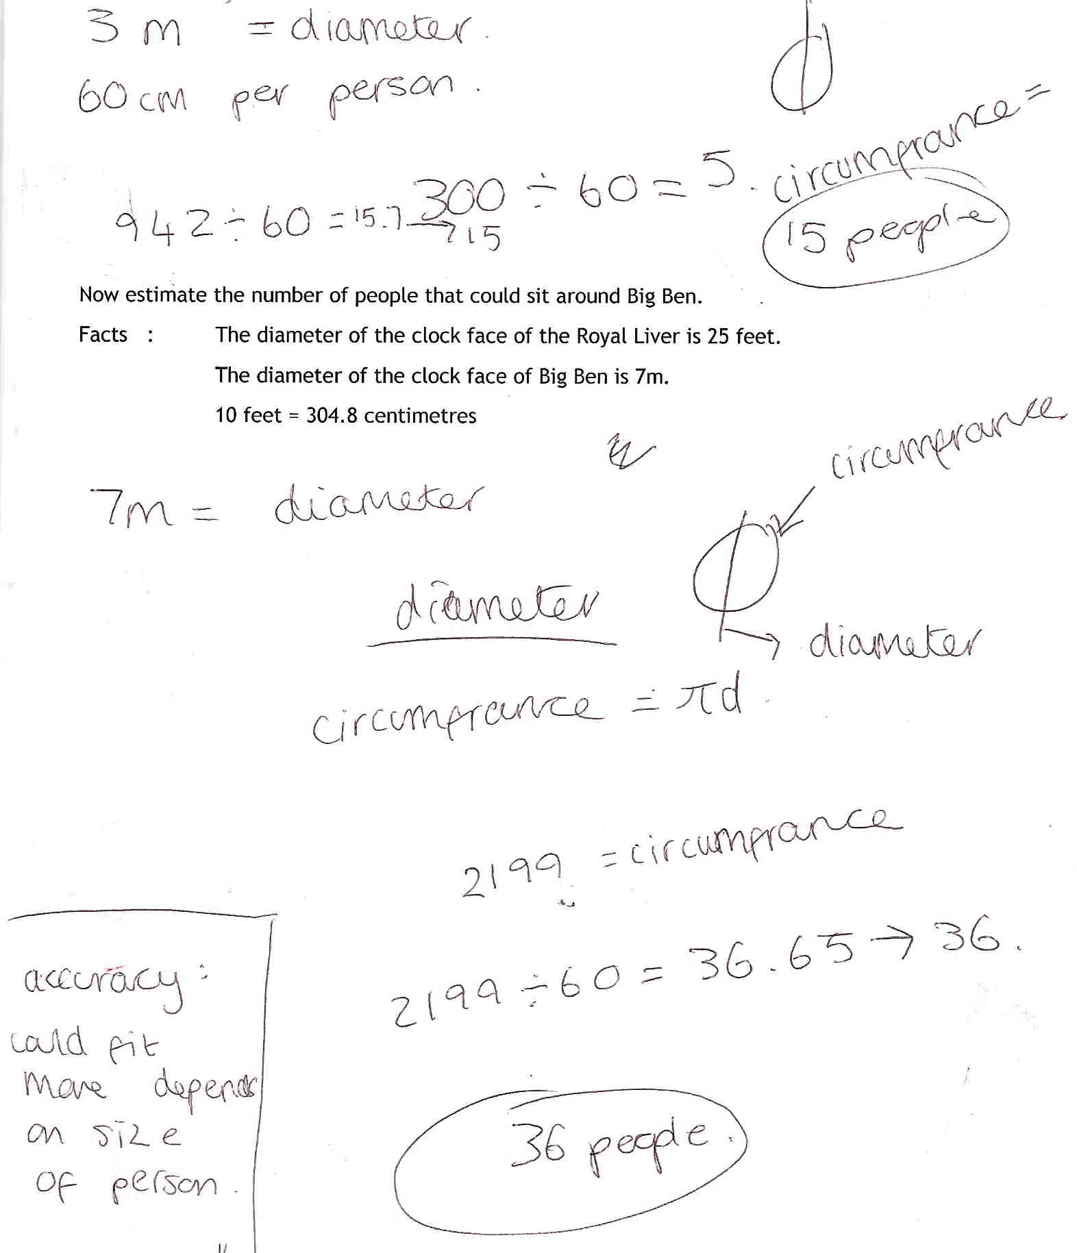

Comments
Pupil B discussed the amount of space a person requires with the teacher; he states that 60 cm is reasonable based on his measurements. The estimate of a total of 15 people ignores the fact that 11 or 12 people can be seen in the photograph. The calculation for Big Ben shows correct conversion of units and correct circumference. Reflection on his solution is shown by his rounding down his answer and the comment on accuracy. He did not compare the number with the Royal Liver, a larger table.

Probing questions and feedback

- When you reach a solution, look back to see if your answer is reasonable – in this task you decided that more people could sit round the smaller table than the bigger one!

Further experience needed of multi-stepped tasks, for example in a Bowland case study (such as Reducing Road Accidents or You Reckon) which require taking a range of factors into account and then analysing the reasonableness of solutions.
Pupil C
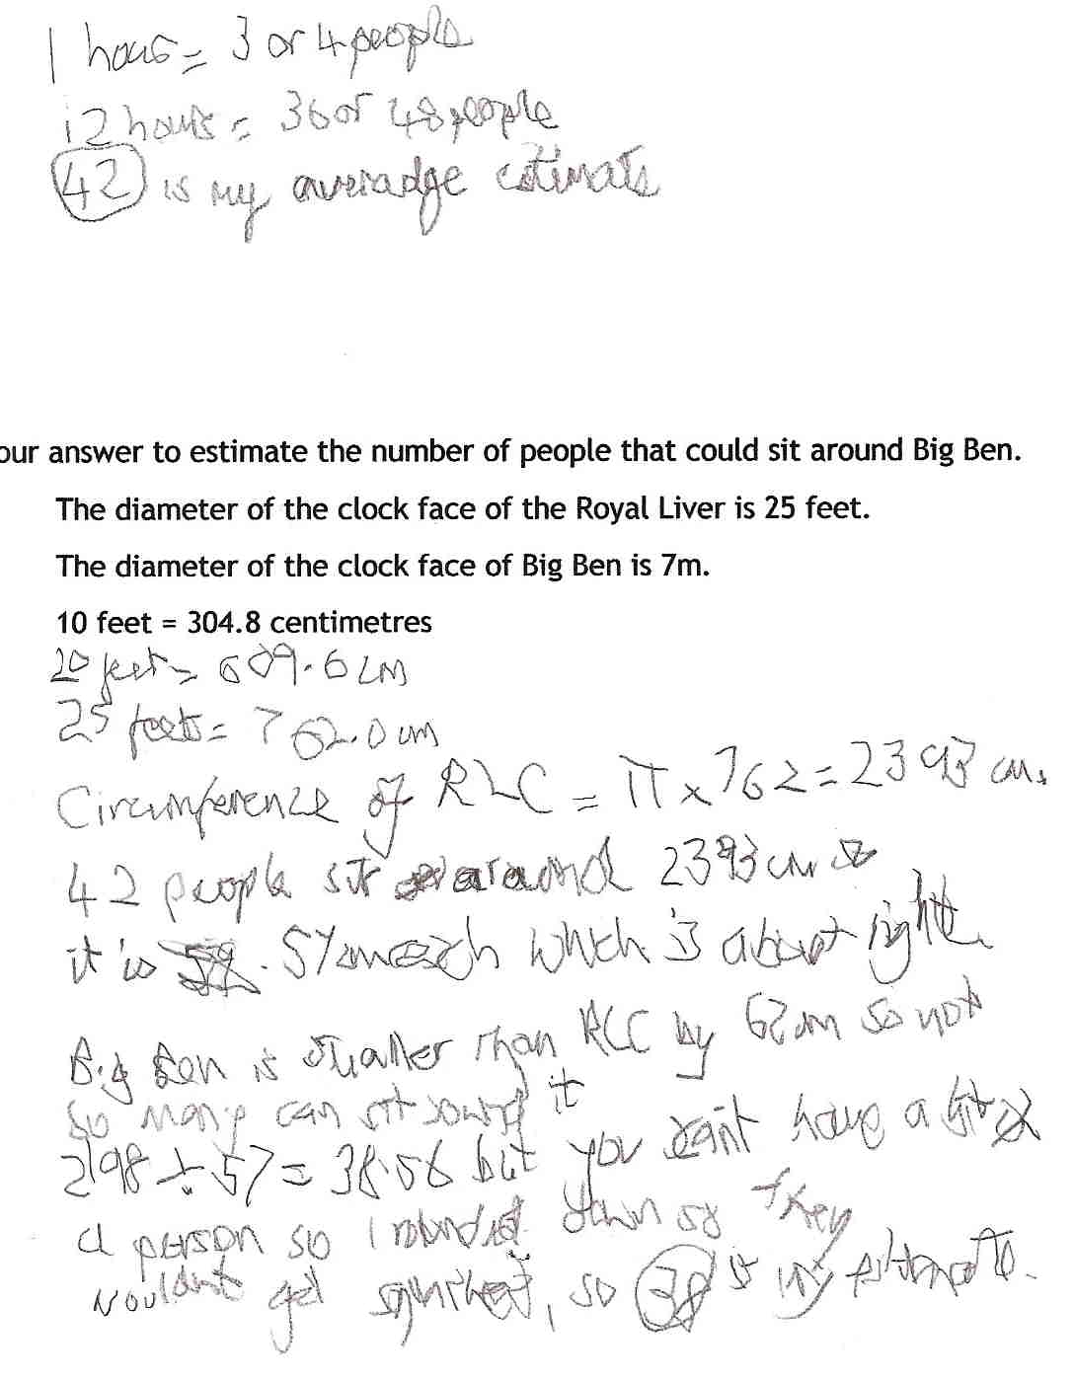
Transcription

1 hour = 3 or 4 people
12 hours = 36 or 48 people
42 is my average estimate

20 feet is 609.6 cm
25 feet is 762cm

Circumference of RLC = π × 762 = 2393 cm.
42 people sit around 2393 cm
it is 57cm each which is about right.

Big Ben is smaller than RLC by 62cm so not
so many can sit round it.
2198 ÷ 57 is 38.56 but you can’t have a bit of
a person so I rounded down so they
wouldn’t get squashed, so 38 is my estimate.

Comments

A transcript is provided as Pupil C has eye-hand coordination problems.

Pupil C uses the hours on the photograph to estimate people per hour, correctly converts 25 feet to metres and then finds the circumference of both clocks. He shows awareness of the relationship between the clocks, suggesting that both answers have been compared to ensure reasonableness. Throughout, he rounds appropriately, relating his findings to the context of the question. His work is clearly laid out with all steps shown.

Probing questions and feedback

- When you work on a problem, look for efficient methods wherever possible, using what you know about mathematics. For example, could you have used your knowledge of proportionality more effectively?

A series of further multi-stepped tasks, with progressively less supporting information, would encourage pupil C to build on his achievements in this task, and extend his ability to apply maths in the real world.

