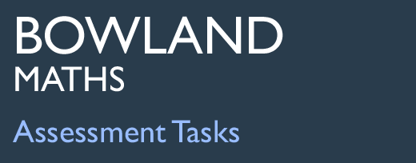 | Rods and Triangles

Task description

Pupils work with the properties of triangles through combining a range of rods to make different types of triangle.

Suitability National Curriculum levels 4 to 7

Time About 30 minutes

Resources Paper, compasses, angle measurer, ruler

Key Processes involved

- Analysing: Identify the triangles, showing the properties of the side lengths and describing the angles; justify their responses through mathematical diagrams or other means.
- Communicating and reflecting: Present work so that others can follow the reasoning.

Teacher guidance

You may wish to introduce the task by showing the slides on a whiteboard.

- You are asked to combine rods to make as many different triangles as you can.
- You are given the length of the rods and two examples of triangles you can make.
- Use everything you know about triangles and present your work so that it can be understood – and the reasons for what you are doing.
- Don’t forget to look for a combination of rods that cannot be made into a triangle
The task requires knowledge of properties of triangles and simple geometric construction. Justification should be given for any reference to acute, obtuse or right-angled triangles. During the work, the following probing questions may be helpful:
- What types of triangle do you know? What are the properties of each type?
- How can you check whether three rods can or cannot make a triangle?
- How can you convince me that a triangle must be right-angled?

Six different types of triangle can be made using the rods:
Scalene, eg using rods of 4, 6 + 8 cm
Isosceles, eg using rods of 6, 2 + 4, 8 cm
Equilateral, eg using rods of 4 + 6, 2 + 8, 10 cm
Acute(-angled), eg using rods of 8, 4 + 6, 2 + 10 cm
Obtuse(-angled), eg using rods of 4, 6, 8 cm
Right(-angled) eg using rods of 6, 8, 10 cm

Rods and Triangles

Here are five rods of different lengths; they are drawn half size.
6cm
10cm
2cm
4cm
8cm

The rods can be joined end-to-end to make triangles; here are two examples

4cm
8cm
10cm
6cm
10cm
8cm
4cm

Each of these triangles is …
- scalene (because all its sides are different lengths).
- obtuse (because one of its angles is greater than 90°).

Combine the rods to make as many different types of triangle as possible.
What are the different types of triangle can you make?
What properties does each triangle have and how do you know?
Also find a combination of rods that cannot make a triangle, and explain why not.

Assessment guidance

Progression in Key Processes

Analysing (i) | Analysing (ii) | Analysing (iii) | Communicating and reflecting
Connections made with what they know by focusing on side lengths and angles  PROGRE  S  S  I  ON | Accurate mathematical diagrams | Understanding constraints | Clear communication throughout the task and reflections on findings
Correctly names equilateral and isosceles triangles, explaining the relevance of their side lengths. Refers, albeit simplistically, to right angles  Pupil A | Accurately draws rods full size or half size |  | Names triangles and identifies clearly which rods are being used  Pupils A and B
Is explicit about the properties of the side lengths of isosceles and equilateral triangles.  States that the angles in the equilateral triangle are 60 degrees  Pupil B | Draws at least one triangle accurately, even if using trials  Pupil B | Identifies a triangle that cannot be made | Diagrams are accurate with clear and logical reasoning  Pupils C + D
Is explicit about the properties of the side lengths and angles of isosceles, equilateral and right-angled triangles. Uses simple angle facts | Accurately constructs, using compasses, a triangle made from the rods | Identifies a triangle that cannot be made, and explains why  Pupils C + D | Throughout the task, presents work clearly, thoroughly, effectively and concisely
Uses Pythagoras’ theorem to justify a right-angled triangle  Pupils C + D | Uses the best method for justification,  eg Pythagoras for right-angled triangles, or construction in other cases |  | Throughout the task clear, effective and concise communication with evidence of reflection

Sample responses

Pupil A
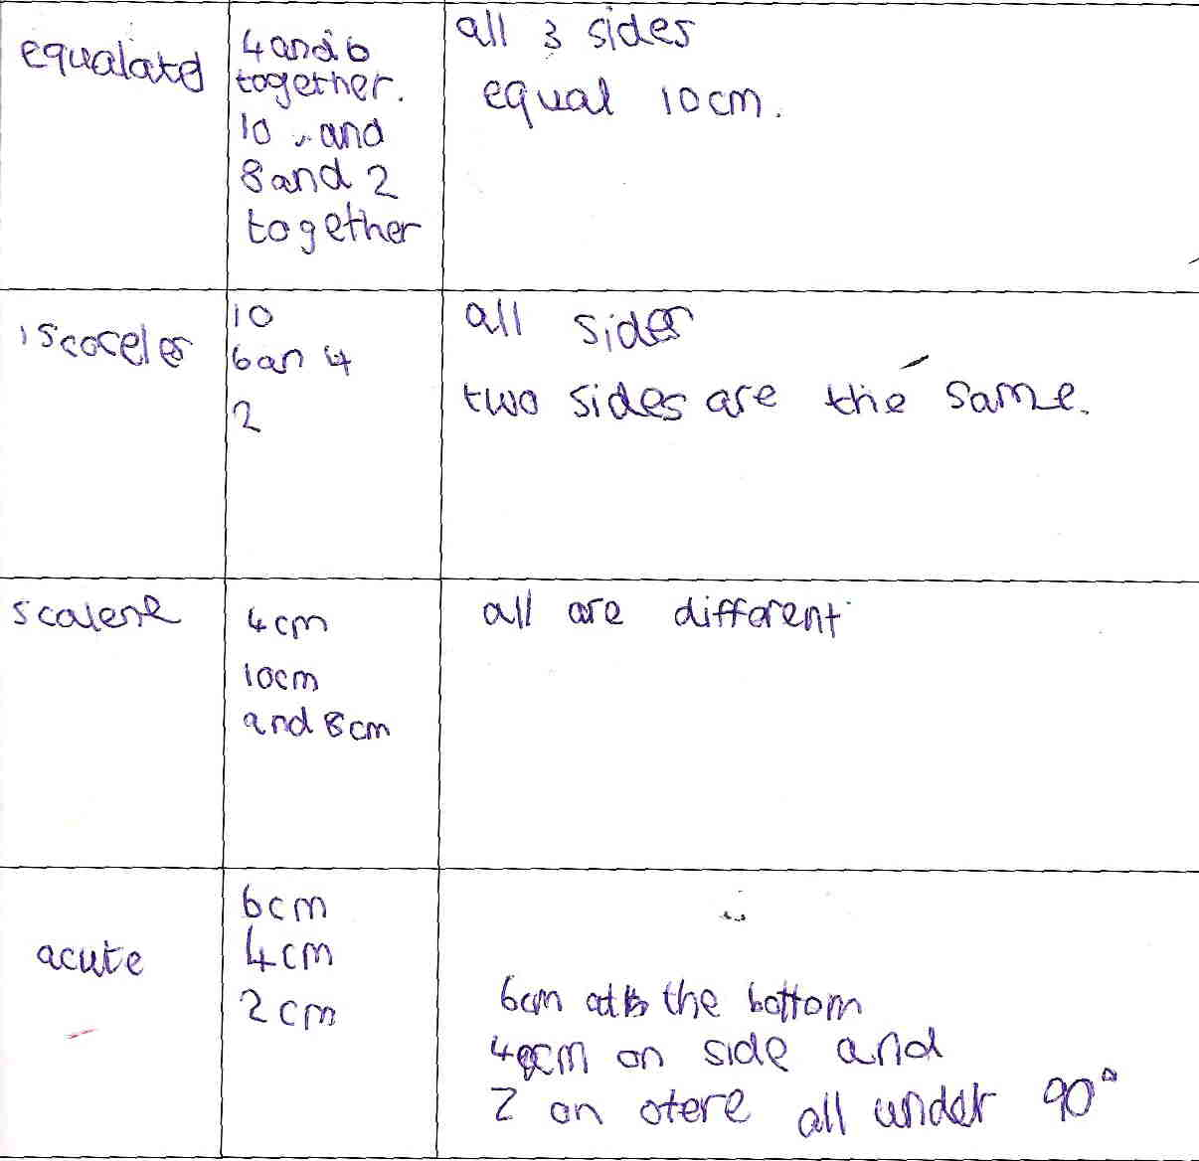

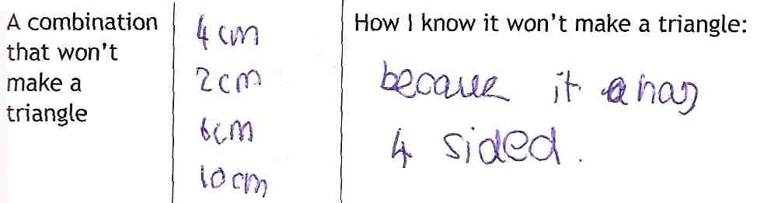

Comments

Pupil A understands some properties of equilateral and isosceles triangles, and uses the vocabulary correctly. His fourth ‘triangle’ is wrong as (6, 4, 2) is not possible. The teacher adapted the presentation to draw his attention to the need to find a combination that cannot make a triangle, but he responded in an unexpected way!

Probing questions and feedback

- When working on a task about shapes, think about properties other than length – for example, could you use what you know about angles?
- Also think about how you present your work. Would it help to show diagrams of the triangles you constructed?

Pupil A might benefit from revisiting this task, focusing on angles rather than lengths of sides. He could then undertake a similar task, choosing for himself the length of rods, and finding which triangles are possible and which are not.

Pupil B
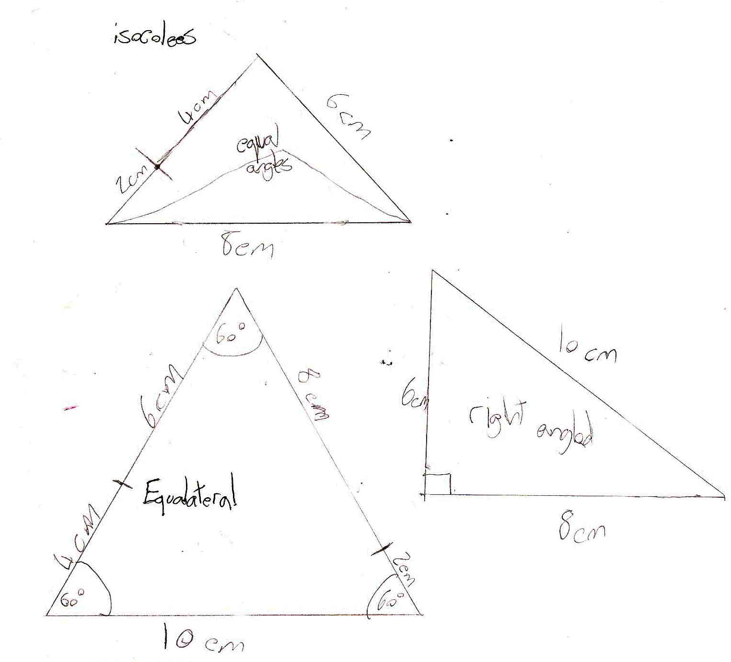

Comments

Pupil B was identified by his teacher as working at level 7, but he does not bring together different aspects of their knowledge such as accurate construction and the use of Pythagoras’ theorem. He identifies only three types of triangle and draws them; his methods of drawing the isosceles and equilateral triangles are not shown but are accurate. The (easiest) right-angled triangle is less accurate. Although communication is minimal, sides are labelled and triangles are named; he makes no attempt to identify a triangle that cannot be made.

Probing questions and feedback

- When working on a task, think back to other work you have done.
- How could you use a pair of compasses to produce accurate triangles?
- Or Pythagoras’ theorem to justify that the triangle you say is right-angled really is.
- A good mathematician brings together all his/her knowledge …’

Pupil B would benefit from further tasks in which he was required to identify mathematical elements of a problem. Further Bowland tasks, such as Three of a Kind would encourage him to use his knowledge, as would Bowland case studies such as Product Wars.

Pupils C and D

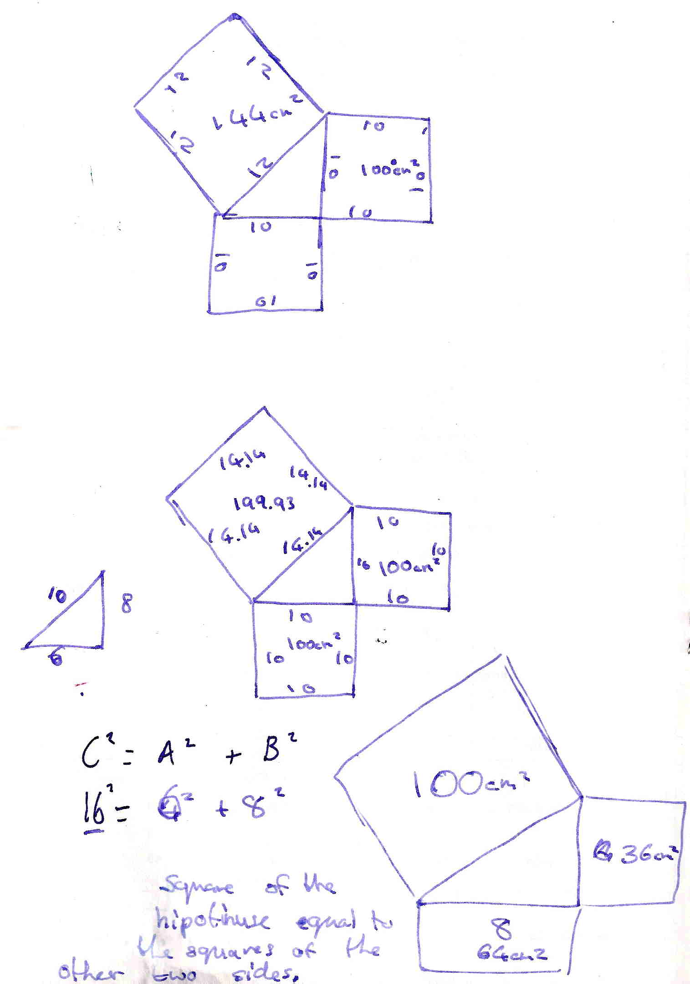
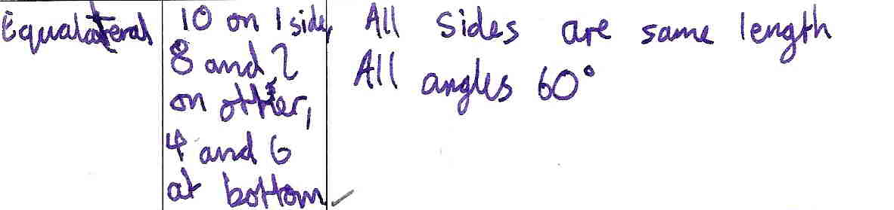
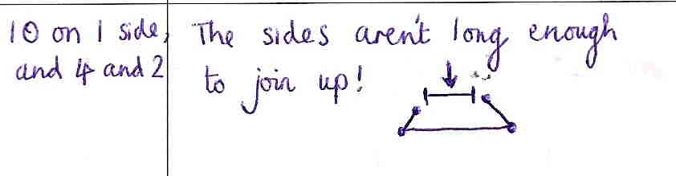

Comments

This work took Pupils C and D most of a lesson to complete; it was consolidation of work completed some weeks previously. They show the properties of an equilateral triangle, and explain why side lengths 10, 4 and 2 cm will not make a triangle. Communication is reasonably effective. They recognise the need to prove a triangle is right-angled by using Pythagoras and correctly explain what they did. The pupils were excited and proud of what they had done, saying that they better understood Pythagoras’ theorem and were looking forward to working on it in the future.

Probing questions and feedback

- Using previous knowledge, as you did, is very good. Do that in tasks in the future, and try to use even more previous knowledge, for example, for this task you could also have used accurate construction.

Working together again, exploring triangles and shapes, would encourage these pupils’ enthusiasm and pleasure in achievement. Bowland case studies, such as You Reckon, would be a good vehicle to extend their learning from this into other areas of maths.

