 | Public Transport

Task description

Pupils analyse a newspaper article, evaluating its (mathematical) claims and identifying its flaws.

Suitability National Curriculum levels 5 to 8

Time 30 to 45 minutes

Resources Paper and calculator

Key Processes involved

- Interpreting and evaluating: Analyse the information presented in the article and evaluate its truth
- Communicating and reflecting: Communicate findings by writing a letter to the Editor of the newspaper, explaining why the article is misleading.

Teacher guidance

To help pupils understand the task, you might begin by showing it on a whiteboard and commenting:

- For this task you are given part of a newspaper article about people switching from driving their cars to using public transport. Think carefully about the information given and why it might be misleading.
- Write a letter to the Editor of the newspaper explaining your views.
- Look not only at what the article says, but also what it misses out! Write down all your reasoning in your letter, so the Editor can understand your point of view.

The task requires pupils to use a range of data handling skills, including sampling.
In trials, pupils tended to focus on a one aspect of the information. Pupils may need encouragement, through probing questions, to explore the information more broadly.

During the work, the following questions may be helpful:
- Why do you think you have been told who carried out the survey?
- What more information would you want to know about the survey?
- What sorts of things does the article not tell you?
- What is the evidence for the headline? How strong is that evidence?
- Have you explained yourself clearly to the editor? Will she understand your points?

As for most open-ended tasks, the task can be approached in different ways. The progression statements refer to two unknowns − the sample and the wording (see Annex for teacher hints).

Public Transport

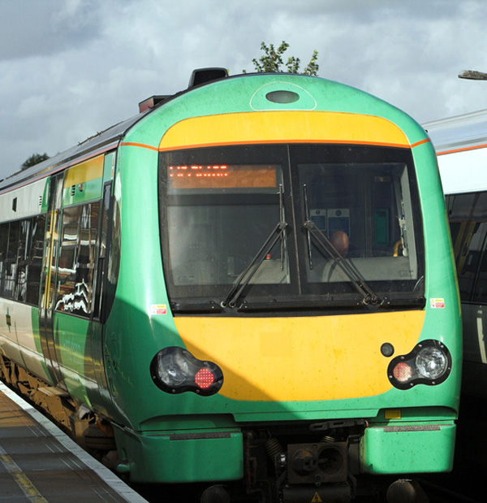

This is an article from a national newspaper:

MORE than three in five drivers
will soon be using public transport
rather than their cars

A survey has shown that 61% of car users are
definitely or probably considering using public transport
because of the change in prices at the petrol pumps.

The survey was carried out by National Express
(a company that runs public transport).

Write a letter or email to the newspaper explaining why you think that the survey and its conclusions may be misleading.
Show that you understand how to plan and interpret surveys fairly; think about what the information tells you, but also about what it does not tell you!

Assessment guidance

Progression in Key Processes

Interpreting and Evaluating  (i) | Interpreting and  Evaluating  (ii) | Interpreting and Evaluating (iii) | Interpreting and Evaluating (iv) | Communicating and reflecting
Identification of the unknown aspects of the sample | Identification of aspects that relate directly to the wording used | Accuracy | Further reflection | Arguments presented in an effective way
States one aspect that is not known  PROGRE  S  S  I  ON  Pupil A | States one aspect that is not known | Shows understanding that 3/5 is equivalent to 60% | Implies possible bias in the survey authors | Expresses one aspect that is not known, but with no explanation of why it is concerning
States one aspect that is not known and why this is relevant | States one aspect that is not known and why this is relevant  Pupils A, B + C | Recognises that ‘more than 60%’ is somewhat misleading as 61% is so close | Gives reasons why the survey authors might be biased  Pupils A, B + C, D | Expresses issues with a simplistic explanation of why they are concerning  Pupils A, B +C, D
States two aspects that are not known and why they are relevant  Pupil D | States two aspects that are not known and why they are relevant | Recognises that ‘definitely or probably’ means the percentage who would definitely change their behaviour is unknown | States how this possible bias could be overcome, eg by asking other bodies | Expresses their concerns fluently
States three or more aspects that are not known and why they are relevant | States three or more aspects that are not known and why they are relevant | Gives more than one way to increase accuracy, eg by reporting ‘definitely’ separately and involving independent organisations | Gives more than one way to increase accuracy, eg by reporting ‘definitely’ separately and involving independent organisations | Expresses their concerns fluently, extending their arguments by providing possible ways of improving the methodology of the survey
Sample responses

Pupil A
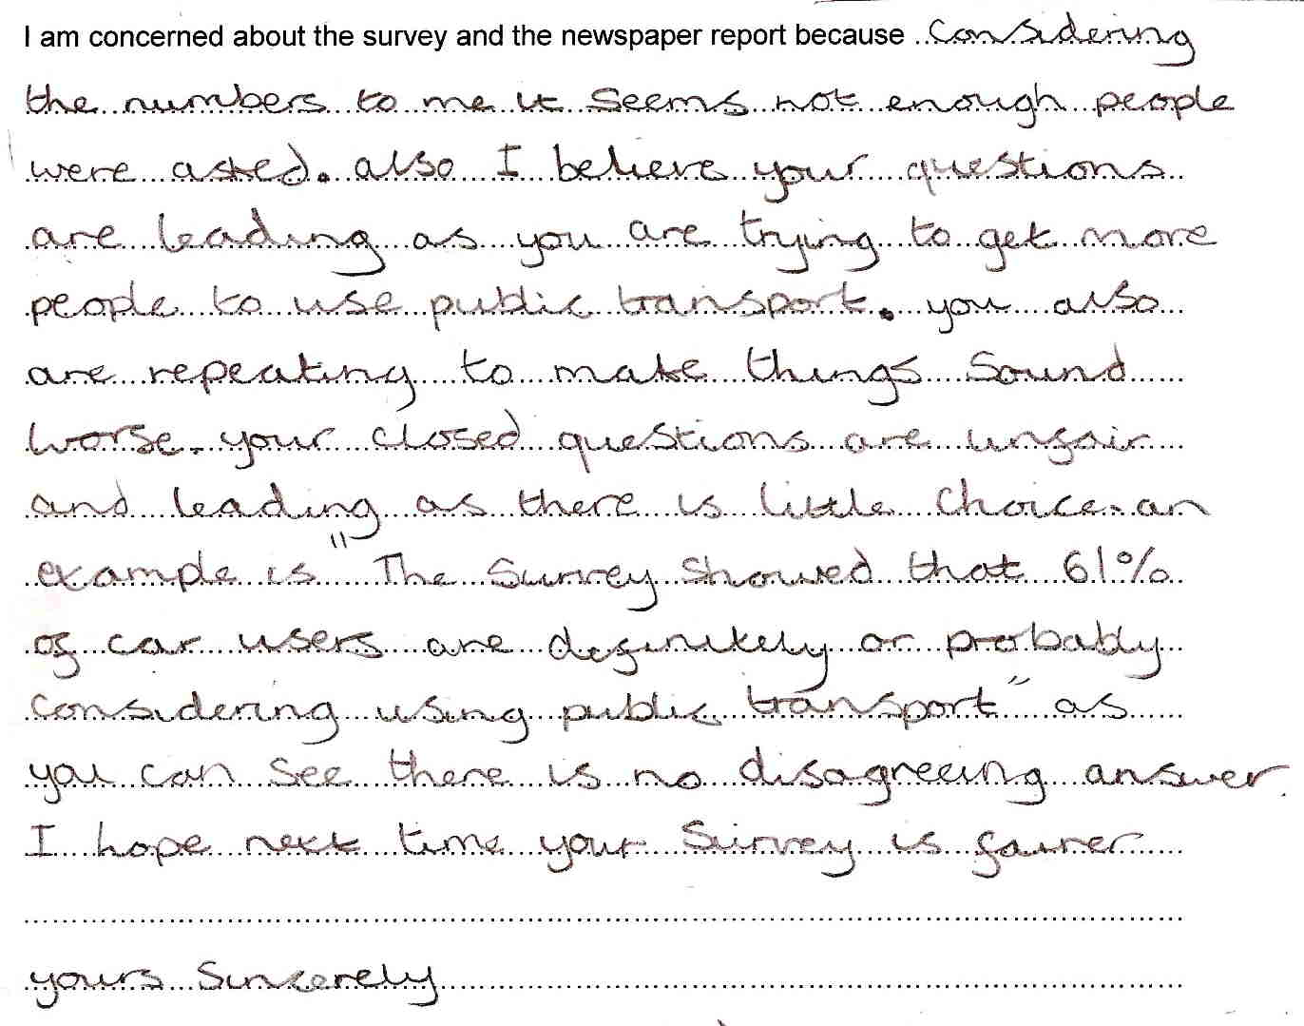

Comments

Pupil A shows insight into some of the things that could be considered, eg closed questions, but does not consider them in any depth.

She starts by referring to the number of people sampled, but this data is not given, so she may have interpreted ‘3 in 5’ literally. She recognises the need to capture all responses but ignores the fact that the remaining 39% of people would comprise a ‘disagreeing answer’.

She questions motives, but does not support her argument. She has confused reporting on a survey with questions asked during a survey.

Probing questions and feedback

- You made some good points, such as the need for an effective sample size, but you could have thought about other things – do we really know how many people would use public transport and how often?

- Try to stand back and really think about the information you need to see if it is sensible or misleading.

Pupil A may benefit from practice at interpreting data from ‘real-world’ sources, eg from newspapers or magazines. Asking her to find her own data source and then to analyse it should engage her in the process and encourage her learning. Explain that, at the beginning of a task, she should really think about the information given – what is it telling her and how can she use it sensibly?

Pupils B and C

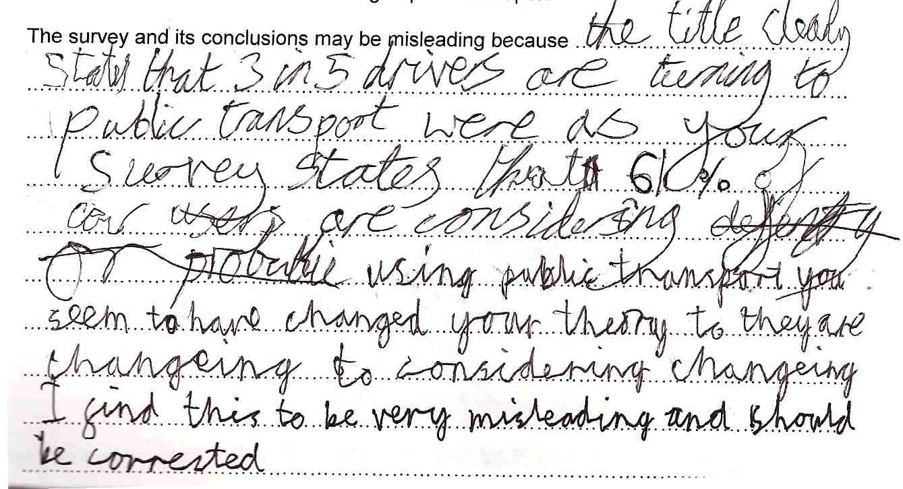
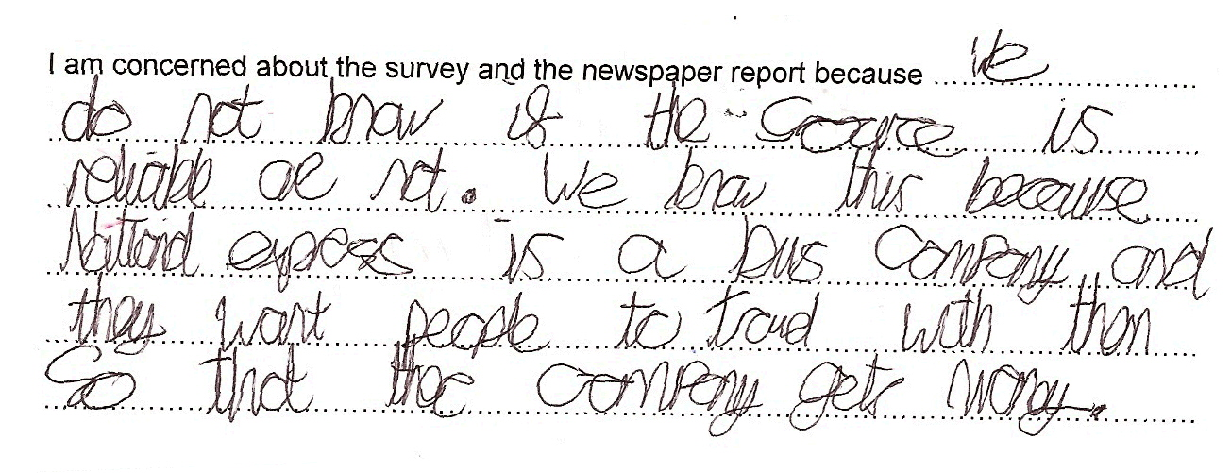

Comments

Pupils B and C start by addressing the issue of ‘3 in 5’ and 61%, but make no comment as to whether they recognise that they are almost equivalent – this may be because the writer changed, interrupting the ‘flow’). They clearly identified an issue with consistency of language, ie that ‘they are changing’ and ‘they are considering changing’ are not the same. They give no reason why this is misleading, but in discussion, they explained that it made it difficult for people to understand what was being claimed. The motives of the company undertaking the survey are questioned, and a clear reason given. They have shown good insight into one section of the task, but with limited reflection.

Probing questions and feedback

- When you are working on a problem that requires interpretation, see if you can find several reasons why the information provided may not be very good − don’t assume you have finished because you have found one or two.

Providing a similar exercise, perhaps with a data source they have found themselves, and emphasising the need to find as many reasons as possible to challenge the information, should encourage these pupils to extend the breadth of their responses.

Pupil D

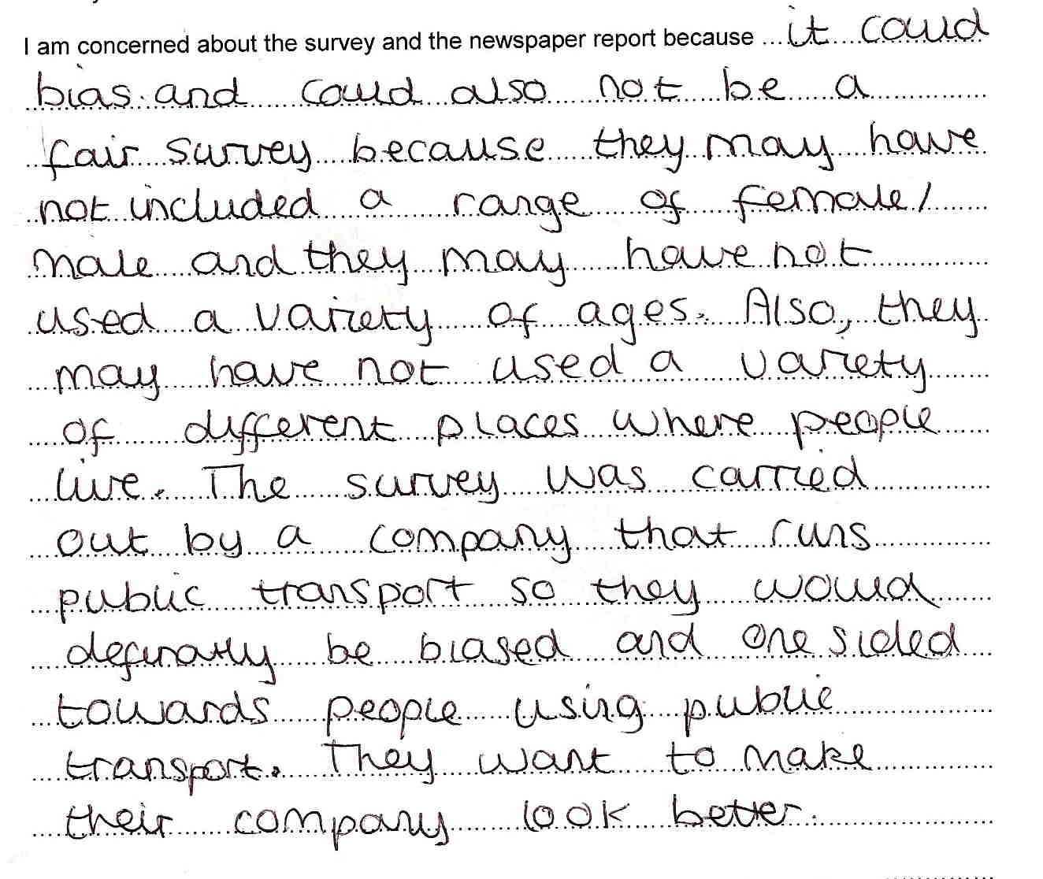

Comments

This pupil has identified two aspects of the sample that are unknown, ie composition of the sample (gender and age) and region. The reference to bias and not being a fair survey shows insight into why these aspects are relevant. The possible bias of the authors is also identified. However, she does not reflect on the wording used or the accuracy claimed.

Probing questions and feedback

- ‘When you review information, think carefully about what is being claimed. Look at the words used – what do they mean and why might they be misleading?’

This pupil would benefit from further practice at interpreting data from non-routine sources. Having had feedback on this task that points out the need to analyse the words used, she may also learn from the opportunity of going back over the information within the task, finding out other misleading issues for herself.

Annex: Hints for teachers

The following are aspects of the sample and how it was collected that are not known but are relevant:

- Number of people surveyed (relevant to ensure representativeness)
- Composition of the sample, eg age group, gender (relevant to ensure representativeness)
- The region(s) in which the survey was completed (relevant to ensure representativeness)
- The specific location(s) in which the survey was completed (relevant since if people were asked outside a bus station, for example, they may already be using public transport)
- Who undertook the questioning (relevant since people may respond differently to people seen as National Express employees)

The following are aspects that relate directly to the wording used:
- What wording was used during the survey (relevant to ensure fairness)
- How the context or questions were introduced (relevant to avoid leading questions)
- What ‘probably’ means in this context (relevant since it does not necessarily imply action will be taken)
- The frequency of intended usage (relevant since people may use public transport only rarely)
- The frequency of actual usage (relevant since people say they are going to do something but not actually do it)

