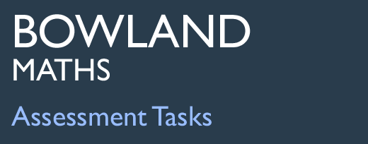 | Problem Page

Task description

Pupils interpret the graph provided to give advice on the statistical ‘acceptability’ of age gaps in relationships.

Suitability National Curriculum levels 6 to 8

Time 45 minutes to 1 hour

Resources Paper

Key Processes involved

- Representing: Identify key features of a graph.
- Analysing: Use equations and / or inequalities to describe these features.
- Interpreting and evaluating: Interpret the graph to give advice.
- Communicating and reflecting: Reflect on how well the graph matches real life.

Teacher guidance

Check that pupils understand the context before they begin, for example, by saying:

- There are ‘problem pages’ in many magazines and newspapers where readers ask for advice; you are asked to provide advice to two readers of ‘Help Online’.
- The two readers ask for advice on age difference between them and their partner.
- There is a graph which shows what some people think is an acceptable age difference between people in a relationship.
- You need to use this graph to provide the advice.

The task requires an understanding of linear graphs.
During the work, the following probing questions may be helpful:
- Are there any important differences between Jenny’s information and Tim’s?
- Is there a way you can work out an acceptable age gap for any age?
- Are there are any other issues you need to consider?
- Would people use this rule in the real world? Why - or why not?

There are three key aspects to this task:
- Interpret the graph: what the lines and the green area represent.
- Define the equations of the lines for the ‘acceptable’ age limits for any given age.
- Apply this to Jenny and Tim’s questions, giving them informed and relevant advice.

Pupils should also reflect on the rule of the ‘half the older one and add seven’ in the real world: is it an appropriate rule to judge the success (or otherwise) of a relationship?

Problem Page

Help online
Hi. I need some advice. I am 35 and I have fallen in love with a man who is 10 years younger than me. Should we get married or is this age difference too big?

Jenny
Problem pages
Help online
I have met a wonderful woman. We love each other and want to get married. There is a 25 year age difference between us but we are really happy together. What should we do?

Tim
Problem pages
Help online

The graph shows what some people think is an acceptable
age difference.
It works using the rule:
‘Half the older one plus seven’.

Let me know what you decide.

Editor

Help online
Your age (years)
Your partner’s
age
(years)
20
30
40
50
60
20
40
60
80
100

Use the graph to give Jenny and Tim advice; use your knowledge of equations to explain how the graph works.

How does the acceptable age gap change as people get older; what does this mean for Jenny and Tim?

Assessment guidance

Progression in Key Processes

Representing | Analysing | Interpreting and Evaluating | Communicating and reflecting
Identification of the key features of the graph | Equations and/or inequalities used to describe key features | Graph interpreted to give advice | Reflections on how well the graph matches real life
Recognises that the solid (red) line represents partners of the same age  PROGRE  S  S  I  ON | Gives a correct equation for the solid (red) line, eg y = x | For Jenny, identifies the point (35, 25) and recognises that the age of her partner is (just) outside the ‘acceptable’ range - or close enough to be ‘acceptable’ | Reflects on the implications of Jenny’s partner being just outside the ‘acceptable’ age range, eg ‘It’s only half a year so it’s probably OK’  Pupils B+C+D
Recognises that the green area represents what is thought to be an ‘acceptable’ age difference | Gives a correct equation for the lower dashed (blue) line: y = x/2 + 7, and shows how to use coordinates when checking equations of lines  Pupils A and B+C+D | Recognises that the advice to Tim is dependent on his age (which is unknown)  Pupil A | Explains why the scales on the axes do not start at zero, eg ‘It would imply you could get married to people who are not yet adult’  Pupils E+F
Recognises the dashed (blue) lines represent the upper and lower limits for the ‘acceptable’ age of a partner  Pupils A, B+C+D, E+F | Gives a correct equation for the upper dashed (blue) line: y = 2x − 14 and shows how to use gradients when finding equations of lines | Recognises that shortly the age difference between Jenny and her partner will be ‘acceptable’; recognises that the older Tim is, the more likely the age difference will be ‘acceptable’  Pupils B+C+D | Explains that the graph only reflects ‘what some people think’
Shows a clear understanding of the meaning of all lines and areas on the graph | Uses inequalities to describe shaded area: y > x/2 + 7 and  y < 2x − 14; shows how to use points within regions when checking inequalities | States if Tim’s partner is older, Tim needs to be at least 39 (or about 40) for ‘acceptable’ age difference, or if Tim’s partner is younger, Tim needs to be about 65  Pupils E+F | Clearly expresses the relevance and implications of their findings, eg ‘it is silly to say that an age difference of, say 20 years is OK but 21 is not!’

Sample responses

Pupil A

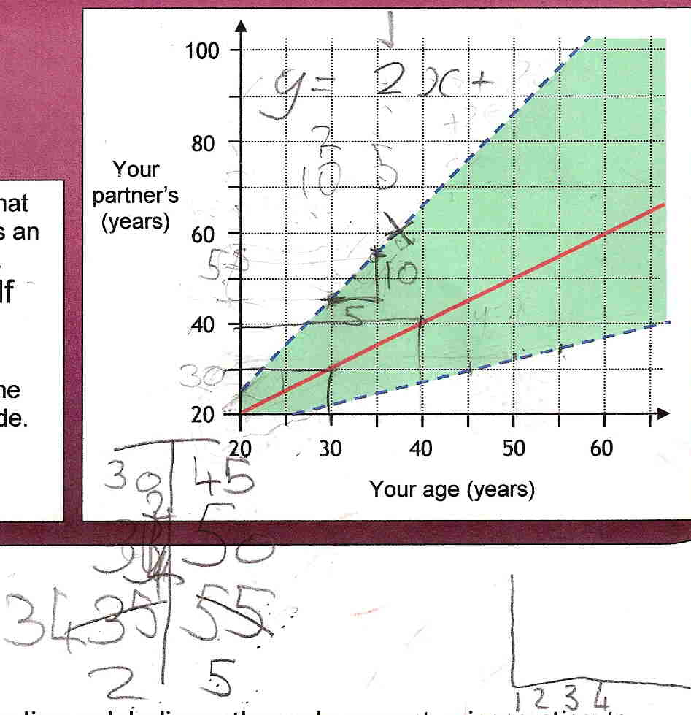

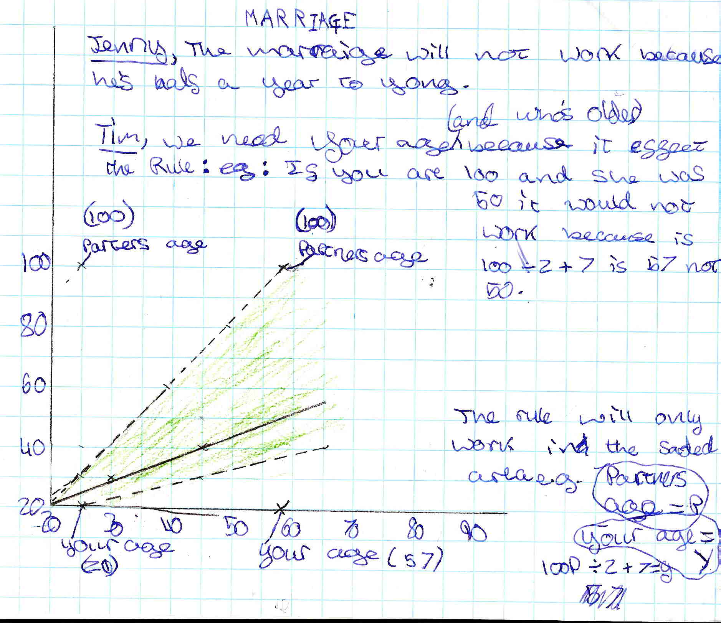

Comments

Pupil A understands the mathematical features of the graph, but her explanation is limited. Her equation is incomplete, but later, she shows she understands the equation y = x/2 + 7, even though this is not clearly expressed. Pupil A gives correct advice for Jenny, but with no reflection on how close to ‘acceptable’ is the age difference, nor how this will change in time. The need for Tim’s age is stated, but her question ‘who is older?’ suggests that she is reading the graph in only one direction. The ‘equation’ confuses the variable, P, with the numerical example, 100P, suggesting knowledge of variables is not secure. She also uses y to represent the value on the x-axis, which could cause confusion. There is no evidence of reflection.

Probing questions and feedback

- When solving a problem, think about what your solution actually means – for example, does it really make sense to say someone should not get married because the difference in their ages is six months longer than the rule says?

Further opportunities to consider the implications and relevance of findings would support the pupil in applying her mathematics within real world situations. She would also benefit from more use of graphs.

Pupils B, C and D (in a group)

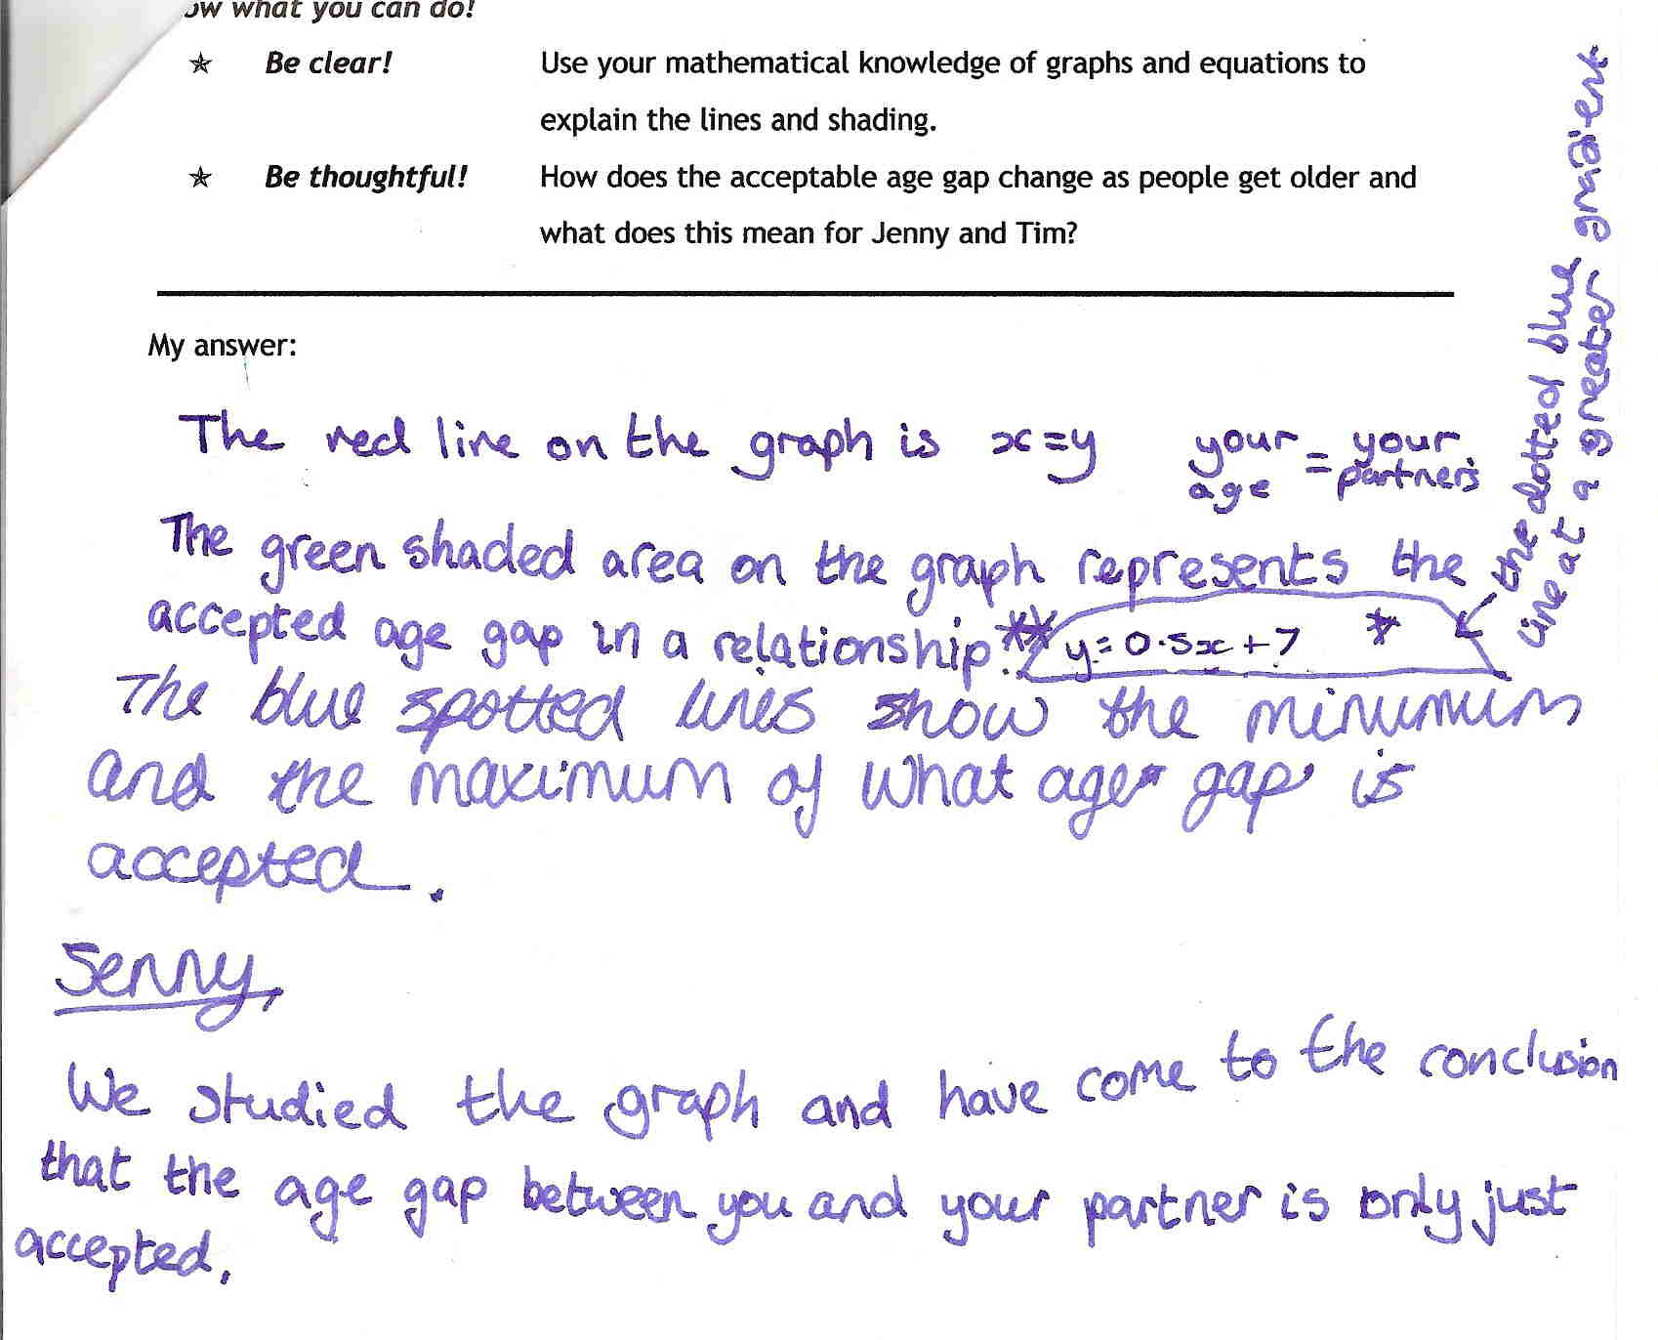

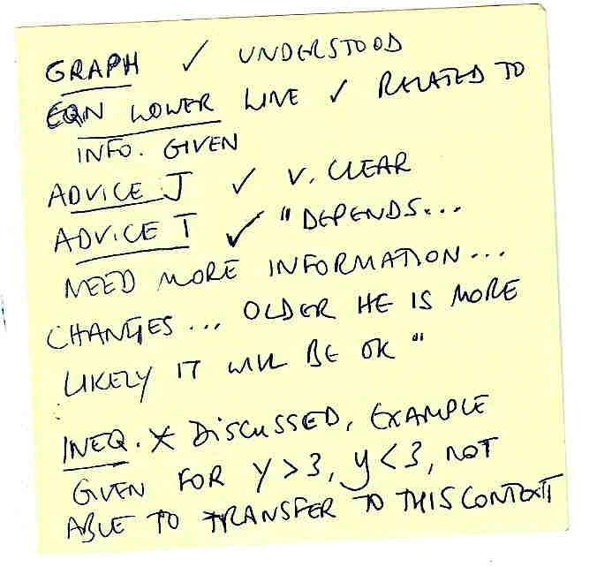

Teacher’s notes, made during the lesson

Comments

The group (B, C and D) spent much time discussing how to read the graph and lines, equations and inequalities, but their written work does not reflect this. During the lesson, the teacher probed and her notes show oral evidence of their understanding of the graph and its implications and relevance, thus supporting the assessment. The group show correct equations for the red and the lower dashed lines, although the latter is incorrectly labelled as the upper dashed line (discussion confirmed this as a ‘slip’). The correct mathematical terminology of gradient is used. The pupils only recently learnt simple inequalities, so their understanding is not secure enough to transfer to this more demanding context. The groups rounded the age of Jenny’s partner and decided the age gap was just ‘acceptable’. The teacher’s notes show they understand how to advise Tim, although specific ‘cut-off’ points are not identified.

Probing questions and feedback

- ‘When solving a problem, think about how you can capture your thoughts while you work – you can do a summary later if you have time, but you need to show evidence of what you are doing and why. Show how much you understand!’

The pupils would benefit from working together in a similar group exploration, perhaps concluding with a poster/letter/presentation, depending on the context. This would enable them to build on their work as a team, and to experience the importance of communicating their work effectively.

Pupils E and F

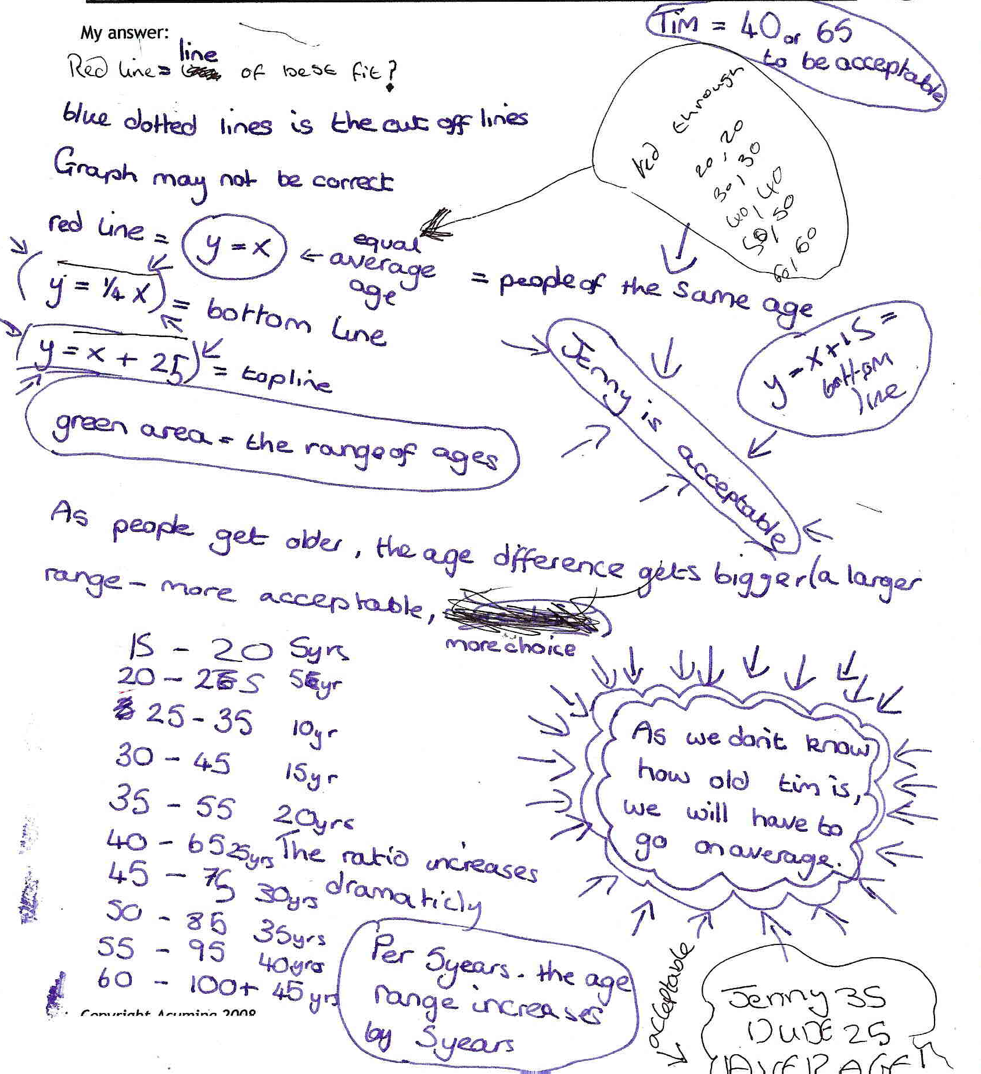

Comments

The pupils E and F described the line y = x as a ‘line of best fit’, then give a clearer explanation as ‘people of the same age’. Their understanding of the dashed lines, ‘cut-off lines’, is strengthened by the recognition of the significance of 40 and 65 as (minimum) ages for Tim if the age difference is to be acceptable. The equations for the dashed lines are incorrect, perhaps from applying rules without understanding – the gradients would be correct if the scale on each axis was the same; the value 25 is likely to represent the y-intercept (incorrectly applied since the scale does not start at zero). The pupils investigate ratio, suggesting that they have not yet made the conceptual links between graphs and proportion. Under the teacher’s questioning, the pupils recognised that the graph represents only what some people thought, and that there could not be a fixed rule since circumstances vary. They could also explain why the graph did not start at zero.

Probing questions and feedback

- When you are using your mathematics, for example equations of lines, think carefully about it – don’t just apply a set of rules without thinking whether the rules are right for this problem.

Although these pupils were able to interpret the graph with accuracy, and to use their understanding to provide appropriate advice to Jenny and Tim, their understanding of equations is not secure; they would benefit from revisiting their understanding of graphs and equations of lines, and from further opportunities to explore this understanding in real-life scenarios.

