 | Patchwork Cushions

Task description

Pupils find a method for calculating the number of triangles and squares that are needed to make cushions in different sizes.

Suitability National Curriculum levels 6 to 7

Time 30 minutes to 1 hour

Resources Ruler, pencil and 1cm squared paper

Key Processes involved

- Representing: Select an appropriate method for counting and recording the squares and triangles in different sized cushions.
- Analysing: Vary the size of the cushion systematically and look for invariance and covariance; reason inductively and deductively.
- Interpreting and evaluating: Examine the data and look for patterns, generalisations and justifications, referring to the structure of the cushion design.
- Communicating and reflecting: Describe findings clearly and effectively.

Teacher guidance

Check that pupils understand the context, for example with questions such as:

- This is a size 3 cushion; can you suggest why I call this “size 3”?
- How many squares and triangles can you see on this cushion?

Pupils can tackle this task in different ways, but those of higher ability might be able to:

- find and describe in words the rule for the next term or the n^{th} term of a sequence where the rule is linear
- find and describe in symbols the next term or n^{th} term of a sequence where the rule is quadratic

Patchwork Cushions

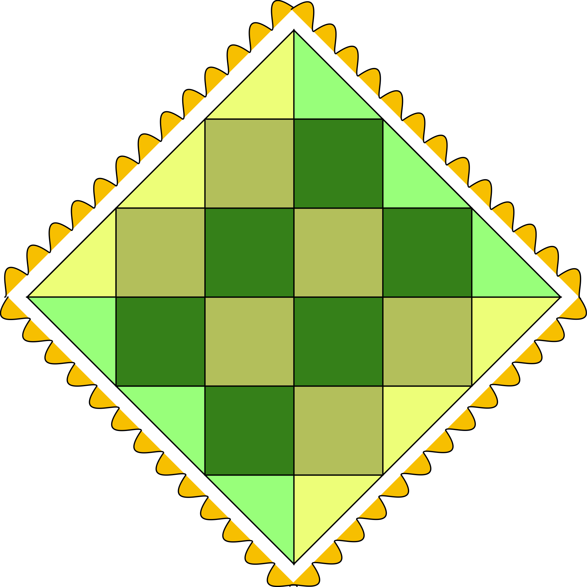

Kate makes patchwork cushions by sewing together right angled triangles and squares. She uses triangles along the edges of each cushion, the rest is made from squares.
The backs of the cushions are made from plain material, not patchwork.

Kate makes cushions in different sizes.

- Kate wants to know how many triangles and squares she needs for a size 5 cushion

- Can you find rules or formulas that will help Kate find out how many squares and triangles she needs for cushions of other sizes? Explain your thinking so that Kate understands it.

Assessment guidance

Progression in Key Processes

Representing | Analysing | Interpreting and evaluating | Communicating and reflecting
Choice of method to approach the task | Results by counting, calculating and use of variables | Finding patterns and relationships and justifying them | Effectiveness, clarity and mathematical sophistication of communication
PROGRE  S  S  I  ON  Chooses an appropriate way to count squares and triangles.  Pupils A and B | Counts the number of squares and triangles for at least one of the presented cushions.  Pupil A | Counts the number of squares and triangles but does not examine the data to look for patterns.  Pupil A | Presents the count of squares and triangles clearly.  Pupils A and B
 | Counts the number of squares and triangles for the size 5 cushion - or for smaller cushions to help find the number of squares and triangles in size 5.  Pupil B | Seeks relationships between the cushion sizes, the number of squares and/or the number of triangles, but partially or incorrectly.  Pupil B | Presents the counts and the relationships clearly.  Pupil C
Chooses a systematic way to count and record the numbers of squares and triangles, for example, using a table.  Pupils C and D | Systematically varies the size of the cushion and thinks of ways to find the numbers of triangles and squares needed.  Pupil C | Examines the data and finds patterns and relationships between the size and the numbers of triangles and squares. Looks for generalisations.  Pupils C and D | Describes findings clearly using words or algebra.
 | Systematically varies the size of the cushion and accurately determines the numbers of triangles and squares needed.  Pupil D | Examines the data and finds patterns and relationships between the sizes and numbers of triangles and squares. Provides justification that the patterns continue. Generalises for triangles and squares. | Describes findings and justifications clearly and effectively using words or algebra.  Pupil D

Sample responses

Pupil A

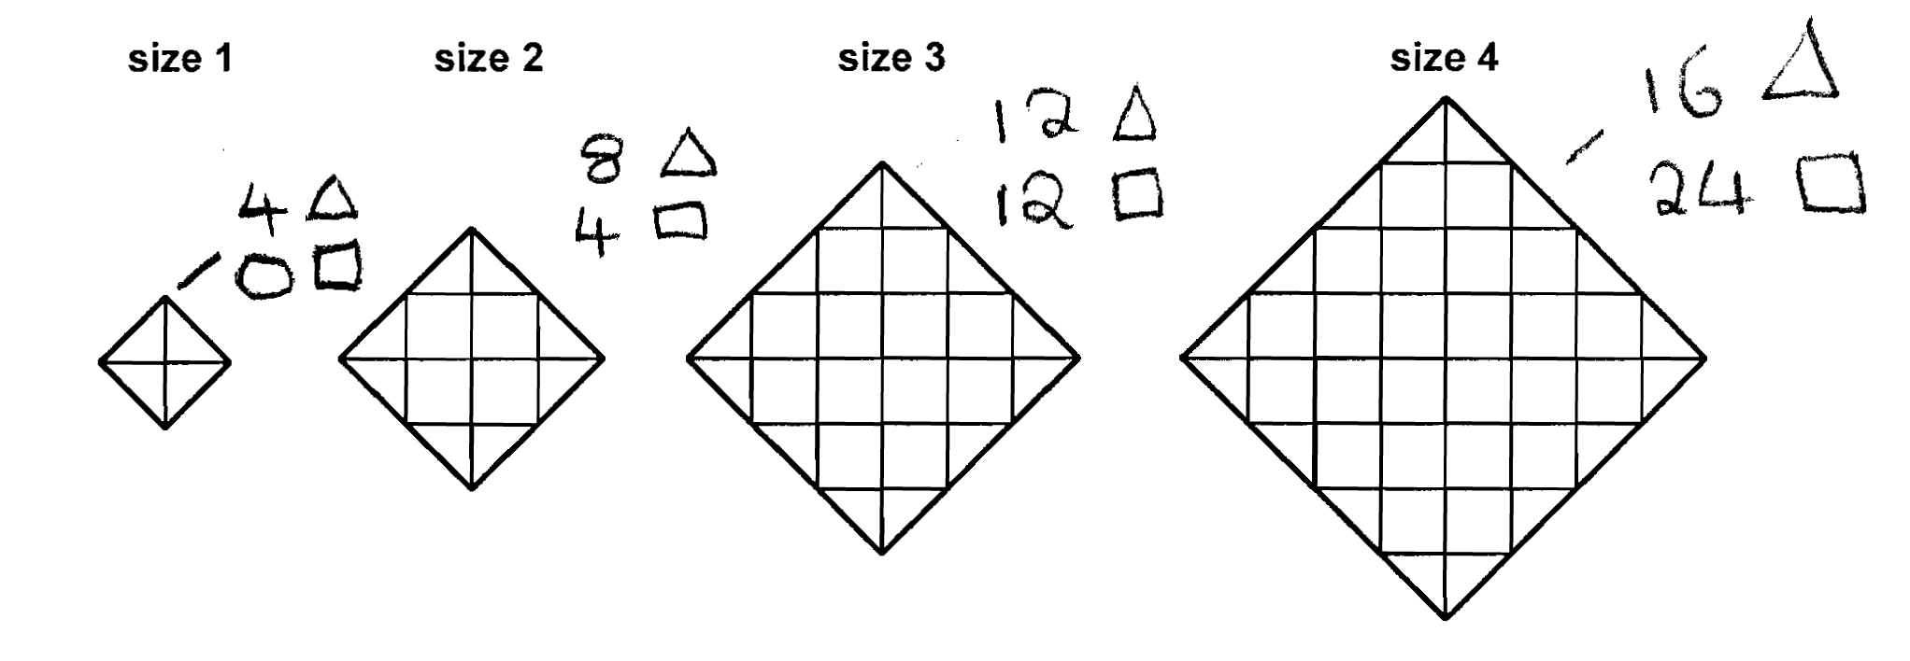
Comments

Pupil A counts the number of squares and triangles for cushion sizes 1 to 4.

Probing questions and feedback

- What would a size 5 cushion look like?
- Can you count the number of squares and triangles in an organised way?
- Can you see any pattern in the number of triangles required?

Pupil B

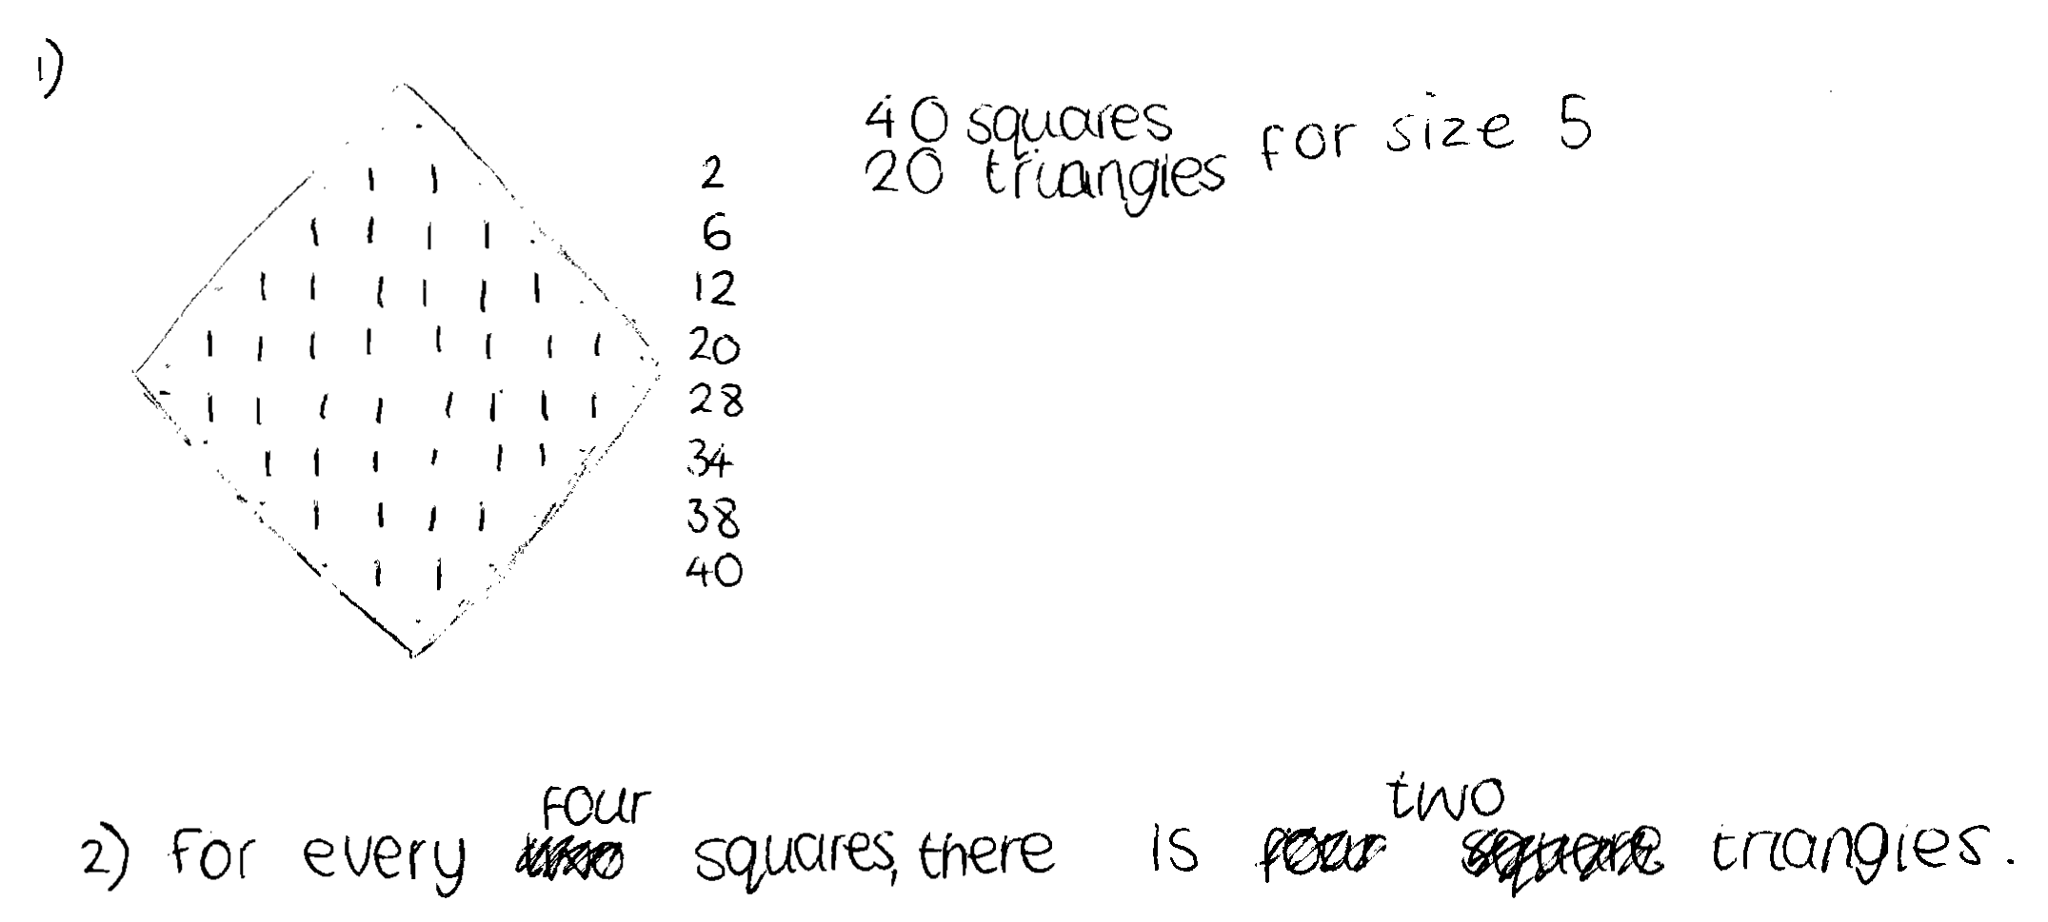

Comments

Pupil B draws a diagram for cushion size 5 and correctly finds the number of triangles for it by counting. She uses a systematic method to count the number of squares, but the relationship she states between squares and triangles is not generalisable.

Probing questions and feedback

- Does your rule for question 2 work for other sizes?
- How could you predict the number of triangles needed for other sizes?
- What data might it be useful to collect to check this? How could you present this data?

Pupil C

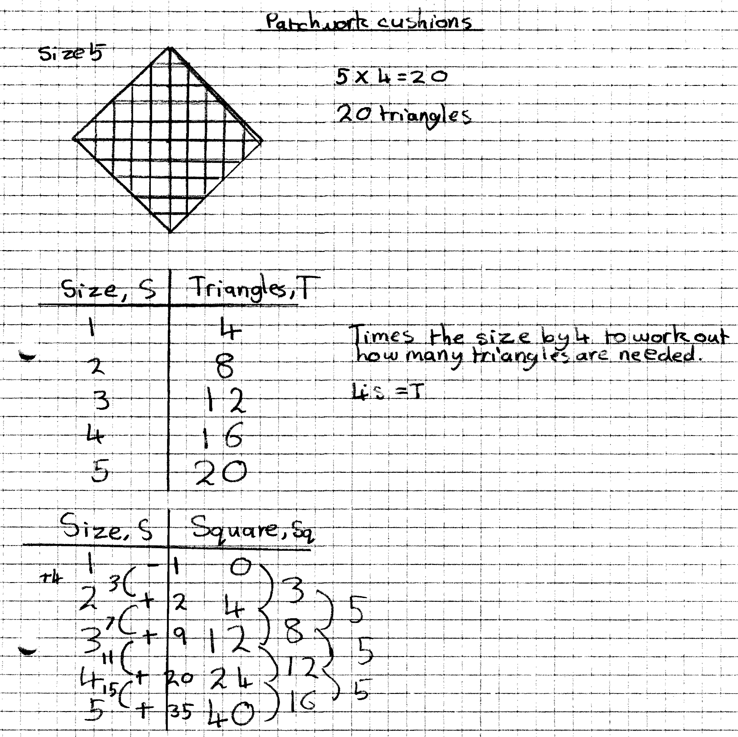

Comments

Pupil C makes a correct table showing the number of triangles for different sizes, and concludes that the number of triangles is four times the size. She does not attempt to explain why this pattern arises nor prove that it will always work. She makes a table showing the number of squares for different sizes, but makes errors in finding the first and second differences.

Probing questions and feedback

- How can you be sure that your rule for finding the number of triangles will work for any size? Can you prove this from the structure of the diagrams?
- Look at your first differences that go 3, 8, 12, 16. Please explain where these come from?
- You say that these differences increase by 5 each time. How can you be sure? Will these patterns continue?
- Can you use the diagrams to explain why the number of squares must go up in multiples of four?

Pupil D

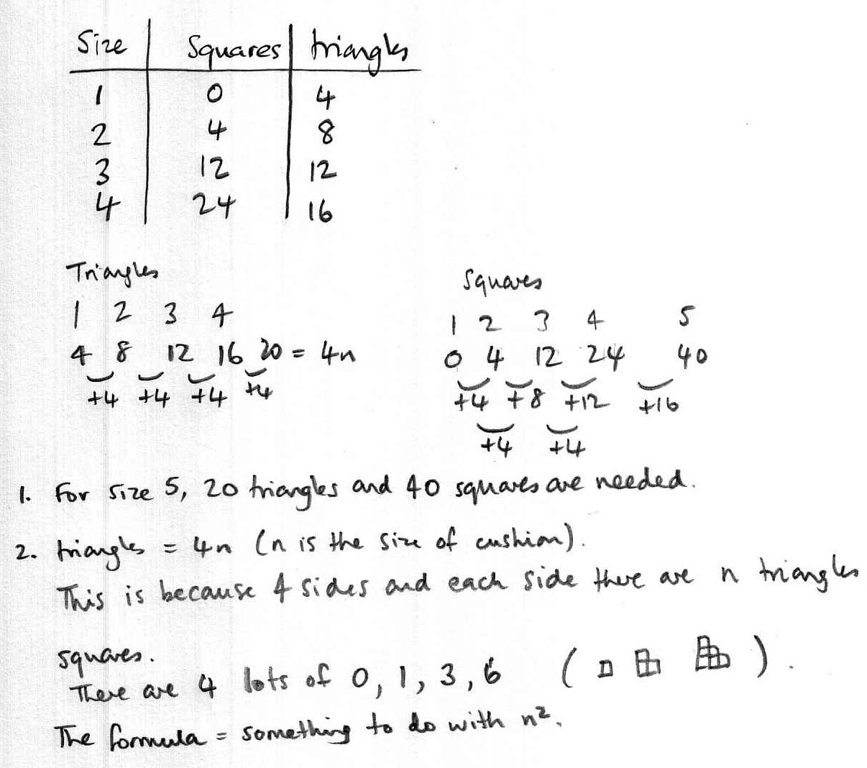

Comments

Pupil D makes a table showing the number of triangles and squares for sizes 1 to 4; he finds the first differences for triangles are 4 and states that triangles = 4n, so for size 5 there must be 20 triangles. He finds the first and second differences for squares and states that the formula for squares is something to do with n². Using the pattern in the first differences, he adds on 16 to find that the number of squares for size 5 is 40. Pupil D attempts to make generalisations and justify why he can be sure that the patterns continue with reference to the structure of the diagrams. Pupils D’s work is clear and easy to follow.

Probing questions and feedback

- Can you find a way of using your small diagrams to help find a formula for the squares?

