 | Olympic Cycling

Task description

Pupils interpret and apply data through devising questions (and answers) relating to lap times in a cycling race.

Suitability National Curriculum levels 3 to 6

Time 30 minutes

Resources Paper and perhaps a calculator

Key Processes involved

- Representing: Pupils identify appropriate questions.
- Analysing: They devise and produce answers for their questions.
- Communicating and reflecting: They present their work so that others can follow their reasoning.

Teacher guidance

You may wish to set the scene by briefly introducing the context as follows and by showing a short video that gives highlights of the race that this task relates to. http://www.youtube.com/watch?v=skAaRP6UdiA

- In the 2008 Olympics, there was a cycling race called the men’s team sprint. Great Britain won gold, France won silver and Germany bronze.

- You are given the lap timings for each team. Your task to think of two questions about this data, write them down and answer them. Think of different types of question, but make sure they show how good you are at mathematics. Try to think of questions that are not the obvious ones.

The task requires calculations involving time and distance.

In trials, there was a tendency for some lower level pupils to write only basic questions, eg ‘Which team had the fastest lap?’ Encourage exploring less obvious aspects of the data.

During the work, the following probing questions may be helpful:
- What sort of questions might a sports commentator ask using this data?
- Are your questions realistic?
- Are your questions different - do they show your mathematical ability?

Some of the data is analysed for teachers in the Annex.

Olympic Cycling

In the 2008 Olympic Games, there was a cycling race called the men’s team sprint.
Great Britain won.

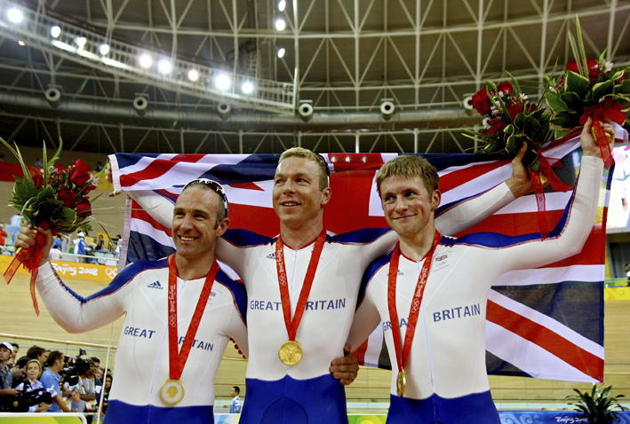

Here are the results.

Medal won | Country | Time taken to cycle each lap (seconds)
Medal won | Country | 1st lap | 2nd lap | 3rd lap
Gold | Great Britain | 17.136 | 12.601 | 13.391
Silver | France | 17.377 | 12.792 | 13.482
Bronze | Germany | 17.733 | 12.945 | 13.336
 |  | Each lap is 250m.

Write two different questions about this data. Then answer each of them!

Think of different types of questions that are appropriate and that show how good you are at mathematics.

Assessment guidance

Progression in Key Processes

Representing | Analysing | Communicating and reflecting
Appropriate questions identified  PROGRE  S  S  I  ON | Their questions answered | Work presented so that their reasoning can be followed
Gives two different appropriate, questions that require simple processing of the data  Pupils A + B | Uses only addition and / or subtraction  Pupils A + B | Shows relevant working, and gives an answer  Pupils A + B
Gives two different appropriate questions, at least one of which is multi-step, eg. ‘By how many seconds did GB beat France?’ | Uses multiplication and / or division | Shows relevant working, and gives at least some correct units
Gives two different appropriate questions, at least one of which is complex and multi-step, eg  ‘What was the average time per lap for Germany?’  Pupil C | Uses mean | Shows relevant working, and gives answers presented with correct units  Pupil C (partially)
Gives two appropriate questions, at least one of which requires the combination of information about length of lap with time, eg ‘What was the average speed for France?’  Pupil D | Uses other range and content correctly, from level 5 or above  Pupils C and D | Shows concise and relevant working, and presents answers with correct units  Pupil D

Sample response

Pupils A and B

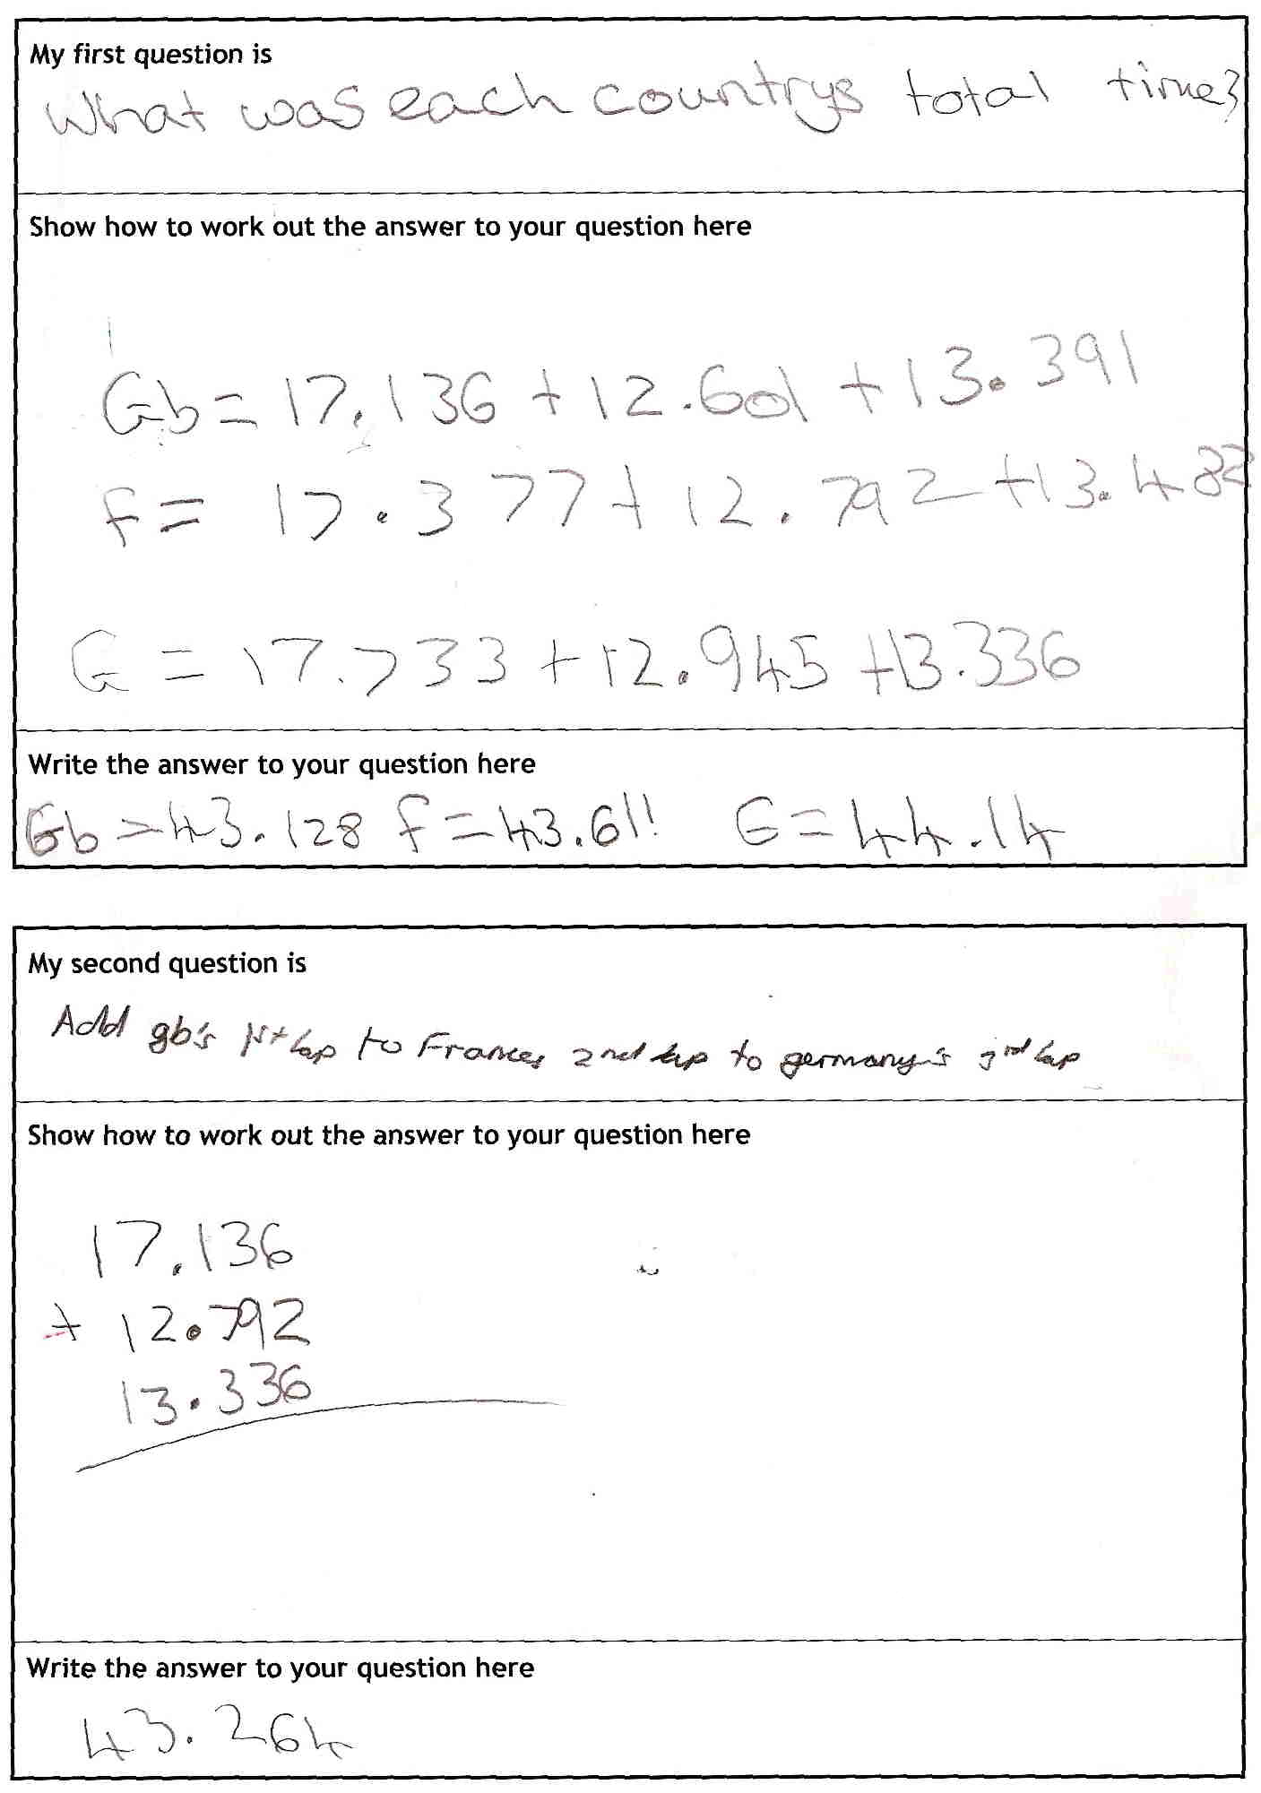

Comments

Pupils A and B proposed very basic questions, focusing on simple addition, which may suggest a lack of confidence with other operations. Their first question is relevant, but two of the three calculations are incorrect. When questioned why the second question would be interesting, the pupils were confused, perhaps indicating a lack of understanding that mathematics is used as a tool in the real world. The answer to the second question is correct - calculators were used.

Probing questions and feedback

- When you are deciding questions for yourself, think about whether the answer is going to be useful or interesting – that way, you can improve what you are asking.

These pupils would benefit from undertaking similar tasks requiring making their own choices of operations; they are likely to need support from the teacher to consider the relevance of those choices.

Pupil C
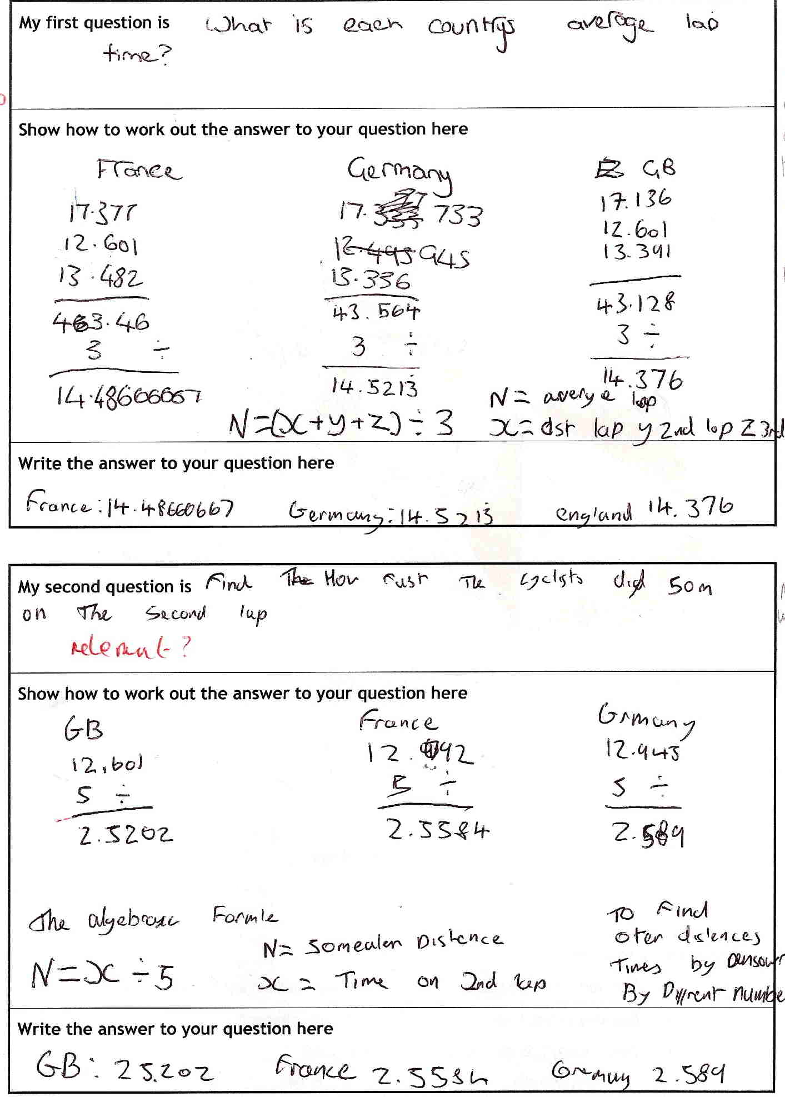

Comments

Pupil C’s questions are reasonably complex, as are his methods. He uses algebra to look for generalisations. His first question is relevant, but his second question is relevant only on the assumption that speed is constant throughout the lap – no evidence that he was aware of this. This time, his attempt to generalise is less successful. Units are omitted throughout. His work indicates how progression statements can only be guidelines − his use of algebra, relevant for its insight into generalisation, compensates for other aspects.

Probing questions and feedback

- When you are working on a problem, check that you have not made slips in your working and try to remember to use units with your answers.

Pupil C could be encouraged in his willingness to stretch himself by giving him further opportunities to apply his learning in real scenarios. Working alongside an equally motivated pupil and asking them to critique each other’s work might also encourage him to be more analytical about his responses and pay greater attention to detail.

Pupil D
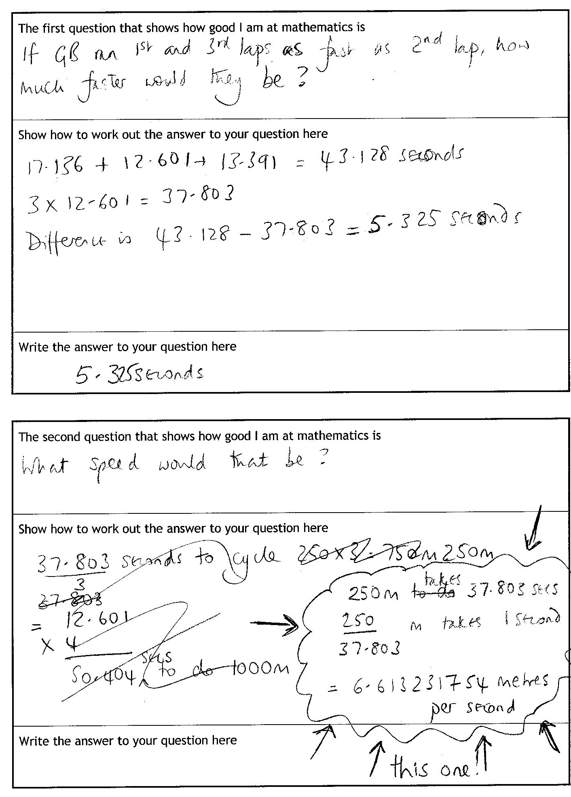

Comments

Pupil D’s first question uses simple operations but is relevant and multi-step. Her work is accurate and clearly explained, using units. Her second question is more complex and shows her ability more clearly. Her first attempt gives an answer in seconds/km, but she recognises her error and uses a unitary method to find a correct speed - even though it is expressed to an inappropriate degree of accuracy.

Probing questions and feedback

- When you give an answer, think about the degree of accuracy that is appropriate. The speeds of the cyclists were given to 3 decimal places, but you used 9 decimal places in your answer!

Pupil D would benefit from working on other open tasks which needed decisions about rounding. A useful resource could be the Bowland case study You Reckon.

Annex for teachers

The following calculations may be helpful.
 | GB | France | Germany
Total time, seconds | 43.128 | 43.651 | 44.014
Average time per lap, sec (2dp) | 14.38 | 14.55 | 14.67
Average speed per lap,  m per sec (2dp) | 14.59 / 19.84 / 18.67 | 14.39 / 19.54 / 18.54 | 14.10 / 19.31 / 18.75
Average speed overall,  m per sec (2dp) | 17.39 | 17.18 | 17.04

