 | Mobile Phones

Task description

Pupils compare two different mobile phone tariffs and decide when one is cheaper than the other.
Suitability National Curriculum levels 6 to 7

Time 20 to 40 minutes

Resources Pencil and paper; graph or squared paper should be made available and supplied on request.

Key Processes involved

- Representing: Select a way of comparing two phone tariffs, for example, using an appropriate table or graph.
- Analysing: Explore the effect of varying the times of calls, working logically and recognising the impact of the constraints. Make accurate calculations or graphs, recording their methods systematically and deduce when one call plan is cheaper.
- Interpreting and evaluating: Interpret their tables and graphs to solve the problem, relating their findings to the original context.
- Communicating and reflecting: Communicate their reasoning and findings clearly.

Teacher guidance

Check that pupils understand the context; for example, show them examples of advertisements of pay as you go and other types of mobile phone tariffs.

- Who has a mobile phone? What kind of tariff are you on?
- How did you decide to go with that tariff?
- It can be very difficult to decide which mobile phone tariff is cheapest for you.
- In this task we compare two mobile phone tariffs.
Pupils can tackle this task in different ways, but higher ability pupils might be expected to:

- formulate and solve linear equations with whole-number coefficients
- use algebraic or graphical methods to solve simultaneous linear equations in two variables

Mobile Phones

Sally is buying a mobile phone. She must choose between the following tariffs.

Pay and Go | Every day 50
No daily charge  For the first 2 minutes of calls each day: 10p per minute.  For the rest of that day:  5p per minute. | Daily charge 50p  For the first 3 minutes of calls each day: No charge.  For the rest of that day:  3p per minute.

Sally reckons she spends 10 minutes on the phone each day.
Which tariff should she choose?

- How much cheaper is this tariff for her?
But she might be wrong and in fact spend longer than 10 minutes on the phone each day!

- When is the Everyday 50 the cheaper tariff? Sally needs to understand your reasoning.

Assessment guidance

Progression in Key Processes

Representing | Analysing | Interpreting and evaluating | Communicating and reflecting
Choice of data to use, method and representation of the two tariffs  PROGRE  S  S  I  ON | Accuracy and technical demand of calculations; use of variables | Interpretation of results in relation to the original problem | Quality of communication of calculations, reasoning and conclusions
Selects some of the key data to perform calculations.  Pupil A | Calculates the cost of the two tariffs for one call time, but with errors e.g. forgets the standing charge.  Pupil A | Interprets calculations to compare the costs of the two tariffs.  Pupil A | Presents calculations but does not explain them.  Pupil A
Selects the key data to perform calculations.  Pupil B | Calculates the cost of the two tariffs for two call times correctly.  Makes a start on calculations for longer times.  Pupil B | Interprets calculations to compare the costs of the two tariffs accurately for two call times.  Pupil B | Presents calculations with some explanation.  Pupils B and C
Selects a way of comparing the two tariffs, for example, using a table or graph.  Pupil C | Analyses the effect of systematically varying the times. Makes accurate calculations or draws a graph.  Pupil C | Interprets tables or graphs to solve the problem, relating findings to the original context, but with inaccuracies.  Pupil C | Presents reasoning and findings clearly.  Pupil D
Selects a systematically way of comparing the two tariffs, for example, using a table or graph.  Pupil D | Analyses the effect of systematically varying the times. Makes accurate calculations or draws a graph.  Deduces when one call tariff is cheaper: checking 15 minutes and 16 minutes as appropriate.  Pupil D | Interprets tables or graphs to solve the problem, relating findings to the original context. Finds that Every day 50 is cheaper for more than 15 minutes.  Pupil D | Explains reasoning and findings clearly.

Sample responses

Pupil A

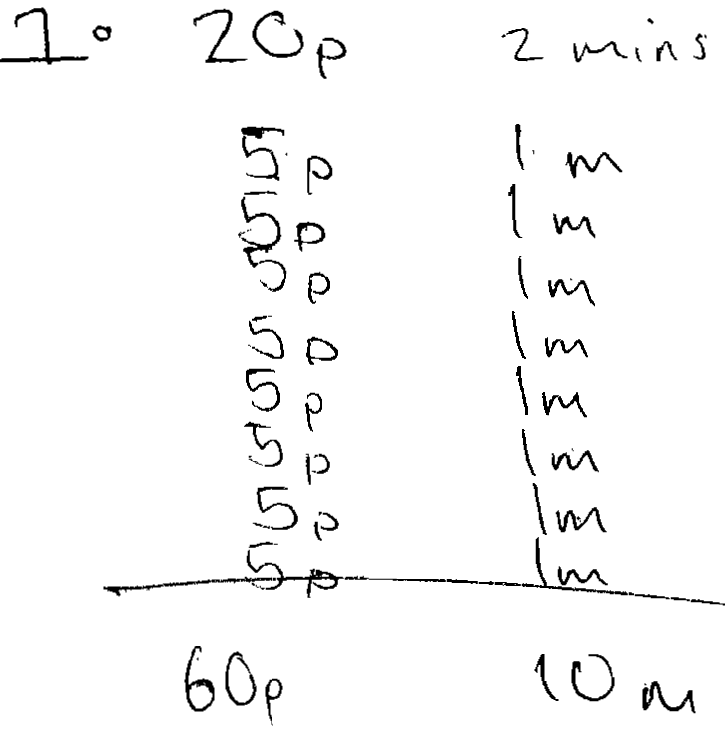 | 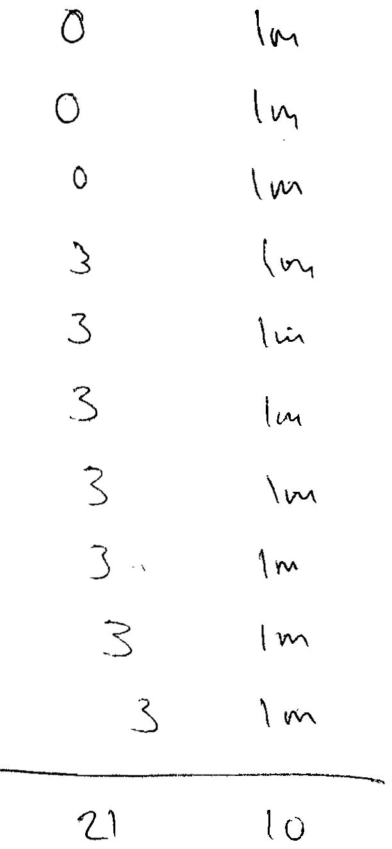

Comments

Pupil A correctly calculates the cost for 10 minutes on Pay and Go and on Every day 50, but does not include the Daily Charge. He does not consider the effect of varying the call times.

Probing questions and feedback

- Did you check that you included all the costs in your calculations?
- What might vary in this question? How would the charges change if Sally uses the phone for a longer time?
- How could you record your results in a systematic way?

Pupil B

Comments

Pupil B correctly calculates the cost for 10 minutes on Pay and Go and on Every day 50. She correctly chooses Pay and Go for 10 minutes. She calculates the cost for 60 minutes and shows that Every day 50 is better for a longer time.

Probing questions and feedback

- You have performed calculations for 10 minutes and 60 minutes of calls each day. What happens for times in between these two?
- How could you investigate and record this systematically?

Pupil C

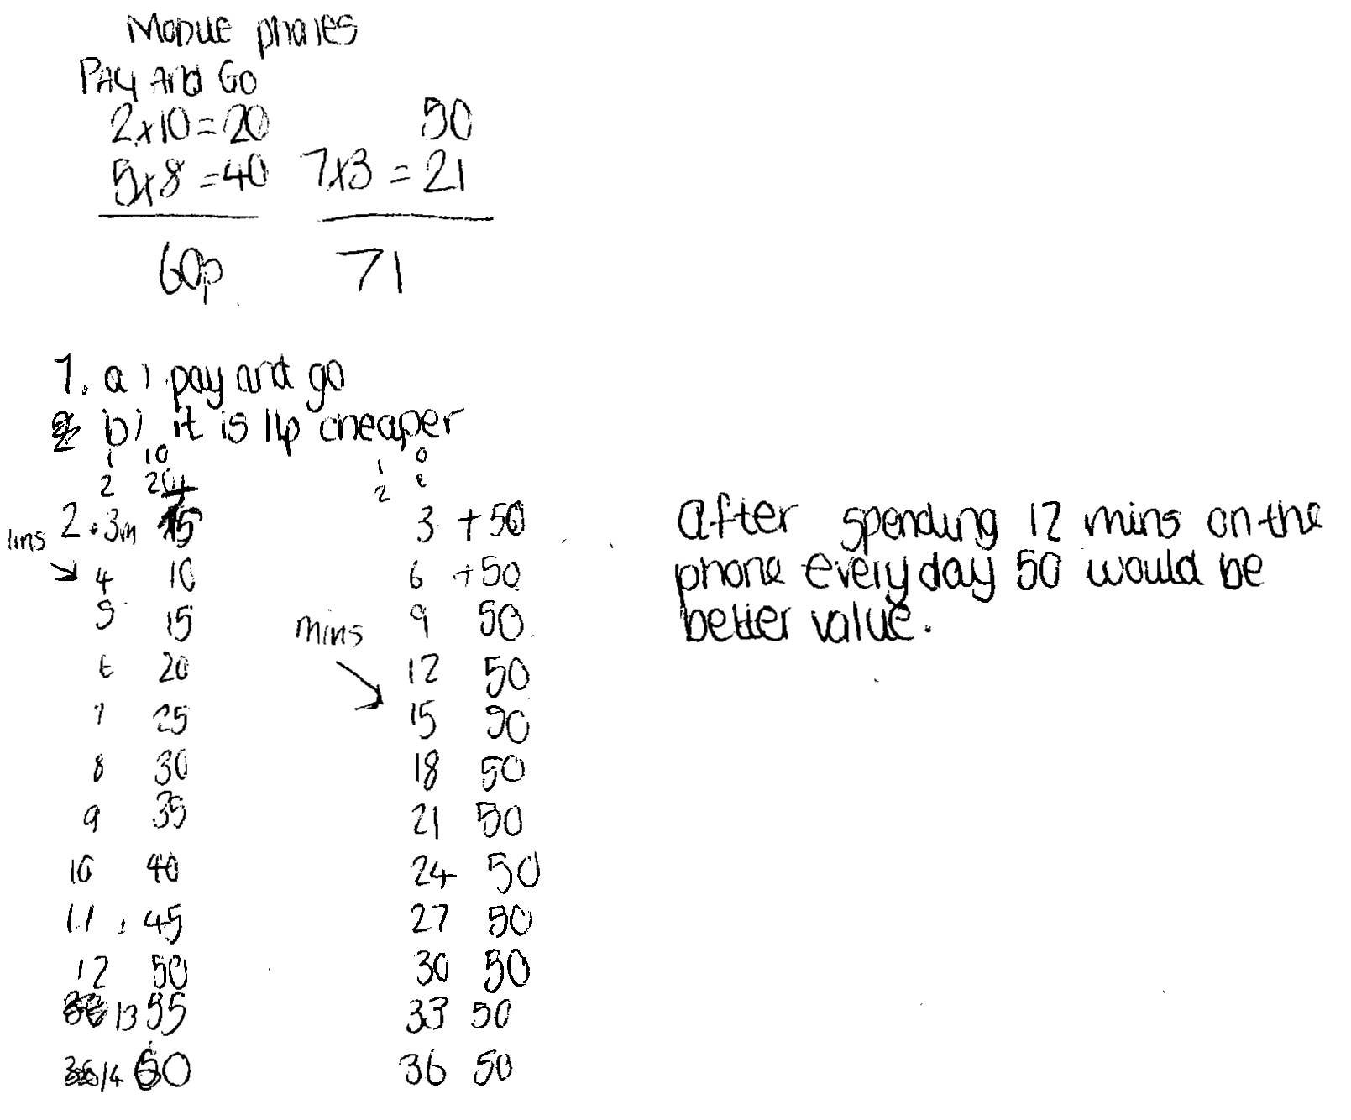

Comments

Pupil C correctly calculates the cost for 10 minutes on Pay and Go and on Every day 50. He correctly chooses Pay and Go for 10 minutes. He makes a list of prices for different lengths of time, but because he makes errors in the costs for Pay and Go, he chooses Every day 50 for more than 12 minutes.

Probing questions and feedback

- You have made useful lists of costs. How could you make these clearer?
- You have stated that if Sally spends 12 minutes on the phone, then Every day 50 would be better value. Please explain how you got this result from your calculations.

Pupil D

Comments

Pupil D correctly calculates the cost for 10 minutes on Pay and Go and on Every day 50 and correctly chooses Pay and Go for 10 minutes. He correctly calculates the costs for up to 15 minutes and states that for times greater than 16 minutes Every day 50 is cheaper. His working is clear, but the quality of the explanation could be improved.

Probing questions and feedback

- How you can be sure that Every day 50 will always be cheaper for times greater than 16 minutes?
- You solved the problem by listing the costs for various numbers of minutes. What other method could you have used?
- What are the strengths and weaknesses of each of these methods?

