 | Magic Sum Puzzle

Task description

Pupils analyse a numerical puzzle, solve some examples and then deduce that a further example is impossible.
Suitability National Curriculum levels 5 to 7

Time 30 minutes to 1 hour

Resources Pencil, paper and sheet of blank grids for rough work

Key Processes involved

- Representing: Choose an appropriate logical way to solve a puzzle.
- Analysing: Make a conjecture (an example is or is not impossible) and then seek to justify it; work logically towards a solution, recognising the impact of the constraints involved.
- Interpreting and evaluating: Form convincing arguments, and formulate proofs.
- Communicating and reflecting: Communicate reasoning and findings effectively.

Teacher guidance

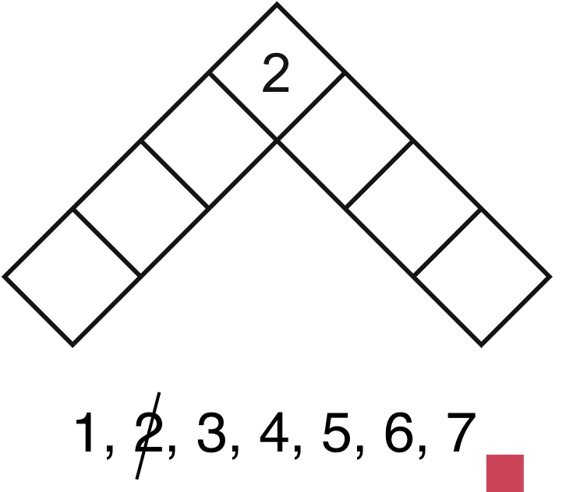
You could begin by showing slide 1. Cross 2 off the list and write it in, at the top of the puzzle. Then make the following points:

- I want to find a way to place the seven numbers in the boxes
so that each straight line adds up to the same total.
- This is called the magic sum.
- I am only allowed to use each number 1 to 7 once in the puzzle.

Now, complete the puzzle as shown, silently,
without telling pupils how you did it.

- Does this work? What is the magic sum? How can you tell?

Slide 2 provides an alternative starting point. The content and range in this task are low, requiring only the use of properties of integers (e.g. even or odd) to make generalisations. There is also an opportunity to construct, express in symbolic form, and use simple formulae when formulating the proof.

Magic Sum Puzzle

The puzzle is to place the numbers from 1 to 7 into the boxes, so that the two straight lines of numbers add up to the same total. This total is known as the Magic sum.

In this example, the Magic sum is 15 because
1 + 5 + 7 + 2 = 15 and 2 + 4 + 3 + 6 = 15

- Complete the following puzzle using the numbers from 1 to 7. Each straight line must have the same total. What is the magic sum this time?

- Try to complete the puzzle so that the Magic sum is 17. You must still only use the numbers 1 to 7. Explain all the steps in your thinking.

- Is it possible to make any other Magic sums using the numbers 1 to 7?
Try to explain how you can be sure.

Assessment guidance

Progression in Key Processes

Representing | Analysing | Interpreting and evaluating | Communicating and reflecting
Choice of method to solve the puzzles | Response to technical demand | Conclusions reached on what magic sums can be made and why | Clarity of solutions and justifications
Attempts to solve the puzzle using an unclear approach  PROGRE  S  S  I  ON  Pupil A | Makes a partial attempt to solve a magic puzzle where the top number is given  Pupil A | Attempts but does not reach a solution for any of the questions  Pupil A | Presents work with little or no explanation  Pupil A
Attempts to solve the puzzle using an apparently ‘trial and error’ approach  Pupil B | Solves a puzzle where the top number is given and makes an attempt to solve a puzzle where only the magic sum is given  Pupil B | Forms an argument about the possibility of a solution but, for example, based on lack of success in finding one  Pupil B | Communicates some of the reasoning and findings  Pupil B
Chooses a systematic approach to solving the puzzle  Pupil C | Solves both puzzles - where the top number is given and where magic sum is given  Pupil C | Forms an argument that it is impossible to make magic sums other than 15, 16 and 17  Pupil C | A valid explanation is given for solutions where the top number or magic sum is given but lacks clarity for explanation of other solutions  Pupil C
Chooses a systematic and economic approach to solving the puzzle.  Pupil D | Can solve a puzzle where the top number is given and solve a puzzle where only the magic sum is given  Pupil D | Forms a convincing argument that it is impossible to make magic sums other than 15, 16 and 17  Pupil D | Communicates reasoning and findings effectively  Pupil D

Sample responses

Pupil A

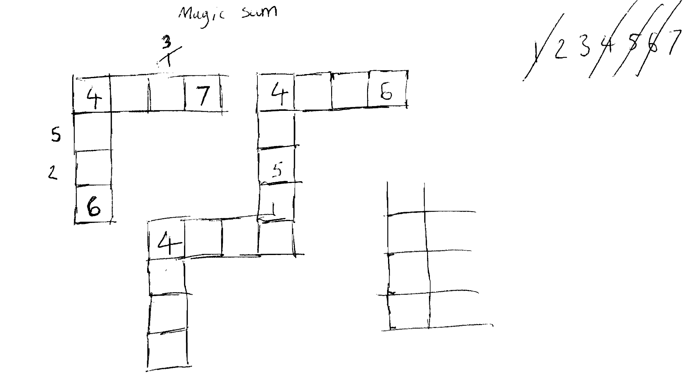
Comments

Pupil A makes a partial attempt to solve a puzzle where a top number is given. No further work is shown.

Probing questions and feedback

- Please explain why you put the numbers 6 and 7 in the squares at the end of each line?
- Can you explain why you have written 5 and 2 on one line and 3 and 1 on the other line?
- What do you think the magic sum is likely to be with 4 at the top?

Pupil B

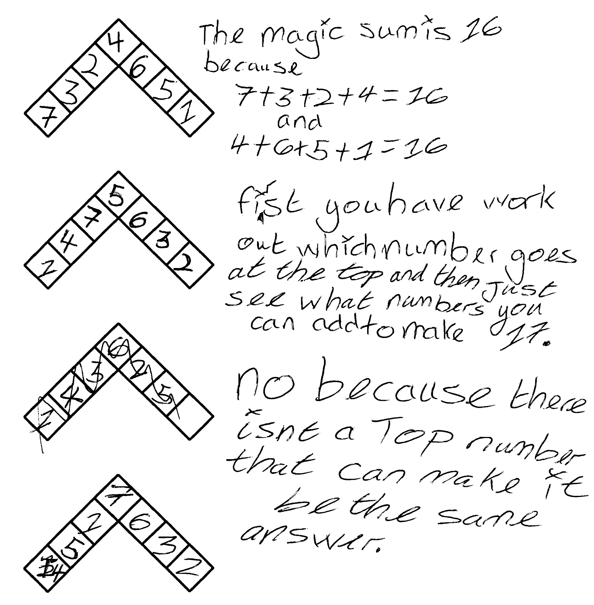
Comments

Pupil B correctly completes a puzzle where one top number is given and finds the magic sum. But he incorrectly completes a puzzle when he is given the magic sum.

Probing questions and feedback

- Following the pattern, what would be a good number to try for the top number for a magic sum of 17?
- What have you noticed that might help you solve other problems on magic sums?
- What are your thoughts on ‘Is it possible to make any other magic sums using the numbers 1 to 7?’
Pupil C

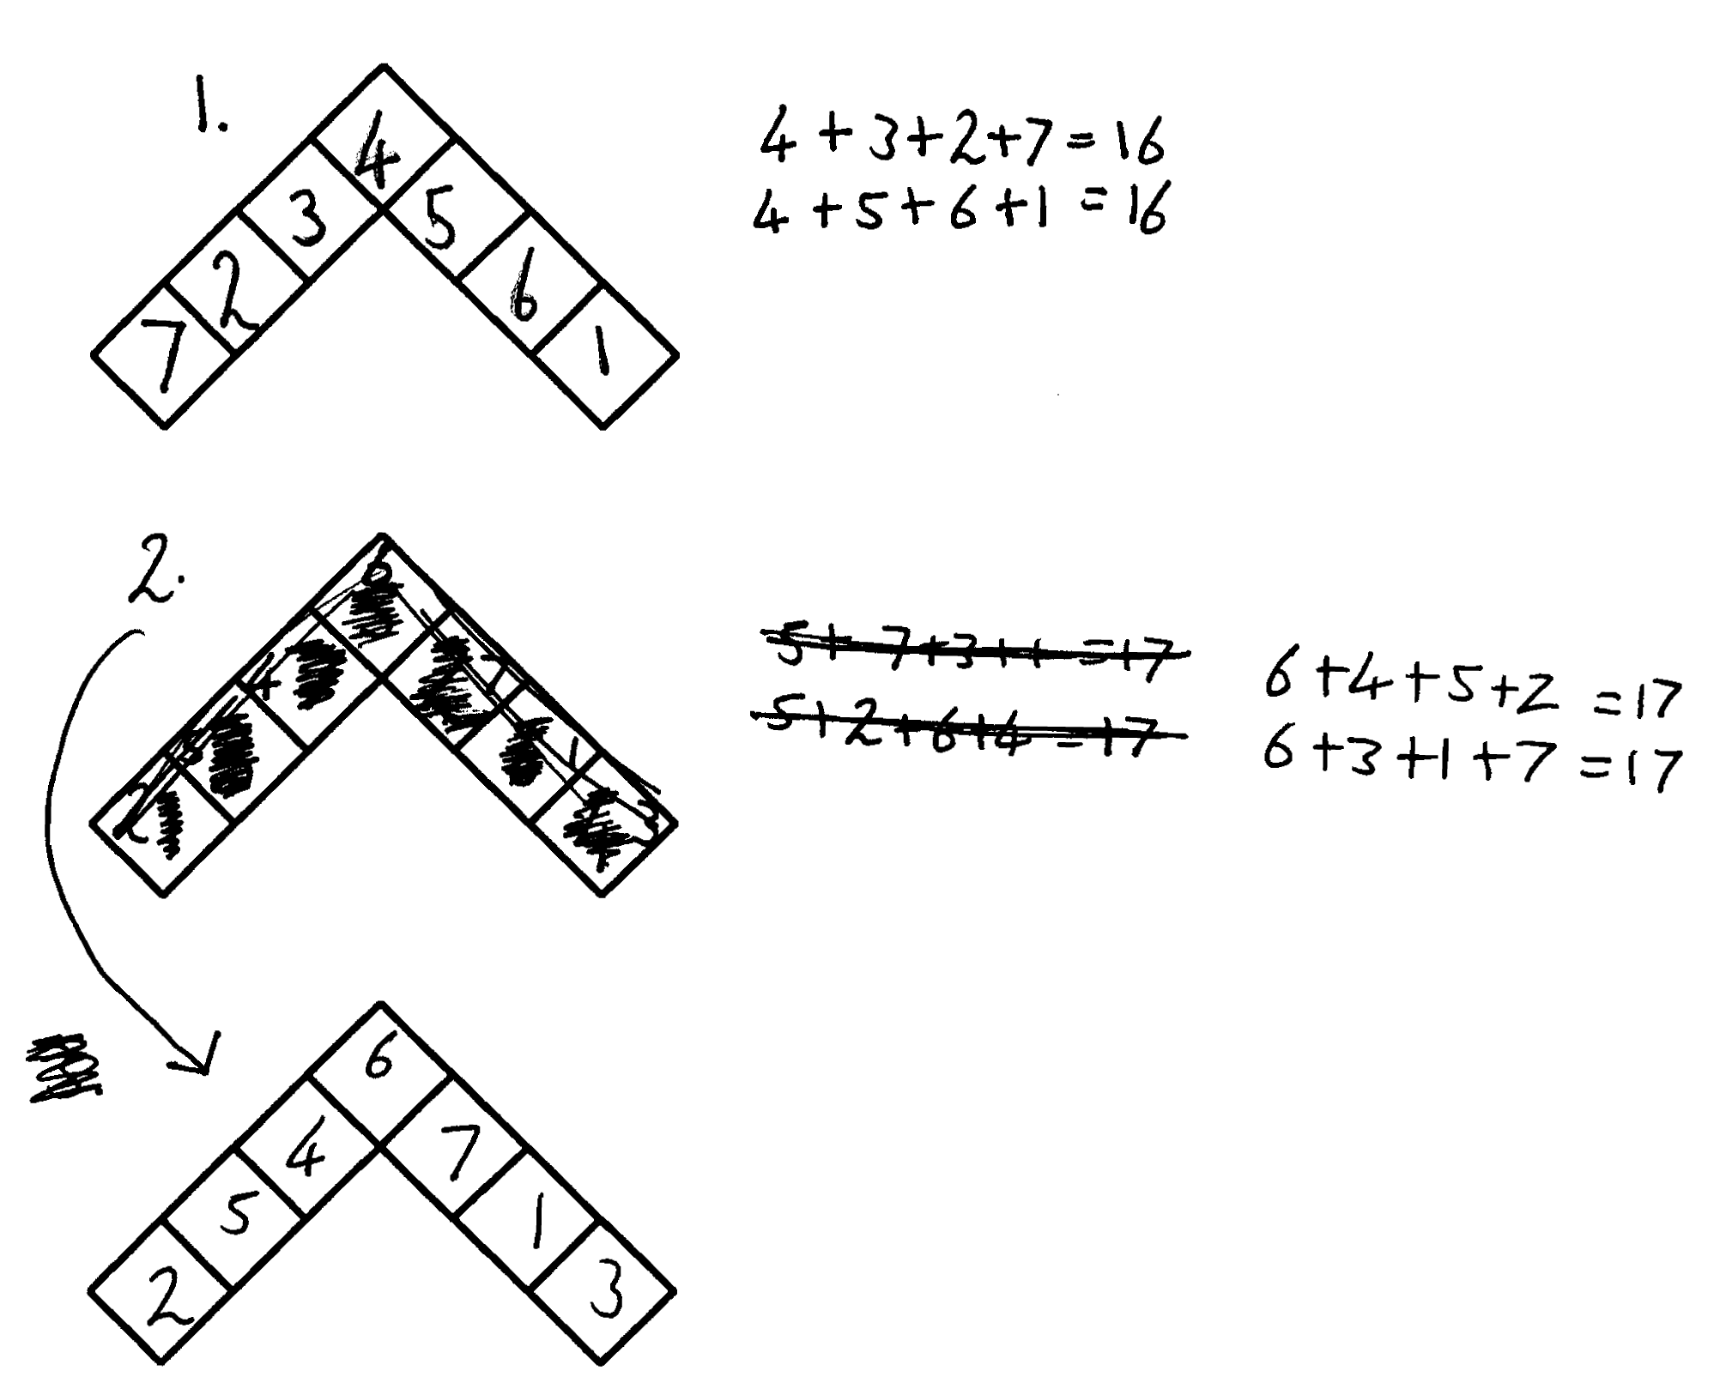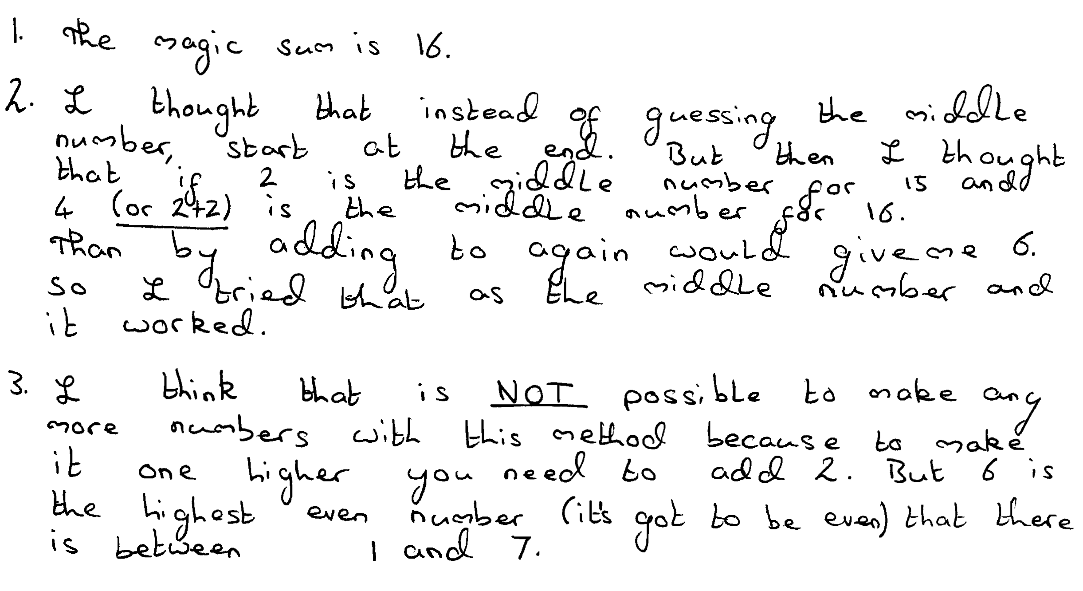
Comments

Pupil C correctly completes a puzzle where the top number is given and finds the magic sum. She then correctly completes a puzzle when she is given the magic sum and shows correct work. She realises that she has been successful with the top number as 2, 4 and 6, and so conjectures that it is not possible to make any other magic puzzles because 6 is the highest even number below 7.

Probing questions and feedback

- Can you explain why the middle number must be even?
- Can you work out a rule or formula that will connect the magic sum to the middle number?

Pupil D
Comments

Pupil D correctly completes the first two parts showing evidence of a systematic approach. He constructs an equation to find the ‘top’ number by adding up all the numbers in the diagram. He then correctly describes why further magic totals are impossible.

Probing questions and feedback

- Can you find a rule or formula that relates the top number in a diagram to the magic sum?

