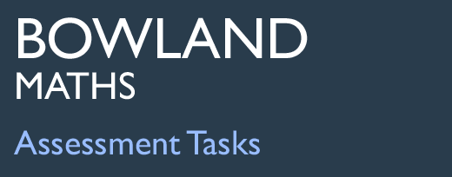 | Ice Cream

Task description

Pupils plan quantities they will buy in order to maximise their profit from selling ice creams at a school event.
Suitability National Curriculum levels 5 to 6

Time 30 minutes to 1 hour

Resources Pencil, calculator and paper

Key Processes involved

- Representing: Interpret diagrams and words and select the appropriate information from them.
- Analysing: Work logically towards a result, recognising the impact of constraints. Calculate accurately and apply routine algorithms, making estimates and checking calculations.
- Interpreting and evaluating: Interpret their calculations in context.
- Communicating and reflecting: Show reasoning clearly

Teacher guidance

Check that pupils fully understand the context, for example by explaining:

- You are planning to make and sell ice cream cones at the school sports day. You need to calculate the costs to make sure that you don’t make a loss.
- What points would you think about?

Pupils may tackle this task in different ways, but might be expected to:

- solve simple problems involving ratio and direct proportion
- calculate fractional or percentage parts of quantities and measurements, using a calculator where appropriate
- interpret graphs and diagrams, including pie charts, and draw conclusions

Ice Cream

You are planning to make and sell ice creams at the school sports day.
You plan to make 300 ice creams and hope to sell them all.
Before buying the ice cream, you survey 60 people to find out what flavours they like. Here are the results of the survey:

You buy ice cream in 1 litre tubs. Each tub costs £2 and you can fill ten cones from each tub.
Each empty cone costs 5p
You plan to sell each filled cone for 80p.

Work out the quantities you need to buy and their costs.

If you sell all 300, how much profit do you expect to make on the day?

Assessment guidance

Progression in Key Processes

Representing | Analysing | Interpreting and evaluating | Communicating and reflecting
Selection of information from the pie chart | Quality of calculations and reasoning throughout | Interpretation of own calculations to conclude the task | Clarity of method used
Selects minimal information from the pie chart or text.  PROGRE  S  S  I  ON | Performs some calculations to determine quantities and costs  Pupil A | Interprets calculations to decide quantity of one or more flavours of ice cream to purchase; calculates resulting costs, but with some errors or omissions  Pupil A | Presents some calculations  Pupil A
Selects some appropriate information from the pie chart or text  Pupils A and B | Works logically, performing some calculations to determine quantities and costs  Pupil B | Interprets calculations to decide quantities of all flavours of ice cream to purchase; calculates resulting costs, but with some errors or omissions  Pupil B | Presents some calculations clearly  Pupil B
Selects most of the appropriate information from the pie chart and text  Pupil C | Works logically, performing calculations to determine quantities, costs and profits  Pupil C | Interprets calculations to decide quantities of all flavours of ice cream to purchase; calculates resulting profit, but with errors e.g. omits the cost of the cones  Pupil C | Gives a detailed and reasonably clear explanation of method used  Pupils C and D
Selects all the appropriate information from the pie chart and text  Pupil D | Works logically, performing accurate calculations to determine quantities, costs and profits  Pupil D | Interprets calculations to make correct decisions on quantities of all flavours of ice cream to purchase; calculates correct profit  Pupil D | Gives a detailed and clear explanation of method used

Sample responses

Pupil A

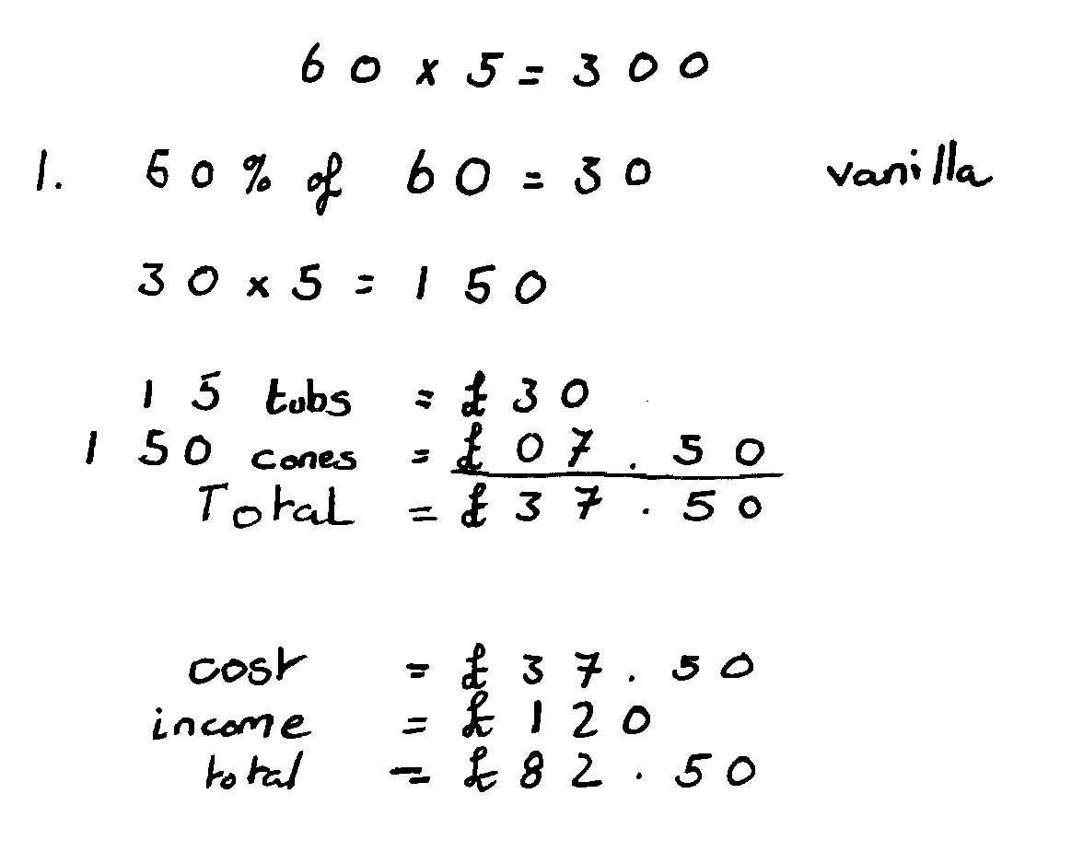
Comments

Pupil A successfully considers the costs of making and selling 150 vanilla ice creams.
No further work is shown.

Probing questions and feedback

- Have you enough ice creams for 300 people?
- What else is needed?
- What about the other flavours?

Pupil B

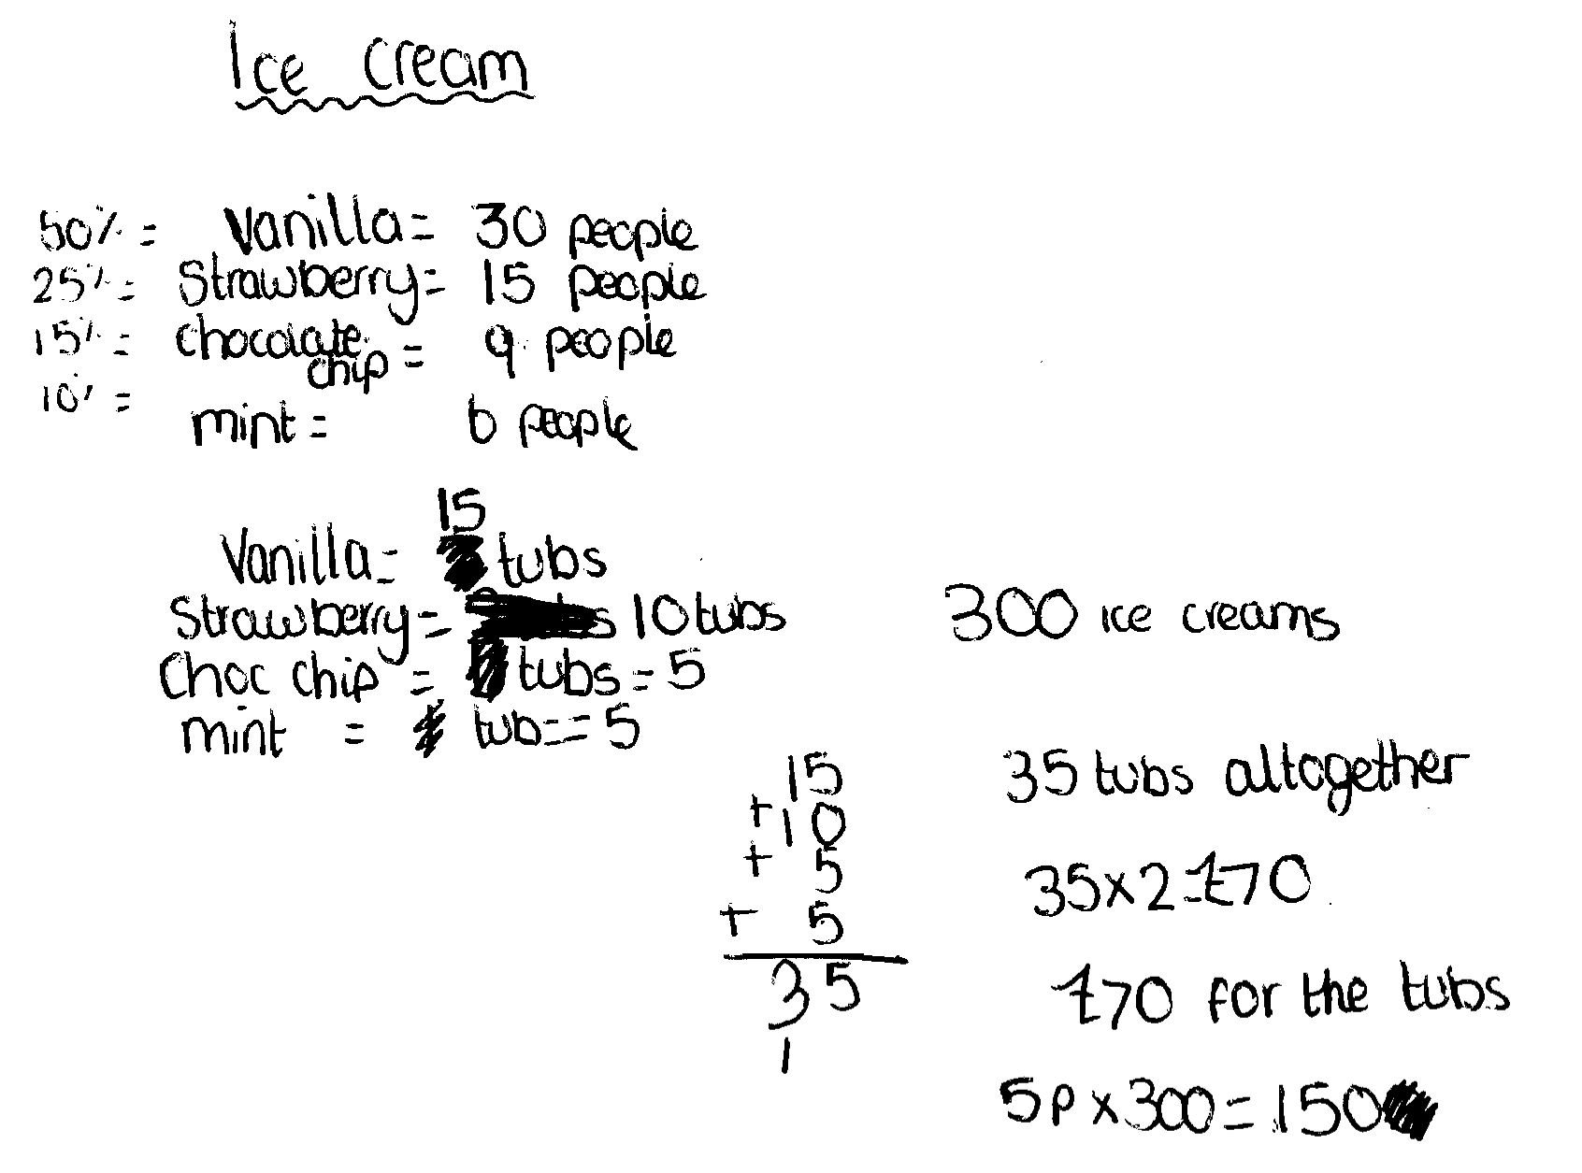
Comments

Pupil B considers buying and selling the four different flavours of ice cream.
The numbers of tubs for vanilla and chocolate chip are correct, but it is not clear how he reached the numbers as there is no link in his reasoning. He also got the wrong numbers of tubs for strawberry and mint, further raising the question of whether he knew what he was doing.

Probing questions and feedback

- How did you calculate the numbers of tubs – show your working!
- You have calculated that you need to purchase 35 tubs of ice cream. How many ice cream cones will this make?
- You have calculated the total cost of the ice cream and the tubs. How do you find the profit?

Pupil C

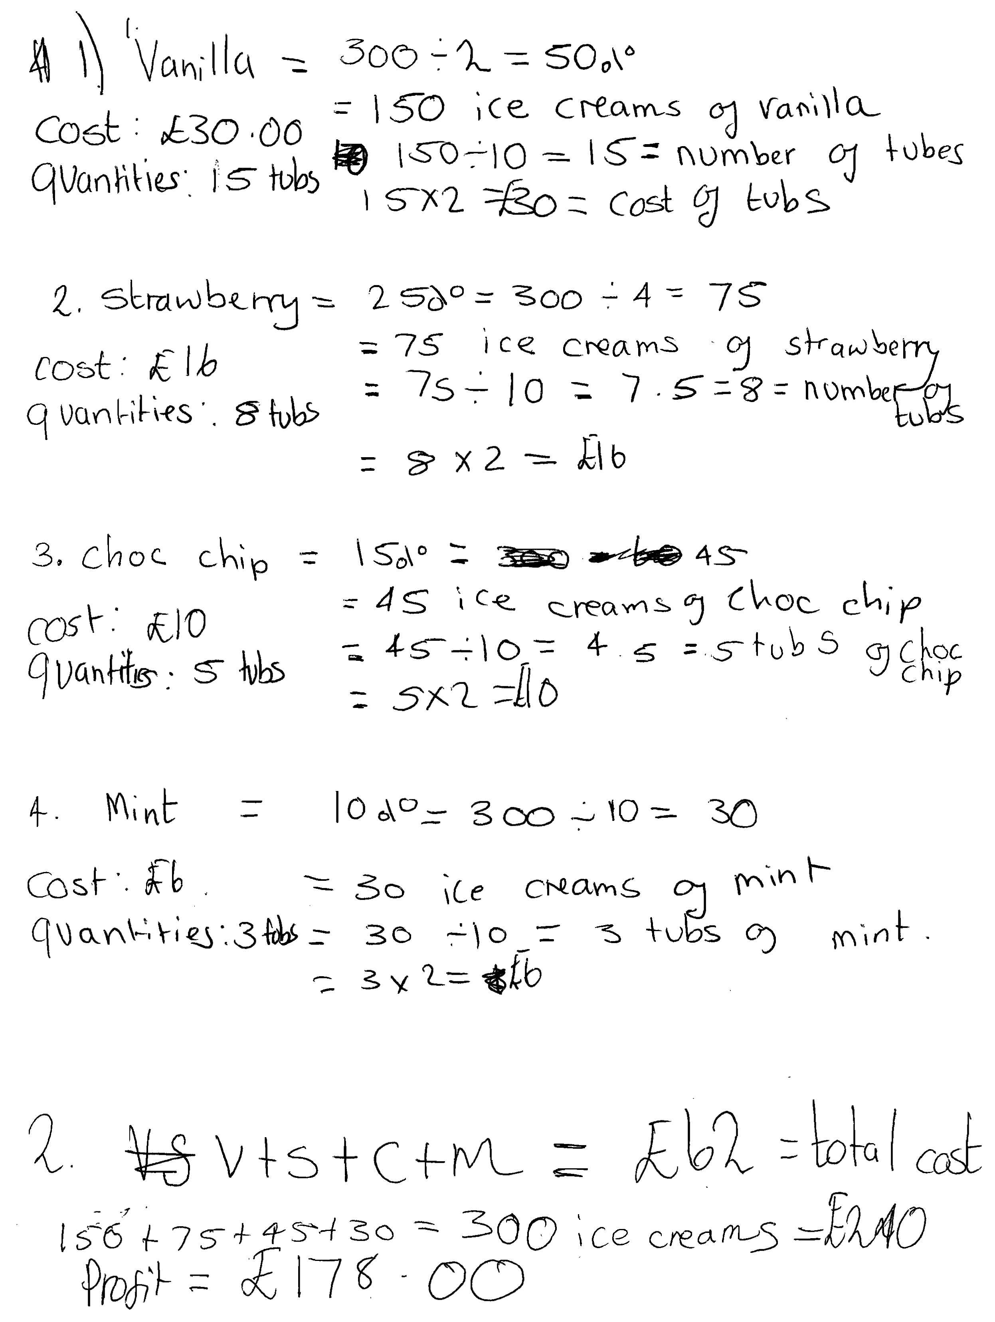

Comments

Pupil C correctly considers buying and selling all four flavours of ice cream. He rounds up both fractional calculations, so that everyone is likely to be satisfied, but he will have some ice cream left over. He forgets to include the cost of buying the cones, so his overall profit is not correct.

Probing questions and feedback

- Did you think about how many cones can be made using the total number of tubs you suggest buying?
- Can you reduce this number, to reduce waste?
- What about the cost of the cones?
- What would be your revised figure for the profit?

Pupil D

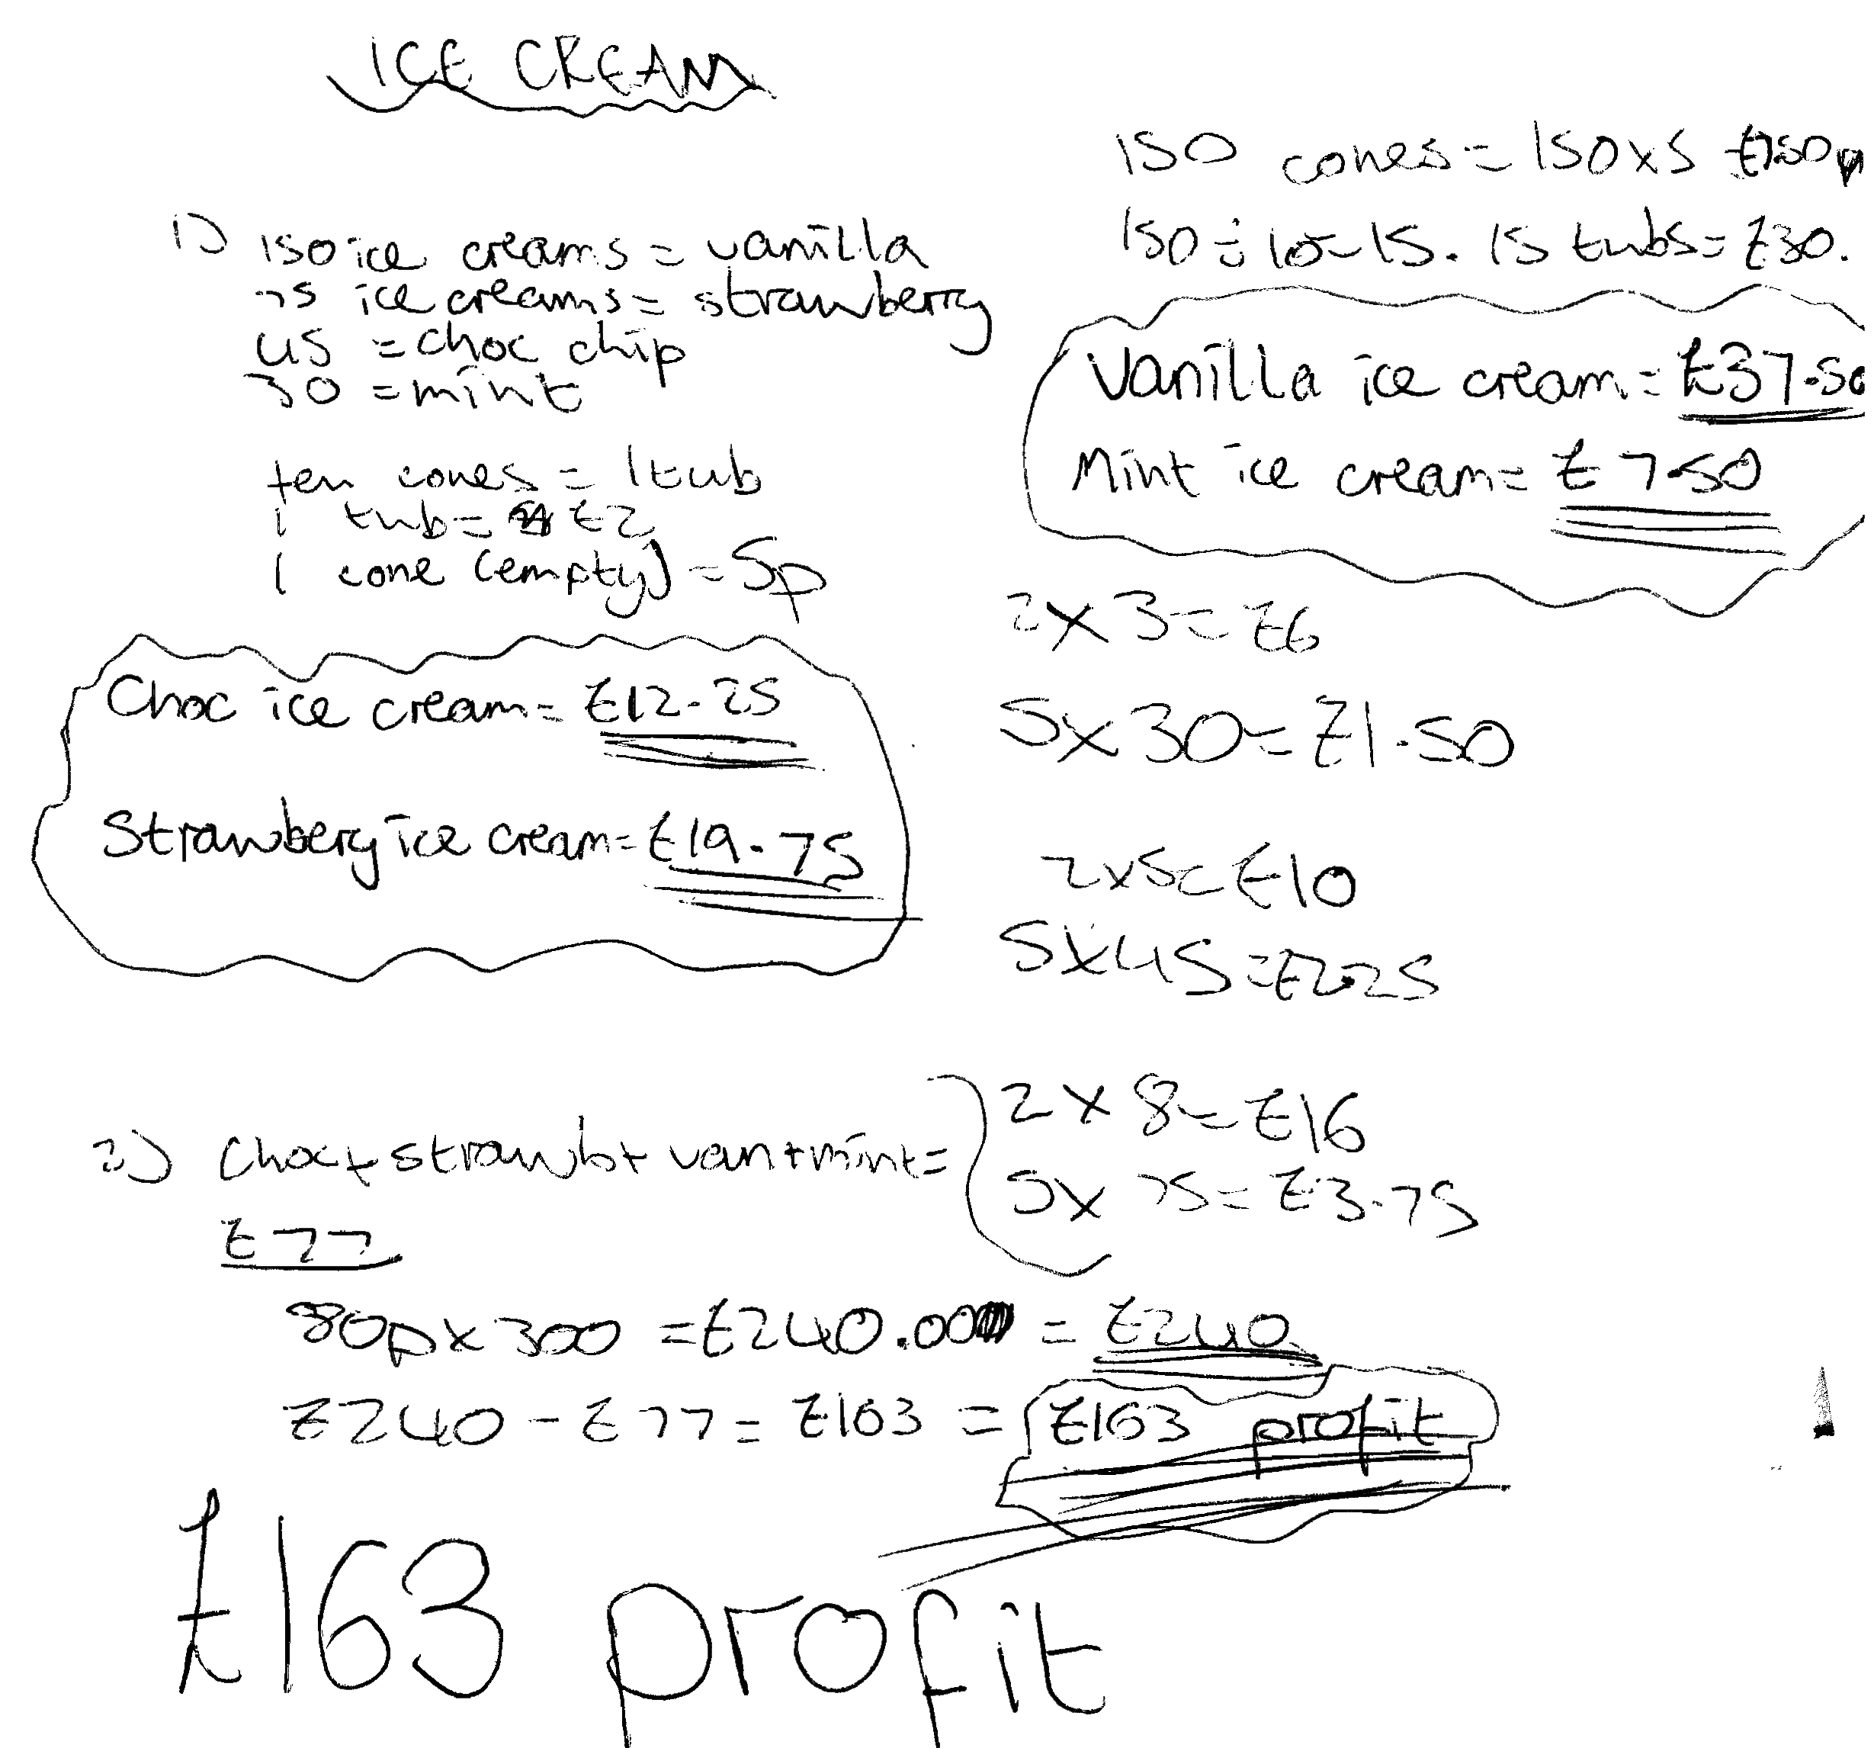

Comments

Pupil D correctly considers buying and selling all four flavours of ice cream, including the cost of the cones. He rounds up the number of tubs needed for strawberry and choc chip which means that everyone is likely to be satisfied, but he will have some ice cream left over. His work is clear but it could be explained more carefully.

Probing questions and feedback

- How much ice cream will you have left over at the end of the day?
- Show this answer to a neighbour and see if he can follow your explanation.
- Can you make the reasoning any clearer?

