 | Hot under the Collar

Task description

Pupils compare two rules for converting temperatures in Celsius to Fahrenheit, one accurate and one approximate.

Suitability National Curriculum levels 7 to 8

Time 20 to 40 minutes

Resources Pencil, calculator and paper; rulers and graph paper available but provided only on request

Key Processes involved

- Representing: Select a way of comparing the two methods, for example, using a table or graph.
- Analysing: Explore the effect of varying the temperature; make accurate calculations or graphs, recording methods systematically. Deduce when the approximate method gives an answer that is too high.
- Interpreting and evaluating: Interpret their tables and graphs to solve the problem, relating their findings to the original context.
- Communicating and reflecting: Communicate their reasoning and findings clearly.

Teacher guidance

Check that pupils understand the context, for example you could show examples of key temperatures e.g. body temperature and temperature of freezer.
- Americans do not use metric units for temperatures, they use degrees Fahrenheit; in Europe, we measure temperature in Celsius or Centigrade.
- John and Anne have two different ways of converting from degrees Centigrade to degrees Fahrenheit.
- One says their method is accurate and the other says their method is near enough for most purposes.

Pupils can tackle this task in different ways, but they might be expected to:

- use algebraic and graphical methods to solve simultaneous linear equations in two variables.

Hot under the Collar

John and Anne are discussing how they change temperatures in degrees Celsius into degrees Fahrenheit.
The accurate way is to:
multiply the Celsius figure by 9,
then divide by 5, then add 32.
John

Anne
I have an easier method: double the Celsius figure then add 30. That is near enough for most purposes.

- If the temperature is 20° C, what would John make this in Fahrenheit?
How far out would Anne be?

- For what temperatures does Anne's method give an answer that is too high?

Assessment guidance

Progression in Key Processes

Representing | Analysing | Interpreting and evaluating | Communicating and reflecting
Selection of information and methods, including methods of calculation  PROGRE  S  S  I  ON | Accuracy of calculations and use of variables including plotting graphs | Interpretation of findings to come to a conclusion that fits the context | Clarity, completeness and accuracy of communication of reasoning and conclusions
Selects some key information and performs relevant calculations.  Pupil A | Makes accurate calculations for at least one of the methods for 20º C.  Pupil A | Attempts to interpret findings in the original context, e.g. states whether Anne’s calculation is too high or low and by how much.  Pupil A | Presents findings clearly but they are incomplete and with errors.  Pupil A
 | Makes some accurate calculations for 20º C and for at least one other temperature.  Pupil B | Interprets findings in the original context, e.g. states whether Anne’s calculation is too high or low and by how much.  Pupil B
Selects a way of comparing the two methods.  E.g. using algebra, a table or a graph.  Method not efficient  Pupils B and C | Explores the effect of varying the temperature. Makes accurate calculations or graphs, recording systematically.  Pupil C | Interprets calculations, tables or graphs to begin to solve the problem, relating findings to the original context.  Pupil C | Communicates reasoning and findings clearly.  Pupils B and C
Selects an efficient way of comparing the two methods.  E.g. using algebra, a table or a graph.  Pupil D | Explores the effect of varying the temperature. Makes accurate calculations or graphs, recording systematically.  Deduces when the approximate method gives an answer that is too high.  Pupil D | Interprets calculations, tables or graphs to solve the problem, relating findings to the original context.  Pupil D | Communicates reasoning and findings clearly and succinctly.  Pupil D

Sample responses

Pupil A

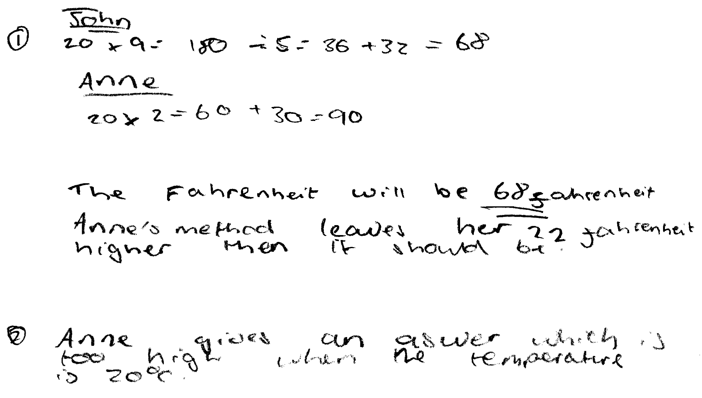

Comments

Pupil A correctly calculates the temperature in degrees Fahrenheit using John’s rule.
He makes an error using Anne’s rule

Probing questions and feedback

- Please explain how you used Anne’s method when the temperature is 20 degrees Centigrade?
- What are you asked to find out in the second question? What other temperatures could you try to see if Anne’s method always gives too high a temperature?

Pupil B

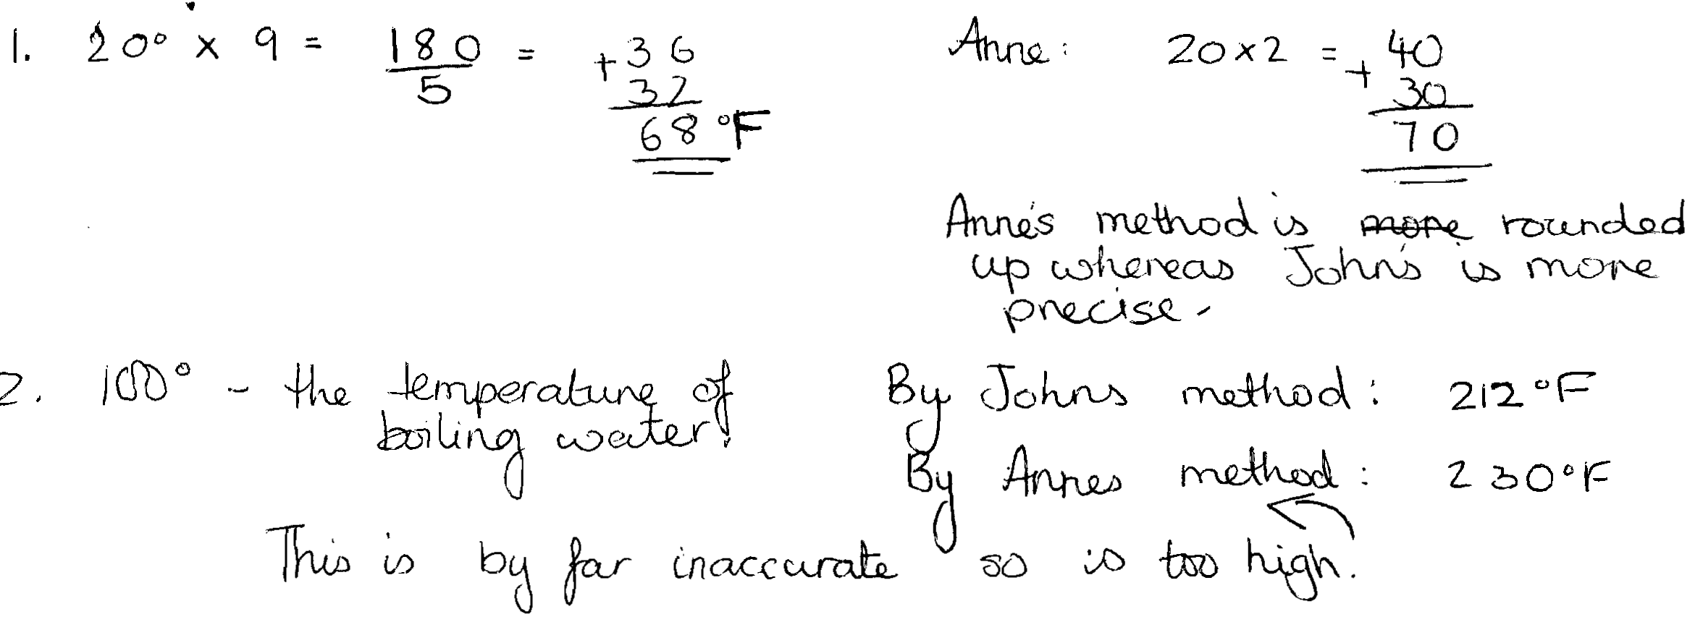

Comments

Pupil B correctly calculates the temperature in degrees Fahrenheit using both John’s rule and Anne’s rule. He makes calculations using both rules for 100°C and states that Anne’s method gives an answer that is too high.

Probing questions and feedback

- What are you asked to find out in the second question? What other temperatures could you try to see if Anne’s method always gives too high a temperature?
- How might you approach this in an organised way?

Pupil C
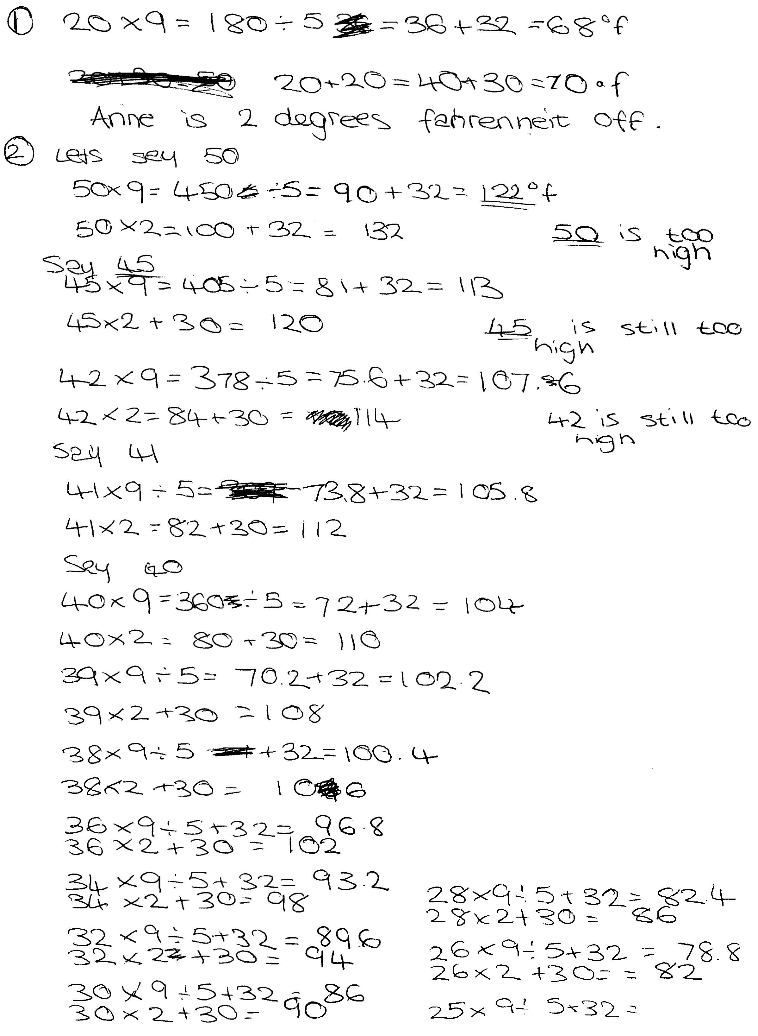

Comments

Pupil C correctly calculates the temperature in degrees Fahrenheit using both John’s rule and Anne’s rule for 20 degrees Celsius. Pupil C makes many calculations using both rules, but her method, though systematic, is very long-winded and she needs to find a more efficient searching strategy. She does not relate her findings to the context.

Probing questions and feedback

- You have tried a number of temperatures working down from 50 to 25 and found that for each of them Anne’s method gives too high a value. What other Celsius temperatures could you try?
- Can you think of a more efficient approach to compare the methods John and Anne used?
Pupil D
Comments

Pupil D correctly calculates the temperature in degrees Fahrenheit using both John’s rule and Anne’s rule for 20 degrees Celsius. He then systematically compares the differences between the two methods for 30°, 10° and 0°. This, together with his result for the first part, reveals a linear pattern in the differences that suggests his conclusion. Pupil D’s solution is thus efficient and correct.

Probing questions and feedback

- Can you think of an algebraic or graphical approach to this problem?
- When would you recommend John’s method and when Anne’s method?

